Research Question

To what extent have AI/ML/NLP research abstracts shifted in their focus from theoretical foundations to real-world applications, changed in how limitations are framed, and accelerated in the diffusion of new terminology over time?

Sub-questions:
- Do we observe early hints, sudden adoption, or gradual diffusion of new terms when comparing papers from before, during, and after each shift? → diffusion of new terminology
- What phrases (e.g., “limitations”, “future work”, “may”, “could”, “we do not address…”) appear in earlier vs. later abstracts, and how does their tone differ? → how limitations are framed
  - Are limitations discussed more when new methods are introduced? And is there a shift from technical limitations → societal/ethical limitations?
- Can topic models reveal a measurable migration of dominant topics from methodology-heavy clusters toward application-heavy clusters across time frame?
- Do modern abstracts acknowledge failure cases more or less explicitly than older ones?

Member 3: Limitation Framing

In this part, how limitations are framed in AI/ML/NLP research over time is discussed. Three different approaches were used to analyze it:
- Lexical Analysis of predefined limitation categories,
- A pipeline using both TF-IDF and Logistic Regression → to identify distinguishing language between early vs late period papers,
- Embedding-based semantic analysis

I defined four categories of possible language limitations used in the papers. (failure, capability, hedging, ethical concerns)

In this part, the analysis included:
- overall trends in each limitation category,
- the shift from technical to ethical limitations,
- tone changes (explicit vs hedging),
- co-occurrence of ethics and explicit failure,
- and whether papers introducing new methods are more likely to mention limitations.

(b) Classification: TF-IDF + Logistic Regression

Comparison of two periods (2010-2013) vs (2018-2020) → Both within the deep learning era to clearly differentiate limitation instead of capturing a broader theme shift. The evaluation of whether the two periods could be differentiated using language alone was done using cross-validation, and then a train-test model was applied to extract the most discriminative words.

TF-IDF allows to transform text (abstract) into numerical feature vectors. Logistic regression is then used to classify between the early and late periods. This choice is appropriate since TF-IDF generates sparse high-dimensional representations that can be easily handled by logistic regression, and feature coefficients can be interpreted directly. Consequently, the model not only assesses the presence of language variation over time but also shows which words play the greatest role in this difference.

Contrary to lexical tracking, where predefined keywords are used, the classifier determines the discriminative language automatically.

(c ) Embeddings - Semantic Analysis (Sentence Transformer Model)

To capture the broader semantic changes in limitation, sentence embeddings were used. The model converts text into semantic numerical vectors (embeddings). It measures the similarity between vectors using cosine similarity, where a closer distance indicates higher semantic similarity.

I calculated a centroid of each time period and calculated the distance between successive time periods to measure semantic shift. I also applied PCA to visualise the path of limitations defining over time in a low-dimensional space.

Interpretation of my findings:

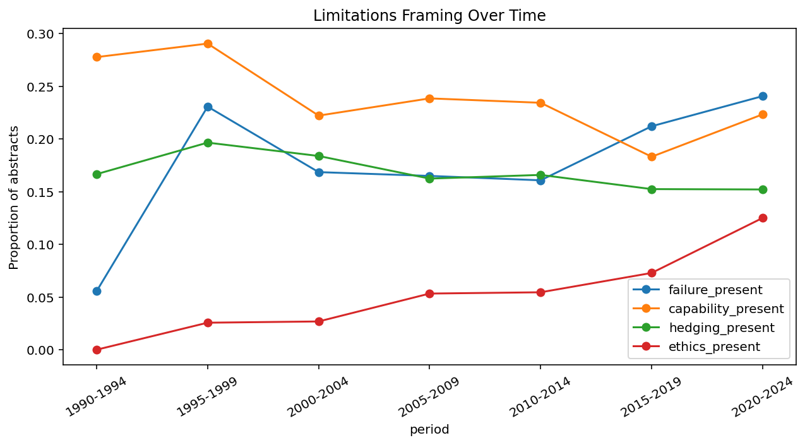

Observation
Failure-related language is low in the early stages, rises between 1995 and 1999, and then goes up again in recent years. Ethical phrases are almost non-existent in the early periods, but they gradually increase, with a stronger rise after 2015. Hedging is largely steady, with a minor reduction in subsequent periods.

Interpretation

This implies that, while technical restrictions (failure/capability) have been constantly highlighted, ethical problems arrive later and gain importance. Simultaneously, the consistent but slightly reducing usage of hedging could indicate a trend toward more upfront reporting of constraints.

Claim
Ethical considerations are a relatively new and developing feature of limitations framing, whereas the use of cautious (hedging) language is consistent but slightly decreasing through time.
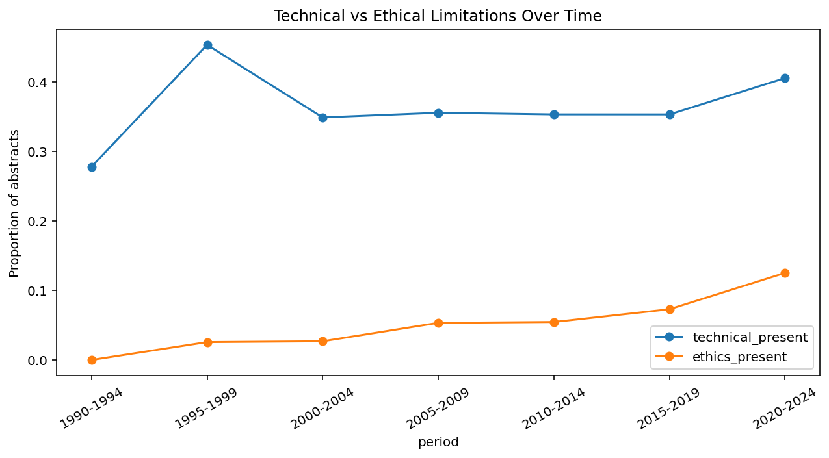
Observation
Technical restrictions are continuously high across every period, but ethical limitations begin at zero and develop considerably, particularly during 2015-2019.

Interpretation
This suggests that technological limits have always been fundamental to study reporting, but ethical issues have just lately gained relevance.

Claim
Limitations framing expands over time from predominantly technical concerns to include ethical and societal considerations.
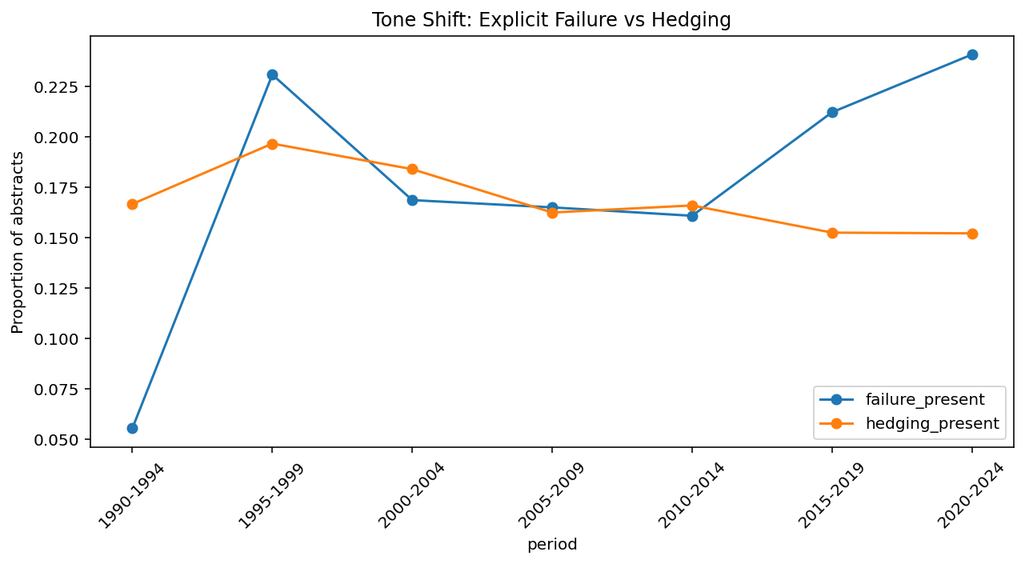

Observation
Hedging was more common in the early times, particularly in the 1990s. The distinction between hedging and explicit failure language narrows with time, with both being used at similar levels in the mid-2000s. In later eras, failure language rises a little above hedging.
Interpretation
This shows a gradual transition from cautious to more explicit reporting of constraints, although both types are present.

Claim
Instead of a total change, there is a progressive rebalancing from hedged language to more explicit failure limitation language.
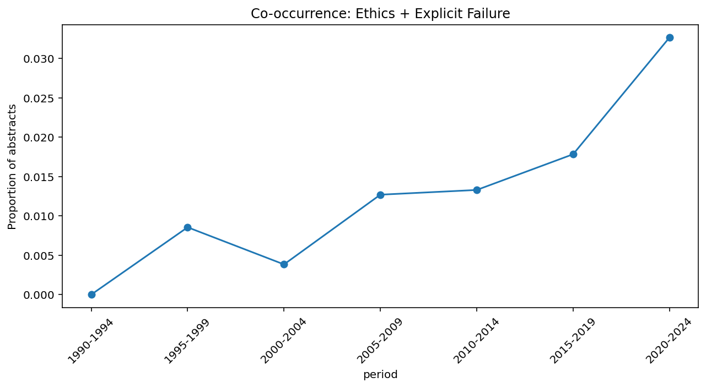
What this plot tries to answer: “What is the proportion of papers that mention both ethics and explicit failure in papers across periods?”

Observation
In the early years, the proportion of papers discussing both ethical problems and explicit failure was relatively low, but it has since increased.

Interpretation
This implies that ethical concerns are increasingly being considered with specific technological limits, rather than independently.

Claim
Recent research increasingly reflects co-occurrence of ethical concerns and explicit limitations, indicating a closer association between these dimensions in limitations framing

Method introduction vs limitation

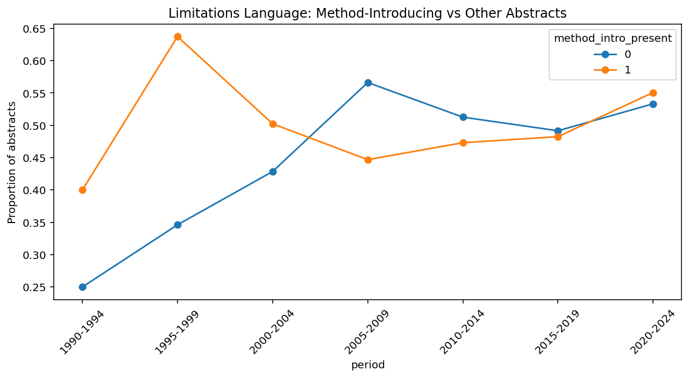

Observation
The aggregate results reveal nearly identical proportions of limitation reporting in method and non-method articles. However, temporal analysis shows that technique articles are more prevalent in the early 2000s, decline in the mid-2000s, and then converge in the late 2000s.

Interpretation
This shows that differences between paper types change over time and are not constant.

Claim
Limitations reporting is not specific to method-introducing papers and becomes increasingly standardised across all research outputs over time.

(b) Interpretation on TF-IDF + Logistic Regression Classifier:

Main output:

Class 0 (early): recall = 0.84
Class 1 (late): recall = 0.88, Accuracy = 0.87, Mean CV accuracy = 0.858

Observation
With similar recall in both classes (0.84 early, 0.88 late), the classifier achieves 87% test accuracy and 85.8% mean CV accuracy.

Interpretation
Class imbalance is no longer a major issue and it is clearly seen by the balanced recall across both classes. Even in the deep learning era, the classifier is able to effectively differentiate between the two eras. This means that language itself has shifted not only the broad vocabulary in the field.

Claim
There are similar results in both classes, indicating that the classifier can successfully separate publications from 2010–2013 from those from 2018–2020. This suggests that there is measurable language changes in limitations framing that occur in the current deep learning period.

Late features (2018–2020) → neural, task, deep, dataset, model, training, neural network, baseline, end, embeddings, challenge, machine learning, human, language, text.
Early features (2010–2013) → algorithm, probability, bayesian, decision, polarity, theory, probabilistic, class, technique, svm, formalism, belief, function, bayesian network, variable.

Interpretation
Deep learning words such as neural, deep, embeddings, neural network, … etc phrases dominate in the late era limiting language. The statistical and probabilistic machine learning vocabulary used in the early period of language, such as algorithm, Bayesian, probabilistic, SVM, formalism, and Bayesian network, reflects that constraints were mainly built around model assumptions and algorithmic bounds.

Claim
The language to express limitations in the deep learning era has moved from statistical and probabilistic to more neuronal and task-focused. This demonstrates that transformation extends beyond broad paradigm shifts.

Cross-validation on TF-IDF + Logistic Regression

Observation
Cross-validation produces consistent accuracy across all five folds: [0.845, 0.840, 0.876, 0.887, 0.841], with a mean of 85.8%.

Interpretation
This shows that the distinction between early and late publications is constant across data splits.

Claim
Consistent accuracy across five folds indicates that the results are stable and not dependent on a single data split. The 85.8% accuracy achieved during the deep learning era suggests that the classifier is capturing meaningful changes in how constraints are presented, rather than merely general vocabulary changes.

Confusion Matrix:

[[178 35]
[108 808]]

Observation
- Early papers → 178 correctly classified; 35 misclassified.
- Late papers → 808 correctly classified; 108 misclassified

Claim
84% of early publications and 88% of late papers are identified accurately by the classifier. As both time frames fall into the deep learning period, the remaining misclassification can be due to the language overlap between these two periods.

Overlap Analysis for Lexical vs Classifier

Observation

Of the top 20 classifier features for each period, only 1 overlapped with the predefined lexical vocabulary — 'challenging' (late) and 'constraint' (early).

Interpretation
The near-zero overlap indicates that the classifier and lexical tracking capture distinct signals: the classifier recognizes the wider vocabulary of each period, whereas lexical tracking examines the presence of predetermined limiting phrases.

Claim
The two approaches are complementary: lexical monitoring determines if constraints are acknowledged, whereas categorization exposes how a language has changed over time.

Embedding Distances:

Semantic distances between consecutive periods (limitations only):
1990-1994 -- 1995-1999 0.3494
1995-1999 -- 2000-2004 0.1676
2000-2004 -- 2005-2009 0.1889
2005-2009 -- 2010-2014 0.12
2010-2014 -- 2015-2019 0.3033
2015-2019 -- 2020-2024 0.0899

Observation
Larger semantic variations are evident during 1990-1995 and 2010-2015, whereas other eras demonstrate minor changes.

Interpretation
This suggests that changes in limiting discourse may not occur uniformly, but rather during moments of more transition.

Claim
Semantic changes in limitation framing occur in sharp shifts rather than gradually over time.

PCA Trajectory:

Major change between 2015 and 2019.

Observation
There is a considerable difference in position from 2010-2014 and 2015-2019.

Interpretation
This shows a significant shift in how restrictions are linguistically communicated throughout this time.

Claim
Limitations framing experiences a large semantic shift in the mid-2010s, indicating a shift in research discourse.

Summary:

The embedding-based analysis shows that there is not a linear pattern of change in limitations framing over the time, rather, it happens in specific periods. Centroid distance calculations and the PCA trajectory show that there was a relatively stable semantic positioning between the years 1990 and 2014. Followingly, there was a notable move between 2010-2014 and 2015-2019. Following this shift, subsequent periods (2015 - 2019 and 2020 - 2021) fill a new area of the semantic space, which indicates a new way of expressing limitations in the papers. The minor change between 2015 - 2019 and 2020 - 2021 suggests that there is some stabilisation of the change after this. These results indicate that discourse of limitation changes slowly over long periods of time, but in the event of critical points, it changes significantly instead of linear, continuous. This is useful to show the overall changes in semantic representation, but it does not reveal precisely what these changes are. Lexical analysis and categorization are additional complementary tools to use in this scenario to understand how constraints are framed.

Notably, these results are not similar to those achieved by lexical and classification methodologies. For instance, lexical analysis indicates more gradual change, such as the rise in the use of ethical language and the comparative stability of hedging, embedding-based approaches indicate more punctuated change (more sudden shifts in meaning). The TF-IDF logistic regression classifier achieves a mean accuracy of 85.8% when applied to a within-era window (2010-2013 versus 2018-2020), with balanced performance in both classes. This cannot be attributed to paradigm-level language variations because both eras occur throughout the deep learning era, indicating that the classifier is identifying true shifts in how restrictions are linguistically defined. All together, this shows that various approaches have different accounts of change: lexical approaches capture more surface-level trends, embeddings capture more semantic shifts, and classification brings out the dominant linguistic differences. This supports the argument that the conclusions regarding the framing of limitations are potentially highly dependent on the chosen representation and analysis approach.

