MLOps / Platform DevOps
Interview Talking Points
End-to-End GitOps Progressive Delivery for an ML Inference API
Project positioning: Designed and implemented an automated GitOps-based progressive delivery platform for an ML inference service on Kubernetes, integrating GitHub Actions, GHCR, Argo CD, Argo Rollouts, Trivy and Prometheus to provide CI/CD, security scanning, controlled canary releases and automated metric-based deployment decisions.

1. STAR Interview Answer

Situation
We needed a safer and more automated way of releasing ML inference services into Kubernetes. A standard rolling deployment was not sufficient because an application could pass CI tests and still exhibit poor behaviour after exposure to production traffic. The objective was to implement GitOps-based progressive delivery where releases could be automatically validated using runtime metrics before full promotion.

Task
My responsibility as the MLOps / Platform DevOps engineer was to design the CI/CD and deployment workflow, separate application and environment configuration, introduce security controls, and implement a deployment strategy capable of automatically stopping unhealthy releases.

Action
- Separated the solution into an application repository and a dedicated GitOps repository. The application repository contained the FastAPI inference service, tests, Dockerfile and GitHub Actions workflow, while the GitOps repository became the source of truth for Kubernetes and Argo Rollouts configuration.
- Built a GitHub Actions pipeline that ran pytest, built a Docker image, performed HIGH and CRITICAL vulnerability scanning with Trivy, pushed an immutable SHA-tagged image to GHCR, and updated the corresponding image reference in the GitOps repository.
- Used Argo CD for continuous reconciliation rather than allowing the CI pipeline to deploy directly into Kubernetes.
- Replaced a standard Kubernetes Deployment with Argo Rollouts and implemented staged canary delivery.
- Instrumented the FastAPI inference service with Prometheus counters and latency metrics and exposed a /metrics endpoint.
- Created an Argo Rollouts AnalysisTemplate using PromQL to calculate prediction API success rate and required the runtime success rate to remain above 95% before rollout progression.
- Tested both positive and negative deployment paths. I deliberately introduced a runtime failure that passed CI but degraded prediction requests after deployment.
- Verified that Prometheus detected the degradation, the AnalysisRun failed the SLO, and Argo Rollouts aborted the deployment and scaled down the unhealthy canary while the previous stable revision remained available.

Result
The resulting platform provided an automated release path from source-code commit to Kubernetes while keeping CI and deployment control properly separated. CI validated and secured the artifact, Argo CD maintained GitOps reconciliation, Argo Rollouts controlled progressive delivery, and Prometheus supplied the runtime evidence used to determine whether a release should be promoted or rejected. During the failure test, the unhealthy revision was prevented from becoming stable while all five replicas of the previous healthy revision remained available.

2. 60-90 Second Interview Version
One project I worked on was building a GitOps-based progressive delivery platform for an ML inference API running on Kubernetes.
I containerised the FastAPI inference service and built a GitHub Actions pipeline that ran pytest, performed Trivy vulnerability scanning, built an immutable SHA-tagged image and pushed it to GHCR. Rather than allowing CI to deploy directly to Kubernetes, the pipeline updated a separate GitOps repository, which Argo CD continuously reconciled with the cluster.
For safer releases I replaced standard Kubernetes deployments with Argo Rollouts and implemented staged canary delivery. I instrumented the inference API with Prometheus metrics and created AnalysisTemplates that used PromQL to enforce a 95% prediction API success-rate threshold.
I tested both successful and failed deployments. When I deliberately introduced runtime failures into a new revision, Prometheus detected the degradation and the AnalysisRun failed, causing Argo Rollouts to abort and scale down the canary while the five healthy replicas of the previous stable version continued serving traffic.
That gave us an automated release process where CI validated the artifact, GitOps controlled deployment state, and production telemetry determined whether a release was safe to promote.

3. Architecture to Explain on a Whiteboard
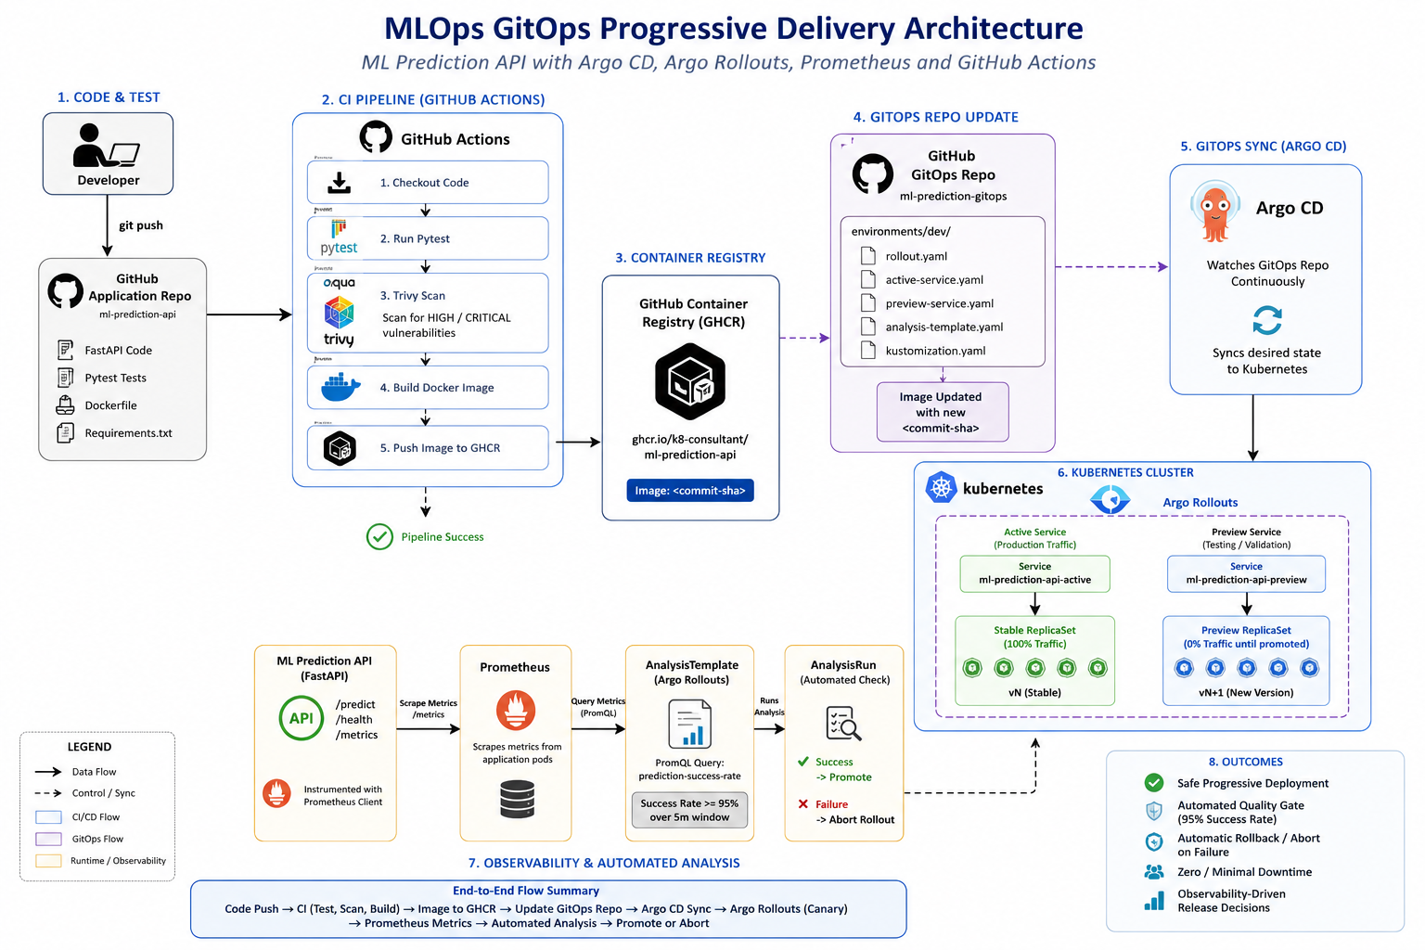
Figure 1. End-to-End MLOps GitOps Progressive Delivery Architecture
Developer
|
| git push
v
Application Repository
|
v
GitHub Actions
|-- pytest
|-- Trivy scan
|-- Docker build
v
GHCR (SHA-tagged image)
|
v
GitOps Repository
|
v
Argo CD
|
v
Kubernetes / Argo Rollouts
|-------------------|
v v
Stable ReplicaSet Canary ReplicaSet
\ /
\ /
FastAPI
/predict /metrics
|
v
Prometheus
|
PromQL
|
v
AnalysisTemplate / AnalysisRun
|
+------+------+
| |
>=95% <95%
| |
Promote Abort

4. Troubleshooting Stories Worth Mentioning
Prometheus / Argo analysis error: An AnalysisRun initially returned 'reflect: slice index out of range'. I traced it to an empty Prometheus result vector while the expression assumed result[0] always existed. I corrected the analysis condition to safely handle empty results before evaluating the threshold.
Cross-repository GitHub authentication: The CI workflow initially received HTTP 403 while attempting to update the GitOps repository. I validated PAT identity and repository permissions, isolated the write-access issue, and corrected the cross-repository update workflow.
Prometheus scraping: Prometheus initially returned no useful application metrics. I verified pod annotations, inspected target discovery, identified 404 responses from an older application image, and confirmed that the new image exposed /metrics once the GitOps pipeline successfully updated the rollout.

5. Skills Demonstrated
Area | Evidence
Kubernetes | Pods, Services, probes, namespaces and ReplicaSets
Docker | Containerised FastAPI inference service
GitHub Actions | Multi-stage CI/CD automation
Testing | pytest quality gate
DevSecOps | Trivy HIGH/CRITICAL vulnerability scanning
Container Registry | GHCR with immutable commit-SHA image tags
GitOps | Separate application and deployment repositories
Argo CD | Continuous reconciliation of desired cluster state
Argo Rollouts | Progressive delivery and automated abort
Canary Delivery | Staged 20% -> 40% -> 60% -> 100% rollout
Observability | Prometheus scraping and application instrumentation
PromQL | Runtime success-rate calculation
SLO Gating | 95% success threshold for deployment progression
MLOps | Versioned inference API and model metadata
Troubleshooting | PAT permissions, scraping, PromQL and AnalysisRun debugging

6. Production MLOps Extension to Discuss
For this project, deterministic prediction logic was used deliberately so the focus remained on the deployment platform. In a production MLOps environment, I would decouple the model artifact from the application lifecycle and retrieve an approved model version from a registry such as MLflow. I would include model version information in deployment metadata and observability labels, and extend the release gate beyond HTTP success rate to model-specific signals such as inference latency, prediction distribution, data/model drift and business or quality metrics.

7. Strong Closing Statement
The key engineering principle demonstrated by this project is that passing CI does not automatically mean a release is safe in production. CI validates the artifact; GitOps controls desired state; progressive delivery limits exposure; and runtime telemetry provides the evidence required to promote or reject the release.

