Hadoop Build
Document Name and Location: | Hadoop Build Document.doc
Document Version:
Date:
Readership:
Summary | Skype Id :  I am looking for someone to build a working clustered Hadoop 2.0 with Hue and all other components.

Amendment History
Version | Date | Comment | By | Approved
1
2
3

Table of Contents
1 Objective 3
2 Definitions, Acronyms and Abbreviations 3
3 Solution overview 4
3.1 Servers 4
3.2 Services web url 5
3.3 Roles of Each nodes 5
3.4 Environment Paths and Scripts 5
3.5 List of all Log Files 5
4 How to start All services at each server 5
4.1 After restart of nodename, datanode machines all stack should come back to life without any errors. 6
4.2 Stop and start cloudera scm server and clouder scm agent 6
5 Post Build Check outs 6
5.1 Stop and started the cluster roles 6
5.2 Rebooted each host and checked the status 6
5.3 Sample map reduce job executed 6
5.4 Able to access hive DB via hue browser 6
5.5 Spark Sample Job Run 6
5.6 Monitoring service enabled in cloudera manager itself 6
6 Hadoop Installation Process 6
6.1 NameNode Installation Process 6
6.2 SecondaryName Node Install Process 6
6.3 DataNode1 Install Process 6
6.4 DataNode2..N Install Process 6
7 How to Add a new Node in cluster 7
8 How to decommission a Node 7
9 Performance Testing and benchmarking using Hadoop Tools 7
10 Issues Identified and Fixes Applied 7
10.1 Memory Issue 7
10.2 Services were down except Cloudera Manager Service 8
11 Errors reported in Testing 8

Objective
Setup Hadoop Multi Node cluster Hadoop 2. YARN stack (http://gethue.com/)
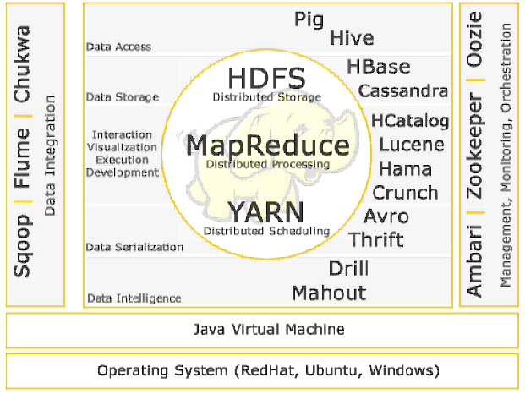

Definitions, Acronyms and Abbreviations
Hortonworks Hadoop System
Component | Details | Version Installed | Namenode | Datanode1 | Datanode2
Hive
HBase
Pig
Squoop
ZooKeeper
Ozzie
Ambari
Spark
Flume
Solr
YARN

Solution overview

Servers

Name | IP / Login Details | Resources | URL
NameNode | 192.168.1.21  hadoop/pass1234! | 8GB/ 250GB
DataNode1 | 192.168.1.20  hadoop/pass1234! | 4GB/ 250GB
DataNode2 | 192.168.1.22  hadoop/pass1234! | 8GB/ 250GB
DataNode3  SecondaryNameNode | 192.168.1.23  hadoop/pass1234! | 4GB/ 250GB

Services web url
Cloudera Manager
ResourceManager UI
Job History server
HBASE
Hue
Solr
Impala StateStore Web UI
Impala Catalog Server Web UI

Roles of Each nodes

Environment Paths and Scripts
JAVA_HOME
HADOOP HOME

Hadoop Installation Process

NameNode Installation Process

SecondaryName Node Install Process

DataNode1 Install Process

DataNode2..N Install Process

List of all Log Files
Namenode
DataNode
Common Files

How to start All services at each server

After restart of nodename, datanode machines all stack should come back to life without any errors.

Stop and start server and agent

Post Build Check outs

Stop and started the cluster roles

Rebooted each host and checked the status

Sample map reduce job executed

Able to access hive DB via hue browser

Spark Sample Job Run

Monitoring service enabled in cloudera manager itself

How to Add a new Node in cluster

How to decommission a Node

Performance Testing and benchmarking using Hadoop Tools
Executed the teragen and terasort job and job execution time is given below
hadoop jar /opt/cloudera/parcels/CDH/lib/hadoop-mapreduce/hadoop-mapreduce-examples.jar teragen 100000000 /user/hadoop/benh_input
JOB completed time - 2 min 18 Sec

hadoop@namenode:~$ hadoop jar /opt/cloudera/parcels/CDH/lib/hadoop-mapreduce/hadoop-mapreduce-examples.jar terasort /user/hadoop/benh_input /user/hadoop/bench_output
Refer the below url for understand about various benchmarking
http://www.michael-noll.com/blog/2011/04/09/benchmarking-and-stress-testing-an-hadoop-cluster-with-terasort-testdfsio-nnbench-mrbench/

Issues Identified and Fixes Applied

Memory Issue
Please increase the Machine memory for sortout the configuration issues. List of warning erro due to memory
HDFS: Java Heap Size of Namenode in Bytes
Java Heap Size of Namenode in Bytes is recommended to be at least 1GB for every million HDFS blocks. Suggested minimum value: 1073741824
namenode: Memory Overcommit Validation Threshold
Memory on host namenode is overcommitted. The total memory allocation is 6.3 GiB bytes but there are only 7.8 GiB bytes of RAM (1.6 GiB bytes of which are reserved for the system). Visit the Resources tab on the Host page for allocation details. Reconfigure the roles on the host to lower the overall memory allocation. Note: Java maximum heap sizes are multiplied by 1.3 to approximate JVM overhead.
datanode3: Memory Overcommit Validation Threshold
Memory on host datanode3 is overcommitted. The total memory allocation is 4.5 GiB bytes but there are only 3.9 GiB bytes of RAM (790.3 MiB bytes of which are reserved for the system). Visit the Resources tab on the Host page for allocation details. Reconfigure the roles on the host to lower the overall memory allocation. Note: Java maximum heap sizes are multiplied by 1.3 to approximate JVM overhead.
datanode2: Memory Overcommit Validation Threshold
Memory on host datanode2 is overcommitted. The total memory allocation is 8.2 GiB bytes but there are only 7.8 GiB bytes of RAM (1.6 GiB bytes of which are reserved for the system). Visit the Resources tab on the Host page for allocation details. Reconfigure the roles on the host to lower the overall memory allocation. Note: Java maximum heap sizes are multiplied by 1.3 to approximate JVM overhead.
datanode1: Memory Overcommit Validation Threshold
Memory on host datanode1 is overcommitted. The total memory allocation is 5.9 GiB bytes but there are only 3.9 GiB bytes of RAM (790.3 MiB bytes of which are reserved for the system). Visit the Resources tab on the Host page for allocation details. Reconfigure the roles on the host to lower the overall memory allocation. Note: Java maximum heap sizes are multiplied by 1.3 to approximate JVM overhead..
Other
Cloudera Management Service: Java Heap Size of Service Monitor in Bytes
The recommended heap size is 256.0 MiB bytes, 112.0 MiB more than is configured.
Cloudera Management Service: Maximum Non-Java Memory of Service Monitor
The recommended non-Java memory size is 1.5 GiB, 414.0 MiB more than is configured.
Cloudera Management Service: Java Heap Size of Host Monitor in Bytes
The recommended heap size is 256.0 MiB bytes, 112.0 MiB more than is configured.
Cloudera Management Service: Maximum Non-Java Memory of Host Monitor
The recommended non-Java memory size is 1.5 GiB, 414.0 MiB more than is configured.

Services were down except Cloudera Manager Service
Sunday 11-Jan-2015
Cloudera manager was started but all other services were down. When investigated I found server has file system errors and hence it was not starting. I had to run fsck and then restart namenode server 192.168.1.21
The file system was left as a READ ONLY
It was proved by doing $ sudo touch /etc/a.txt (Returned Error)
Services were restarted using method listed

Errors reported in Testing

