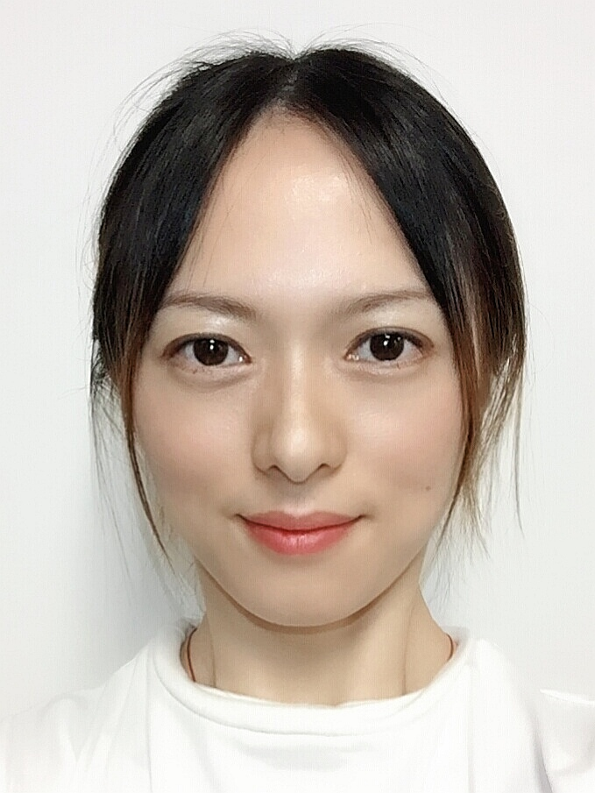
Chris Chen
Address | Room 309A, 2200 Pearl Street, 78705, Austin, Texas.
Email | k_83714@foxmail.com
Phone | 5122005874

WORK/INTERN EXPERIENCE
▋INTEL, Shanghai | Software Engineer | 2015 - 2019
 | Virtual machine, android system, runtime, linker and loader, compiler related, statistical analysis, machine learning.
▋IBM | Software Developer intern | 2014.12-2015-2
 | Web-page (UI)develop.
TAL Education | Math competition teacher(parttime) | 2014.2-2014.12
 | Lecturing for 120 students and their parents/grandparents.
Bank of China | Foreign customer service intern | 2012.7-2012.8
 | Responsible for communicating with foreign clients for products
National Astronomical Observatory of China | Data processing intern | 2010.7-2010.8
 | data analyzing, image processing

Programming Skills
Languages | Fluent: C / I can use: python java html / not very familiar: C++
Areas | Virtual machine/Runtime/linux/Compiler/Android platform

EDUCATION
Master  (graduate in 2021) | University of Texas, Austin | Computational Sciences, Engineering and Mathematics
Master | Chinese Academy of Sciences | Computer Simulation/Astrophysics | GPA 3.2/4.0
Bachelor | Nanjing University | Astronomy | GPA 3.3/4.0
Bachelor Double Degree | Nanjing University | Business Administration

NATURE SCIENCE COMPETITION
Zhejiang University Olympic Math Champion, 3rd Award.
Chinese National Olympic Math Champion, 2nd Award; Science (Physics/Chemistry/Biology) Champion, 1rt Award, 2ed Award
Chinese National Olympic Math Champion, 1rt Award; High School Chemistry Champion, 1rt Award.

PERSONALITY
Interests/hobbies | oil painting, play piano/violin/cello
personality | curious, resilient, prudent, open-minded.

