## Appendix: Supplementary Material

**Article Title:** *Fuel constraints not fire weather conditions limit fire behavior in reburned boreal forests*

**Authors:** Katherine Hayes, Chad Hoffman, Rod Zin, Justin Ziegler, Brian Buma

### Allometrics

|  |  |  |  |  |  |  |
| --- | --- | --- | --- | --- | --- | --- |
| Table S1. Allometric equations used to calculate aboveground biomass, reported by species. Y represents aboveground dry biomass in grams. DBH stands for diameter at breast height (measured and reported in centimeters), MSE stands for mean square error, SE stands for standard error. | | | | | | |
| Species | Source | Equation | | R2 | Published DBH range | Our DBH range |
| *Populus tremuloides* | Bond-Lamberty et al. 2002 | Log10Y = 2.614 + 0.852*(log10DBH) | | 0.99 | 0.3-23.7 | 0.1–6.5 |
| *Populus balsamifera* | Byrd 2013 | Y = 0.261e0.0591*DBH | | 0.86 | AV 2.77 | 1.3–2.3 |
| *Betula neoalaskana* | Bond-Lamberty et al. 2002 | Log10Y = 2.462 + 1.095*(log10DBH) | | 0.66 | 0.3-0.7 | 0.1–23.5 |
| *Picea Mariana* | Bond-Lamberty et al. 2002 | Log10Y = 3.011 + 1.202*(log10DBH) + -.01(AGE) + 0.972(Log10DBH*AGE) | | 0.97 | 0.5-17 | 0.1-20 |
| *Salix* | Bond-Lamberty et al. 2002 | Log10Y = 2.481 + 1.19(log10DBH) | | 0.54 | 0.3-1 | 0.1–8.1 |
| *Alnus* | Binkley et al. 1984 | Leaves | LogeY = 1.82 + 2.38(LogeDBH) | 0.88 | 2-7 | 0.2–4.5 |
| Stem | LogeY = 4.5 + 2.3(LogeDBH) | 0.88 | 2-7 | 0.2-4.5 |

### Tree Height

Our observations of tree heights informed the upward space of the model. Given the age of reburned stands (15 years on average), tree height was much shorter in reburned plots than in mature stands, which contained birch and black spruce individuals, reaching a maximum height of 17 m (Fig. S1). Based on these observations, we set the domain of the modeled landscape to a maximum height of 20 m.

**Figure S1.** Heights in meters of tree species across reburn history. Dots represent outliers (defined as 1.5 the interquartile range less than the first quartile and greater than the third).

*Surface fuels*

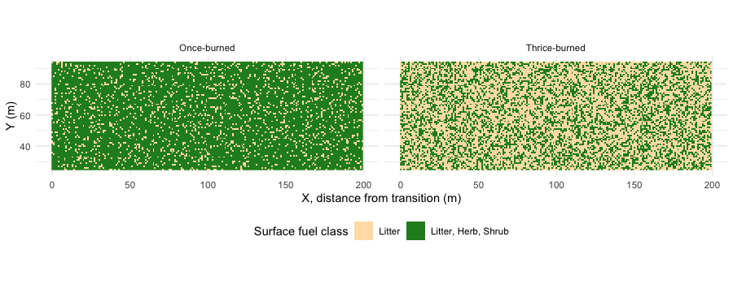

**Figure S2.** Surface fuels across once- and thrice-burned simulated landscapes. X = 0 indicates the transition zone. Surface fuels are split into two classes:1) litter only, shown in tan, where leaves, lichen, moss, and organic material are present, but not understory vegetation; and 2) litter, herbs, and shrubs, shown in green, where herbs and woody shrubs are present on top of the existing litter layer.

### 3.4 Modeled Fire Effects

We estimated canopy and canopy consumption in each scenario, measured as the percentage of dry mass consumed between the start and end of the simulation. Canopy fuel consumption was estimated as the average consumption of tracked trees (the number of which was determined by computational restraints) in the area of interest for each scenario.

Canopy consumption was greatest in the once-burned, mean fuel, and extreme weather scenarios (Fig. 10); again, it was the only scenario to burn past 75 m beyond the transition point (x = 0). All other scenarios displayed high canopy consumption (< 75%) within the first 25 m of combustion before dropping to 0% by the first 40 m of the reburned domain (Fig. 11).

**Figure 10.** Two-dimensional canopy consumption between 1-time and three-time burns and across median and high-fuel scenarios. X of 0 at the bottom left indicates the start of the burned fuels and the beginning of the transition between mature and burned landscapes. High-fuel scenarios contain fewer trees owing to computational limits to the number of trees that can be tracked in WFDS (the modeling domain remained consistent, however).

The average crown consumption was close to zero percent within 30 – 40 m past the transition zone in all thrice-burned landscapes (Fig. 11).

**Figure 11**. Crown consumption across 1-time and 3-time burns and median and high-fuel scenarios. Circles represent the difference between the starting crown mass and ending crown mass, with larger circles indicating a larger difference. Blue line represents the average.