Nau-Mai Visitor System

Project Documentation

Kathleen Livingstone | Applied Software Practice | May 1, 2022

# Executive Summary

Nau-Mai is a visitor management system tool for locations with a warehouse/ distribution center on the property. Unlike traditional visitor management systems, the Nau-Mai captures the additional required information drivers must provide to pick up or drop off a shipment at the facility. Using a digital visitor log system that stores the data in a database eliminates the need to keep paper logbooks and allows site leadership to quickly list who is currently onsite in the case of an emergency. When an emergency requires everyone on site to either seek shelter or go to a regress point, the site leadership must physically transport the logbook. In the case of a fire emergency, would you want a member of your staff to retrieve the visitor book when you can use a tablet or cellphone to access the data? Nau-Mai performs the book-keeping, allowing leadership on site to remain focused on getting people to a safe location.

Nau-Mai is written in Java Swing. The data acquired from the visitor management system is stored in TK file format, while the order data pulled from the WMS and the staffing directory are stored in CSV file format. Therefore, we can protect the central WMS database from misuse, damage, and intrusion by pulling reports from the WMS and holding them in CSV format. In addition, we can easily use the staffing directory for other projects. Nau-Mai is open source and available on GitHub.

* GitHub repository: [https://github.com/k8tlivingstone/Capstone.git](https://github.com/k8tlivingstone/SDEV435)
* General walkthrough video: <https://drive.google.com/file/d/1OY-o6xDXTQqfb1k_ubhrQ78GD-C8Fyue/view?usp=sharing>
* Datastore walkthrough video: <https://drive.google.com/file/d/1VaTJG0y5iLZer4Ii03xFe4Tw6nV_AjGa/view?usp=sharing>
* Reusable code walkthrough video: <https://drive.google.com/file/d/1Mu-LsUyFARBGtMUaH7NVKCCoMH-3eiuu/view?usp=sharing>
* Verification and validation walkthrough video: <https://drive.google.com/file/d/1cenWcbM4Eaz_FSh1zf4SRYNib5gQhNuu/view?usp=sharing>

## Project Completion Status: 70%

Open Action Items to Do:

* Menu page graphics should be replaced with higher pixelated images.
* Setup virtual keyboard listeners to connect with textfield displays
* Adjust Login and Admin screens to adjust positioning when the screen size changes
* Pull a report from WMS system to upload into the database. That report is needed to validate warehouse active orders. Since that application is on my employer’s network, the WMS team needs to create a custom pull report template. Personal school projects are low priority therefore, it has not been completed to date.
* Review the structure of the program for the opportunity to reduce runtime. For example, many screens where the database connection is initiated causes them to load slower. A customer would want a smooth transition from screen to screen (no slight pauses).
* Complete full test plan

## Scenario | User on Site for Interview, Meeting, or Contract work

A user selects the start button on the initial welcome screen and is directed to the menu screen. Next, the user selects either the Interview, the Meeting, or the Contractor button. Next, the application displays a safety message for the location. After the user selects the Continue button, the application shows the security information regarding photos and videos being taken on site. Continuing again takes the user to the first input screen, where the user must enter their first and last name and mark whether they are a US citizen. If the person represents an organization, they can enter that information into the corresponding field.

Scenarios 1-a: Landing Page for Application

Scenario 1-b: Menu Screen to direct people to their areas

Scenario 1-c: Safety message to display

Scenario 1-d: Photography Policy

Scenario 1-e: Form to capture the name of the visitors

Scenario 1-g: Closing message explaining their person has been notified and where to wait.

## SCENARIO | USER ONSITE FOR WAREHOUSE DELIVERY/SHIPMENT

Like the previous scenario, a user selects the start button on the initial welcome screen and is directed to the menu screen. Next, the user selects the warehouse button. Next, the application displays a safety message for the location. After the user selects the Continue button, the application shows the security information regarding photos and videos being taken on site. Continuing again takes the user to the order screen, where they must enter the order number or confirmation code for the shipment or delivery; they are there to complete. If the driver is working for a LTL carrier, they can mark that option. If the order number or confirmation code does not match any records, they will be advised to check the information and try again or contact their dispatcher for the information. They will have up to 3 tries before the system informs them that they need to contact their dispatcher.

After the order number or confirmation code is verified as an open order planned to be received, the system takes the user to enter their first and last name and organization and mark whether they are US citizens. Next, the driver is directed to the designated building or specific dock door for loading or unloading a shipment. The window clerk will be notified that the driver for order X has arrived and is moving to building/door Y.

## SCENARIO | USER ONSITE TO CHECK-OUT

When a person leaves the location, they can select the check-out option from the menu screen. The person will be directed to the Name screen to enter their first and last name. After they click Next, the system will check if they are in the system. Once verified, the exit screen will open, asking them to confirm they are checking out. If they select yes, a closing message will display. The database will capture the date and time and mark them as checked out. Otherwise, they will be directed back to the menu screen.

## Reports

The program can produce a current onsite report for use in the case of an Emergency. The onsite report is exported as a pdf document, and the design is modeled after the attendance log sheets used at warehouses currently for visitors.

## System Architecture

Nau-Mai runs as a local application on Microsoft Windows. Regular display items were created in reusable style panels to reduce the number of frames within the system. These panels are then layered in a specific order, like a deck of cards.

## Source Code Structure

The source code was organized following the Maven standard.

## Executables

Since the Project is unfinished, the executables have not been created yet. However, the plan is to have an installer wizard walk users through installing all the necessary components.

## Code Architecture



## DATABASE OR DATASTORE

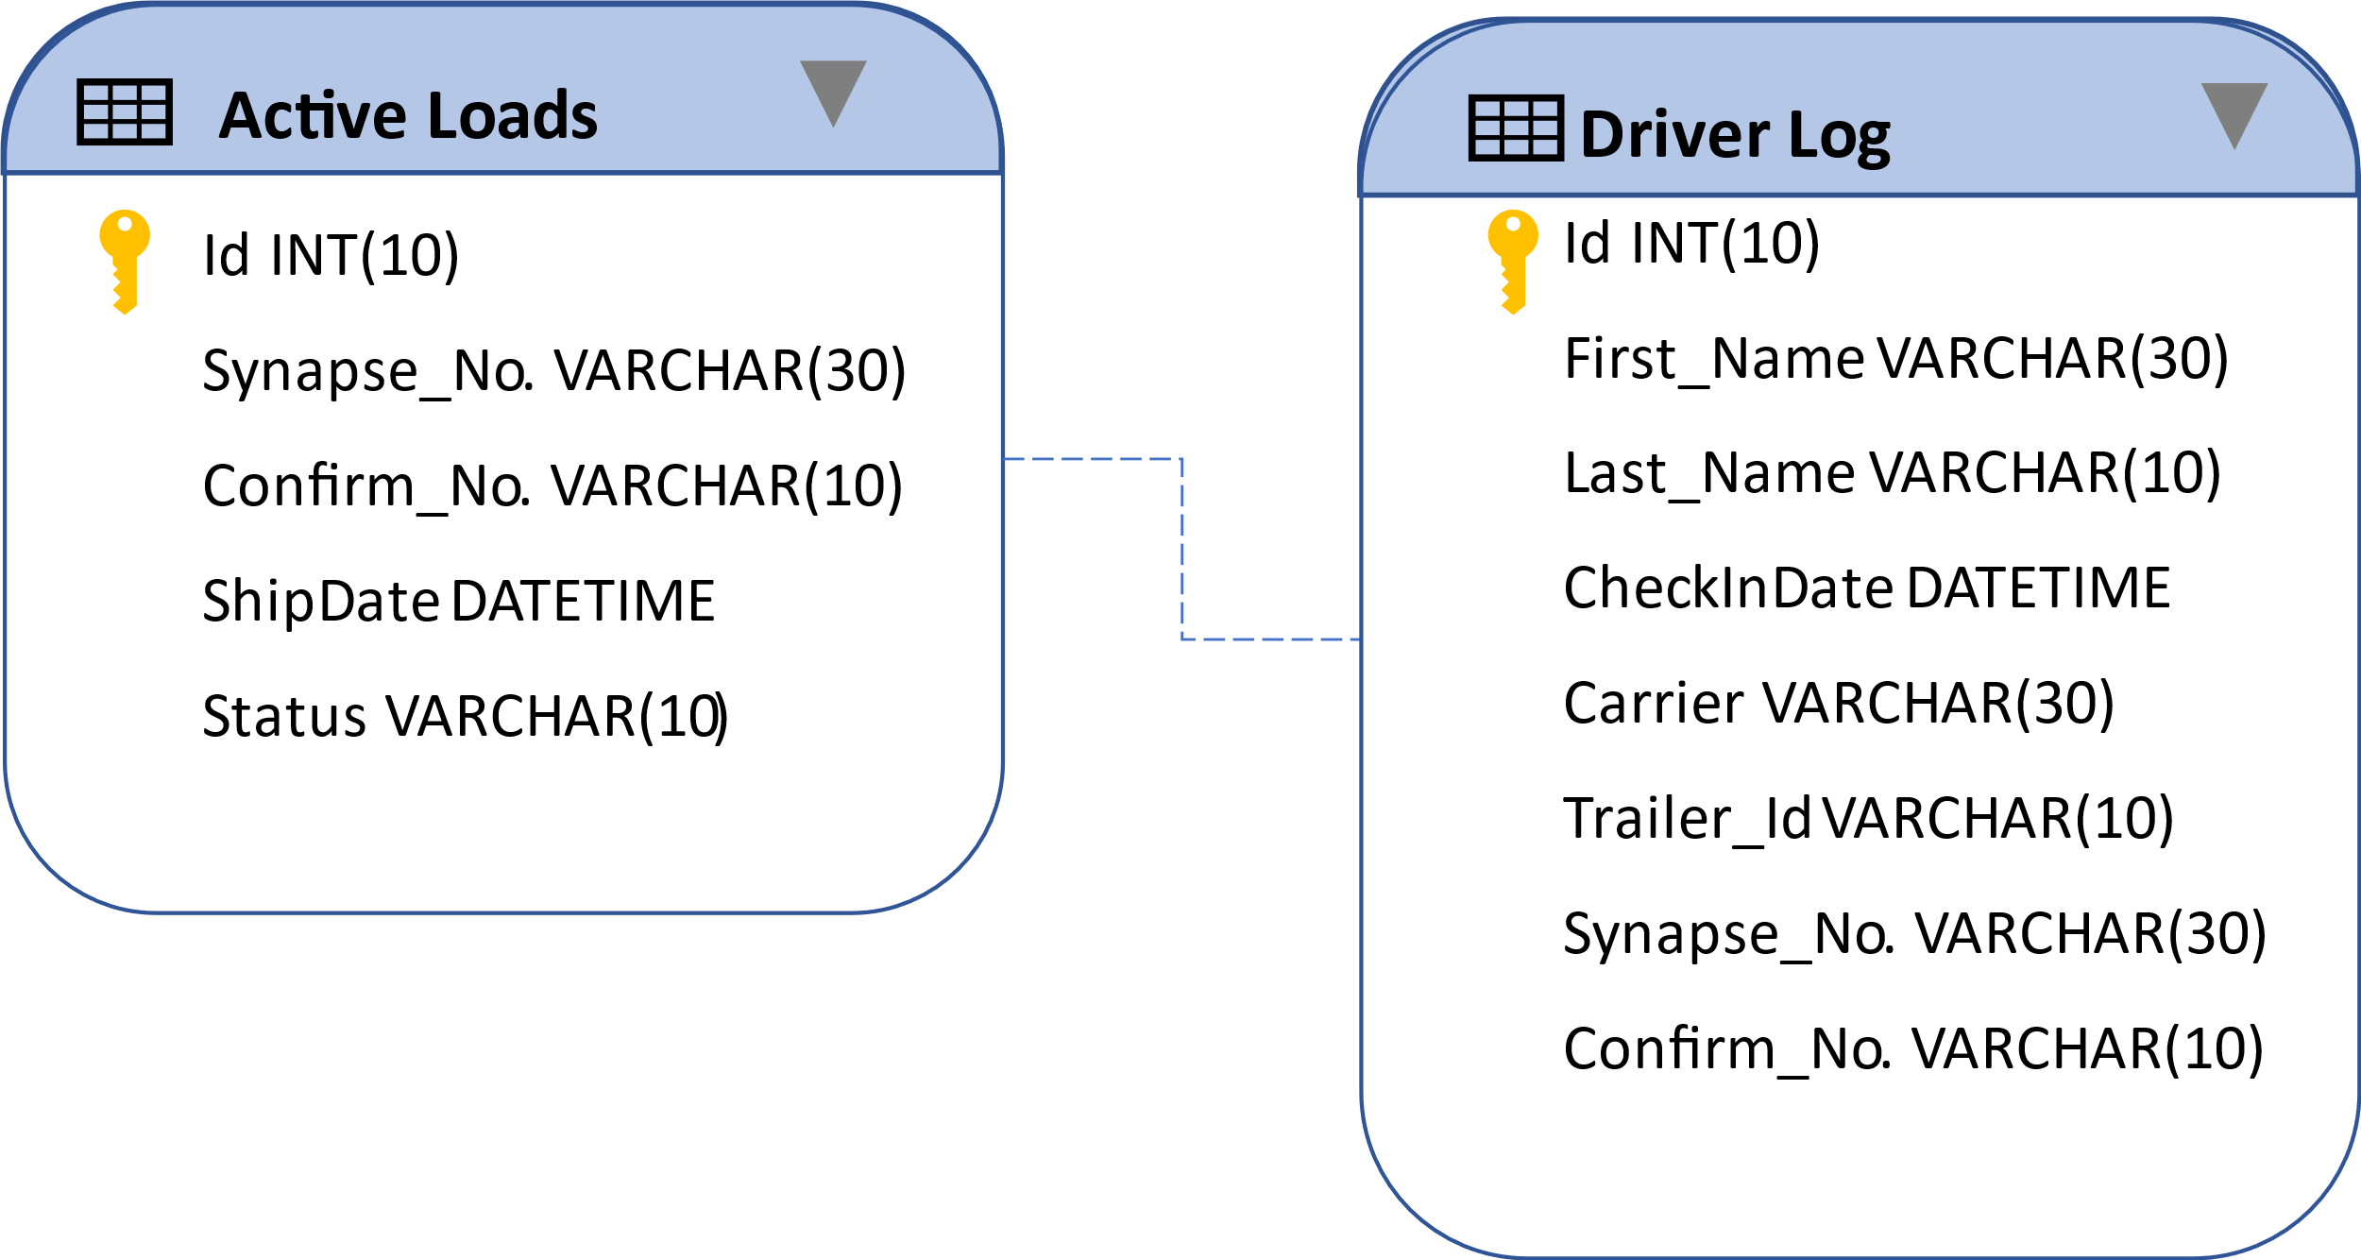

## External Files & Data

Directory Data Sample used in the tool. I used Excel and SQL formats for the data.

## Programming Language | Java Swing

## Project Classes

The Project has four packages (folders). One folder is dedicated to images, and another is dedicated to additional library jars not included in Java 17's JRE standard library. The other two packages are Admin and Capstone. For example, the keyboard class in the capstone folder probably should have been placed in the admin folder. Segregating the files makes it easier to locate the type of file needed.

Admin Package includes the admin screen, login screen, and the mailsubclass for sending emails to people on site.

## Program Start and End Flow

## Summary

This Project was a definite challenge. Handling the front end, back end, and administrative steps within 15 weeks is a challenge. The program uses Java Swing and SQL for data storage. Although the program is not complete, the building and refining of the program will continue. An opportunity for refinement would move the application to web-based. That would provide an opportunity to use CSS coding for the formatting and JavaScript for more advanced features of the tool. This program would be a great benefit to a logistics environment which is the area of software development that interests me. For this assignment, this is version 1.0.

## Appendix A (Test Plan)

Below is a small portion of the test plan created for this application. As each element was tested, what to expect, the results and any oddities noted during testing. For example, it is noted that the frames after the menu page open slowly due to the database connection in the beginning. Reviewing how that SQL connection is set up will be an element looked at in version 2. The complete plan is available upon request.

## Appendix C (Client Installation Instructions)

The expected goal is to have the application installer contain all the necessary components for a client to install the program. If the installer is in a zip file, they will extract the contents to a known location. The Git repository will have the files that will be in the installer:

* Capstone/

The plan is to have the executable program start installing as soon as the client initiates the setup script. Users will choose where to keep their database and assign permissions to authorized administrative individuals. The program does not have the option to create user groups. Maintaining the database will be the client's responsibility. When the installation is complete, Nau-Mai will be installed with a desktop shortcut for ease of use.

## Appendix D (Developer Setup Instructions)

The following tasks are required to configure a development environment to work on Nau-Mai:

* Install Eclipse IDE for Java Developers version 12 or newer
* Download all the files from the repository, including the library files.
* Designate the database you will handle the pull/push requests.
* Clone the Project from GitHub. (<https://github.com/k8tlivingstone/Capstone>)