디지털 영상처리 연구실 연구보고서

김우헌

#Fully Convolutional Networks (FCN) for Segmentation

## Convolutional Auto Encoder(CAE)

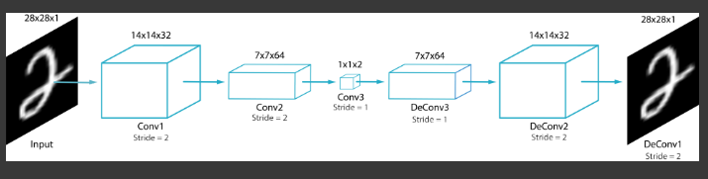

## FCN

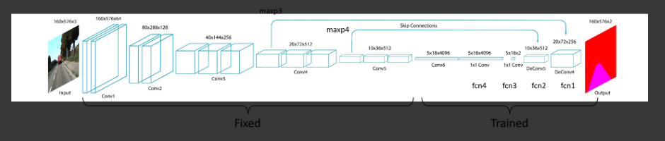

* skip connection

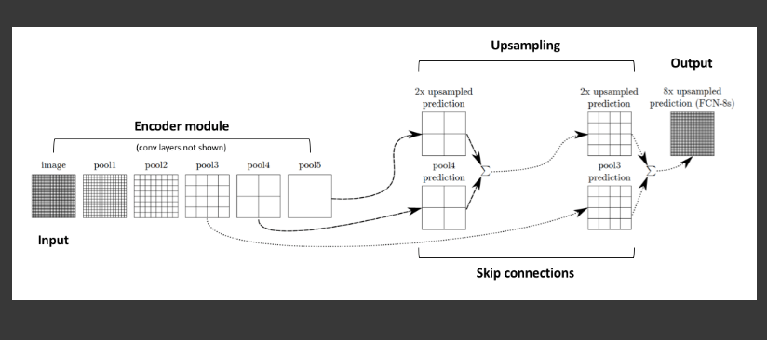

* FCN model 생성

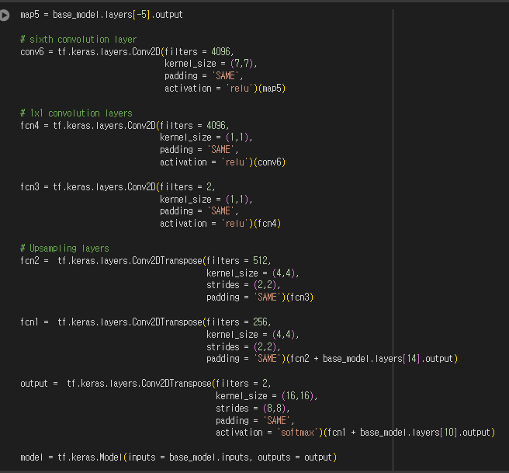

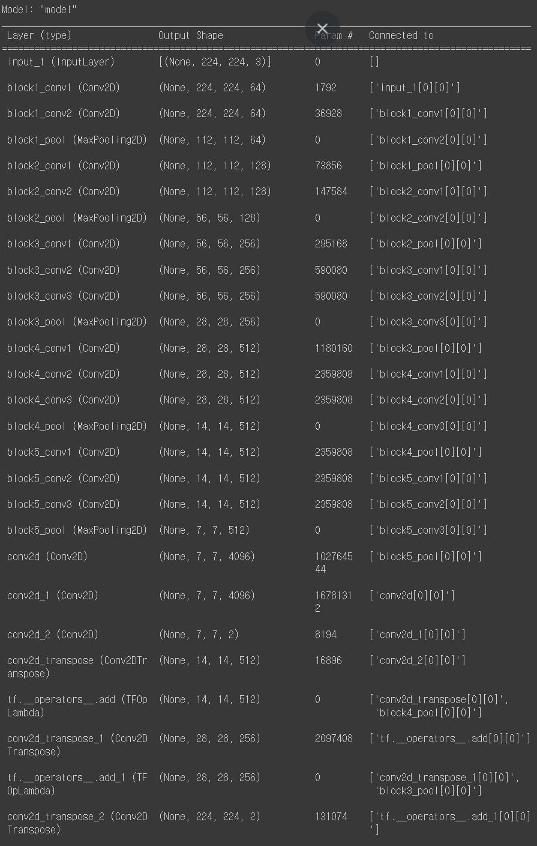

* 데이터 시각화

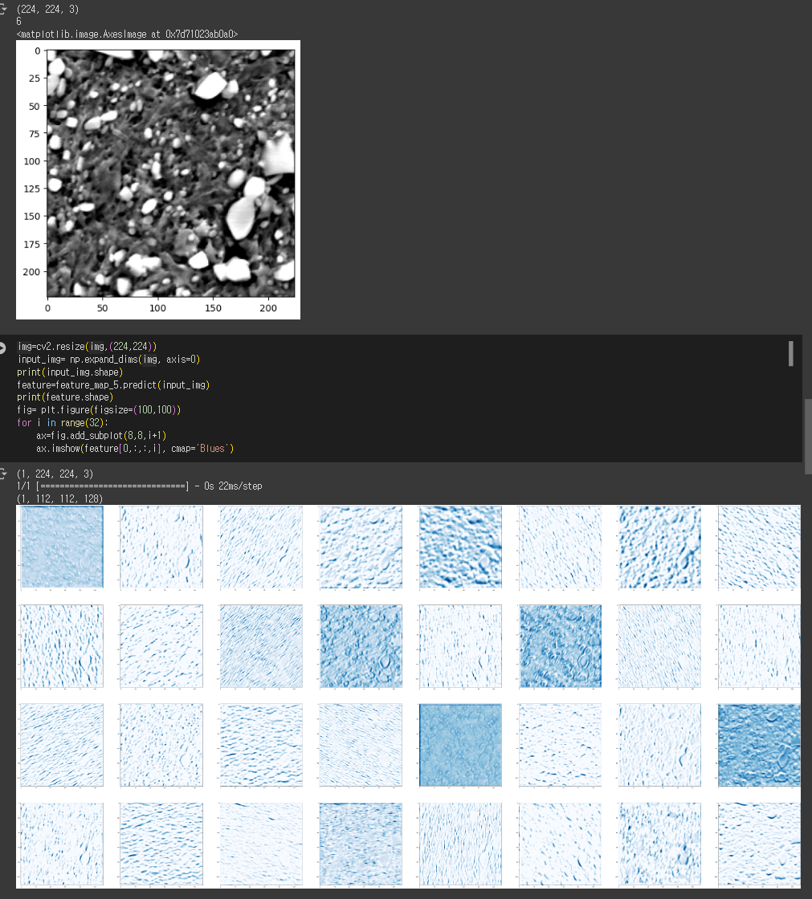

->input



->block2_conv2 (Conv2D) -> (None, 112, 112, 128)

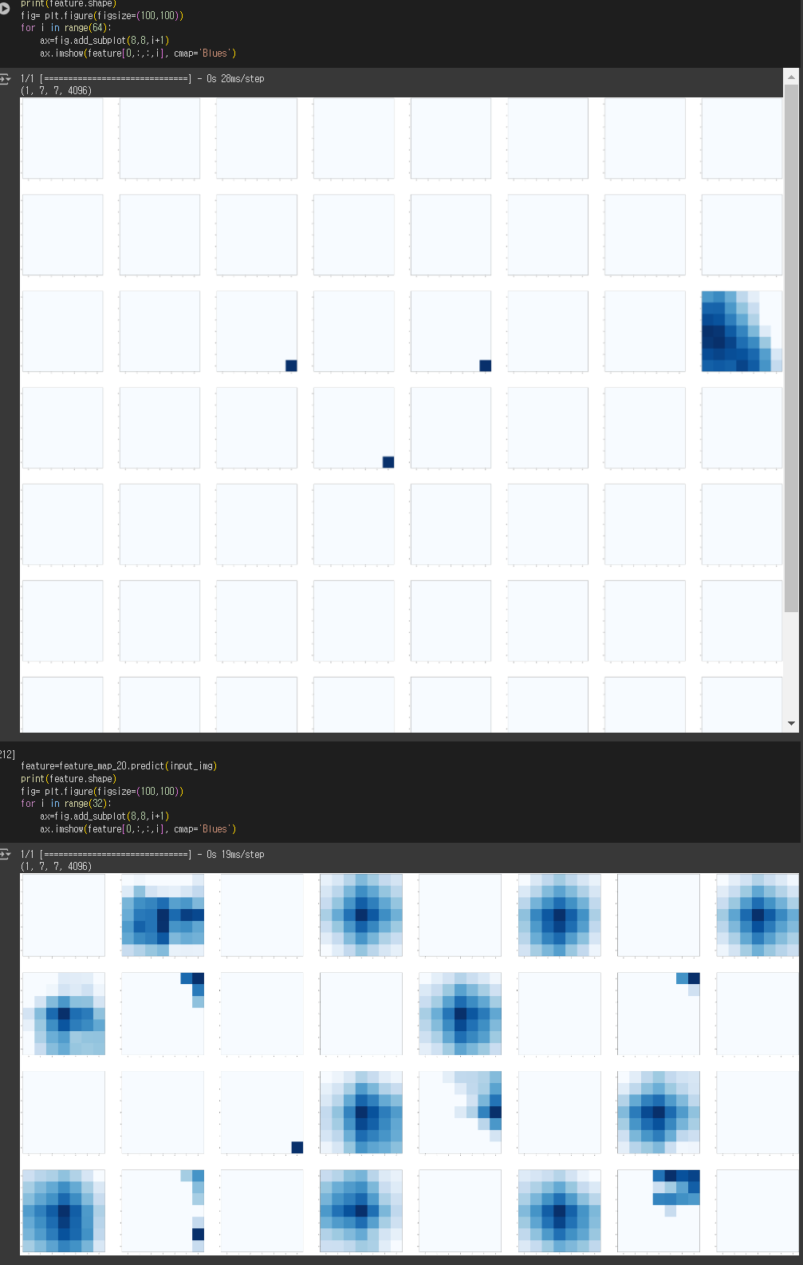

-> conv2d (Conv2D) -> (None, 7, 7, 4096)



-> conv2d_1 (Conv2D) -> (None, 7, 7, 4096)

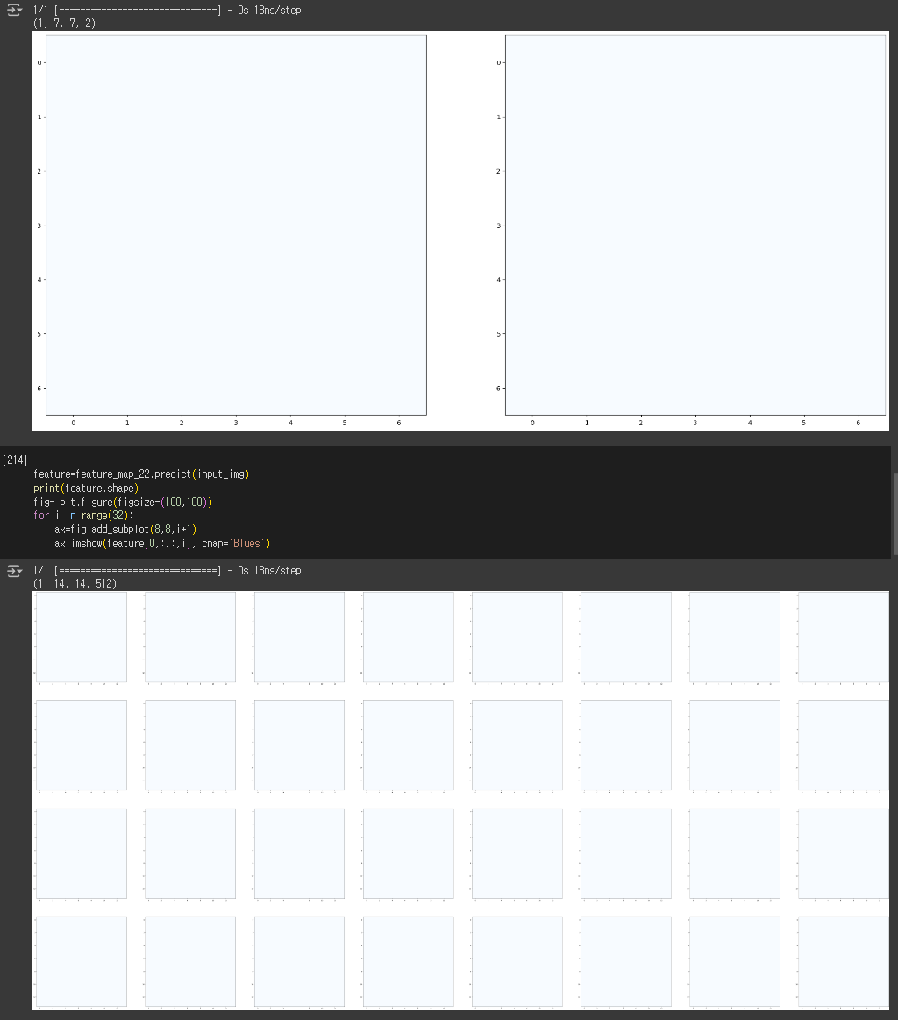

-> conv2d_2 (Conv2D) -> (None, 7, 7, 2)



->conv2d_transpose_6 (Conv2D Transpose) ->(None, 14, 14, 512)

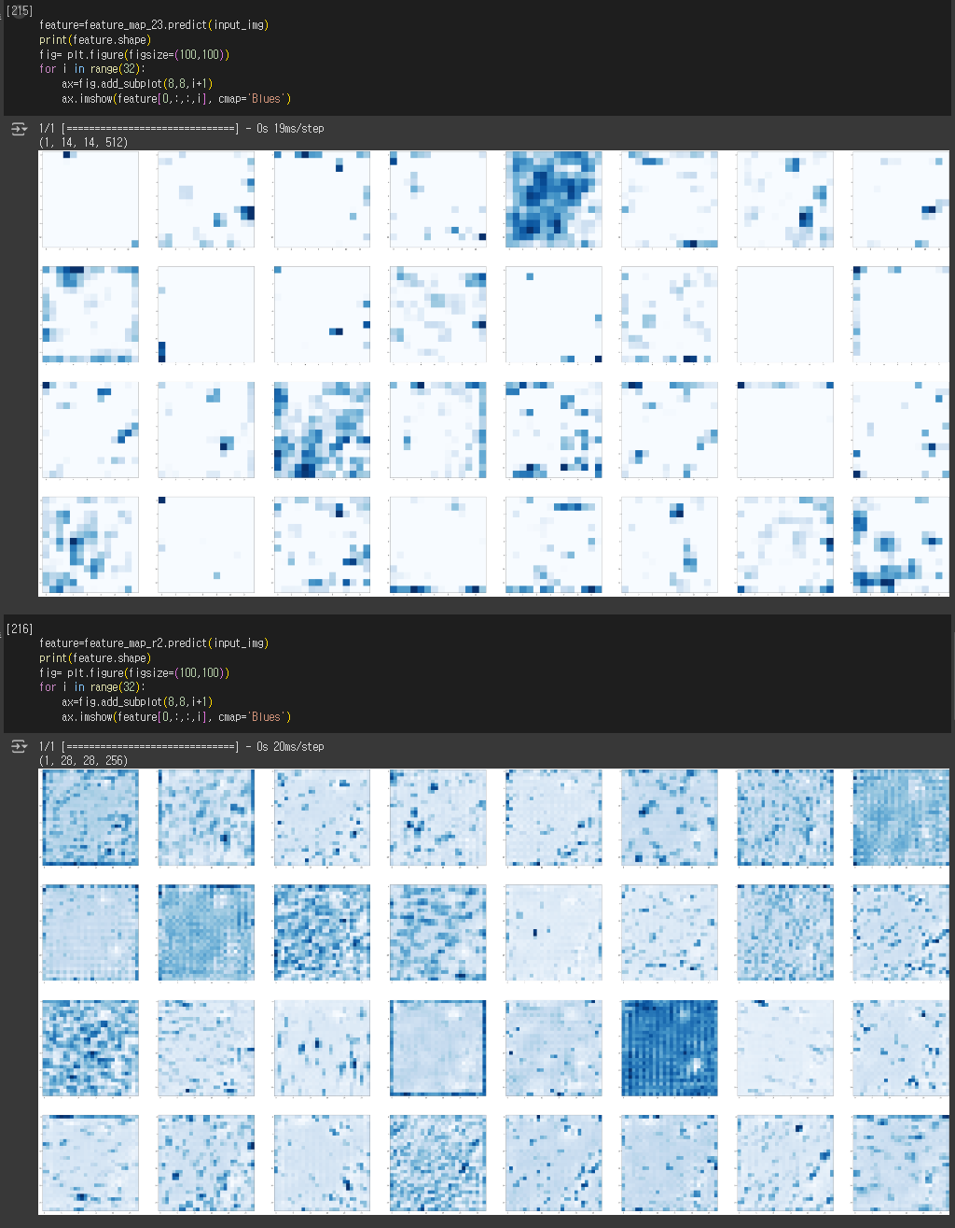

->tf.__operators__.add (TFOp Lambda) ->(None, 14, 14, 512) + block4_pool (MaxPooling2D)



->tf.__operators__.add_1 (TF OpLambda) -> (None, 28, 28, 256)+ block3_pool (MaxPooling2D)

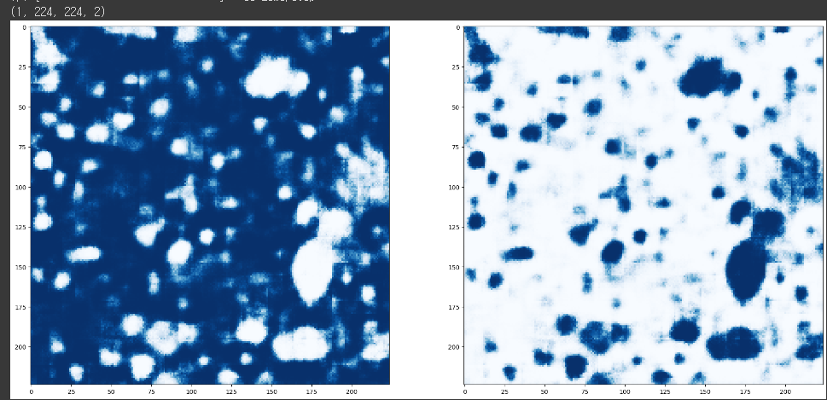

->conv2d_transpose_2 (Conv2D Transpose) ->(None, 224, 224, 2)

* result

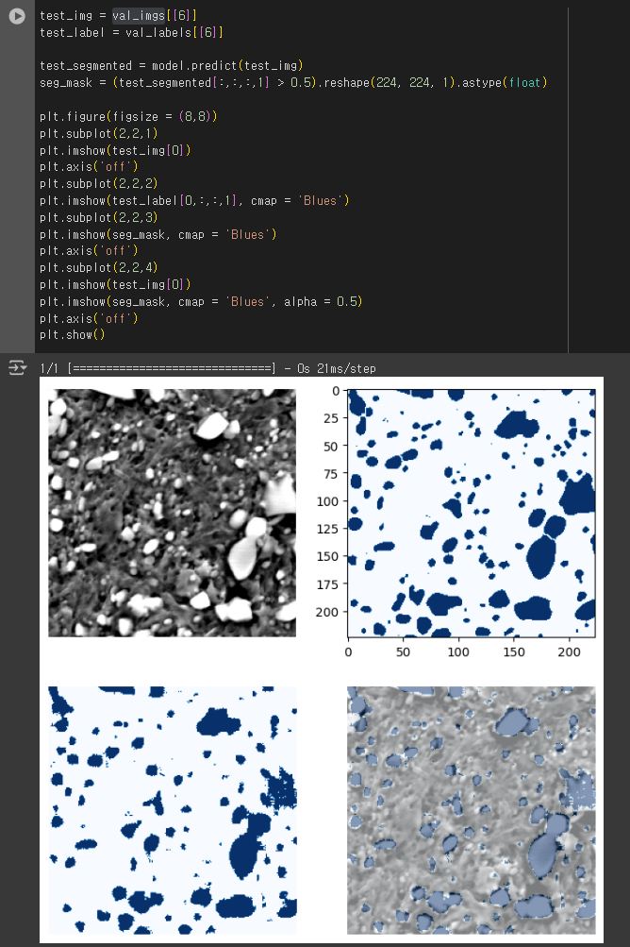

##skip connection 제거?

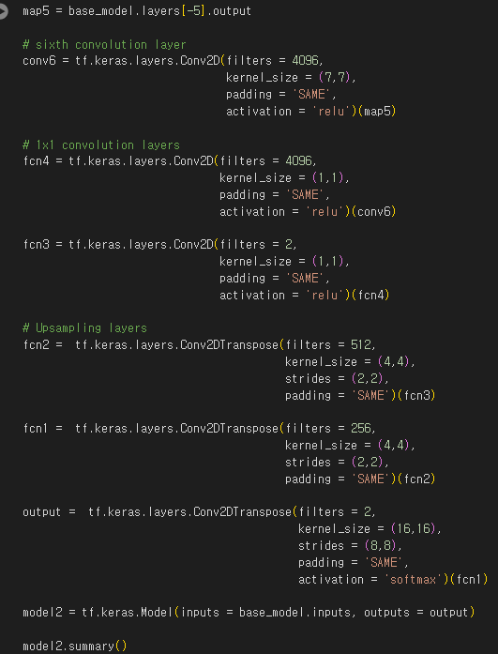

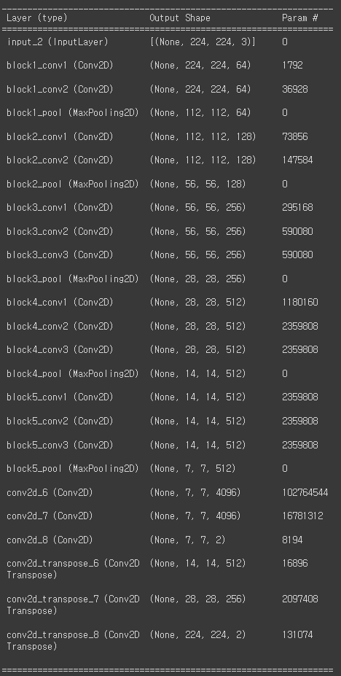

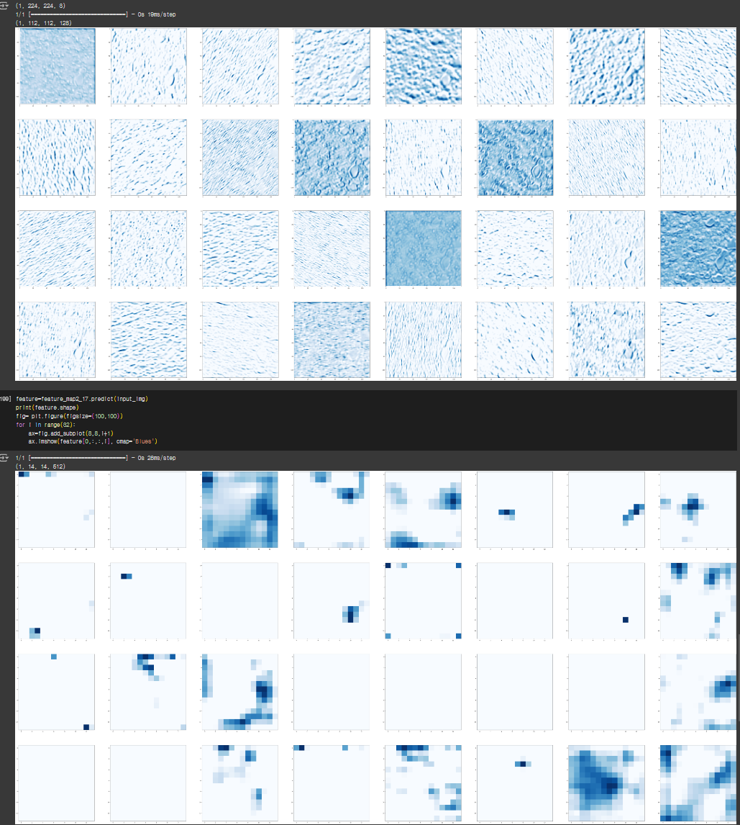

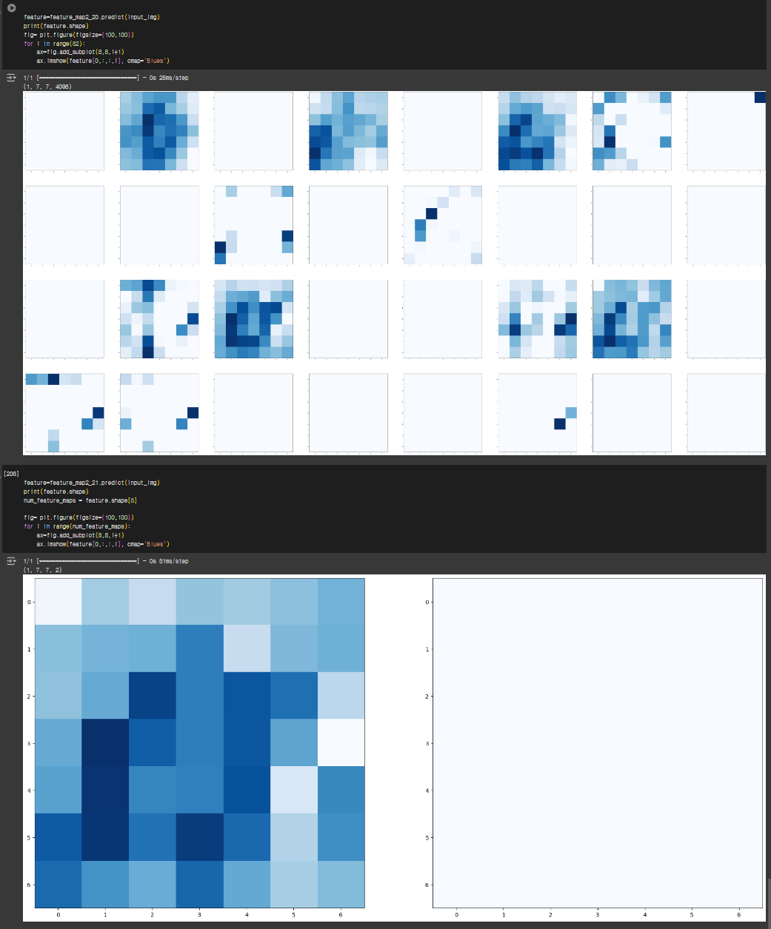

->encoder 부분

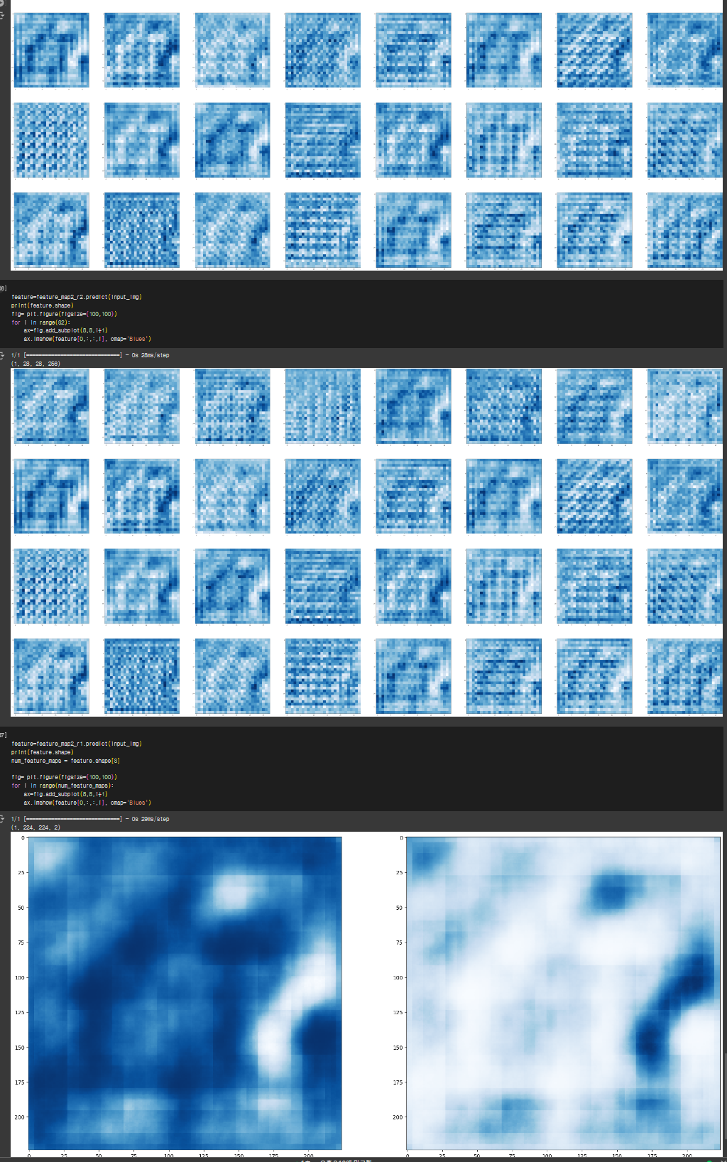

* skip connection제거 result

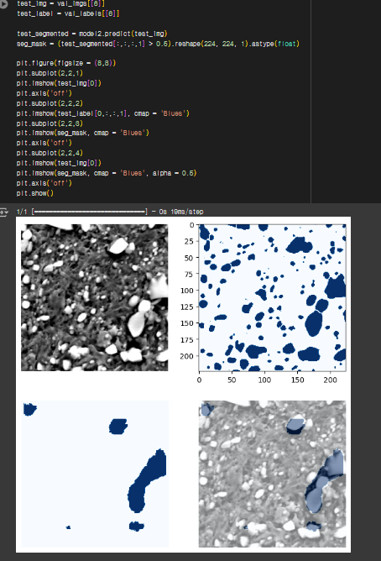

#U-NET

