Lex的日志角色和权限配置 （需要提前创建日志组和s3目录）

<https://docs.aws.amazon.com/zh_cn/lex/latest/dg/conversation-logs-policies.html>

clouldwatch 日志组创建

<https://console.aws.amazon.com/cloudwatch/home?region=us-east-1#logs>:

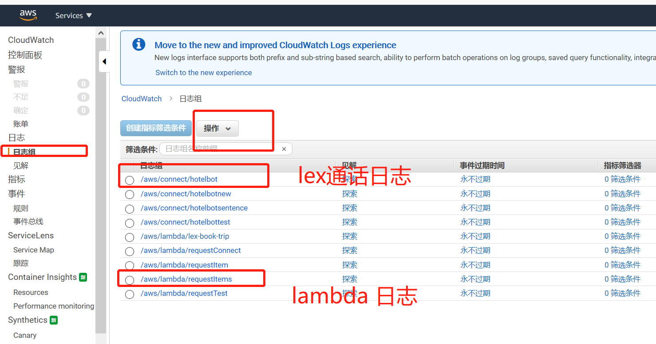

创建s3目录

<https://s3.console.aws.amazon.com/s3/home?region=us-east-1>

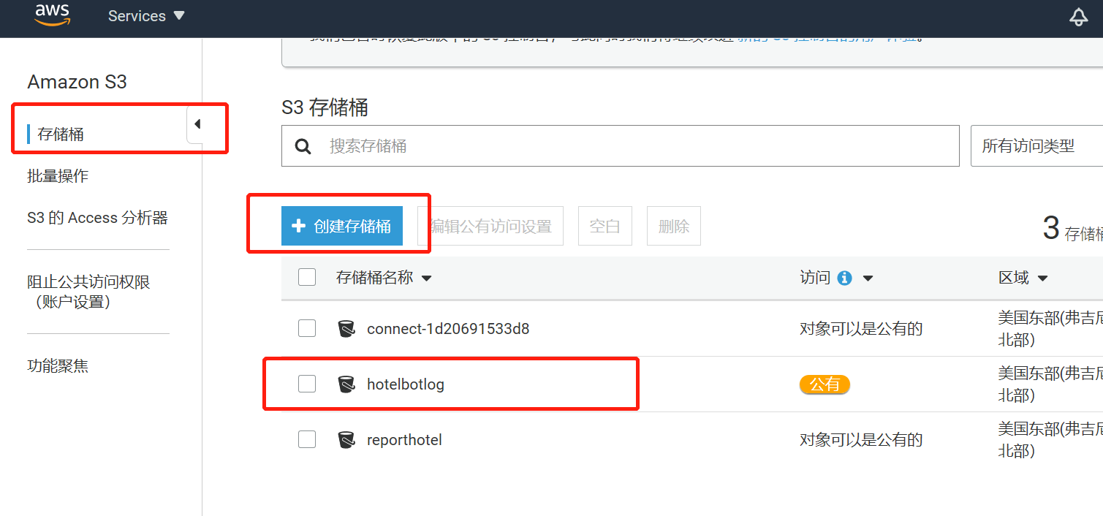

Lambda函数权限更新

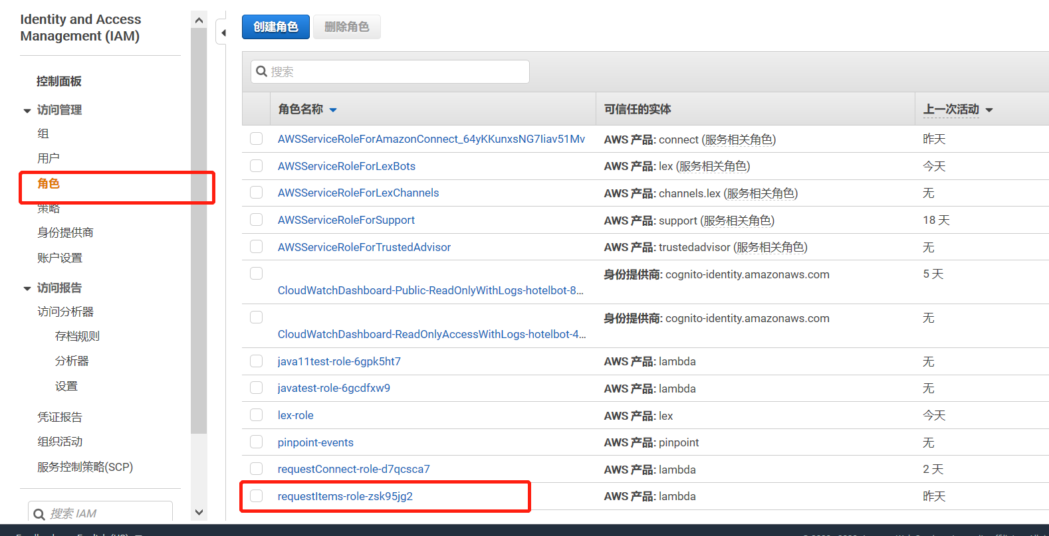

添加一个内联策略，copy如下json（红色部分的id是pinpoint的id，需要提前创建一个pinpoint的project）

{

"Version": "2012-10-17",

"Statement": [

{

"Sid": "VisualEditor0",

"Effect": "Allow",

"Action": [

"connect:ListPhoneNumbers",

"connect:GetMetricData",

"connect:ListInstances",

"connect:GetContactAttributes",

"connect:ListContactFlows",

"logs:CreateLogGroup"

],

"Resource": "\*"

},

{

"Sid": "VisualEditor1",

"Effect": "Allow",

"Action": [

"logs:CreateLogStream",

"mobiletargeting:SendMessages",

"mobiletargeting:SendUsersMessages"

],

"Resource": [

"arn:aws:mobiletargeting:us-east-1:942752865267:apps/\*",

"arn:aws:logs:\*:\*:\*"

]

},

{

"Sid": "VisualEditor2",

"Effect": "Allow",

"Action": [

"logs:CreateLogStream",

"logs:PutLogEvents"

],

"Resource": "arn:aws:logs:\*:\*:\*"

},

{

"Sid": "VisualEditor3",

"Effect": "Allow",

"Action": "lex:\*",

"Resource": "\*"

},

{

"Sid": "VisualEditor4",

"Effect": "Allow",

"Action": "logs:CreateLogGroup",

"Resource": "arn:aws:logs:\*:\*:\*"

}

]

}