DODAF SE AUTOMATION

Version 0.1 — Initial Release
November 2025

CrewAI Agentic Process flow Design Document
November 17, 2025
IBM

Revision History
Version | Date | Author | Description | Reviewed by
0.1 | November 2025 | Ravi Natarajan  Brian Bibber | Initial release – baseline DoDAF SE automation, components, and architecture flow. | <pending review>
0.2 | TBD | TBD | TBD

Table of Contents
Revision History 1
Environment 3
Full Flow All components 3
DoDAF SE Stages -> DoDAF 2.0 Artifacts Mapping 4
Stage-Level Sections 5
Stage 1 — Intake & Fit-for-Purpose (F2P Gate) 5
Flow diagram: 6
Stage 2 — ICD Generation (Capability Definition + DOTMLPF-P) 6
Flow Diagram: 7
Stage 3 — Operational Views (OV-1, OV-2, OV-3) 7
Flow Diagram: 8
Stage 4 — System Views (SV / SvcV) 8
Flow Diagram: 9
Stage 5 — Standards Views (PV / StdV) 9
Flow Diagram: 10
Stage 6 — Final Summary & Fit-For-Purpose Consolidated View 10
Flow Diagram: 11
Sequence diagram showing full flow 11
DoDAF Architecture Repository – Schema 12
Transactions Database — dodaf_se 12
EA Repository — adr (Enterprise Architecture Repository) 12
VectorDB knowledge store 14
Initial load of knowledge into VectorDB 14
DoDAF Stages Using + Updating VectorDB) 14
🚧 Work in Progress / Design Enhancements 16
1. Add Stage 0.5 / Stage 6.5 — Human Correction & Feedback Loop 16
2. Implement Confidence Scoring + Conditional Human-in-the-Loop 16
3. Auto-Generate DIV-3 Traceability Matrices After Stage 6 16
4. IL5/IL6-Ready Security Hardening (Next Release Target) 17
5. Strengthen Governance Layer 17
6. Expand the EA Repository (ADR) for Better MBSE Interoperability 17
7. Integrate an Ensemble Cross-Check (Self-Consistency Layer) 17
8. Add a “Pipeline Health & Drift Dashboard” 18

Environment
Development IDE – VSCode, Agents – CrewAI, CrewAI Enterprise Studio
Component | Purpose
Docling | OCR + PDF ingestion + text extraction (mission context, constraints, diagrams)
Milvus (VectorDB) | Retrieve related prior jobs + global DoDAF knowledge (RAG)
Drools (Rules Engine) | F2P validation rules, routing decisions, classification
PostgreSQL | Store extracted text, Stage-1 results, F2P Manifest
Redpanda Kafka | Console streaming, stage status events
MinIO | Raw document storage (uploads, extracted images)
Neo4J | Store operational activities and relationships
IBM Rhapsody | IBM Rhapsody is used to generate authoritative SysML and DoDAF-compliant architecture models and diagrams, ensuring formal traceability, engineering accuracy, and seamless integration with DoD systems-engineering workflows.

Full Flow All components
The full DoDAF-SE automation flow begins with user-submitted documents, which are parsed by Docling and routed into the six-stage CrewAI pipeline. Each stage uses Milvus for RAG context, Drools for rules-based validation, and stores outputs in PostgreSQL transactions and the EA Repository. Operational and system relationships are captured in Neo4j, diagrams are generated using PlantUML and IBM Rhapsody, and final artifacts—including the ICD and F2P Summary—are packaged and delivered back to the user.

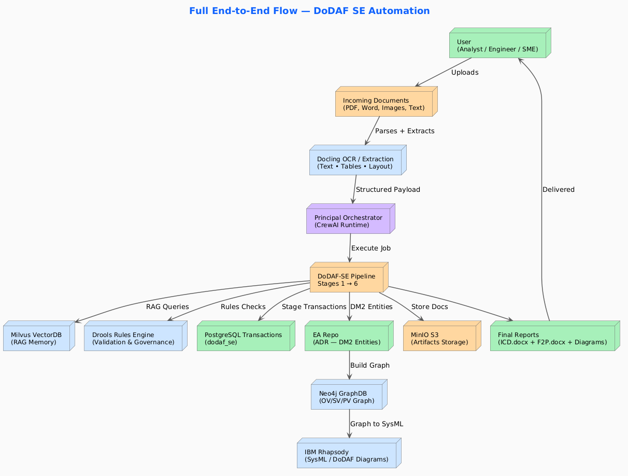

DoDAF SE Stages -> DoDAF 2.0 Artifacts Mapping
Each stage of the DoDAF-SE pipeline aligns directly with corresponding DoDAF 2.0 artifacts—ranging from AV, CV, and OV views to SV, PV, and StdV products—ensuring that every output is traceable, standards-compliant, and suitable for formal architecture documentation such as the ICD, operational views, system views, and final Fit-For-Purpose deliverables.

DoDAF-SE Stage | Purpose | Primary DoDAF Artifacts Produced / Used
Stage 1 — Identify Intended Use (F2P Gate) | Intake, classification, routing, extract mission context | • AV-1 Overview Information• High-level capability needs• Initial Purpose & Scope• F2P Decision Record (internal)
Stage 2 — Define Architecture Scope (ICD) | Full ICD creation: capability definition, gaps, DOTMLPF-P | ICD (Integrated Capabilities Document) containing:• Capability Requirements (CV-1/CV-2 content)• Capability Gaps (CV-3 content)• Operational Context (OV-1 text elements)• DOTMLPF-P Analysis (DoDAF: PV/Activity input)• Constraints + Assumptions (AV-1/AV-2 style)
Stage 3 — Identify Required Data (Operational Views) | Build operational activities, flows, nodes | OV (Operational Viewpoint):• OV-1 High-Level Operational Concept• OV-2 Operational Resource Flow• OV-3 Operational Activity Models• OV performers + nodes (DM2: Performer, Activity)
Stage 4 — Collect & Correlate Data (System Views) | Build system functions, components, interfaces | SV / SvcV (System & Service Views):• SV-1 Systems Interface Description• SV-2 System Resource Flow• SV-4 Functional Models• SvcV-1/2 if services identified• System nodes, components, ports (DM2 System elements)
Stage 5 — Analyze Objectives (Standards Views) | Align systems + activities to standards and constraints | PV (Project Viewpoint) / StdV (Standards Views):• StdV-1 Standards Profile (e.g., NIST/DoD/IC)• StdV-2 Standards Forecast• Platform constraints / compliance mappings• Policy + Interoperability constraints
Stage 6 — Present Results (Summary + F2P) | Consolidate all stages into final reports | Final Fit-For-Purpose (F2P) View:• Consolidated ICD• OV + SV + PV diagram sets• Traceability Matrices (OV→SV, SV→PV)• High-level summary (AV-1 consolidation)• Rhapsody / PlantUML diagram set exports

Stage-Level Sections
This pipeline implements a DoDAF 2.0, JCIDS-aligned, six-stage architecture development process built on hybrid AI (CrewAI + LLMs), governed by a rules engine (Drools), reinforced with vector-based memory (Milvus), and augmented by a DoDAF knowledge graph (Neo4j). All stage outputs are persisted in enterprise repositories (PostgreSQL for transactions and the EA Repository for normalized DM2 entities), with MinIO supporting document and artifact storage.
Below is the exact mapping of which components are used in each stage.

Stage 1 — Intake & Fit-for-Purpose (F2P Gate)
Purpose:
Ingest, classify, extract, validate, and produce the Stage-1 routing manifest.
Components Used
- Docling — OCR, PDF text/layout extraction
- Milvus (VectorDB) — Retrieve prior knowledge + store Stage-1 chunks
- Drools — F2P rules, classification, routing logic
- PostgreSQL — Store extracted text + F2P manifest
- MinIO — Store uploaded files and extracted images
- Redpanda (Kafka) — Console updates & job status events
- IBM Rhapsody - project initialization, define model namespace, prepare structure for upcoming OV/SV artifacts

Flow diagram:
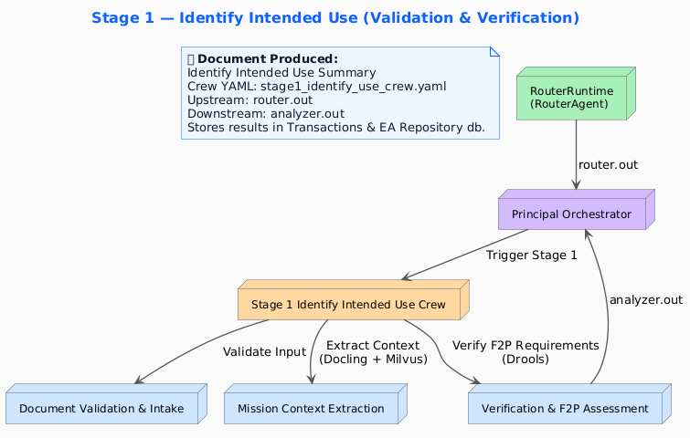

Stage 2 — ICD Generation (Capability Definition + DOTMLPF-P)
Purpose:
Generate the full ICD document: executive summary → capability needs → gaps → DOTMLPF-P → recommendations.
Components Used
- Milvus — Retrieve Stage-1 + DoDAF ICD spec chunks; store Stage-2 chunks
- Drools — ICD structure rules, DOTMLPF-P completeness validation
- PostgreSQL — Persist ICD sections (transaction + master)
- MinIO — Store ICD Markdown/DOCX files
- Redpanda — Pipeline console streaming
- Docling (optional) — If ICD references embedded diagram
- IBM Rhapsody - Create initial SysML blocks for capabilities, Establish structure for future traceability, auto-generate model elements from ICD sections

Flow Diagram:
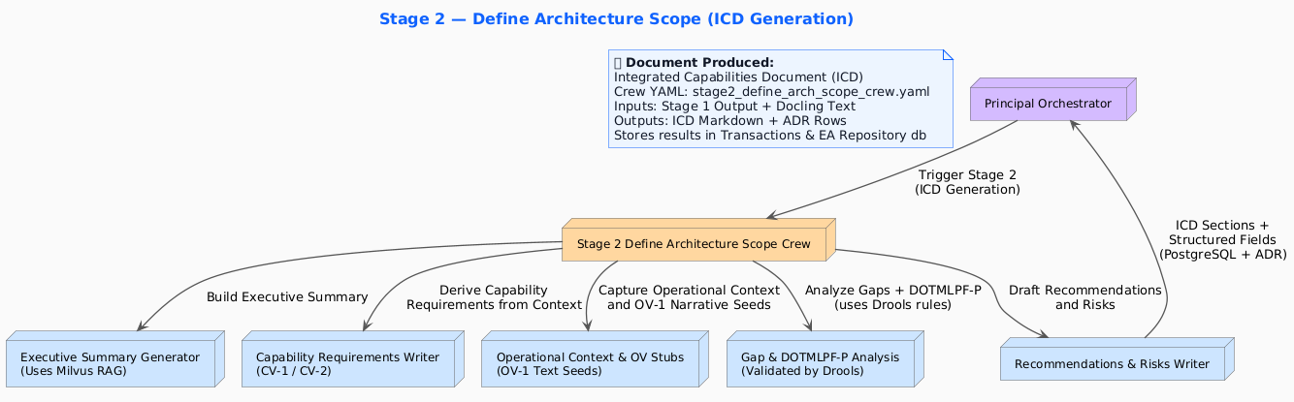

Stage 3 — Operational Views (OV-1, OV-2, OV-3)
Purpose:
Generate OV concepts, operational nodes, flows, and activity models.
Components Used
- Milvus — Retrieve ICD + Stage-1 + OV definitions; store OV chunks
- Drools — Operational activity/flow validation rules
- Neo4j (DoDAF Graph) — Store OV nodes, flows, and relationships
- PostgreSQL — Store OV-1 narrative, OV-2 matrices, OV-3 models
- Redpanda — Console updates
- IBM Rhapsody - OV-1 operational concept diagrams, OV-5 activity models, OV-2 node and flow diagrams

Flow Diagram:
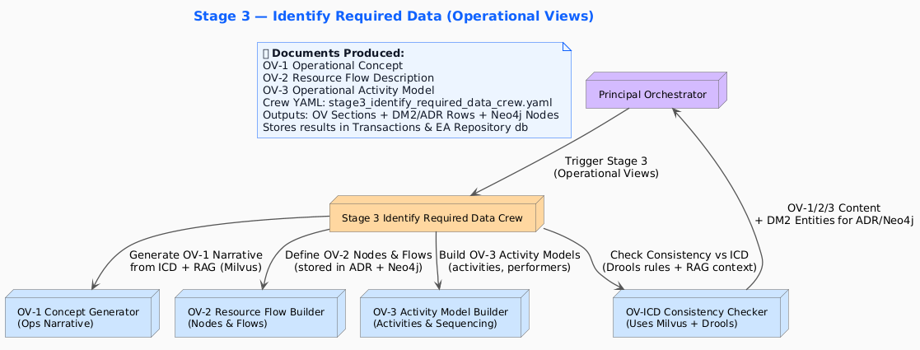

Stage 4 — System Views (SV / SvcV)
Purpose:
Generate system functions, component mappings, and system interfaces based on operational activities.
Components Used
- Milvus — Retrieve OV + ICD + system-mapping context; store SV chunks
- Drools — System-to-activity traceability rules
- Neo4j — Store system nodes, components, interfaces
- PostgreSQL — Persist SV/SvcV sections
- Redpanda — Pipeline updates
- IBM Rhapsody - System block definition (SV-1), System interfaces (SV-2), Sequence/Activity diagrams for system behavior

Flow Diagram:
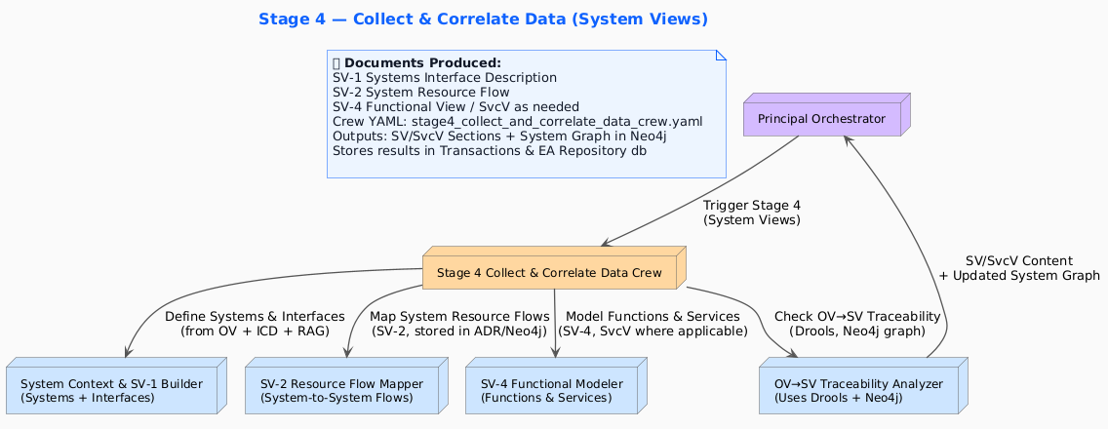

Stage 5 — Standards Views (PV / StdV)
Purpose:
Document technical standards, policies, interoperability, and platform constraints.
Components Used
- Milvus — Retrieve all prior stages + DoDAF PV/StdV definitions; store PV chunks
- Drools — Standards compliance + policy rules
- Neo4j — Map standards to systems & components
- PostgreSQL — Store PV/StdV outputs
- MinIO — Store related attachments/schemas
- Redpanda — Console updates
- IBM Rhapsody - Standards mapping to system components, Compliance modeling (constraints, policies)

Flow Diagram:
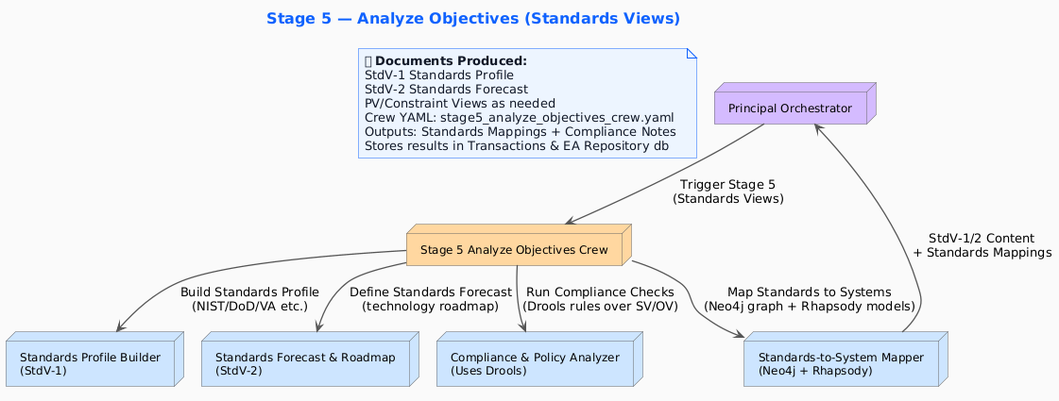

Stage 6 — Final Summary & Fit-For-Purpose Consolidated View
Purpose:
Generate the final consolidated F2P View with cross-stage consistency.
Components Used
- Milvus — Retrieve entire job memory from all stages
- Drools — Final validation of architectural completeness
- Neo4j — Retrieve graph relationships for summary
- PostgreSQL — Consolidate all stage outputs + generate final report
- MinIO — Store final DOCX/PDF artifacts
- Redpanda — Final job event broadcast
- IBM Rhapsody - Export final SysML packages, Generate architecture diagrams for the Final F2P view, Produce integrated DoDAF diagram sets (OV/SV/PV)

Flow Diagram:
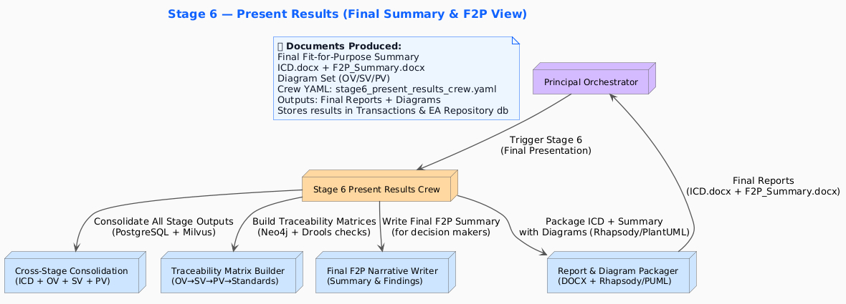

Sequence diagram showing full flow
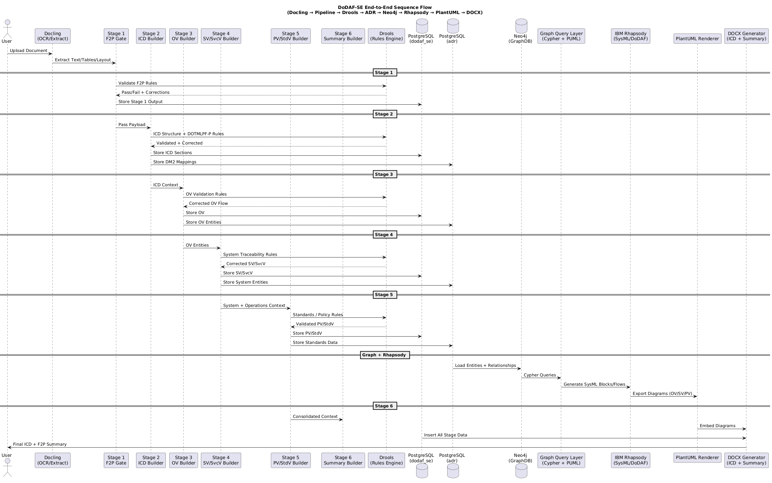

DoDAF Architecture Repository – Schema
Box folder: https://ibm.box.com/s/cqw6sa80hkuxubfltdtcivfmi75fknal
ERD diagram: https://ibm.box.com/s/502aifnlqzomh8bxoxnatk8gaursrv6p

Transactions Database — dodaf_se
Stores stage outputs, job metadata, and final reports.
Table | Purpose
jobs | Tracks each processing job (job_id, file name, timestamps, status).
stage_transactions | Stores agent outputs per stage (stage_num, section_name, content).
dodaf_report | Consolidated cross-stage report (ICD, Summary, diagrams metadata).
routing_manifest | F2P decisions, classification, routing info from Stage 1.
raw_doc_text | Extracted raw text from Docling.

EA Repository — adr (Enterprise Architecture Repository)
Stores DM2-normalized architecture elements created by Stages 2–6.
Feeds Neo4j GraphDB and Rhapsody.
Table | Purpose
dm2_capability | Capability definitions from ICD (CV-1/2/3).
dm2_activity | Activities from OV-3.
dm2_performer | Actors/performers for OV-1/OV-2/OV-3.
dm2_system | System elements for SV-1/SV-2/SV-4.
dm2_interface | Interfaces and flows between systems (SV-1/SV-2).
dm2_standard | Standards and compliance elements (StdV-1/2).
dm2_relationships | Cross-view traceability (OV→SV→PV).
diagram_records | Metadata for PlantUML/Rhapsody diagram exports.

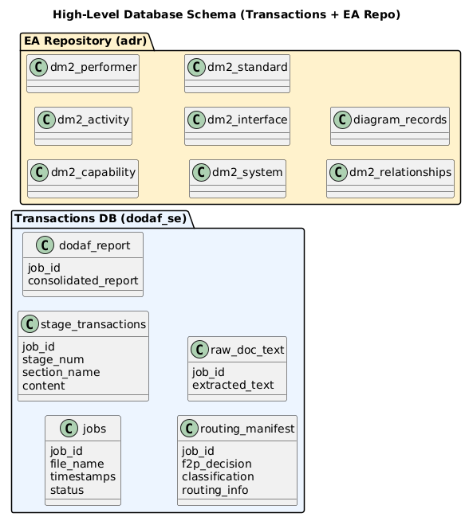

VectorDB knowledge store

Initial load of knowledge into VectorDB
This diagram shows how the initial authoritative corpus of knowledge is loaded into the Vector Database. A Knowledge Engineer uploads official DoD documents—such as manuals, technical orders, MIL-SPEC/MIL-STD, DoDAF policy materials, and legacy ICD/CDD/CPD files. These documents pass through the ingestion pipeline (loader → chunker → embedding → metadata → governance → HITL review) before being stored as validated embeddings in the Vector DB, forming the foundation knowledge for all DoDAF pipeline operations.
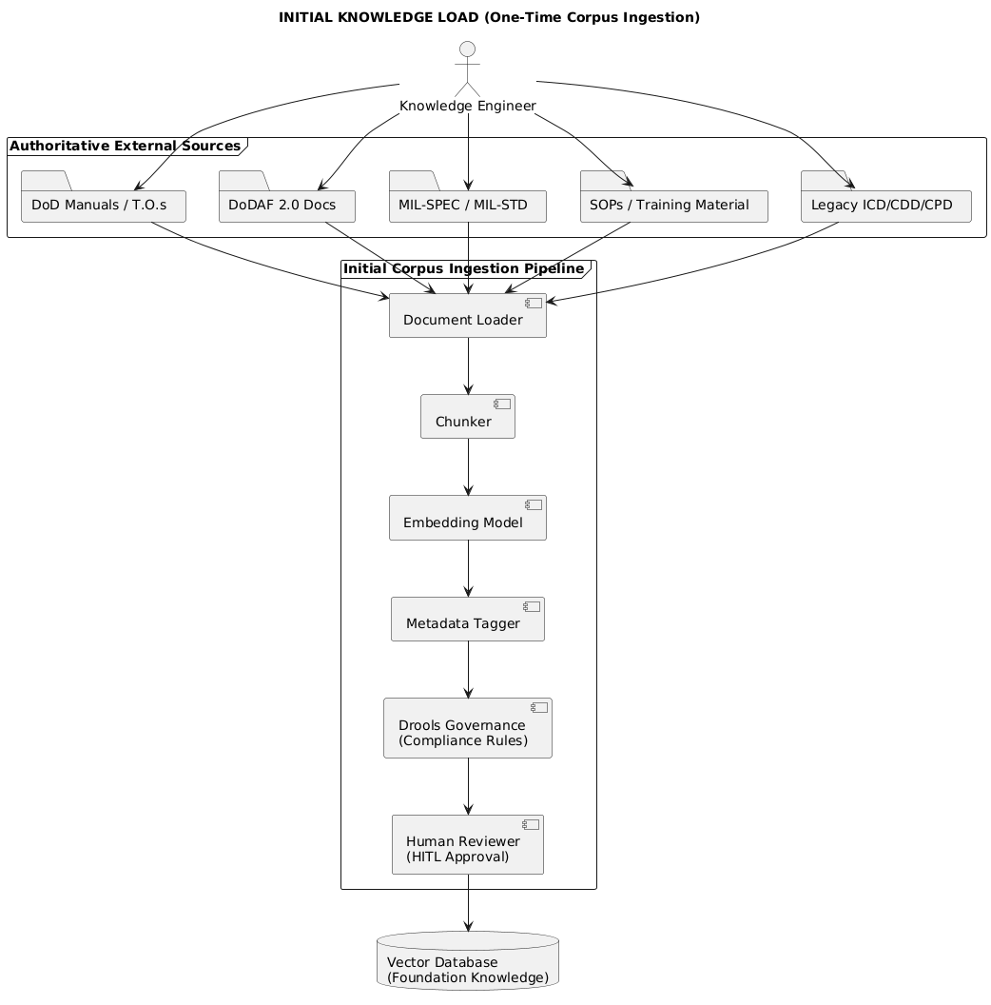

DoDAF Stages Using + Updating VectorDB)
This diagram illustrates how the DoDAF 6-stage pipeline interacts with the Vector Database during real-time execution. Each stage (S1–S6) queries the VectorDB to retrieve relevant operational, capability, system, data, and standards knowledge needed for grounded, non-hallucinated outputs.
After the pipeline produces results—such as ICD sections, OV/CV/SV updates, or validated analysis—those outputs flow through Drools governance and Human-In-The-Loop review. Only approved, authoritative content is written back to the VectorDB, enabling continuous learning and maintaining an accurate, evolving DoDAF Architecture Knowledge Store.
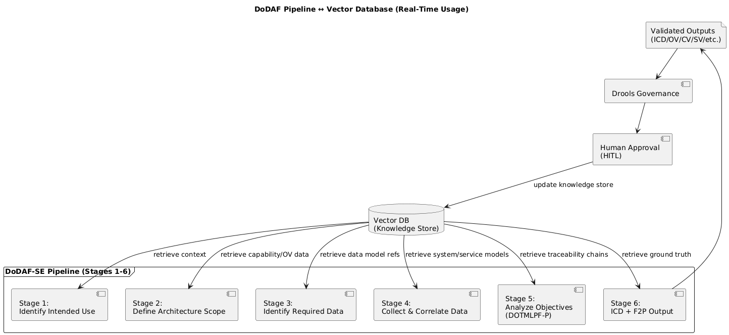

Agents do not and must not directly update the Vector Database.
All updates occur only through strict governance, where candidate artifacts generated by the pipeline pass through:
- Automated Drools rule validation (structure, vocabulary, compliance, DoDAF correctness)
- Human-in-the-loop (HITL) approval
- Metadata tagging and final verification
Only after approval are these artifacts converted into validated, safe, authoritative chunks and stored in the VectorDB for future retrieval.
The VectorDB acts as the DoDAF Architecture Knowledge Store and must never be polluted by:
- hallucinated or speculative text
- draft, partial, or unverified agent outputs
- incorrect or misleading LLM content
- unvalidated stage results
- content lacking provenance
- sensitive or classified-looking material
- outdated or deprecated doctrine
This ensures that the VectorDB remains a trusted, authoritative, and traceable knowledge source for all DoDAF agents and crews during runtime.

🚧 Work in Progress / Design Enhancements

1. Add Stage 0.5 / Stage 6.5 — Human Correction & Feedback Loop
Purpose: Formalize SME intervention so the system continuously improves.
Enhancements:
- Allow SMEs to review and correct ICD, OV, SV, PV sections.
- Feed corrections back into Milvus as high-quality training exemplars.
- Update or propose new Drools rules automatically.
- Capture deltas as “Architecture Feedback Records” in the EA Repo.
Impact: Creates a continuously learning DoDAF architecture factory.

2. Implement Confidence Scoring + Conditional Human-in-the-Loop
Add per-artifact confidence thresholds:
Example thresholds:
- OV-1 narrative >0.90 → auto-approve
- SV-4 functional flow <0.75 → route to SME for approval
- Standards mapping (StdV-1) >0.85 → auto-integrate into ADR
Implementation:
- LLM ensemble voting (Grok 4, Claude 3.5, Granite Guardian, local Llama).
- Store confidence scores in stage_transactions.
- Trigger human review when thresholds are not met.

3. Auto-Generate DIV-3 Traceability Matrices After Stage 6
Using Neo4j and your DM2 data:
- OV Activities → mapped to
- SV Functions → mapped to
- PV Standards / Constraints
Generated Artifacts:
- DIV-3 Traceability Matrix (CSV + DOCX)
- OV-SV-PV tri-link graphs
- Rhapsody traceability diagrams (optional)
Value: This is VERY high-value for DoD PMOs.

4. IL5/IL6-Ready Security Hardening (Next Release Target)
Prepare for DoD accreditation:
- Replace MinIO → AWS S3 or Azure Blob with SSE-KMS
- Integrate HashiCorp Vault / AWS Secrets Manager for secrets
- Run CrewAI agents in isolated Podman containers with eBPF network policies
- Sign all DOCX/PDF outputs using CAC/PKI (Adobe AATL or DoD root)

5. Strengthen Governance Layer
Add rule categories in Drools:
- Structural checks: required ICD sections, OV completeness
- Semantic checks: activity-to-function alignment
- Compliance checks: NIST 800-53, DoD 8500.01, zero-trust mappings
- Quality checks: grammar, contradiction detection, missing operational nodes
Governance should now run at:
- Post-Stage output (existing)
- Pre-Stage execution for upstream consistency
- Post-Stage 6 for final document gating

6. Expand the EA Repository (ADR) for Better MBSE Interoperability
Extend schema:
- dm2_rhapsody_artifact (track model file IDs)
- dm2_traceability_link (explicit OV→SV→PV relationships)
- dm2_feedback (human corrections from Stage 6.5)
- dm2_rule_evidence (Drools rule hits/misses)

7. Integrate an Ensemble Cross-Check (Self-Consistency Layer)
Before accepting any agent-generated section:
- Query multiple models (local + cloud)
- Perform majority vote
- Run contradiction and completeness checks
- Store results in transactions.validation_scores
- This improves reliability and reduces hallucination risk.

8. Add a “Pipeline Health & Drift Dashboard”

Using Redpanda + Neo4j metadata:
- Drift in agent outputs
- Drools rule hit/miss patterns
- Confidence score trends
- OV/SV/PV coverage gaps
- Feedback loop metrics (from Stage 6.5)

