**Operating Systems Fall, 2019**

**Programming Assignment 2**

系級: 資科四 學號: 105703037 姓名: 孫啟偉

**實驗結果圖:**

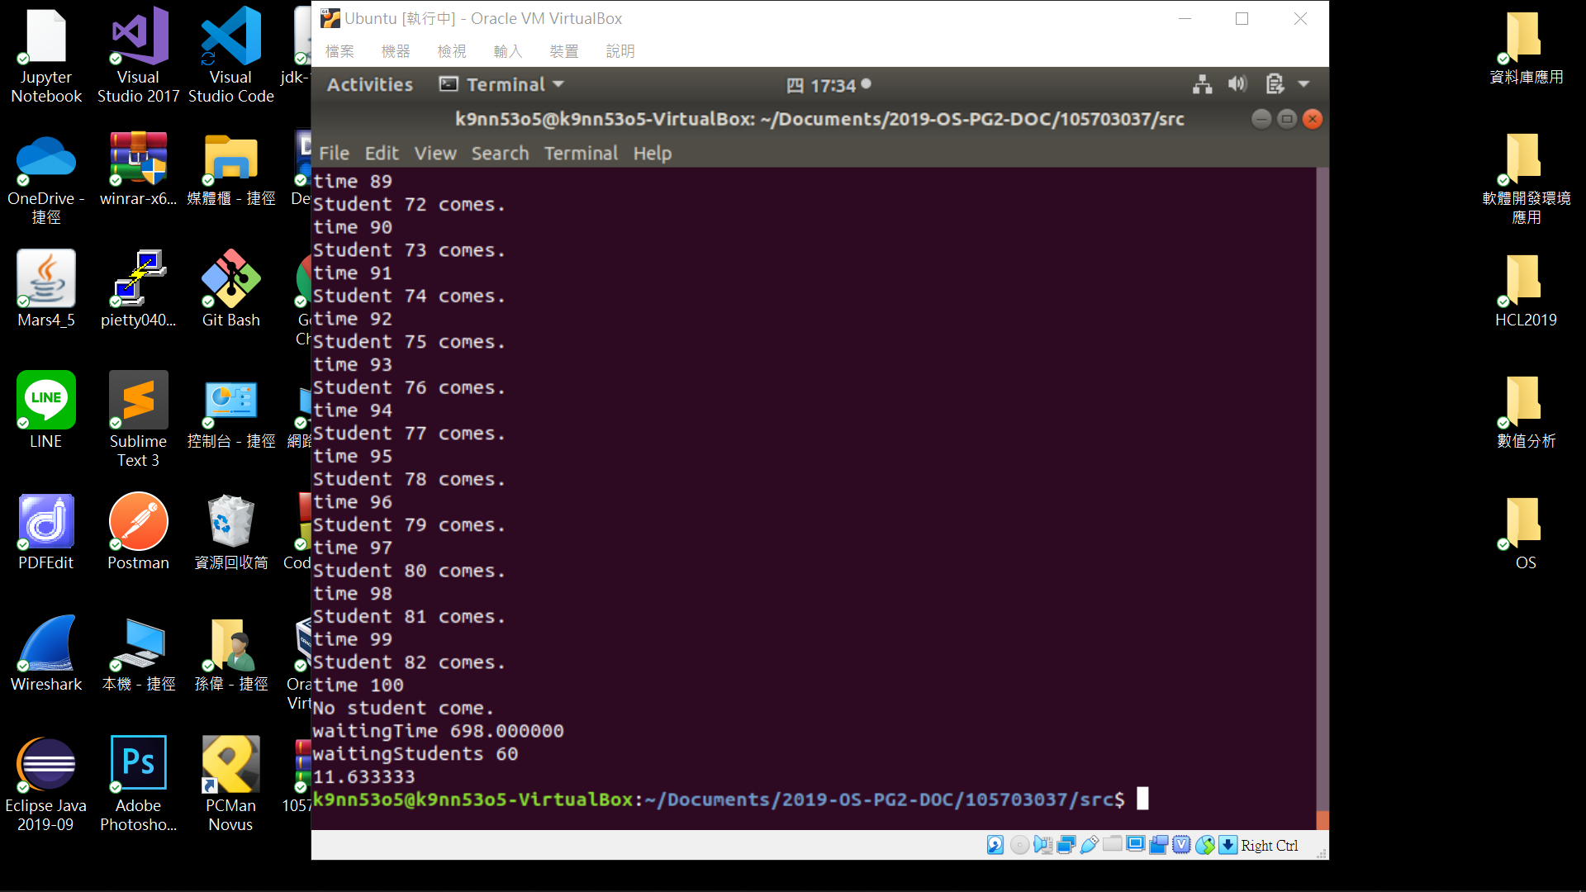

**程式運作流程:**

(請描述一下你的程式如何運作，如何計算出結果)

It will start from reading file which have 1 and 0 to represent students coming to find TA in each period of time. Then we create a thread call TA it will check if there is any student available that need to be teach, if there is student are waiting. TA will teach student in 2 msec, and -1 to the occupied chairs outside and then keep waiting student. And we also create threads called student_id[i], it represent student start to wait at chair and make occupied chair number +1 and the waiting for TA. The time a student wait for TA will be occupied chair number * 2(sitting on chair waiting) + 2(being tauch in TA office)

**心得:**

(請寫下完成本次作業的心得、學到哪些東西、困難點的部分。)

弄懂題目及各個鎖及變數是這次做業花最長時間的地方，打起程式還蠻快的，把程式做填空，可是最後debug才發現原來pthread_join是容易出錯的地方，student_id[i] 的thread要注意是studentPerTime[i] == 1的才要join，然後TA 的thread不要join，不然程式會卡在無窮迴圈。