Mason Gingery, Ben Walker, Tong Wang

Scientific Importance and Motivation (TW)

Galaxies are massive collections of stars, gas, and dust which are held together by gravitational forces. Learning the dynamics of these galaxies is crucial to learn more about the universe. There are two ways of calculating galaxy masses, one of which is to use the orbital velocity of the galaxy and use the formula $v_{o} = \sqrt{\frac{GM}{r}}$ to get the mass of the galaxy. The other way is to use the luminosity of the galaxy to calculate its mass. However, when comparing the result of the two methods, the mass from the orbital velocity method seems to be larger than from luminosity method, which brings up a hypothesis that there are some matters exist in the universe that can’t emit or reflect any light so that their masses can’t be measured by luminosity method. To further research why there is difference when calculating galaxy masses in the two different ways, a key method is to study of galactic rotation curves. The rotation velocities of galaxies are contributed by the masses inside of it, we could observe the rotation velocities of galaxies and compared with the total rotation velocities contributed by all masses that we’ve known. If the rotational velocities contributed by the masses of all stellar components that we’ve known is different with the rotational velocities we observed, it could be the evidence for the existence of dark matter. If the two velocities are the same, we need a new hypothesis for the difference when calculating galaxy masses using the two methods. Andromeda, as our nearest galaxy, its galactic rotation curves play a massive role in discovering the existence of dark matter.

Underlying Physics and Math (BW):

For an object to stay in orbit around a central body, the centripetal force and the gravitational force must be equivalent. The formula of centripetal force is, $F_{c}=\frac{mv_{o}^{2}}{r}$ and the formula of gravitational force is $F_{g}=G\frac{Mm}{r^{2}}$. Setting these equations equal and solving for $v_{o}$, we obtain that the equation for orbital velocity is $v_{o}=\sqrt{\frac{GM}{r}}$, where G = gravitational constant, M = mass of the center body, and r = radius of the orbit. According to this equation, the orbital velocities of these rotation curves should decrease for increasing distances from the galactic center (for increasing radius).

Method (MG)

The method used to calculate the rotation curve was executed by first defining the mass distribution of the andromeda galaxy using observed data reported by Carignan et al. (2006)1, in which a table is provided with several data points indicating the radius (kpc) and the relative velocity (km s-1) from the center of the galaxy. For our analysis, we extracted the data to a plain text file and uploaded it to our python notebook and used this as our array of data points. The next step was to define the equation for orbital velocity within the python code. Once the equation V = sqrt(G\*M/r) was defined, we utilized a “for” loop to calculate the rotational velocity of the individual bodies.

The andromeda galaxy is composed of four main components: the central black hole, the bulge, the disk, and the halo. This led to one major consideration when developing the code: For some data points, the “central body” imbuing its gravitational force on them is different. For instance, an individual rotating body with a small radius is primarily affected solely by the central black hole. Whereas an individual rotating body with a large radius may be affected gravitationally by more than one component. This means that the central mass (M) for each data point was not always the same. We had to calculate the true central mass (M) by offsetting the total radius of the component by the distance between the edge of the component and the individual body. To calculate the resulting mass, we had to assume that the bulge was a three-dimensional sphere, and the disk was a two-dimensional circle. This would allow simple calculations for the volume and area, respectively. We were able to extrapolate the total mass and radius of each galactic component from an online source2 and calculate the density. Once we knew the density, we could plug it into our volume equation to compute the resulting true central mass. Putting this together, we calculated the rotational velocity of each data point and plotted the resulting figures within python.

Results

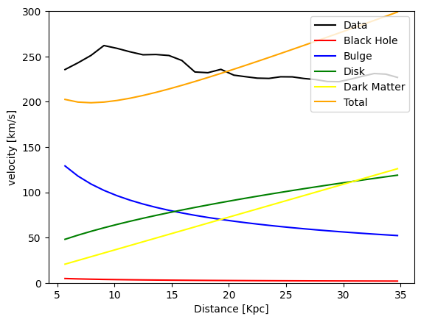

Figure 1: Distance from Galactic Center vs Orbital Velocity

Result and Interpretation (TW, MG)

Figure 1 portrays a relationship between velocity and distance from the center of the galaxy. Each trendline is a representation of the rotational velocities of each component. Our results indicate that there is not enough mass between the four galactic components to justify the speed at which the galaxy is spinning. This gap between observations and predictions leads to an assumption of unaccounted and unobservable mass surrounding the galaxy. However, one problem that is shown in the graph is that after adding dark matter into the calculation, we found that there is small deviation between our calculated result and observed data. When the radius is small, the velocity is smaller than the observed velocity, while it becomes larger than the observed velocity as the radius becomes larger. Compared our result with the graph from Carignan et al1, one hypothesis we have is that the density of disk is not constant as we assumed. When radius is small, disk have high density thus forcing higher rotational velocity of galaxy, while the density of disk is smaller when distance is higher, thus resulting in smaller rotation velocity. Adding the consideration of uneven distribution of disk density, we believe our result could better align with the observed data, future studies of disk density distribution are needed for us to verify the hypothesis.

Conclusion (BW):

This analysis aimed to examine the discrepancy between observed rotation curves of the M31 galaxy and the predicted values based on orbital mechanics. The difference between the expected orbital velocities based on visible matter and the calculated orbital velocities raises suggests the presence of dark matter. This unseen mass provides the extra gravitational force that is required to close this gap between the expected and calculated orbital velocities. The observation of steady rotation curves at increasing distances from the center of the galaxy is convincing evidence that dark matter is present in the Andromeda galaxy.

References

1. Carignan, C., Chemin, L., Huchtmeier, W. K., & Lockman, F. J. (2006). The extended Hi rotation curve and mass distribution of M31. *The Astrophysical Journal*, *641*(2). <https://doi.org/10.1086/503869>
2. *M31*. M31 Fact Sheet - StarDate’s Black Hole Encyclopedia. (n.d.). <http://blackholes.stardate.org/objects/factsheet-M31.html>