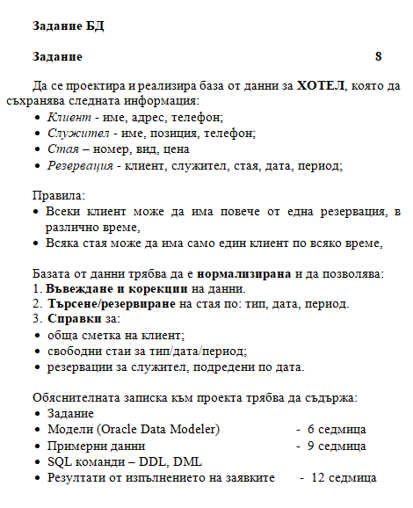

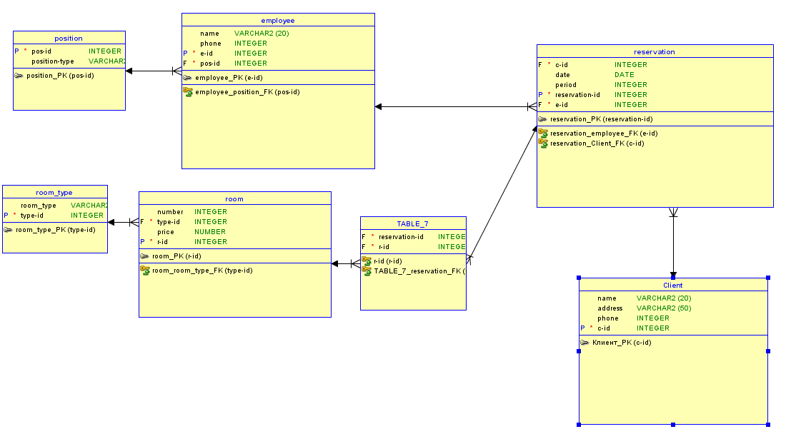**МОДЕЛИ**

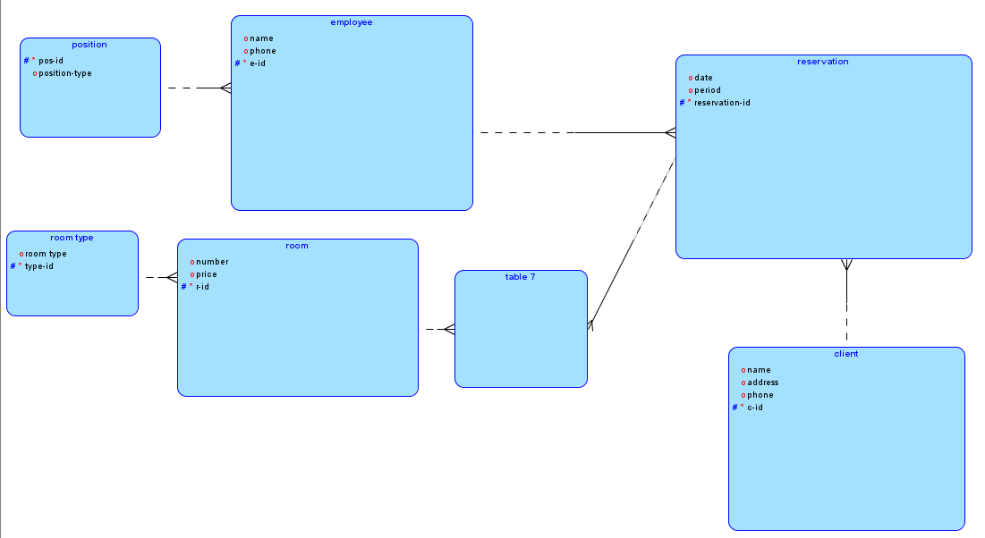

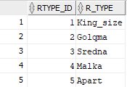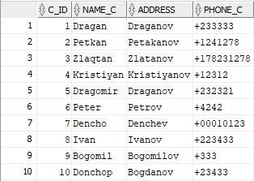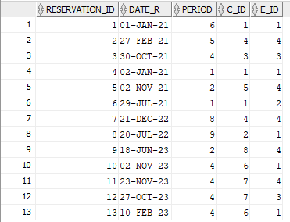**ПРИМЕРНИ ДАННИ**

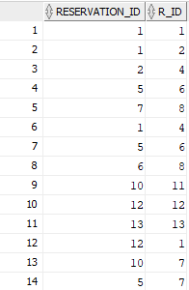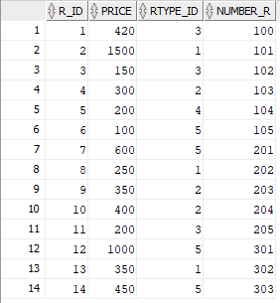

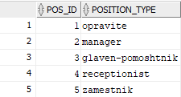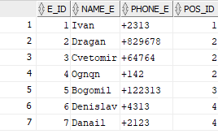

**SQL КОМАНДИ**

Create table position(

pos_id int not null,position_type varchar(20));

Alter table position

add primary key(pos_id);

Create table employee(

e_id int not null,name_e varchar(20),phone_e varchar(20),pos_id int);

Alter table employee

add primary key(e_id);

Create table room_type(

rtype_id int not null,r_type varchar(50));

Alter table room_type

add primary key(rtype_id);

Create table room(

r_id int not null,price number,rtype_id int,number_r int);

Alter table room

add primary key(r_id);

Create table room_res(

reservation_id int ,r_id int);

Create table reservation(

reservation_id int not null ,date_r date,period int,c_id int,e_id int);

Alter table reservation

add primary key(reservation_id);

Create table client(

c_id int not null,name_c varchar(20),address varchar(50),phone_c varchar(20));

Alter table client

add primary key(c_id);

Alter table employee

add foreign key(pos_id)

references position(pos_id);

Alter table room

add foreign key(rtype_id)

references room_type(rtype_id);

Alter table reservation

add foreign key(c_id)

references client(c_id);

Alter table reservation

add foreign key(e_id)

references employee(e_id);

Alter table room_res

add foreign key(r_id)

references room(r_id);

Alter table room_res

add foreign key(reservation_id)

references reservation(reservation_id);

insert into client values(1,'Dragan','Draganov','+233333');

insert into client values(2,'Petkan','Petakanov','+1241278');

insert into client values(3,'Zlaqtan','Zlatanov','+178231278');

insert into client values(4,'Kristiyan','Kristiyanov','+12312');

insert into client values(5,'Dragomir','Draganov','+232321');

insert into client values(6,'Peter','Petrov','+4242');

insert into client values(7,'Dencho','Denchev','+00010123');

insert into client values(8,'Ivan','Ivanov','+223433');

insert into client values(9,'Bogomil','Bogomilov','+333');

insert into client values(10,'Donchop','Bogdanov','+23433');

insert into room_type values(1,'King_size');

insert into room_type values(2,'Golqma');

insert into room_type values(3,'Sredna');

insert into room_type values(4,'Malka');

insert into room_type values(5,'Apart');

insert into room(r_id,rtype_id,price,number_r)

values(1,3,420,100);

insert into room(r_id,rtype_id,price,number_r)

values(2,1,1500,101);

insert into room(r_id,rtype_id,price,number_r)

values(3,3,150,102);

insert into room(r_id,rtype_id,price,number_r)

values(4,2,300,103);

insert into room(r_id,rtype_id,price,number_r)

values(5,4,200,104);

insert into room(r_id,rtype_id,price,number_r)

values(6,5,100,105);

insert into room(r_id,rtype_id,price,number_r)

values(7,5,600,201);

insert into room(r_id,rtype_id,price,number_r)

values(8,1,250,202);

insert into room(r_id,rtype_id,price,number_r)

values(9,2,350,203);

insert into room(r_id,rtype_id,price,number_r)

values(10,2,400,204);

insert into room(r_id,rtype_id,price,number_r)

values(11,3,200,205);

insert into room(r_id,rtype_id,price,number_r)

values(12,5,1000,301);

insert into room(r_id,rtype_id,price,number_r)

values(13,1,350,302);

insert into room(r_id,rtype_id,price,number_r)

values(14,5,450,303);

insert into position values(1,'opravite');

insert into position values(2,'manager');

insert into position values(3,'glaven-pomoshtnik');

insert into position values(4,'receptionist');

insert into position values(5,'zamestnik');

insert into employee(e_id,pos_id,name_e,phone_e)

values(1,1,'Ivan','+2313');

insert into employee(e_id,pos_id,name_e,phone_e)

values(2,2,'Dragan','+829678');

insert into employee(e_id,pos_id,name_e,phone_e)

values(3,2,'Cvetomir','+64764');

insert into employee(e_id,pos_id,name_e,phone_e)

values(4,2,'Ognqn','+142');

insert into employee(e_id,pos_id,name_e,phone_e)

values(5,3,'Bogomil','+122313');

insert into employee(e_id,pos_id,name_e,phone_e)

values(6,4,'Denislav','+4313');

insert into employee(e_id,pos_id,name_e,phone_e)

values(7,4,'Danail','+2123');

insert into reservation(reservation_id,e_id,c_id,date_r,period)

values (1,1,1,'01-JAN-21',6);

insert into reservation(reservation_id,e_id,c_id,date_r,period)

values (2,4,4,'27-Feb-21',5);

insert into reservation(reservation_id,e_id,c_id,date_r,period)

values (3,3,3,'30-OCT-21',4);

insert into reservation(reservation_id,e_id,c_id,date_r,period)

values (4,1,1,'02-JAN-21',1);

insert into reservation(reservation_id,e_id,c_id,date_r,period)

values (5,4,5,'02-NOV-21',2);

insert into reservation(reservation_id,e_id,c_id,date_r,period)

values (6,2,1,'29-JUL-21',1);

insert into reservation(reservation_id,e_id,c_id,date_r,period)

values (7,4,4,'21-DEC-22',8);

insert into reservation(reservation_id,e_id,c_id,date_r,period)

values (8,1,2,'20-JUL-22',9);

insert into reservation(reservation_id,e_id,c_id,date_r,period)

values (9,4,8,'18-JUN-23',2);

insert into reservation(reservation_id,e_id,c_id,date_r,period)

values (10,1,6,'02-NOV-23',4);

insert into reservation(reservation_id,e_id,c_id,date_r,period)

values (11,4,7,'23-NOV-23',4);

insert into reservation(reservation_id,e_id,c_id,date_r,period)

values (12,3,7,'27-OCT-23',4);

insert into reservation(reservation_id,e_id,c_id,date_r,period)

values (13,1,6,'10-FEB-23',4);

insert into room_res values(1,1);

insert into room_res values(1,2);

insert into room_res values(2,4);

insert into room_res values(5,6);

insert into room_res values(7,8);

insert into room_res values(1,4);

insert into room_res values(5,6);

insert into room_res values(6,8);

insert into room_res values(10,11);

insert into room_res values(12,12);

insert into room_res values(13,13);

insert into room_res values(12,1);

insert into room_res values(10,7);

insert into room_res values(5,7);

update room_res

set reservation_id=2

where r_id=4;

delete from room_res

where r_id=4;

**ТЪРСЕНЕ**

select room.r_id,room_type.rtype_id,room_type.r_type,date_r,period

from reservation

join room_res on reservation.reservation_id=room_res.reservation_id

join room on room_res.r_id=room.r_id

join room_type on room_type.rtype_id=room.rtype_id

where room_type.rtype_id=&rtype_id;

select room.r_id,room_type.rtype_id,room_type.r_type,date_r,period

from reservation

join room_res on reservation.reservation_id=room_res.reservation_id

join room on room_res.r_id=room.r_id

join room_type on room_type.rtype_id=room.rtype_id

where reservation.date_r='&date_r';

select room.r_id,room_type.rtype_id,room_type.r_type,date_r,period

from reservation

join room_res on reservation.reservation_id=room_res.reservation_id

join room on room_res.r_id=room.r_id

join room_type on room_type.rtype_id=room.rtype_id

where reservation.period=&period

**СПРАВКИ**

select client.c_id,price

from room

join room_res on room_res.r_id=room.r_id

join reservation on reservation.reservation_id=room_res.reservation_id

join client on client.c_id=reservation.c_id

where client.c_id=&c_id;

select employee.e_id,reservation.reservation_id,reservation.date_r

from employee

join reservation on reservation.e_id=employee.e_id

where employee.e_id=&e_id

order by date_r;

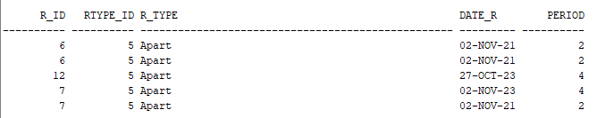 **РЕЗУЛТАТИ ОТ ИЗПЪЛНЕНИЕ НА ЗАЯВКИТЕ**

