Regular Expression to NFA conversion

Computer Design Lab 2021

Name: Dushyanth

Roll No: 18CS01009

Examples:

1. **Input**: (a|b)+&a (Note: The macro ‘COUNT’ is 2)

**Output:**

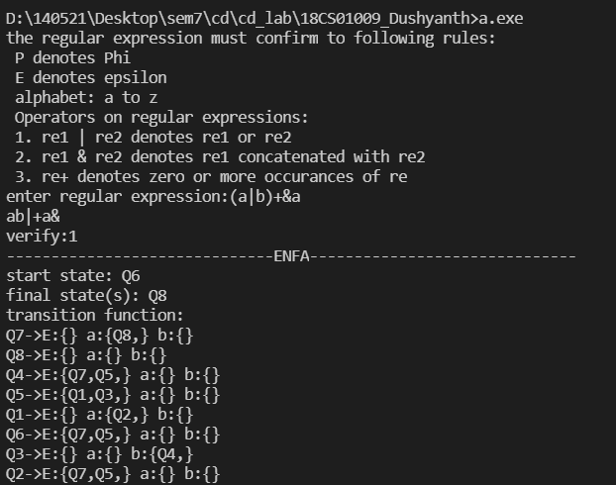

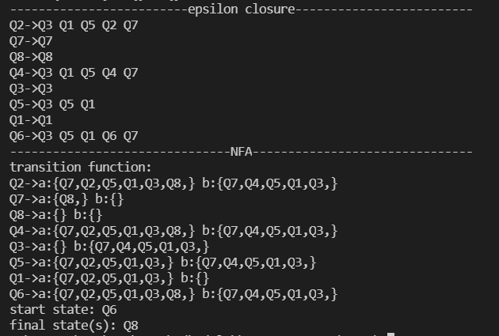

2. **Input**: (a&b|a)+

**Output**:

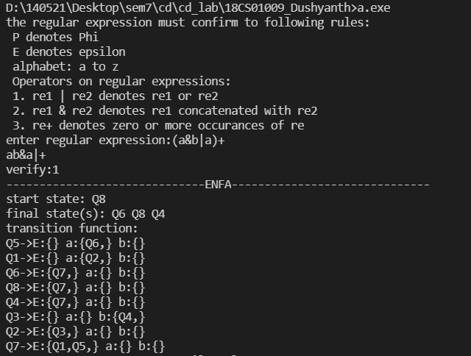

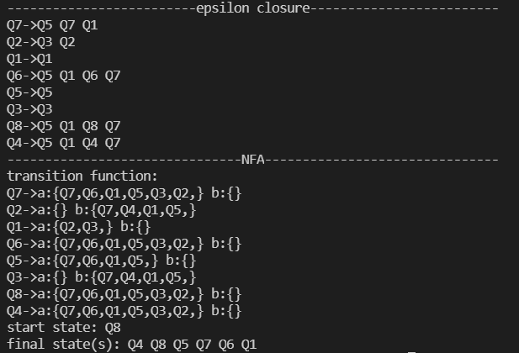

Epsilon NFA diagrams:

1.

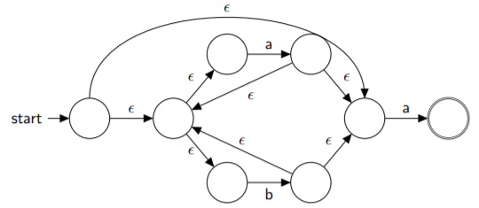

2.

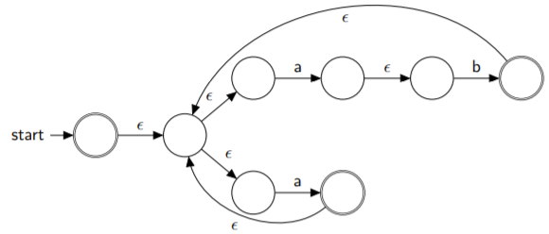

DFA minimization using Single Pass Table Filling Algorithm (O(n2))

Example:

