Compiler Design Lab 2021

Assignment-2

Lexical Analysis

Name: Dushyanth

Roll No: 18CS01009

Examples:

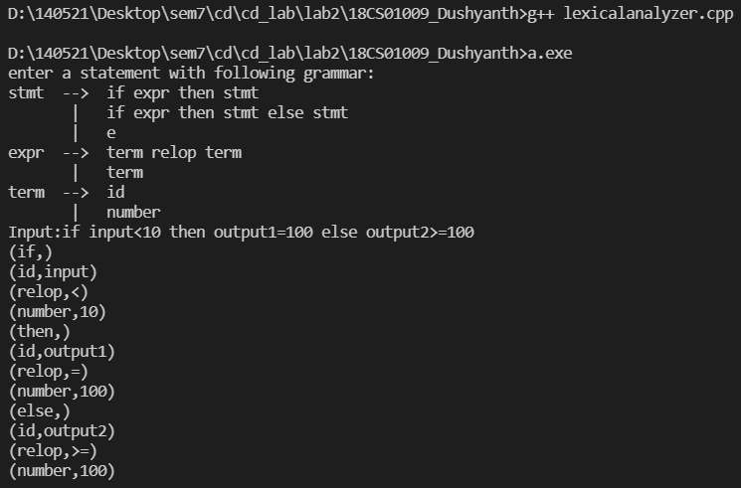

1. White spaces in input are handled appropriately.

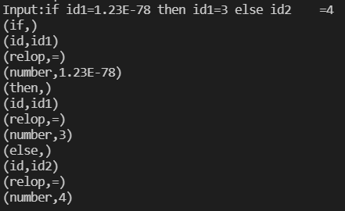

1. Identifiers with keywords as prefix are also handled

