Compiler Design Lab

Assignment-4

Name: Dushyanth

Roll No: 18CS01009

1. A program to remove left-recursion from grammar G given as input.

example:

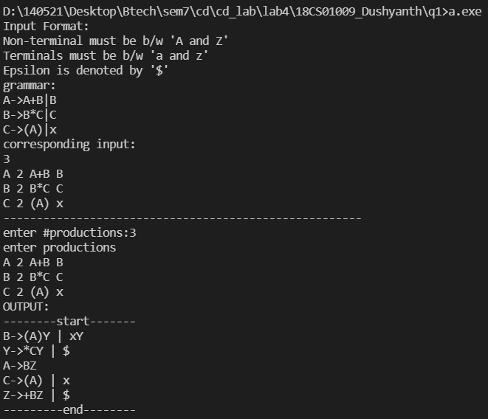

1. A program that takes a grammar as input and produces an equivalent left factored grammar as output.

example-1:

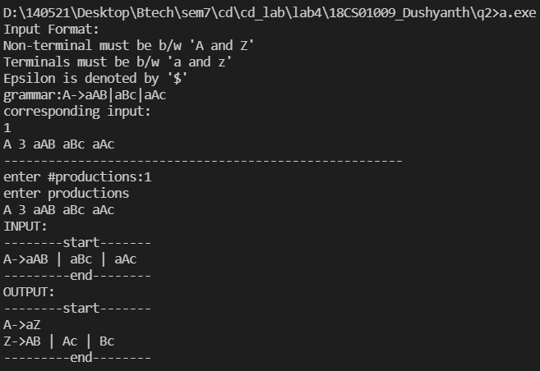

example-2:

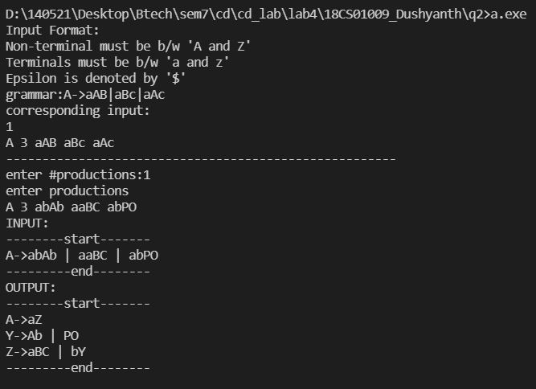

example-3:

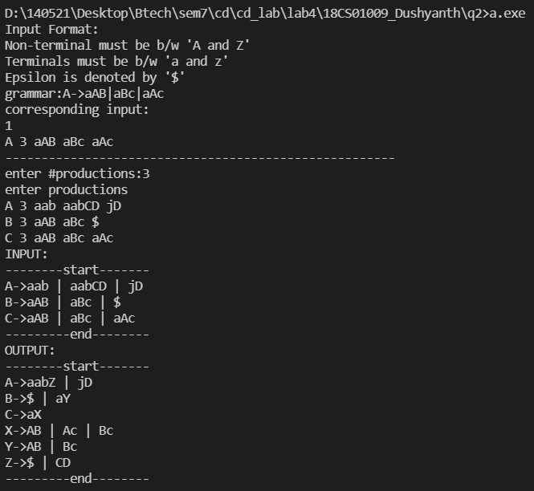

1. A recursive descent parser for the given expression grammar:

example-1:

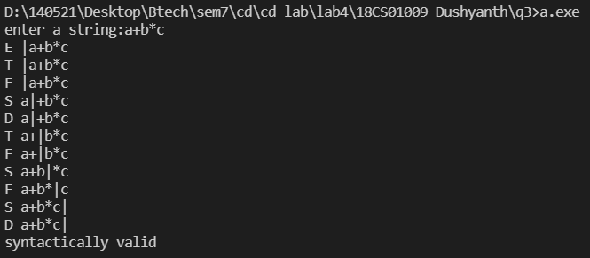

example-2:

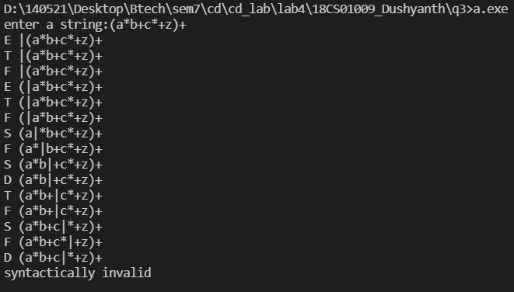

example-3:

