CN LAB ASSIGNMENT

LAB-4

Name: Dushyanth

Roll No:18CS01009

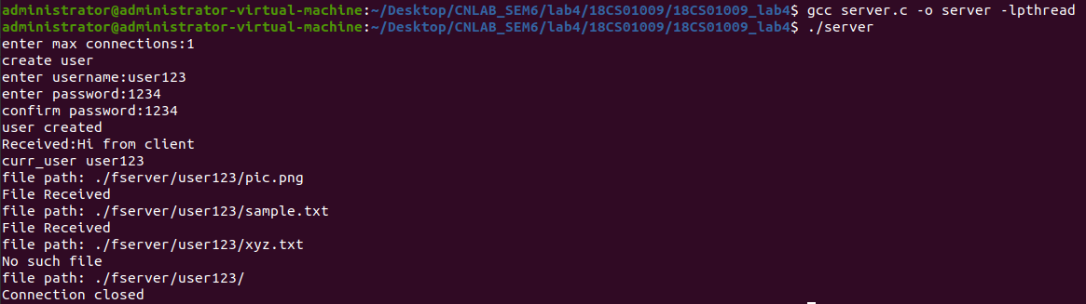

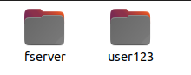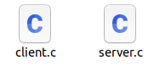

The above specified commands in server process creates the folders- fserver, user123 which simulate server side and client side respectively.

Sample files used: pic.png and sample.txt for transfer

