

**NUS REWIRED Report**

By Team Packet Loss

**Project Links**

Frontend: <https://github.com/kKar1503/rewired-client-2024>

Backend: <https://github.com/kKar1503/rewired-server-2024>

Hardware: <https://github.com/UltraRaptorYT/ReRemote>

### **Introduction 🎤**

#### What’s our project about?

Who still watches TV these days? In our digital era, the relevance of traditional remote controls is waning as people increasingly venture online. This made the idea of repurposing these remotes not only intriguing but also something every member of our team could relate to.

Our project revolves around **utilising infrared (IR) sensors to replace conventional motion sensors**. We're developing a sustainable solution that’s both affordable and eco-friendly. And, as a team of aspiring software engineers, we naturally aim for scalability and versatility across various applications. We demonstrate how our system can be seamlessly integrated into different environments, such as offices and homes, to enable energy savings and enhance efficiency.

### The Journey Begins 🗺️

#### How we decided on the problem to solve

We wanted to take a bottom-up approach in deciding our focus. From our experience in numerous hackathons, we knew that a top-down approach often led to wasting time on endless debates about "what problem to solve." Instead, we set a direction early on to stay focused.

Our teammate Kar Lok came up with the creative idea of **using TV remote’s IR sensors to detect people**, inspired by a small group project where IR sensors were creatively employed to check if an object was moved. In this project, anything blocking the constantly emitting IR would emit a negative signal, which Kar Lok found to be a fun and innovative use of IR technology. We thought this was a great reimagination of IR sensors and decided to root this idea as the core of our project.

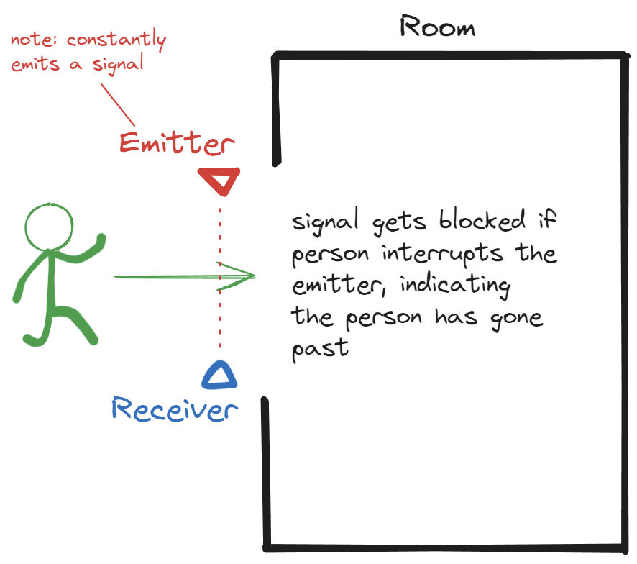

*Our teammate Kar Lok’s core idea in mind*

Another teammate, Kenneth, introduced Sequoia Capital’s Arc Product-Market Fit framework, which helped us narrow down our options. This framework allowed us to pinpoint exactly what severity and kinds of problems we wanted to tackle. For instance, while COVID-related applications were a consideration, like counting the number of people in a building to inform potential visitors, the severity of this problem was not appropriate to rely on upcycled materials.

We then pivoted to addressing a less severe but still relevant issue—energy consumption. The idea was that by counting the number of people in a specific area, we would have the ability to downstream this information to control room temperature, air conditioning, and lighting in an efficient manner. For instance, if nobody is present in an area, one might turn off the power of certain appliances to save energy.

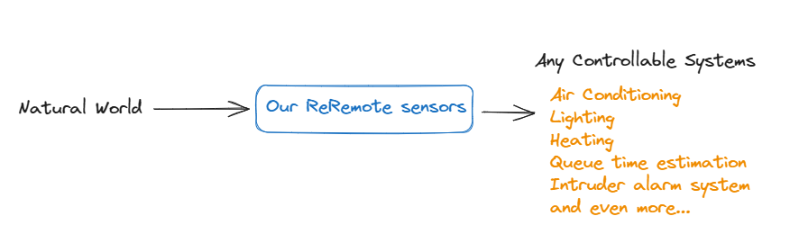

*Some examples of what our ReRemote sensors we imagine can work with*

However, we decided to focus on a particular sector, settling on a specific problem statement that we felt motivated to tackle and one that was most relevant to NUS Rewired’s sustainability theme: **“How might we upcycle IR sensors to enable energy savings?”**

### Ideation Phase 💡

#### Too many what-ifs, too little time

After focusing on energy inefficiencies, our team split efforts to explore applications and refine our solution. One part developed the idea of using IR sensors to reduce energy consumption, while the other evaluated the potential impact and alternative use cases.

Initially, we considered using IR sensors in malls to optimize HVAC systems. However, malls typically run air conditioning constantly, limiting our solution's effectiveness. On top of this, malls have large groups of people passing by large entrances, which necessitate a much more accurate people counter.

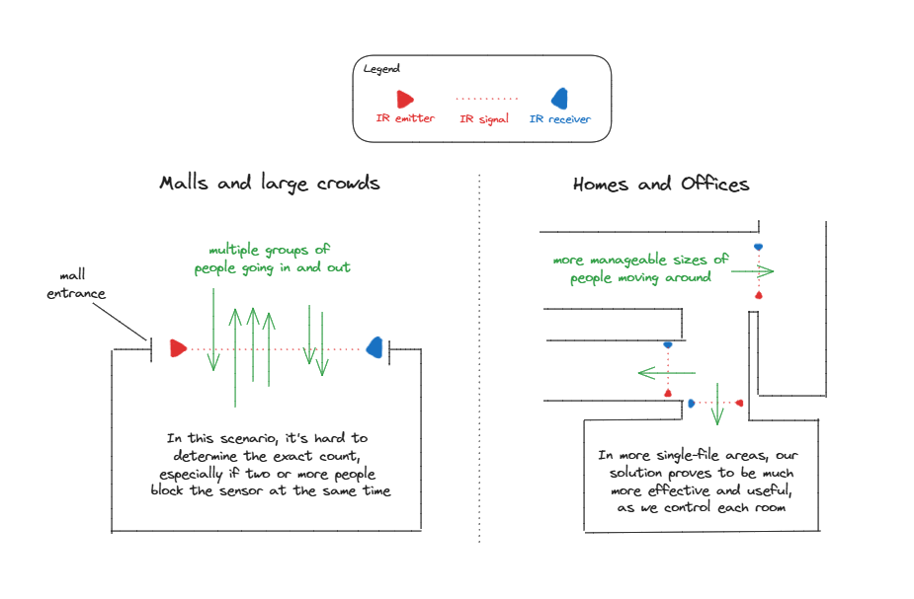

*Illustrating how our sensors work better for smaller crowds*

This realisation led us to explore other applications for IR sensors, with a focus on homes and offices. We recognized that these environments have more variable occupancy patterns and greater potential for energy savings through optimised lighting and HVAC systems. By using **IR sensors to detect the presence of people in specific rooms or areas, we could enable more targeted and efficient control of HVAC** systems, ultimately reducing energy waste and costs for homeowners and businesses.

To enhance our solution, we thought of incorporating some information display collected by the IR sensors and integrating cloud databases for data storage. This would provide users with valuable insights and enable data-driven decision-making.

### **Solution Building ✍️**

#### What we did

At the core of our project was to repurpose IR sensors to act as gates that would help track the number of persons that pass by. With scalability in mind, we aimed at targeting many use cases. For instance, our motion sensors are intended to be attached as a sort of ‘signal’ detector, that can be extended to smart appliances like controlling air conditioning, lights and more.

However our final solution has the following features:

1. IR receivers/emitters, Arduino, ESP for counting
2. Buttons to adjust for any counting errors
3. SQLite Cloud Data Storage

Additionally, we also designed a mockup AutoCAD to get a better understanding of how our solution might function if deployed in real life.

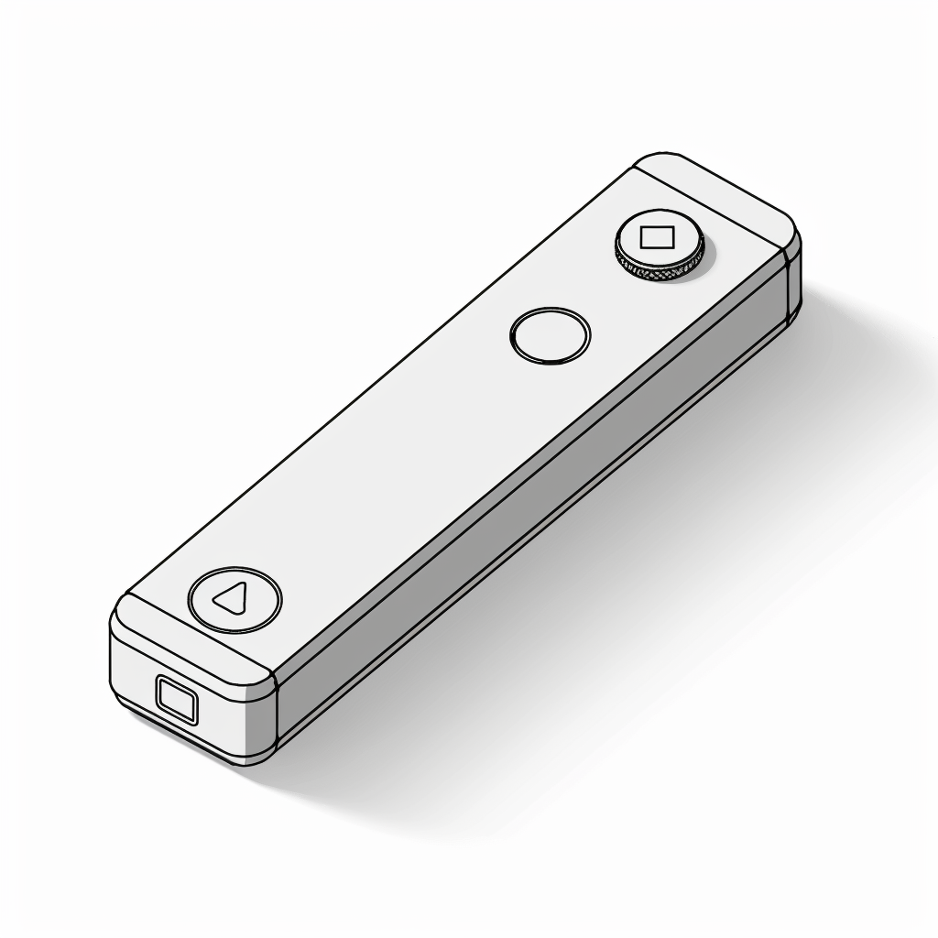

*AutoCAD diagram of how we envision the device to be encased*

### Problems faced and our solutions **🤓**

#### How we untangled the knots in our journey

**Determining the direction**

One of the initial challenges we faced was how to determine the direction of movement using an emitter and a receiver. Our basic setup could detect if something had passed by, but not the direction in which it moved. This was crucial for accurately tracking the number of people in a room.

To solve this, our teammate Thaddeus suggested using two IR sensor pairs. By placing two emitters and two receivers in sequence, we could determine the direction based on the order in which the signals were interrupted. For example, if the left sensor is triggered before the right, it indicates movement towards the right.

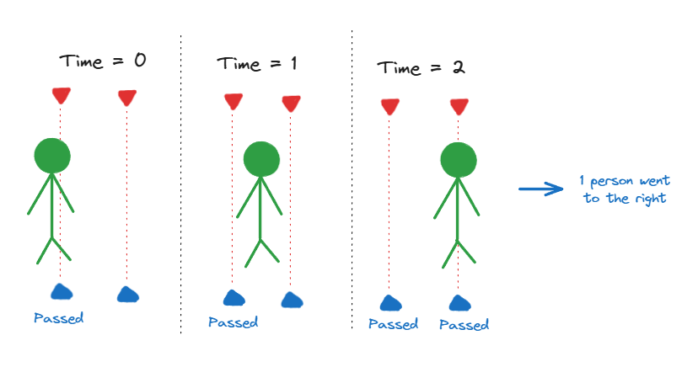

*Illustration of Thaddeus’s idea*

**Algorithm Development**

With the concept of direction in place, the next step was to develop an efficient algorithm to process the signals. Kar Lok designed a suitable algorithm that worked as follows:

1. **Initialization**: Set up the IR emitters and receivers, and initialize variables to store state and timestamps.
2. **Polling**: Regularly check the status of both receivers.
3. **State Change Detection**: Record the timestamp when a receiver's state changes from unblocked to blocked.
4. **Direction Determination**: Compare timestamps; if Receiver 1 is blocked before Receiver 2, movement is "In"; if Receiver 2 is blocked first, movement is "Out".
5. **Reset**: Prepare for the next polling cycle by resetting states

**Hardware limitations**

One significant hardware limitation we faced was integrating multiple IR receivers with a single ESP8266 microcontroller. Given the physical distance between the two receivers and the Arduino, a single receiver setup wasn't feasible.

Through this thread (<https://forum.arduino.cc/t/how-to-use-2-ir-receivers/123048>), our teammate Hong Yu discovered that using multiple ESP8266 modules in conjunction with an Arduino could effectively manage the separate IR receivers. The proposed solution involved using each ESP8266 module to handle one IR receiver and connecting them to the Arduino for centralized processing. This approach allowed us to overcome the distance issue and ensured reliable signal processing.

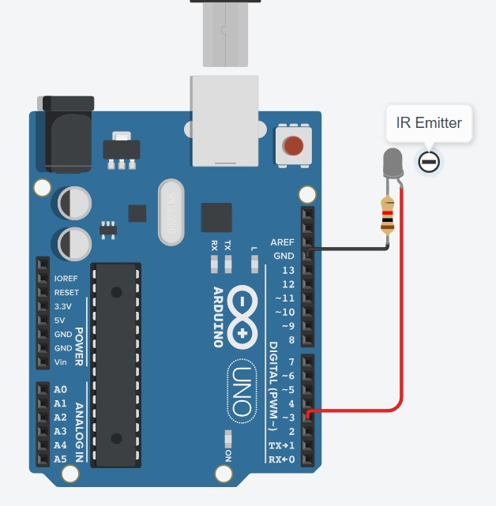

IR Emitting Circuit Diagram

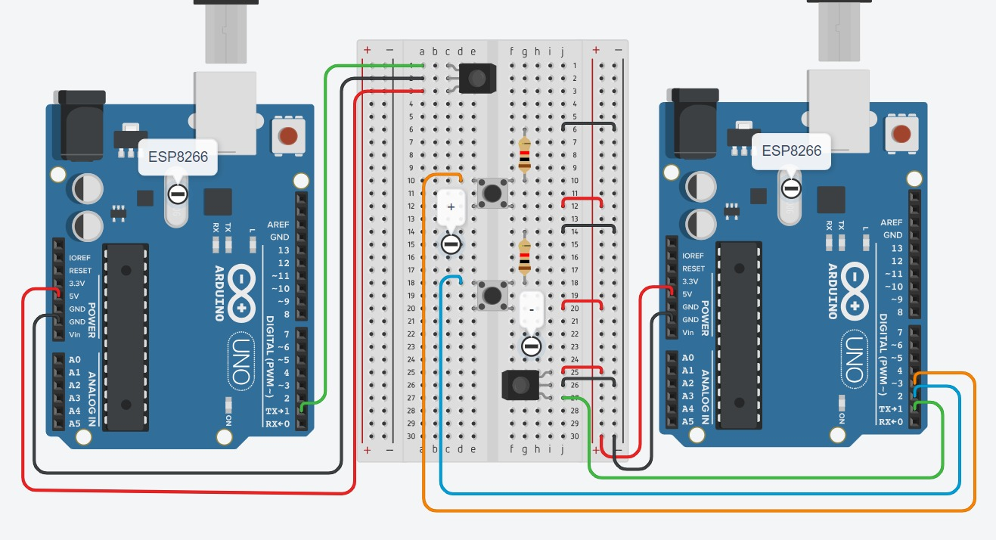

ESP IR Receiver Circuit

Hong Yu's final design:

* 1 Arduino
* 2 ESP8266 modules
* 2 IR Receivers
* 1 IR Emitter
* Jumper Wires
* 2 Buttons for manual adjustment
* Recycled remote control components

The key steps he took to implement this solution were:

1. **ESP8266 Setup**: Configured each ESP8266 module to interface with one IR receiver.
2. **Arduino Coordination**: Programmed the Arduino to communicate with both ESP8266 modules, collecting and processing the data from the IR receivers.
3. **Signal Processing**: Ensured the signals from the IR receivers were synchronized and correctly interpreted by the Arduino to maintain accurate direction tracking.

**More sustainable than today’s sensors**

We wanted to know whether the cost and energy efficiency of our solution was comparable to existing motion sensors. To estimate the costs, our team mate Rezky researched prices of both new and repurposed components. He found that traditional motion sensors cost around $114 per unit, whereas our upcycled IR sensors could be assembled for approximately $10 per unit.

For energy consumption, Rezky conducted detailed measurements. He first gathered data from product datasheets of standard motion sensors, which indicated a standby power consumption of approximately 3 Watts. Assuming the sensors are on standby 24/7, this equates to about 72 Wh/day. For our IR sensors, he measured the power draw using a multimeter while the sensors were active. The results showed that our IR sensors consumed around 0.5 Watts continuously, translating to about 12 Wh/day.

By reducing idle energy consumption, our project offers substantial financial savings and contributes to environmental sustainability.

### Conclusion 🚀

#### All good reports must come to an end

Our project repurposes IR sensors from TV remotes to replace conventional motion sensors, aiming for affordability and eco-friendliness. By detecting occupancy and optimising HVAC systems in homes and offices, we enhance energy efficiency. Our solution is cost-effective, with sensors costing $10 compared to $114 for traditional sensors, and significantly reduces energy consumption, offering substantial financial savings and promoting environmental sustainability.