Step 1: Organized work space.

Step 2: Familiarized oneself with sensor. Ie. Get datasheet from website Maxbotix 7384

<http://www.maxbotix.com/documents/HRXL-MaxSonar-WR_Datasheet.pdf>

i2c = 2 lines between sensor from master. Slaves talk only when master calls. Address assigned.

spi = 3 lines (on/off switch)

uart (TTL/RS232)

TTL – on/off

RS232 – positive on/ negative off

TTL sensor

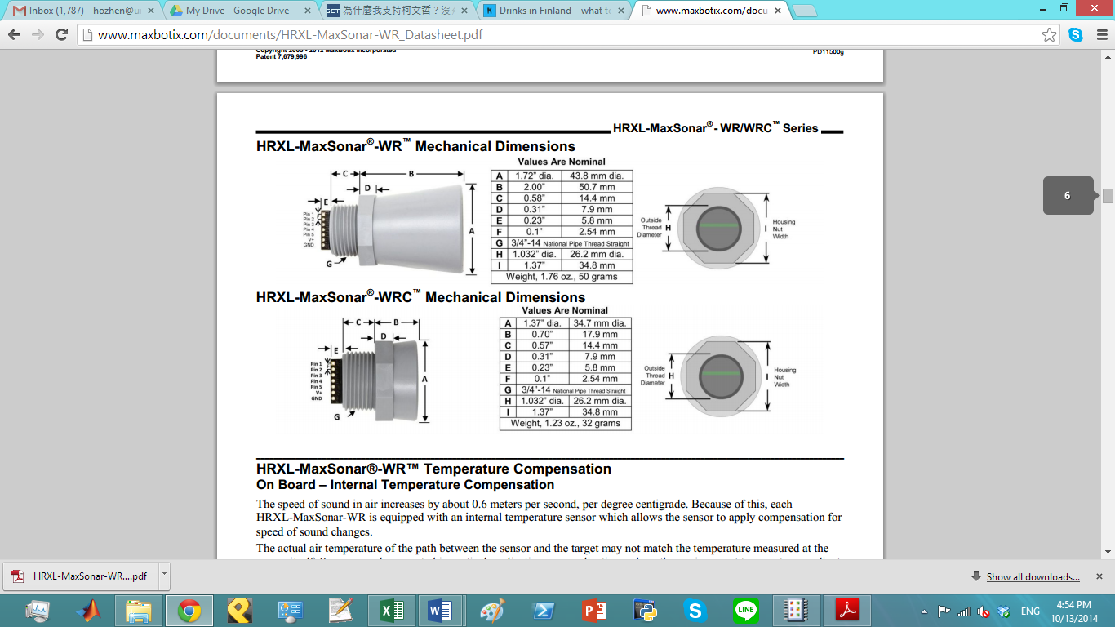

Even though we have PWM and analog outputs. We’ll use serial output (digital)

3 pin setup

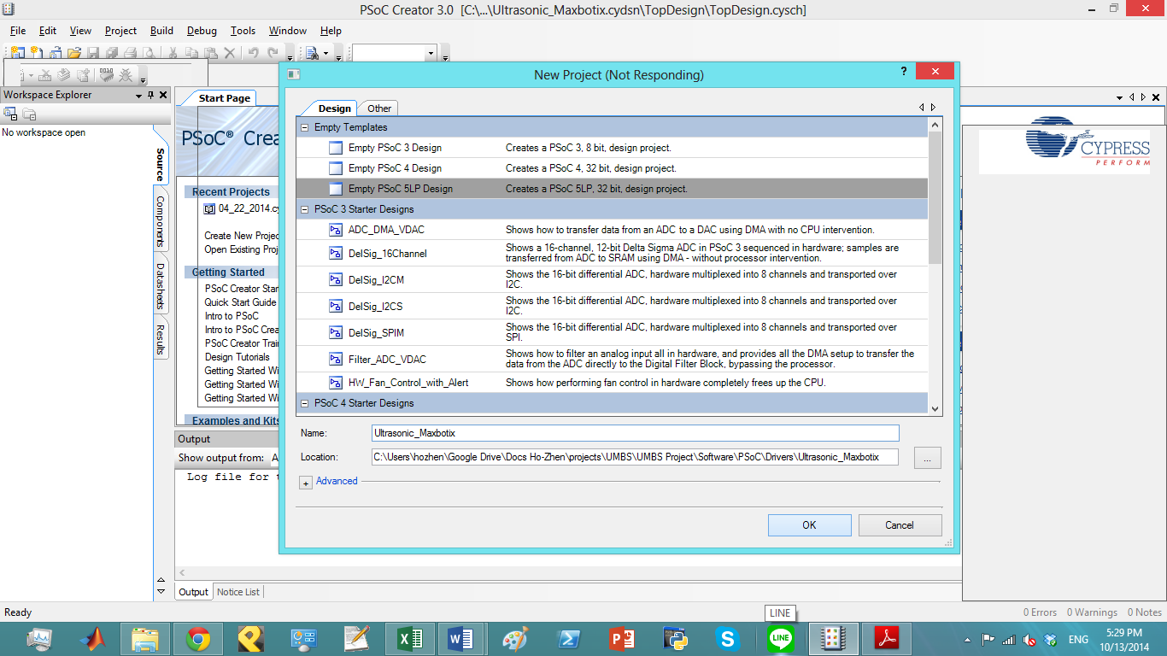

Pin 5-Serial Output: The MB736X sensors have an RS232 data format (with 0V to Vcc levels) and the MB738X sensors have a

TTL outputs. The output is an ASCII capital “R”, followed by four ASCII character digits representing the range in millimeters,

followed by a carriage return (ASCII 13). The maximum range reported is 4999 mm (5-meter models) or 9998 mm (10-meter

models). A range value of 5000 or 9999 corresponds to no target being detected in the field of view.

The serial data format is 9600 baud, 8 data bits, no parity, with one stop bit (9600-8-N-1).

Because the data is presented in a binary data format, the serial output is most accurate .

R 522/r

Create function Take_Maxbotix_Reading

Read fomr URAT get sensor reading.