**NAME-SHASHANK SHEKHAR PATHAK**

**ROLL-2022ITB030 (HX)**

**ASSIGNMENT-2**

**AND GATE:**

**TestBench Code:**

-- Testbench for AND gate

library IEEE;

use IEEE.std_logic_1164.all;

entity testbench is

-- empty

end testbench;

architecture tb of testbench is

-- DUT component

component and_gate is

port(

a: in std_logic;

b: in std_logic;

q: out std_logic);

end component;

signal a_in, b_in, q_out: std_logic;

begin

-- Connect DUT

DUT: and_gate port map(a_in, b_in, q_out);

process

begin

a_in <= '0';

b_in <= '0';

wait for 1 ns;

assert(q_out='0') report "Fail 0/0" severity error;

a_in <= '0';

b_in <= '1';

wait for 1 ns;

assert(q_out='0') report "Fail 0/1" severity error;

a_in <= '1';

b_in <= '0';

wait for 1 ns;

assert(q_out='0') report "Fail 1/X" severity error;

a_in <= '1';

b_in <= '1';

wait for 1 ns;

assert(q_out='1') report "Fail 1/1" severity error;

-- Clear inputs

a_in <= '0';

b_in <= '0';

assert false report "Test done." severity note;

wait;

end process;

end tb;

**Design Code:**

-- Simple AND gate design

library IEEE;

use IEEE.std_logic_1164.all;

entity and_gate is

port(

a: in std_logic;

b: in std_logic;

q: out std_logic);

end and_gate;

architecture behavioral of and_gate is

begin

process(a, b) is

begin

if a = '1' and b= '1' then q<='1';

     else q <= '0';

     end if;

end process;

end behavioral;

**OUTPUT:**

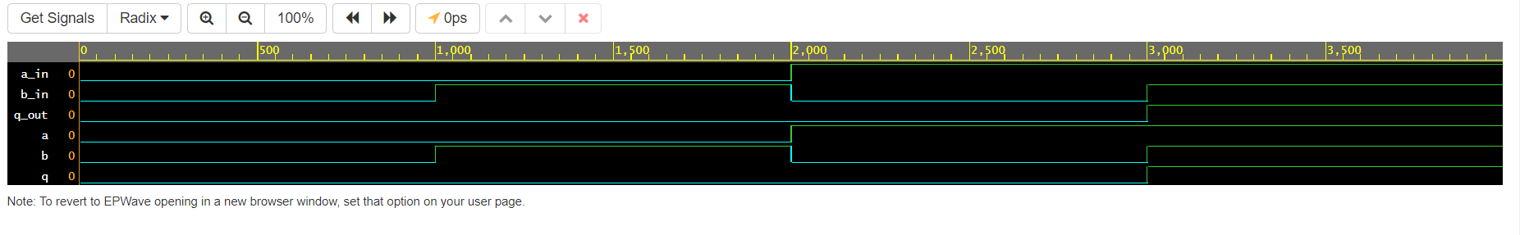

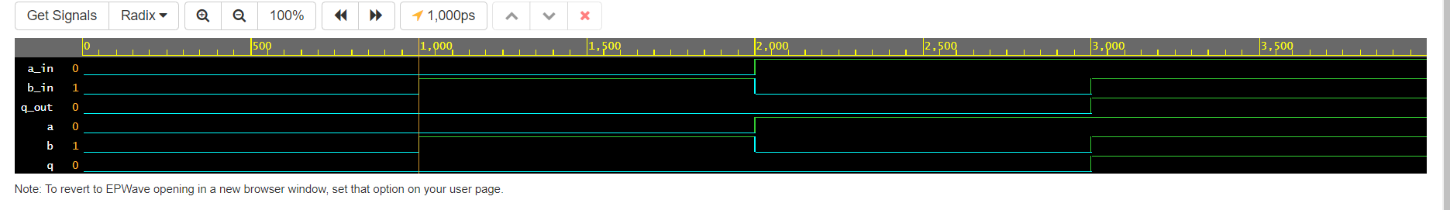

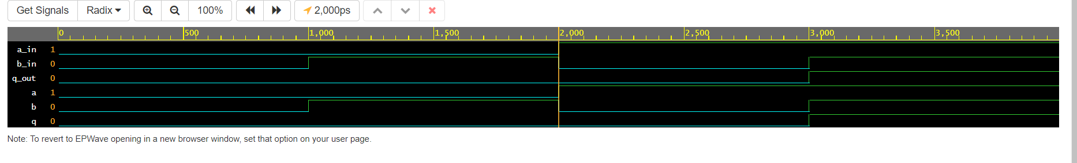

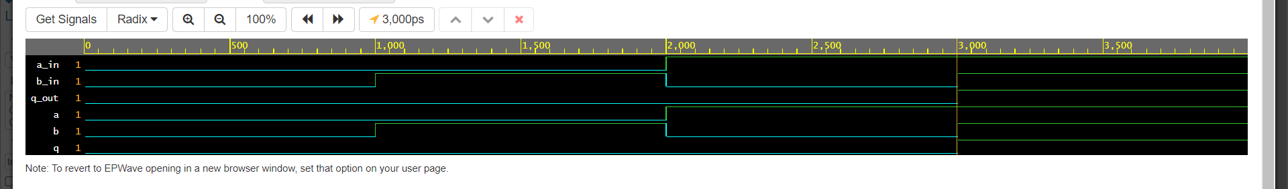

**OR GATE:**

**TestBench Code:**

-- Testbench for OR gate

library IEEE;

use IEEE.std_logic_1164.all;

entity testbench is

-- empty

end testbench;

architecture tb of testbench is

-- DUT component

component or_gate is

port(

a: in std_logic;

b: in std_logic;

q: out std_logic);

end component;

signal a_in, b_in, q_out: std_logic;

begin

-- Connect DUT

DUT: or_gate port map(a_in, b_in, q_out);

process

begin

a_in <= '0';

b_in <= '0';

wait for 1 ns;

assert(q_out='0') report "Fail 0/0" severity error;

a_in <= '0';

b_in <= '1';

wait for 1 ns;

assert(q_out='1') report "Fail 0/1" severity error;

a_in <= '1';

b_in <= '0';

wait for 1 ns;

assert(q_out='1') report "Fail 1/X" severity error;

a_in <= '1';

b_in <= '1';

wait for 1 ns;

assert(q_out='1') report "Fail 1/1" severity error;

-- Clear inputs

a_in <= '0';

b_in <= '0';

assert false report "Test done." severity note;

wait;

end process;

end tb;

**Design Code:**

-- Simple OR gate design

library IEEE;

use IEEE.std_logic_1164.all;

entity or_gate is

port(

a: in std_logic;

b: in std_logic;

q: out std_logic);

end or_gate;

architecture behavioral of or_gate is

begin

process(a, b) is

begin

if a = '0' and b= '0' then q<='0';

    else q <= '1';

    end if;

end process;

end behavioral;

**OUTPUT:**

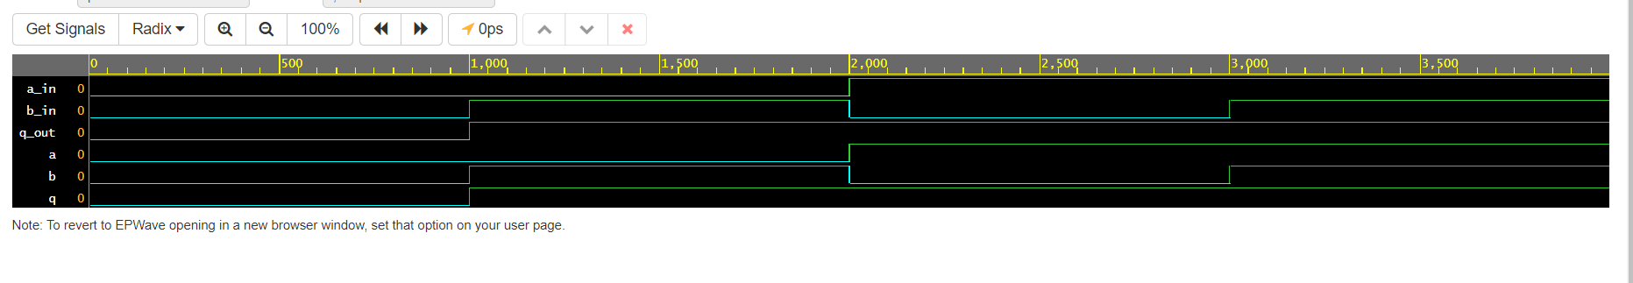

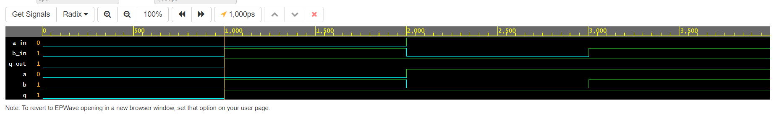

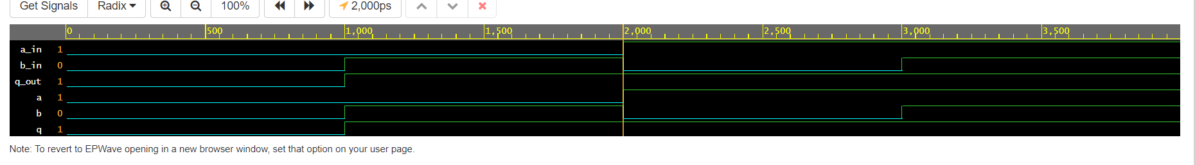

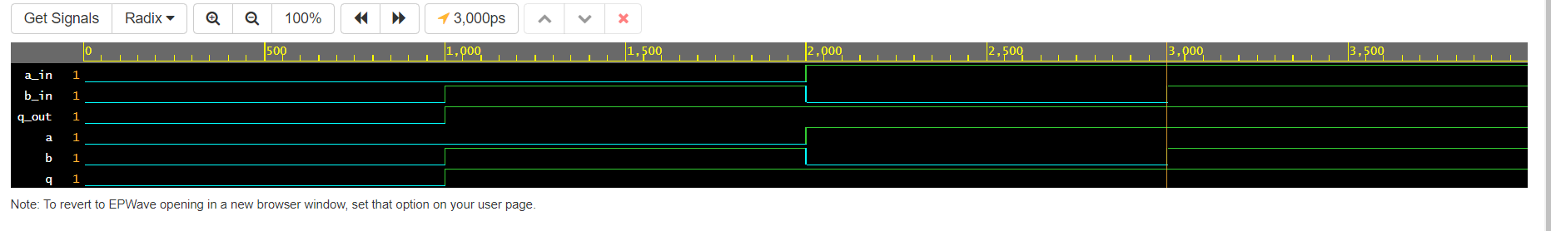

**NOT GATE:**

**Testbench Code:**

-- Testbench for NOT gate

library IEEE;

use IEEE.std_logic_1164.all;

entity NOTGate is

-- empty

end NOTGate;

architecture tb of NOTGate is

-- DUT component

component not_gate is

port(

a: in std_logic;

q: out std_logic);

end component;

signal a_in, q_out: std_logic;

begin

-- Connect DUT

DUT: not_gate port map(a_in, q_out);

process

begin

a_in <= '0';

wait for 1 ns;

assert(q_out='1') report "Fail 0" severity error;

a_in <= '1';

wait for 1 ns;

assert(q_out='0') report "Fail 1" severity error;

-- Clear inputs

a_in <= '0';

assert false report "Test done." severity note;

wait;

end process;

end tb;

**Design Code:**

--NOT gate design

library IEEE;

use IEEE.std_logic_1164.all;

entity not_gate is

port(

a: in std_logic;

q: out std_logic);

end not_gate;

architecture behaviour of not_gate is

begin

process(a) is

begin

if a = '0' then q<='1';

    else q <= '0';

    end if;

end process;

end behaviour;

**OUTPUT:**

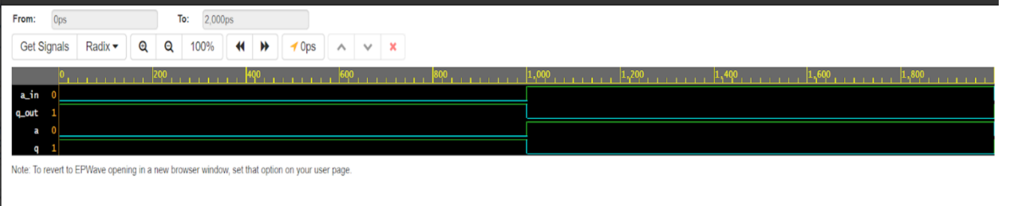

**NAND GATE:**

**Testbench Code:**

-- Testbench for NAND gate

library IEEE;

use IEEE.std_logic_1164.all;

entity testbench is

-- empty

end testbench;

architecture tb of testbench is

-- DUT component

component nand_gate is

port(

a: in std_logic;

b: in std_logic;

q: out std_logic);

end component;

signal a_in, b_in, q_out: std_logic;

begin

-- Connect DUT

DUT: nand_gate port map(a_in, b_in, q_out);

process

begin

a_in <= '0';

b_in <= '0';

wait for 1 ns;

assert(q_out='1') report "Fail 0/0" severity error;

a_in <= '0';

b_in <= '1';

wait for 1 ns;

assert(q_out='1') report "Fail 0/1" severity error;

a_in <= '1';

b_in <= '0';

wait for 1 ns;

assert(q_out='1') report "Fail 1/X" severity error;

a_in <= '1';

b_in <= '1';

wait for 1 ns;

assert(q_out='0') report "Fail 1/1" severity error;

-- Clear inputs

a_in <= '0';

b_in <= '0';

assert false report "Test done." severity note;

wait;

end process;

end tb;

**Design Code:**

-- Simple NAND gate design

library IEEE;

use IEEE.std_logic_1164.all;

entity nand_gate is

port(

a: in std_logic;

b: in std_logic;

q: out std_logic);

end nand_gate;

architecture behavioral of nand_gate is

begin

process(a, b) is

begin

if a = '1' and b= '1' then q<='0';

     else q <= '1';

     end if;

end process;

end behavioral;

**OUTPUT:**

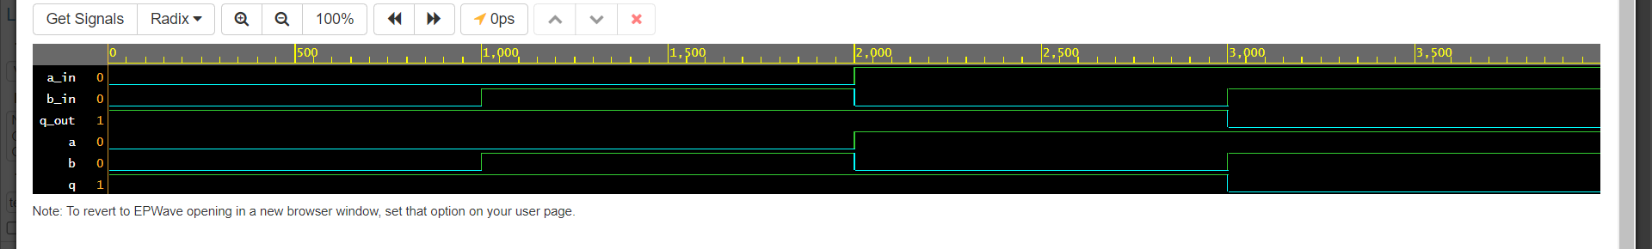

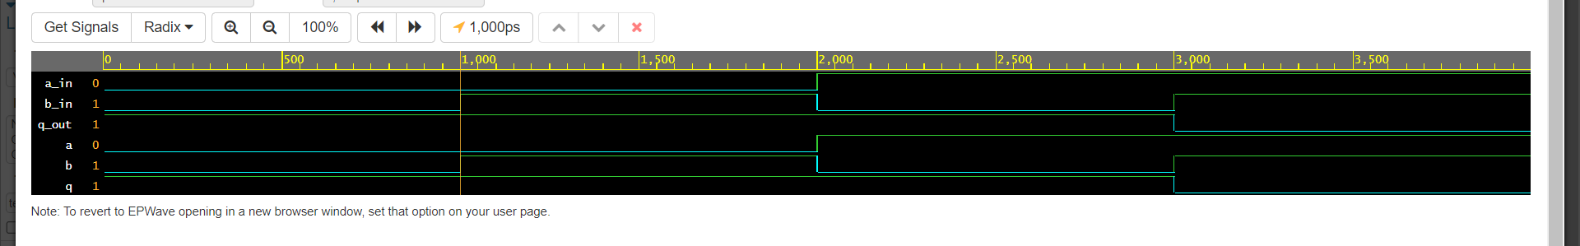

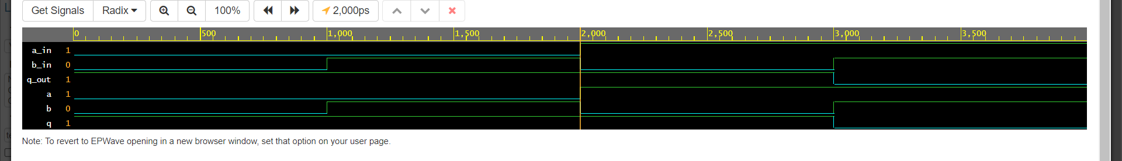

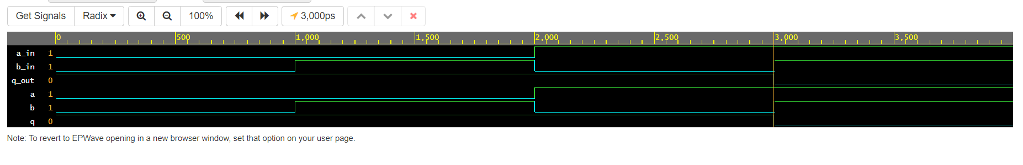

**NOR GATE:**

**Testbench Code:**

-- Testbench for NOR gate

library IEEE;

use IEEE.std_logic_1164.all;

entity testbench is

-- empty

end testbench;

architecture tb of testbench is

-- DUT component

component nor_gate is

port(

a: in std_logic;

b: in std_logic;

q: out std_logic);

end component;

signal a_in, b_in, q_out: std_logic;

begin

-- Connect DUT

DUT: nor_gate port map(a_in, b_in, q_out);

process

begin

a_in <= '0';

b_in <= '0';

wait for 1 ns;

assert(q_out='1') report "Fail 0/0" severity error;

a_in <= '0';

b_in <= '1';

wait for 1 ns;

assert(q_out='0') report "Fail 0/1" severity error;

a_in <= '1';

b_in <= '0';

wait for 1 ns;

assert(q_out='0') report "Fail 1/X" severity error;

a_in <= '1';

b_in <= '1';

wait for 1 ns;

assert(q_out='0') report "Fail 1/1" severity error;

-- Clear inputs

a_in <= '0';

b_in <= '0';

assert false report "Test done." severity note;

wait;

end process;

end tb;

**Design Code:**

-- Simple NOR gate design

library IEEE;

use IEEE.std_logic_1164.all;

entity nor_gate is

port(

a: in std_logic;

b: in std_logic;

q: out std_logic);

end nor_gate;

architecture behavioral of nor_gate is

begin

process(a, b) is

begin

if a = '0' and b= '0' then q<='1';

     else q <= '0';

     end if;

end process;

end behavioral;

**OUTPUT:**

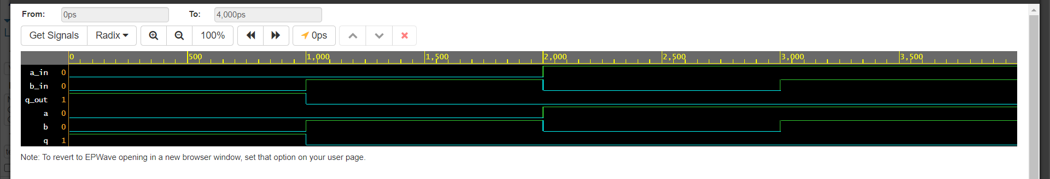

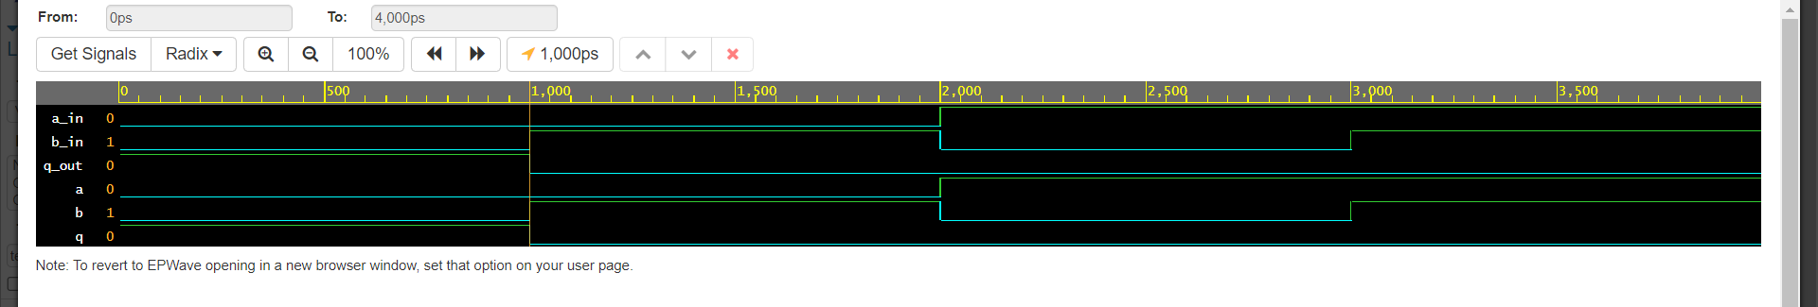

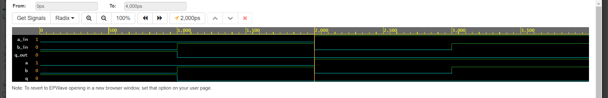

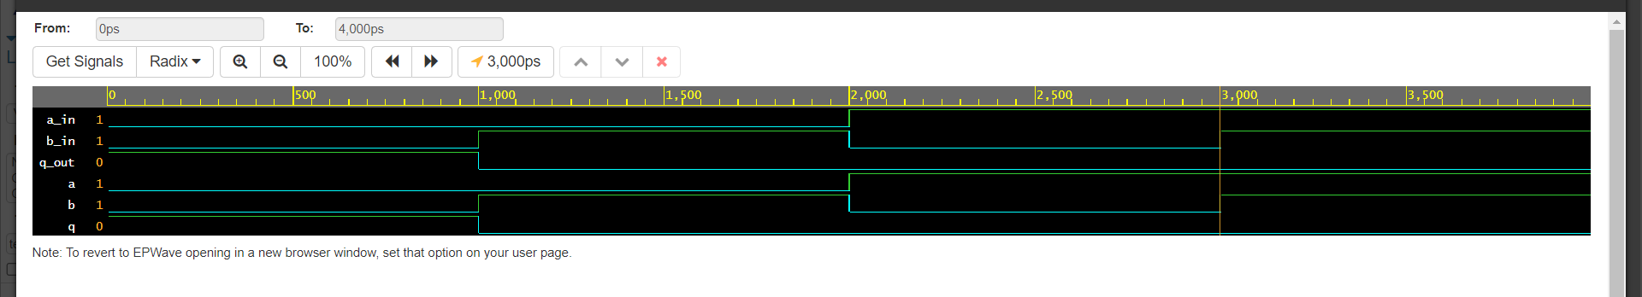

**XOR GATE:**

**Testbench Code:**

-- Testbench for XOR gate

library IEEE;

use IEEE.std_logic_1164.all;

entity testbench is

-- empty

end testbench;

architecture tb of testbench is

-- DUT component

component xor_gate is

port(

a: in std_logic;

b: in std_logic;

q: out std_logic);

end component;

signal a_in, b_in, q_out: std_logic;

begin

-- Connect DUT

DUT: xor_gate port map(a_in, b_in, q_out);

process

begin

a_in <= '0';

b_in <= '0';

wait for 1 ns;

assert(q_out='0') report "Fail 0/0" severity error;

a_in <= '0';

b_in <= '1';

wait for 1 ns;

assert(q_out='1') report "Fail 0/1" severity error;

a_in <= '1';

b_in <= '0';

wait for 1 ns;

assert(q_out='1') report "Fail 1/X" severity error;

a_in <= '1';

b_in <= '1';

wait for 1 ns;

assert(q_out='0') report "Fail 1/1" severity error;

-- Clear inputs

a_in <= '0';

b_in <= '0';

assert false report "Test done." severity note;

wait;

end process;

end tb;

**Design Code:**

-- Simple XOR gate design

library IEEE;

use IEEE.std_logic_1164.all;

entity xor_gate is

port(

a: in std_logic;

b: in std_logic;

q: out std_logic);

end xor_gate;

architecture behavioral of xor_gate is

begin

process(a, b) is

begin

if a = b then q<= '1';

    else q <='0';

    end if;

end process;

end behavioral;

**OUTPUT:**

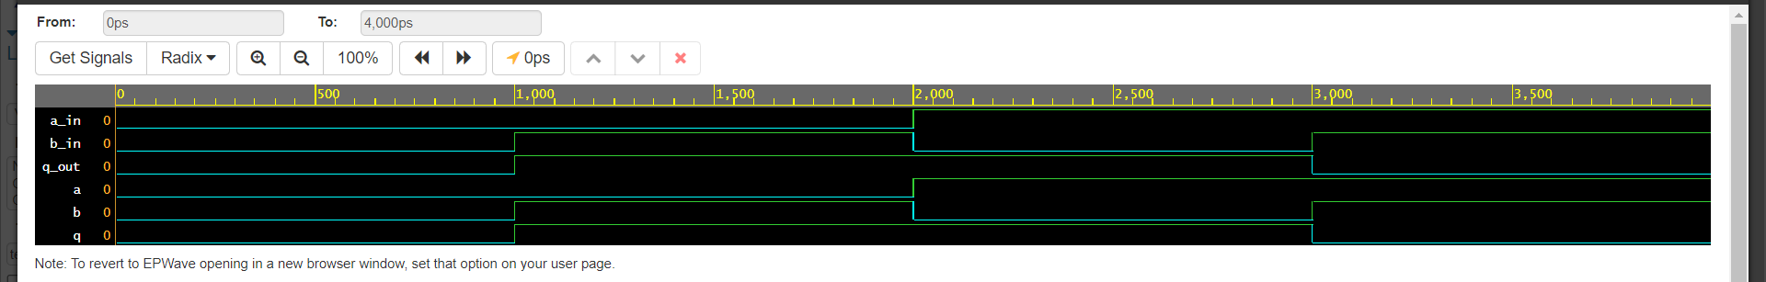

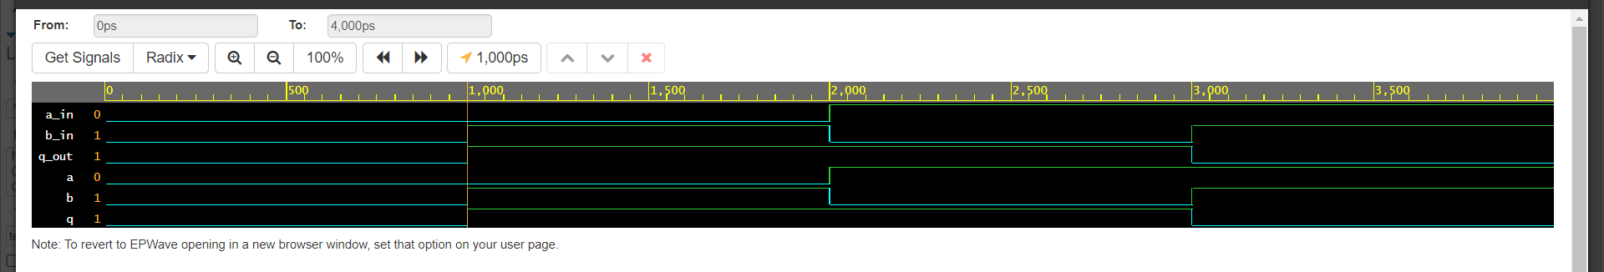

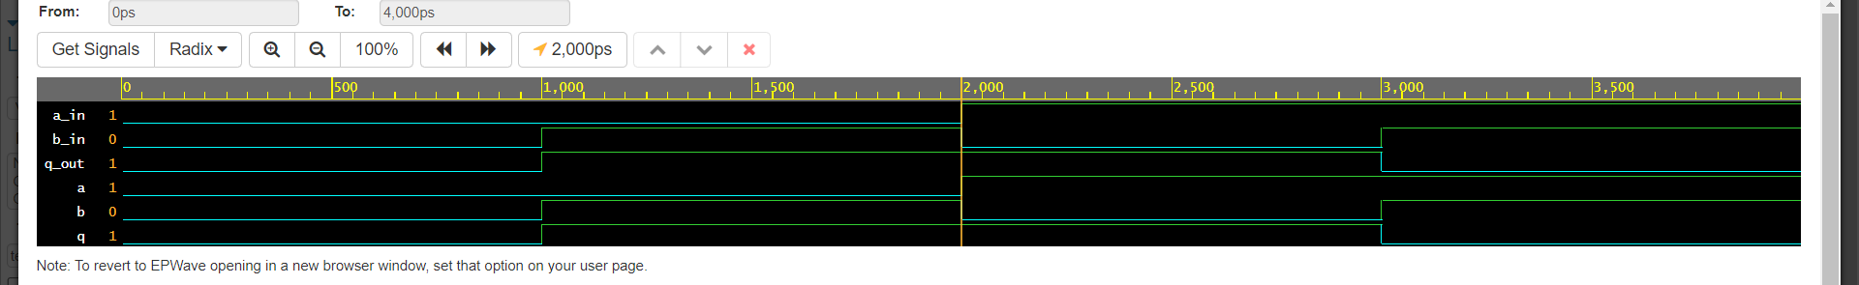

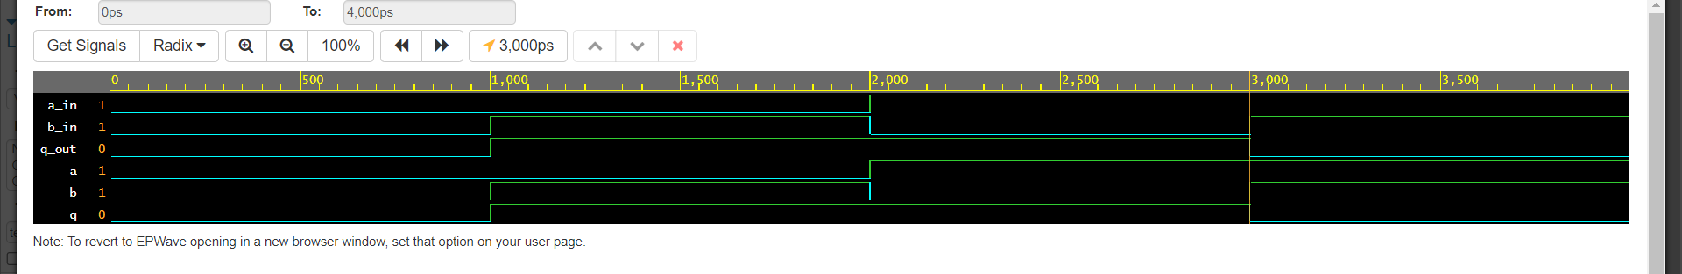

**XNOR GATE:**

**Testbench Code:**

-- Testbench for XNOR gate

library IEEE;

use IEEE.std_logic_1164.all;

entity testbench is

-- empty

end testbench;

architecture tb of testbench is

-- DUT component

component xnor_gate is

port(

a: in std_logic;

b: in std_logic;

q: out std_logic);

end component;

signal a_in, b_in, q_out: std_logic;

begin

-- Connect DUT

DUT: xnor_gate port map(a_in, b_in, q_out);

process

begin

a_in <= '0';

b_in <= '0';

wait for 1 ns;

assert(q_out='1') report "Fail 0/0" severity error;

a_in <= '0';

b_in <= '1';

wait for 1 ns;

assert(q_out='0') report "Fail 0/1" severity error;

a_in <= '1';

b_in <= '0';

wait for 1 ns;

assert(q_out='0') report "Fail 1/X" severity error;

a_in <= '1';

b_in <= '1';

wait for 1 ns;

assert(q_out='1') report "Fail 1/1" severity error;

-- Clear inputs

a_in <= '0';

b_in <= '0';

assert false report "Test done." severity note;

wait;

end process;

end tb;

**Design Code:**

-- Simple XOR gate design

library IEEE;

use IEEE.std_logic_1164.all;

entity xnor_gate is

port(

a: in std_logic;

b: in std_logic;

q: out std_logic);

end xnor_gate;

architecture behavioral of xnor_gate is

begin

process(a, b) is

begin

if a = b then q<= '1';

    else q <='0';

    end if;

end process;

end behavioral;

**OUTPUT:**

