Automated cocoa garden robot and real-time cocoa disease analysis with CNN
Supphakon Yimi¹, Jirapong Thawonkaew¹
Advisors: Thapanawat Chooklin¹, Kutsalin Thipmanosing¹

¹Princess Chulabhorn Science High School Nakhon Si Thammarat, 120 Village No.1, Sunanan Road, Bangchak Subistrict, Mueang Nakhon Si Thammarat District, Nakhon Si Thammarat 80000, Thailand
*E-mail: t.lookmee@pccnst.ac.th

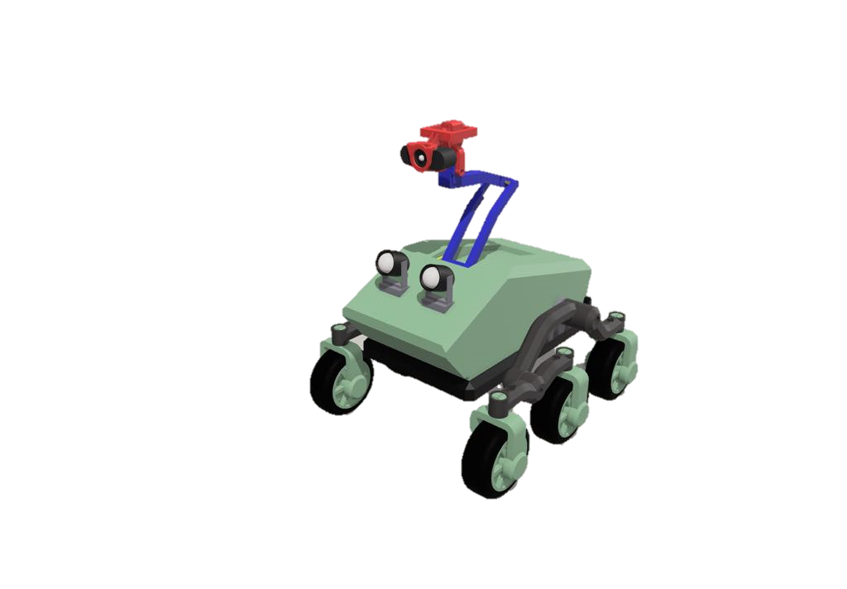

At the present, agriculture is an important part of human life because it is the main food producer for the people. Cocoa, as a future Thai economic plant, will play an important role in strengthening the future economy of Thailand. However, due to climate change, both the rainy season with a large amount of rainfall and the hot season that has to face a more severe drought than usual. The more abundant rainfall has created a large number of swamps in the farm, leading to the spread of cocoa diseases such as black pod disease, swollen shoot virus. As a result, farmers encounter obstacles in farming due to the spread of cocoa diseases. If not prevented or carefully cared for, it may spread to other plants, resulting in damage to agricultural products, poor quality products, and leading to massive loss of income for farmers. Thus, the creators have developed an automatic cocoa garden care robot and checked for plant diseases using Convolutional Neural Network by using a camera to capture images of cocoa trees and then send them to the processing unit to analyse abnormalities of the cocoa tree so that farmers can be informed and prevent the spread effectively. The robot can move automatically along the path specified by the farmer, covering the plants in the farm. The developed robot will help farmers take care of their plants efficiently, resulting in quality agricultural products, saving both time and labour. Including creating sustainable income for farmers.

Keywords: Climate Change, Cocoa Disease, Convolutional Neural Network, Automatic Robot

