Automated cocoa garden robot and real-time cocoa disease analysis with CNN
Supphakon Yimi¹, Jirapong Thawonkaew¹
Advisors: Thapanawat Chooklin¹, Kutsalin Thipmanosing¹

¹Princess Chulabhorn Science High School Nakhon Si Thammarat, 120 Village No.1, Sunanan Road, Bangchak Subistrict, Mueang Nakhon Si Thammarat District, Nakhon Si Thammarat 80000, Thailand
*E-mail: t.lookmee@pccnst.ac.th

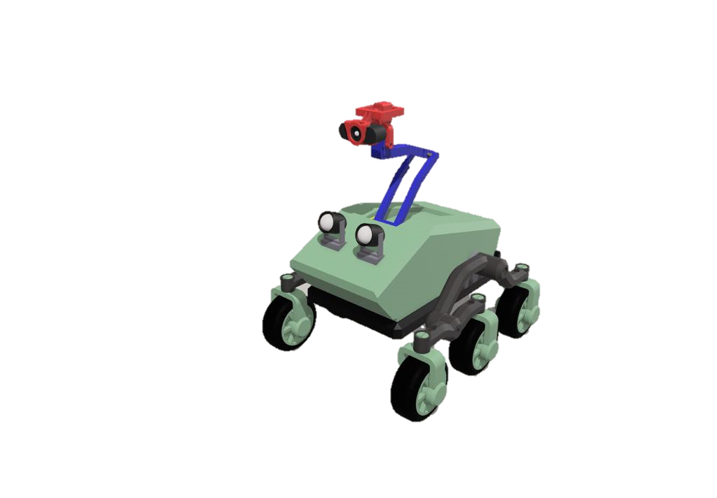

At the present, agriculture is an important part of human life because it is the main food producer for the people. Cocoa, as a future Thai economic plant, will play an important role in strengthening the future economy of Thailand. However, due to climate change, both the rainy season with a large amount of rainfall and the hot season that has to face a more severe drought than usual. The more abundant rainfall has created a large number of swamps in the farm, leading to the spread of cocoa diseases such as black pod disease, swollen shoot virus. As a result, farmers encounter obstacles in farming due to the spread of cocoa diseases. If not prevented or carefully cared for, it may spread to other plants, resulting in damage to agricultural products, poor quality products, and leading to massive loss of income for farmers. Thus, the creators have developed an automatic cocoa garden care robot and checked for plant diseases using Convolutional Neural Network by using a camera to capture images of cocoa trees and then send them to the processing unit to analyse abnormalities of the cocoa tree so that farmers can be informed and prevent the spread effectively. The robot can move automatically along the path specified by the farmer, covering the plants in the farm. The developed robot will help farmers take care of their plants efficiently, resulting in quality agricultural products, saving both time and labour. Including creating sustainable income for farmers.

Keywords: Climate Change, Cocoa Disease, Convolutional Neural Network, Automatic Robot

1. Introduction
At present, agriculture is an important part of human life because it is the main food producer for the people. Cocoa, the Thai future cash crops, will play an important role in strengthening the future economy of Thailand. In 2023, 80% of cocoa production will be sold domestically and 20% will be exported to neighboring countries, which is expected to generate sustainable income in the future. However, due to the problem of abnormal weather changes or Climate Change that affects the environment in various ways, causing both the rainy season to have a large amount of rainfall, including the hot season that causes more severe drought than usual. The more abundant rainfall than usual has created a large number of swamps in the plantation, leading to the spread of cocoa plant diseases such as black pod disease and swollen shoot virus, causing farmers to encounter the obstacles. If not prevented or taken care of carefully, it may spread to other plants, resulting in damage to agricultural products, poor quality products, leading to a large loss of income for farmers. Therefore, the developer has developed an automatic cocoa plantation care robot and analyzed plant diseases in cocoa to let farmers know and prevent the spread effectively

2. Framework
This project is an automated cocoa garden robot in Mars rover’s model, named “Acoabot”. Used to detect cocoa diseases automatically while moving around in garden by AI and videos from webcam, installed with the robot. Gardener can inspect information, including robot’s location, number of infected plants, and robot’s view via web application.
The dataset of cocoa diseases used for the processing and analysis of AI is limited and coverless all types of disease, thus making the detection inaccurate for classifying type of disease, especially when light is not appropriate. However, the project aims to help gardeners for detecting cocoa disease as soon as possible and notice them to eliminate infected cocoa yield. As a result, the robot can reduce damage and gardener’s labor from disease outbreak

3. Finding and Discussion
1. Research cocoa in Nakhon Si Thammarat and the content related to robot development, including programming AI detection, algorithm CNN-Object detection (YoloV8), web application development, microcontrollers, sensors, and robot manufacture
2. Search cocoa disease dataset for training AI model, which is COCOA DISEASE DETECTION Computer Vision Project from Roboflow
3. Train AI model
4. Plan and design workflow of the project
4.1 Plan and design workflow of the robot operation
4.2 Plan and design workflow of the robot manufacture
5. Assembly the robot
6. Develop web application, communicating to the robot’s components
7. Test the performance of the robot
7.1 Test the performance of the robot operation
7.2 Test the performance of AI detection
8. Fix the error and complete the project

Materials
Hardware
Structure parts
- ABS, PLA, and PET-G
- 6 Tires
- Nuts and bolts
Electronic parts
- 6 DC motors with Encoders (12 Volt)
- 6 servo motors (movement)
- Raspberry Pi 4
- Arduino MEGA 2560
- 3 motor controllers
- 12 Volt 7200 mAh Battery
- 2 spotlights
- 4 servo motors (stabilizer)
- 1 Webcam
Software
- Visual studio code program
- Python
- YoloV8
- Flask HTML, CSS, JavaScript
- Sharp 3D
Figure 1 Diagram of robot’s system

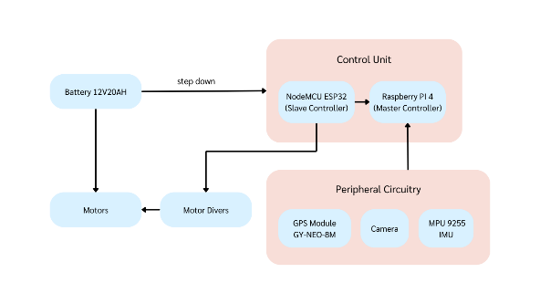

Figure 2 Diagram of autonomous movement system.

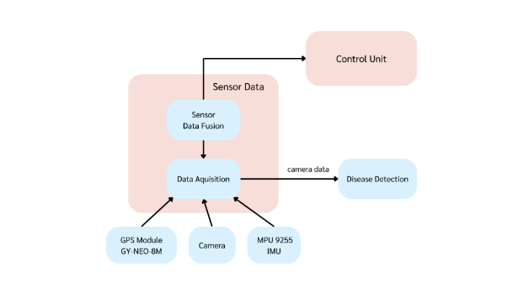

Figure 3 Confusion matrix

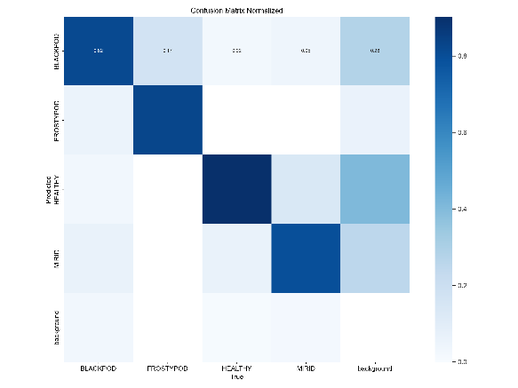

Figure 4 Use case of AI detection

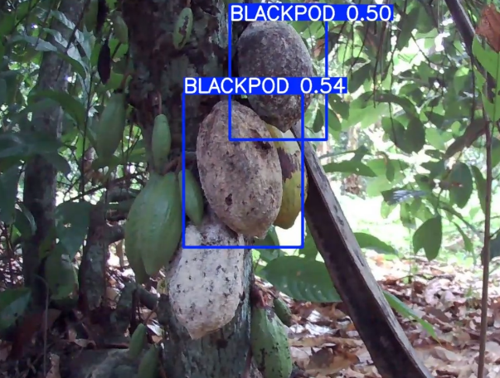

Figure 5 Acoabot

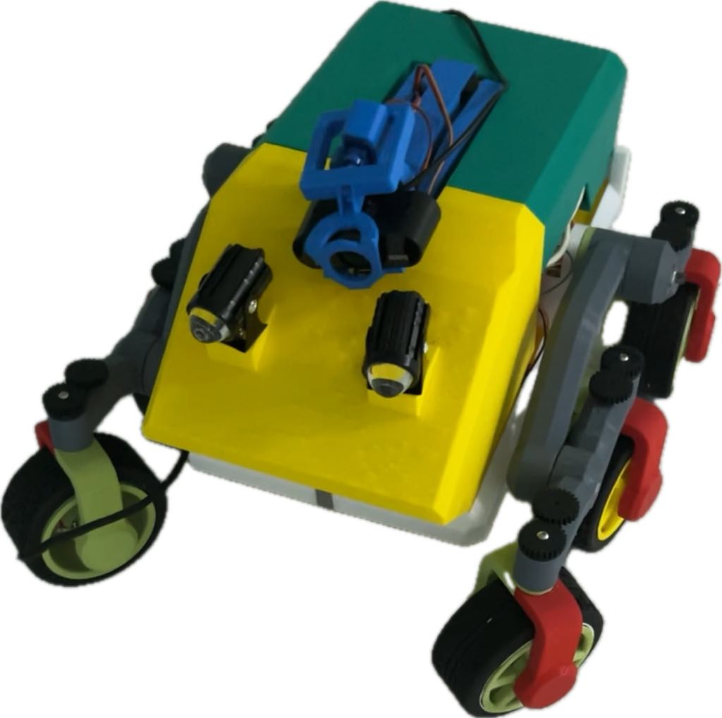

4. Conclusion
In developing the automatic cocoa plantation care robot and checking plant diseases in cocoa in real time with CNN, the main objective is to help farmers reduce damage to cocoa production from plant disease problems. In addition, it also focuses on collecting important data for analysis and more systematic management of cocoa plantations. From the development, it was found that farmers can be aware of the status of plant diseases and take preventive or treatment actions quickly and efficiently. Working in real time, the robot can detect and report the status of plant diseases and the environment in the cocoa plantation. The data can be sent through the server, allowing farmers to know the information and various statuses of the robot in the cocoa plantation, which helps farmers adjust the management of the cocoa plantation to suit the environment and needs.

5. Acknowledgement
This project was able to be successfully completed due to the kindness and support from Mr. Thapanawat Chooklinand, Ms. Kutsalin Thipmanosing, and particularly Princess Chulabhorn Science High School Nakhon Si Thammarat who kindly gave advices and suggestions on contributing equipments and improving various defects of the report book until this research was successfully completed.

6. References
Davinder Singh, Naman Jain, Pranjali Jain, Pratik
Kayal, Sudhakar Kumawat, and Nipun Batra. 2020. PlantDoc: A Dataset for Visual Plant Disease Detection. In Proceedings of the 7th ACM IKDD CoDS and 25th COMAD (CoDS COMAD 2020). Association for Computing Machinery, New York, NY, USA, 249–253. https://doi.org/10.1145/3371158.3371196 [accessed 6 Jan, 2024]
Miss Nyarko, COCOA DISEASE DETECTION Dataset
.Roboflow , 2023. [Online]. Available: https://universe.roboflow.com/miss-nyarko-s2gtm/cocoa-disease-detection [accessed 6 Jan, 2024]
Deep Neural Networks and Kernel Density
Estimation for Detecting Human Activity Patterns from Geo-Tagged Images: A Case Study of Birdwatching on Flickr - Scientific Figure on ResearchGate. Available from: https://www.researchgate.net/figure/YOLO-network-architecture-adapted-from44_fig1_330484322 [accessed 6 Jan, 2024]
W. Lv et al., DETRs Beat YOLOs on Real-time Object Detection. 2023.
Jocher, G., Chaurasia, A., & Qiu, J. (2023).
Ultralytics YOLO [Computer software]. https://github.com/ultralytics/ultralytics [accessed 2 Jan, 2024]

