Execute this in the below order from root folder of project

- Git pull or clone
https://github.com/prasannac-ai/bootcamp_mar_2026.git
- Rename .env.example to .env
- docker compose -f docker-compose_v2.yml up --build

Note: you will see following services.
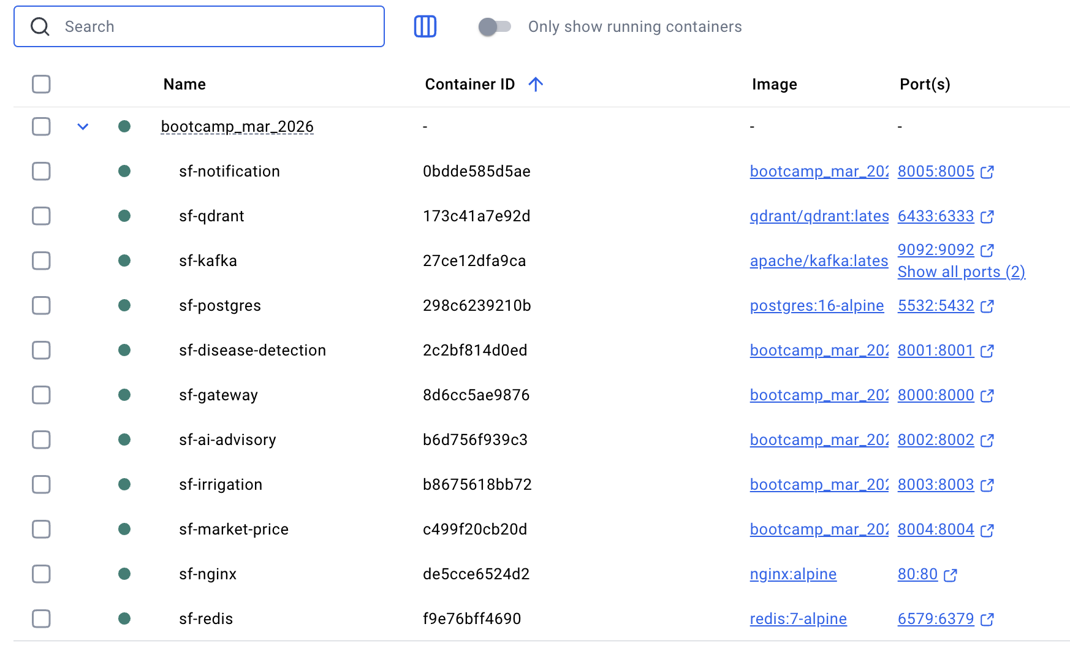

- docker exec -it sf-gateway alembic upgrade head
Note : for this, should see some thing like
Running upgrade -> 397c5cfce421, initial schema

- http://localhost/docs or http://localhost:8000/docs
You should see swagger ui.

https://9b04-2409-40f2-3119-3aeb-397c-f96-63bf-7823.ngrok-free.app

# OPENAI_API_KEY=
# OPENAI_BASE_URL=https://generativelanguage.googleapis.com/v1beta/openai
# OPENAI_MODEL=gemini-2.5-flash

SMTP_HOST=smtp.gmail.com
SMTP_PORT=587
SMTP_USER=you mail id
SMTP_PASSWORD=
SMTP_FROM_EMAIL=your mail id

