ASSIGNMENT – 4
TASK 1 : Create Snowflake Objects
I ) Create Warehouse
CREATE OR REPLACE WAREHOUSE HEALTHCARE_WH
WITH
WAREHOUSE_SIZE = 'XSMALL'
AUTO_SUSPEND = 60
AUTO_RESUME = TRUE;
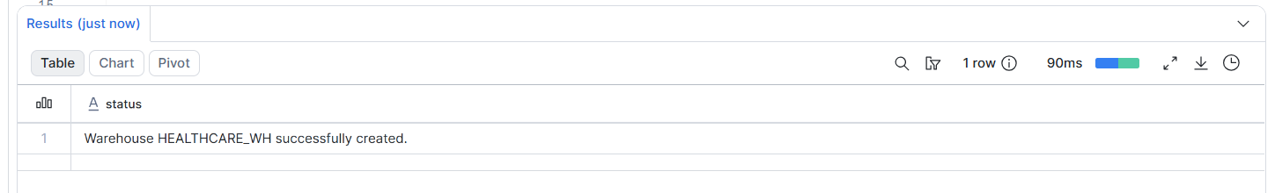
II ) Create Database
CREATE OR REPLACE DATABASE HEALTHCARE_DB;
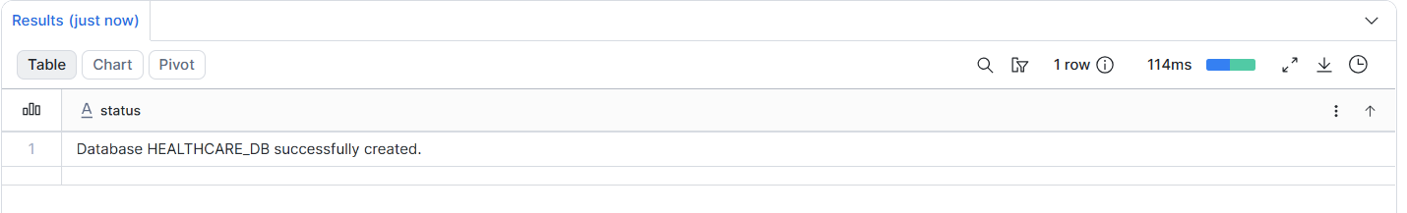

III )Create Schema
CREATE OR REPLACE SCHEMA HEALTHCARE_DB.APPOINTMENT_SCHEMA;
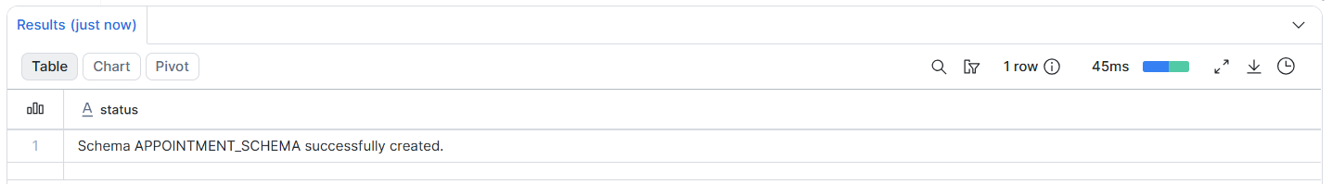

IV ) CREATING FILE FORMAT :
CREATE OR REPLACE FILE FORMAT CSV_FORMAT
TYPE = CSV
SKIP_HEADER = 1
FIELD_OPTIONALLY_ENCLOSED_BY = '"';
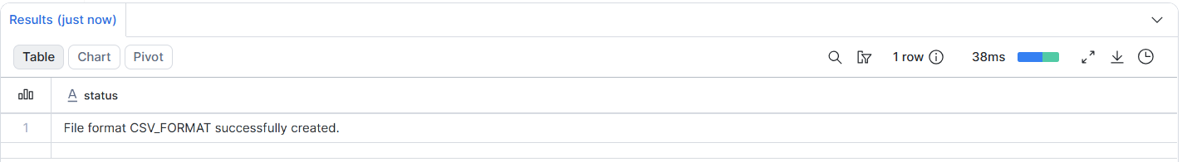
V ) Create Internal Stage
CREATE OR REPLACE STAGE APPOINTMENT_STAGE
FILE_FORMAT = CSV_FORMAT;
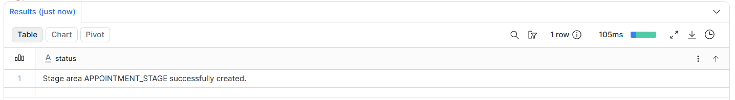

TASK – 2 : Scale Warehouse Up and Down
I ) Scale it up to SMALL
ALTER WAREHOUSE HEALTHCARE_WH
SET WAREHOUSE_SIZE = 'SMALL';
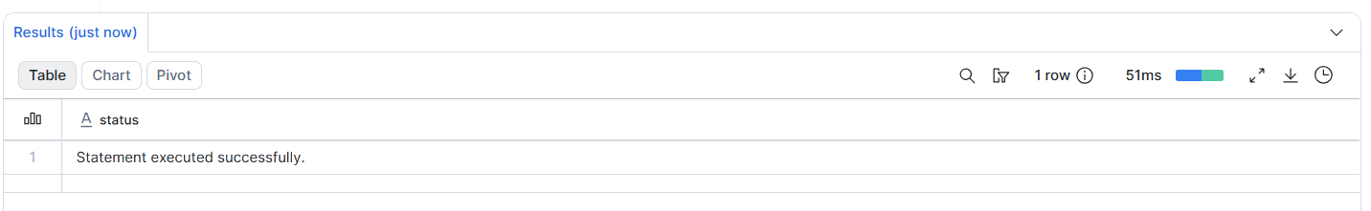

II ) Scale it down again to XSMALL
ALTER WAREHOUSE HEALTHCARE_WH
SET WAREHOUSE_SIZE = 'XSMALL';
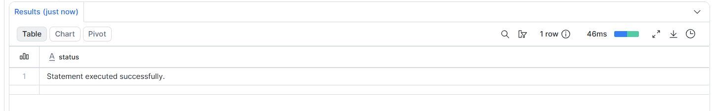

III ) Suspend the warehouse manually
ALTER WAREHOUSE HEALTHCARE_WH SUSPEND;
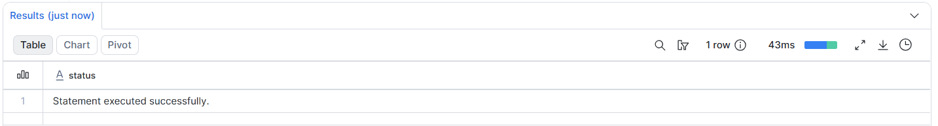

IV ) Resume the warehouse manually


TASK – 3 : Download Dataset from Open URL
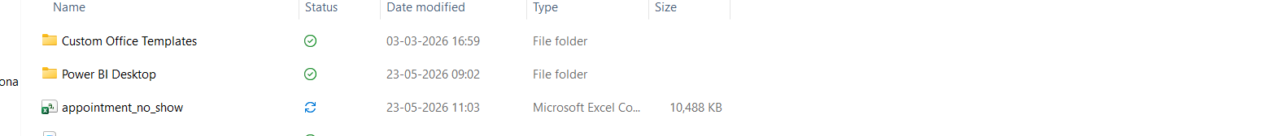

TASK – 4 : Upload CSV into Snowflake Stage
LIST @APPOINTMENT_STAGE;
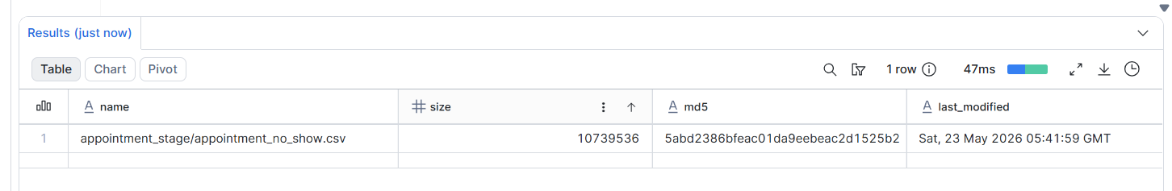

TASK – 5 : Create Raw Table
CREATE OR REPLACE TABLE APPOINTMENT_RAW (
PATIENTID NUMBER,
APPOINTMENTID NUMBER,
GENDER STRING,
SCHEDULEDDAY STRING,
APPOINTMENTDAY STRING,
AGE NUMBER,
NEIGHBOURHOOD STRING,
SCHOLARSHIP NUMBER,
HIPERTENSION NUMBER,
DIABETES NUMBER,
ALCOHOLISM NUMBER,
HANDCAP NUMBER,
SMS_RECEIVED NUMBER,
NO_SHOW STRING
);
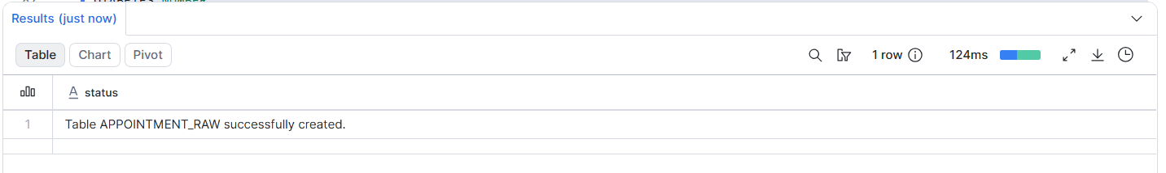

TASK - 6
Ii ) loading the data from stage to table
COPY INTO APPOINTMENT_RAW
FROM @APPOINTMENT_STAGE/appointment_no_show.csv
FILE_FORMAT = (
TYPE = CSV
SKIP_HEADER = 1
FIELD_OPTIONALLY_ENCLOSED_BY = '"'
)
ON_ERROR = 'CONTINUE';
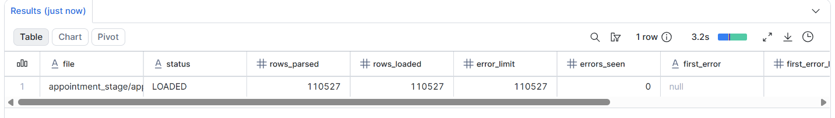

Task – 7 : Create Final Table
CREATE OR REPLACE TABLE APPOINTMENT_FINAL (
PATIENT_ID NUMBER,
APPOINTMENT_ID NUMBER,
GENDER STRING,
AGE NUMBER,
AGE_GROUP STRING,
SCHEDULED_DATE TIMESTAMP,
APPOINTMENT_DATE DATE,
WAITING_DAYS NUMBER,
NEIGHBORHOOD STRING,
SCHOLARSHIP NUMBER,
HYPERTENSION NUMBER,
DIABETES NUMBER,
ALCOHOLISM NUMBER,
HANDICAP NUMBER,
SMS_RECEIVED NUMBER,
NO_SHOW_STATUS STRING,
ATTENDANCE_STATUS STRING
);
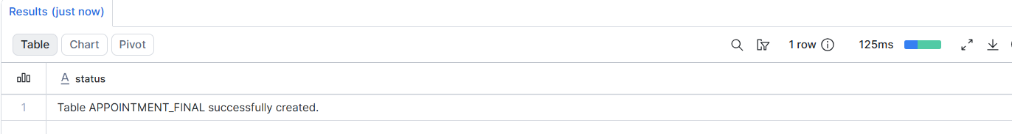

Task – 8 : Create Snowpark Python Stored Procedure

CREATE OR REPLACE PROCEDURE SP_TRANSFORM_APPOINTMENT()
RETURNS STRING
LANGUAGE PYTHON
RUNTIME_VERSION = '3.11'
PACKAGES = ('snowflake-snowpark-python')
HANDLER = 'main'
AS
$$
from snowflake.snowpark import Session
from snowflake.snowpark.functions import *
from snowflake.snowpark.types import *

def main(session: Session):

df = session.table("APPOINTMENT_RAW")

transformed_df = df.with_column(
"AGE_GROUP",
when(col("AGE") < 18, lit("Child"))
.when((col("AGE") >= 18) & (col("AGE") < 40), lit("Adult"))
.when((col("AGE") >= 40) & (col("AGE") < 60), lit("Middle Age"))
.otherwise(lit("Senior Citizen"))
).with_column(
"SCHEDULED_DATE",
to_timestamp(col("SCHEDULEDDAY"))
).with_column(
"APPOINTMENT_DATE",
to_date(col("APPOINTMENTDAY"))
).with_column(
"WAITING_DAYS",
datediff(
"day",
to_date(col("SCHEDULEDDAY")),
to_date(col("APPOINTMENTDAY"))
)
).with_column(
"NO_SHOW_STATUS",
when(col("NO_SHOW") == "Yes", lit("Missed"))
.otherwise(lit("Visited"))
).with_column(
"ATTENDANCE_STATUS",
when(col("NO_SHOW") == "Yes", lit("No Show"))
.otherwise(lit("Visited"))
)

final_df = transformed_df.select(
col("PATIENTID").alias("PATIENT_ID"),
col("APPOINTMENTID").alias("APPOINTMENT_ID"),
col("GENDER"),
col("AGE"),
col("AGE_GROUP"),
col("SCHEDULED_DATE"),
col("APPOINTMENT_DATE"),
col("WAITING_DAYS"),
col("NEIGHBOURHOOD").alias("NEIGHBORHOOD"),
col("SCHOLARSHIP"),
col("HIPERTENSION").alias("HYPERTENSION"),
col("DIABETES"),
col("ALCOHOLISM"),
col("HANDCAP").alias("HANDICAP"),
col("SMS_RECEIVED"),
col("NO_SHOW_STATUS"),
col("ATTENDANCE_STATUS")
)

final_df.write.mode("overwrite").save_as_table("APPOINTMENT_FINAL")

return "Transformation Completed"
$$;

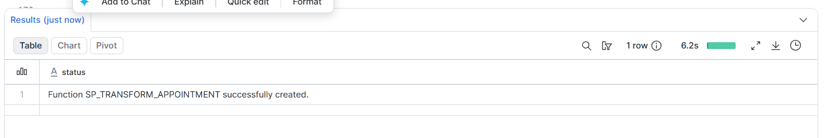

TASK 9 : CREATING THE STREAM
CREATE OR REPLACE STREAM APPOINTMENT_STREAM
ON TABLE APPOINTMENT_RAW;
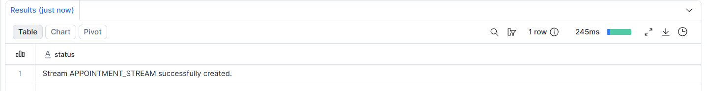

TASK 10 : Use Stream
INSERT INTO APPOINTMENT_RAW
VALUES
(
999999,
888888,
'F',
'2026-05-23T10:00:00Z',
'2026-05-30',
30,
'Central',
1,
0,
0,
0,
0,
1,
'No'
);
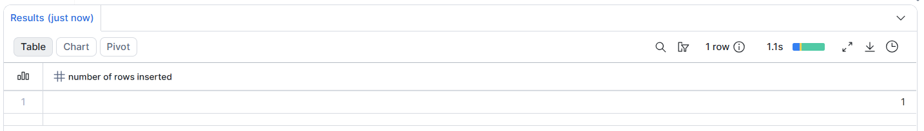

II ) INSERTING TO THE FINAL TABLE
INSERT INTO APPOINTMENT_FINAL
SELECT
PATIENTID,
APPOINTMENTID,
GENDER,
AGE,

CASE
WHEN AGE < 18 THEN 'Child'
WHEN AGE BETWEEN 18 AND 39 THEN 'Adult'
WHEN AGE BETWEEN 40 AND 59 THEN 'Middle Age'
ELSE 'Senior Citizen'
END,

TO_TIMESTAMP(SCHEDULEDDAY),

TO_DATE(APPOINTMENTDAY),

DATEDIFF(
DAY,
TO_DATE(SCHEDULEDDAY),
TO_DATE(APPOINTMENTDAY)
),

NEIGHBOURHOOD,
SCHOLARSHIP,
HIPERTENSION,
DIABETES,
ALCOHOLISM,
HANDCAP,
SMS_RECEIVED,

CASE
WHEN NO_SHOW = 'Yes' THEN 'Missed'
ELSE 'Visited'
END,

CASE
WHEN NO_SHOW = 'Yes' THEN 'No Show'
ELSE 'Visited'
END

FROM APPOINTMENT_STREAM;

TASK 11 : CREATING THE SNOWPIPE
CREATE OR REPLACE PIPE APPOINTMENT_PIPE
AUTO_INGEST = FALSE
AS
COPY INTO APPOINTMENT_RAW
FROM @APPOINTMENT_STAGE
FILE_FORMAT = (
TYPE = CSV
SKIP_HEADER = 1
FIELD_OPTIONALLY_ENCLOSED_BY = '"'
)
ON_ERROR = 'CONTINUE';
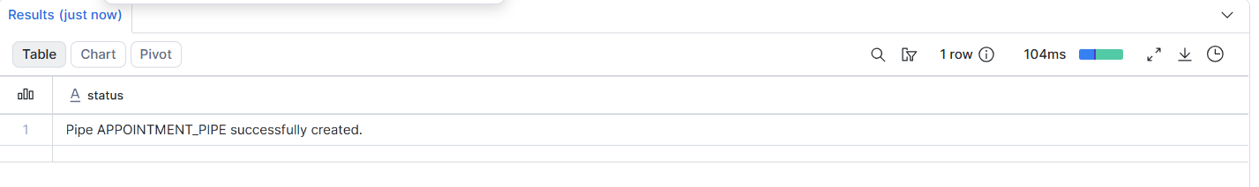

Task 12: Create Reporting View
CREATE OR REPLACE VIEW VW_APPOINTMENT_DASHBOARD AS
SELECT
PATIENT_ID,
APPOINTMENT_ID,
GENDER,
AGE,
AGE_GROUP,
SCHEDULED_DATE,
APPOINTMENT_DATE,
WAITING_DAYS,
NEIGHBORHOOD,
SCHOLARSHIP,
HYPERTENSION,
DIABETES,
ALCOHOLISM,
HANDICAP,
SMS_RECEIVED,
NO_SHOW_STATUS,
ATTENDANCE_STATUS
FROM APPOINTMENT_FINAL;

