# Road Safety Analysis

**Team: Tragic Bytes**

Kriti Gupta1, Kumari Priyanka2, Minni Kumari3

11nt20ec066.kriti@nmit.ac.in, 2priyankasingh1939745@gmail.com, 31nt20ec076.minni@nmit.ac.in

Electronics and Communication Engineering, Nitte Meenakshi Institute of Technology

Date:9 september,2023

Institute Mentor: Dr Rajesh N, Professor, Dept of ECE, NMIT

Abstract — Road safety analysis is a study that examines and evaluates various factors affecting safety on roads. It involves assessing traffic conditions, driver behavior, road design, and the effectiveness of safety measures. The goal is to identify risks and propose solutions to reduce accidents and save lives. This research plays a crucial role in improving road safety and preventing accidents.

# Introduction

The introduction of a road safety analysis serves as the gateway into a comprehensive examination of factors crucial to enhancing safety on our roadways. In this pivotal section, we acknowledge the critical issue at hand – the alarming prevalence of accidents on our roads leading to injuries, loss of life, and substantial economic consequences. Our primary objective in this analysis is to delve deep into the underlying reasons for these accidents and, more importantly, to identify effective strategies for their prevention. To achieve this, we will scrutinize various facets of road safety, including driver behavior, road conditions, and traffic management, with a keen focus on their interplay. Road safety is not merely a matter of convenience; it is a matter of utmost significance, affecting the lives and well-being of countless individuals while also exerting a substantial influence on our society and economy. As we proceed with this analysis, we will outline our methodology, which will guide our investigation, and anticipate that the outcomes will extend beyond statistical figures. Our aim is to foster safer roads, thereby safeguarding lives and advancing the overall efficiency and sustainability of our transportation systems.

# Related Work

The related work in the domain of road safety analysis utilizing data analytics and logistic regression models comprises a significant body of research that sheds light on various aspects of this critical field. Many studies have delved into the collection and preprocessing of road safety data, often encompassing accident reports, weather conditions, road infrastructure details, and driver characteristics [1]. Descriptive analyses have been conducted to discern patterns, such as accident hotspots, common causes, and driver demographics [2]. Logistic regression models and other predictive analytics tools have been employed to forecast accident likelihood, drawing on a multitude of factors like road geometry, traffic density, weather elements, and driver behavior [3]. These studies have also explored feature engineering techniques to select the most influential variables for modeling. Additionally, model evaluation using metrics like accuracy, precision, recall, and F1-score has been prevalent, facilitating the assessment of predictive performance. Some investigations have gone further to analyze spatial and temporal variations in accidents, offering valuable insights for localized safety interventions [4]. Moreover, the implications of this research extend to policy recommendations and practical applications in traffic management and accident prevention. The acknowledgment of data sources and limitations remains a consistent aspect, ensuring transparency and awareness of potential biases. By building upon this extensive body of related work, researchers can advance the field of road safety analysis, addressing its complex challenges and striving for safer roadways [5].

# Proposed Method

The steps involved in building of the ML model and the operational process are shown in Fig. 1

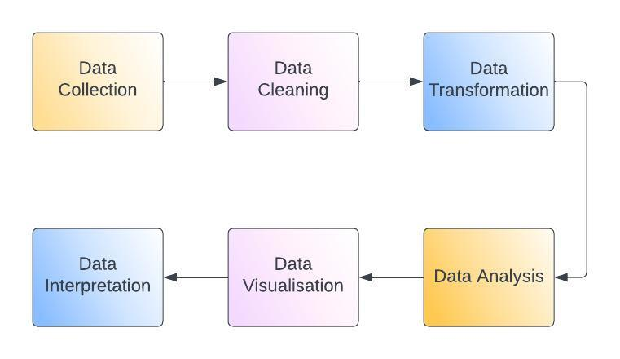

Fig. 1: Proposed Methodology Flowchart.

1. Software Environment

Table : Software Environment

|  |  |
| --- | --- |
| Programming Language | Python 3.8.15 |
| Libraries | Matplotlib, Pandas, Seaborn, OS |
| Operating System | Windows 10 (64-bit OS) |

Python has been selected as the programming language for developing machine learning as well as deep learning algorithms. Google Collab is used as a machine learning environment for model training as it provides better computational power. Although there are many machine learning libraries available for Python such as Scikit-Learn, TensorFlow, Keres, PyTorch, etc., MLX tend offers additional functionalities and can be a valuable addition to your data science toolbox. MLxtend is a python library of useful tools for day-to-day data science tasks. It has the apriority algorithm and association rules algorithm built in.

Pandas is a library module that has features to clean up data sets and assign them to rows and columns for further processing.

Matplotlib provides tools to plot the obtained result in an easy-to-understand visual representation.

Python data visualization library, simplifying creation of attractive statistical plots and enhancing data exploration with built-in themes and palettes.

.

# Result and Analysis

1. Displays histogram where x- axis is latitude, longitude accordingly and y-axis is frequency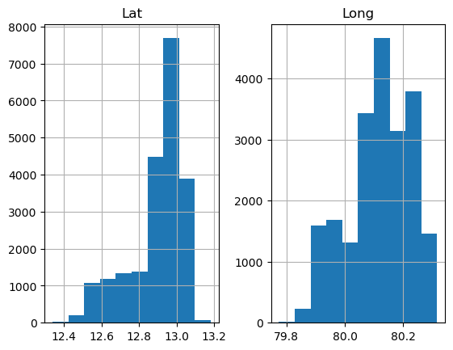.
2. Displays frequencies of various types of alerts respectively.

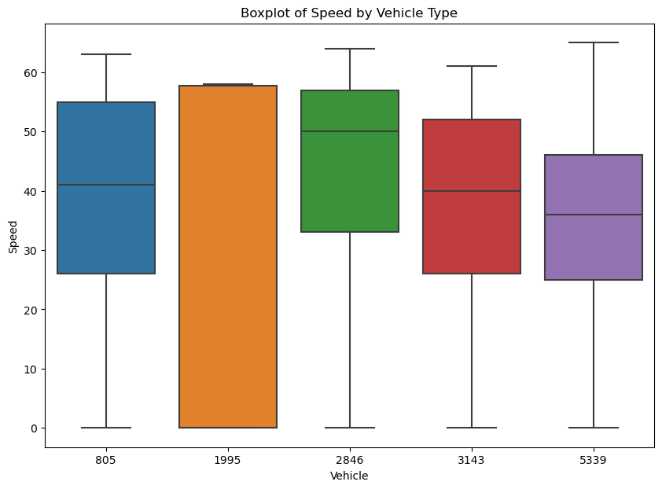

1. Displays a boxplot where x-axis is vehicle and y-axis is speed.



1. Displays a pie chart based on the 'Accident_severity' column.

1. Displays a scatter plot to visualize the vehicle's path(Geospatial Analysis).
2. Displays correlation matrix of three columns Latitude, Longitude and SpeedA map of a vehicle path

   Description automatically generated.

Input code:

lat = int(input("Enter new Latitude:"))

long = int(input("Enter new Longitude:"))

speed = int(input("Enter new Speed:"))

newCust = [[lat,long,speed]]

result = model.predict(sc.transform(newCust))

print(result)

Output:

Enter new Latitude:80

Enter new Longitude:88

Enter new Speed:42

['cas_hmw']

# Conclusion

In conclusion, our road safety analysis, employing data analytics and logistic regression modeling, has provided critical insights into the factors influencing road accidents. We have identified key variables, such as weather conditions, road design, and driver behavior, that significantly impact accident probabilities. While our logistic regression model exhibits predictive capability, it also highlights the multifaceted nature of road safety, suggesting the need for a holistic approach. The implications of our findings extend beyond statistical trends; they underscore the urgency of proactive safety measures. By leveraging data-driven insights, we can tailor interventions, enhance traffic management, and prioritize infrastructure improvements to mitigate accidents and their consequences. Road safety remains a paramount concern, with the potential to save lives, reduce economic burdens, and create safer roadways for all. Future endeavors in this field should explore real-time data integration and advanced modeling techniques, further advancing our collective efforts to make roads safer and protect our communities.

# References

|  |  |
| --- | --- |
| [1] | I. a. S. Demyanushko, "Development of an algorithm for solving the problem of determining the size of the deflection of road barriers based on video recordings of full-scale crash tests," pp. 1-5, 2022. |
| [2] | L. Zbigniew, "Can anything optimistic be found in the statistics of road accidents in Poland," pp. 1-4, 2020. |
| [3] | P. Z. Zhongqing Xie, "Evaluative study of the culture construction of road traffic safety based on structural equation modeling," pp. 1169-1173, 2019. |
| [4] | A. Kalasova, K. Culik and A. Hajnik, "Young drivers and their risky behaviour on the roads," pp. 1-6, 2020. |
| [5] | A.V.Kostsov and L. a. T.K.Komarova, "The study of motorcar time intervals at railway crossings," pp. 1-4, 2021. |

GitHub: <https://github.com/priyanka191001/intel_unnati>