Staging Layer Setup
The first step of the ETL implementation was the creation of the `STG_POLICY` table, which serves as the staging layer for incoming policy data. This table represents the source data that will be transformed and loaded into the integrated layer according to the Source-to-Target Mapping (STTM) requirements.
The staging table contains all source attributes required for the transformation process, including policy information, customer details, state and line-of-business codes, premium amounts, cancellation indicators, and source update timestamps.
A comprehensive set of test records was loaded into the staging table to support validation of the ETL business rules. The test data was intentionally designed to cover both valid and invalid scenarios, allowing verification of transformation logic, data quality rules, lookup validations, defaulting behavior, and error handling.
The test dataset includes:
- Valid policy records representing standard source data.
- Duplicate policy numbers with different `SRC_UPDATE_TS` values to validate latest-record selection logic.
- Invalid and malformed date values to test date conversion and validation.
- Valid, invalid, lowercase, and null state codes to support state lookup validation.
- Unknown and null line-of-business codes to test lookup and defaulting behavior.
- Null premium amounts to verify default value assignment.
- Missing first name and last name values to support insured name derivation testing.
- Policy numbers containing leading and trailing spaces to validate trimming logic.
- Various cancellation flag values to support status derivation testing.
The `SRC_UPDATE_TS` column was included specifically to support the business requirement that only the most recent record for a policy number should be retained when duplicate records exist in the source.

SQL Implementation - Staging Layer
The following SQL script performs the initial setup of the staging environment for the ETL process.
The script includes:
- Creation of the Insurance_ETL_CaseStudy database.
- Creation of the STG_POLICY staging table.
- Population of test data covering both positive and negative test scenarios.
- Test records designed to validate ETL transformation, lookup, defaulting, deduplication, and error-handling requirements.
Staging Table Structure
The STG_POLICY table stores raw policy data received from source systems. The SRC_UPDATE_TS column is included to support the business requirement of retaining only the latest record when duplicate policy numbers are encountered.
Test Data Categories
The sample dataset includes records covering the following scenarios:
Category | Purpose
Valid Records | Verify successful processing of standard policy data
Duplicate Policies | Verify latest-record selection using SRC_UPDATE_TS
Invalid Dates | Verify date validation and conversion logic
State Code Variations | Verify state lookup validation and rejection handling
LOB Lookup Scenarios | Verify lookup behavior and default value assignment
Null Premium Amounts | Verify defaulting to 0.00
Name Concatenation Cases | Verify insured name derivation
Policy Number Formatting | Verify trimming of leading/trailing spaces
Status Flag Variations | Verify status derivation logic
SQL Script
CREATE DATABASE Insurance_ETL_CaseStudy
USE Insurance_ETL_CaseStudy
CREATE TABLE dbo.STG_POLICY (
POL_NBR VARCHAR(20) NULL,
EFF_DT VARCHAR(8) NULL,
PREM_AMT DECIMAL(12,2) NULL,
ST_CD CHAR(2) NULL,
LOB_CD VARCHAR(10) NULL,
LNAME VARCHAR(40) NULL,
FNAME VARCHAR(40) NULL,
CANCEL_FLG CHAR(1) NULL,
SRC_UPDATE_TS DATETIME2 NULL
);
INSERT INTO dbo.STG_POLICY (...)
VALUES (...);

Verification Query
SELECT *
FROM dbo.STG_POLICY;

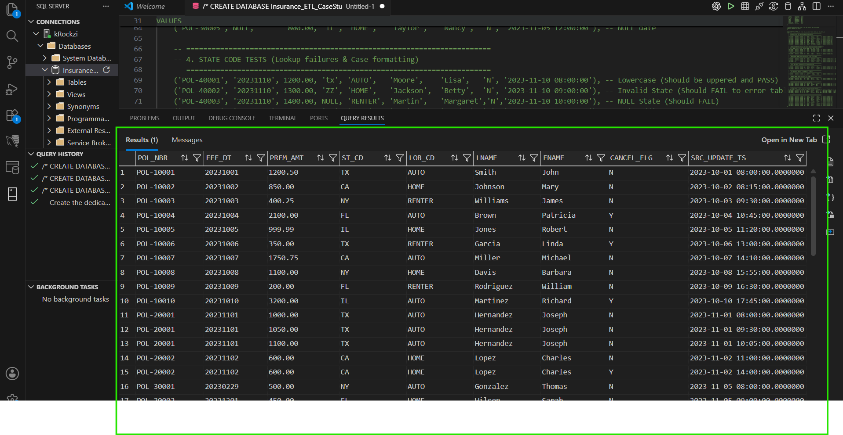

Reference (Lookup) Tables Setup

To support data validation and business rule implementation, two reference tables were created: `REF_STATE` and `REF_LOB`.
These tables serve as lookup datasets that will be referenced during the ETL transformation process to validate incoming source data and derive target values.

REF_STATE
The `REF_STATE` table contains the list of valid state codes accepted by the system.
Purpose:
- Validate incoming `ST_CD` values from `STG_POLICY`.
- Ensure only recognized state codes are processed.
- Support rejection of records containing invalid or missing state codes.
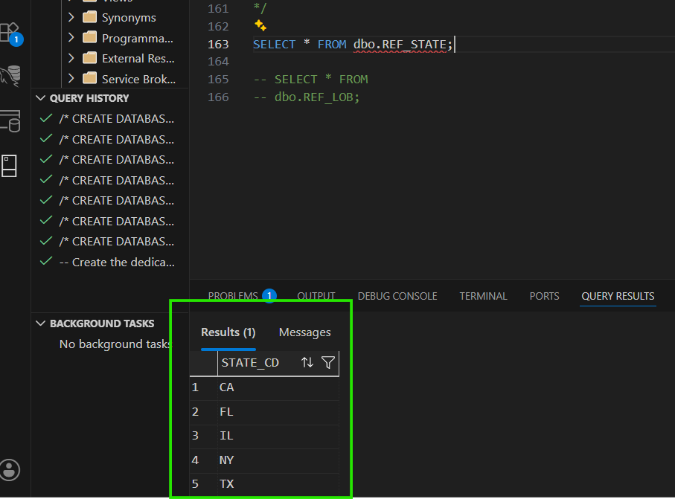
REF_LOB
The `REF_LOB` table contains valid Line of Business (LOB) codes and their corresponding business descriptions.
Purpose:
- Support lookup business descriptions from source `LOB_CD` values.
- Standardize Line of Business information during transformation.
- Provide a controlled list of accepted business categories.
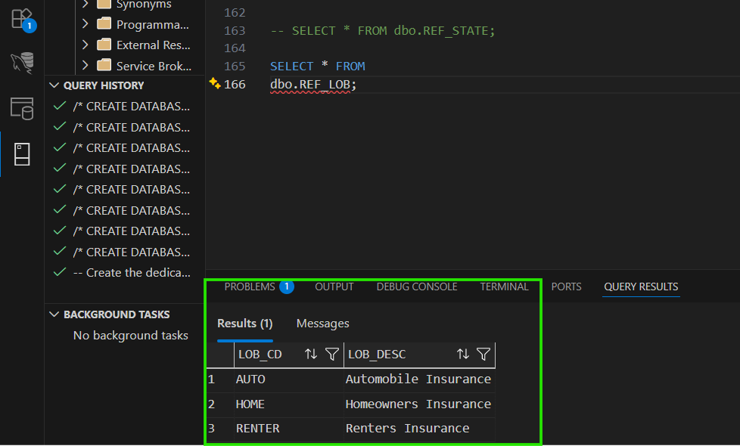
Implementation Notes
Both reference tables were populated with a controlled set of values designed to support testing of lookup validations and transformation rules defined in the Source-to-Target Mapping (STTM).
The test data intentionally includes source records containing invalid state codes and unknown Line of Business codes to verify lookup behavior during subsequent ETL processing.

Target and Error Table Setup

Following the creation of the staging and reference tables, the target and error tables were created to support the ETL load process.
ILM_POLICY (Integrated Layer Target Table)
The `ILM_POLICY` table represents the integrated layer target table defined in the STTM. This table stores the final transformed and validated policy records that successfully pass all business rules and data quality checks.
The table structure reflects the required target mappings and transformations, including:
- Trimmed policy numbers (`POLICY_NUMBER`)
- Converted effective dates (`EFFECTIVE_DATE`)
- Standardized premium amounts (`PREMIUM_AMOUNT`)
- Validated state codes (`STATE_CODE`)
- Derived line of business descriptions (`LINE_OF_BUSINESS`)
- Concatenated insured names (`INSURED_NAME`)
- Derived policy status (`STATUS`)
- System-generated load timestamp (`LOAD_TS`)
The `LOAD_TS` column is automatically populated using `SYSDATETIME()` to provide auditability and track when records are loaded into the integrated layer.

ERROR_POLICY (Rejected Records Table)
The `ERROR_POLICY` table was created to store records that fail validation during the ETL process.
In accordance with the acceptance criteria, invalid records must not be silently dropped. Instead, all rejected records are captured in the error table together with the reason for rejection.
The table preserves the original staging values in their raw format, allowing failed records to be reviewed, investigated, and reprocessed if necessary.

Additional audit columns were included:
- `REJECT_REASON` - Stores the business or validation rule that caused the rejection.
- `REJECT_TS` - Stores the timestamp when the record was rejected.
This design supports the requirement that all rejected records remain traceable and documented throughout the ETL process.

Design Considerations
- `ILM_POLICY` stores only validated and transformed records.
- `ERROR_POLICY` stores records that fail validation rules.
- Successful and rejected records are separated to simplify reconciliation and auditing.
- Audit timestamps are automatically generated using `SYSDATETIME()`.
- The error table intentionally allows nullable source columns to ensure invalid source records can be captured without additional load failures.

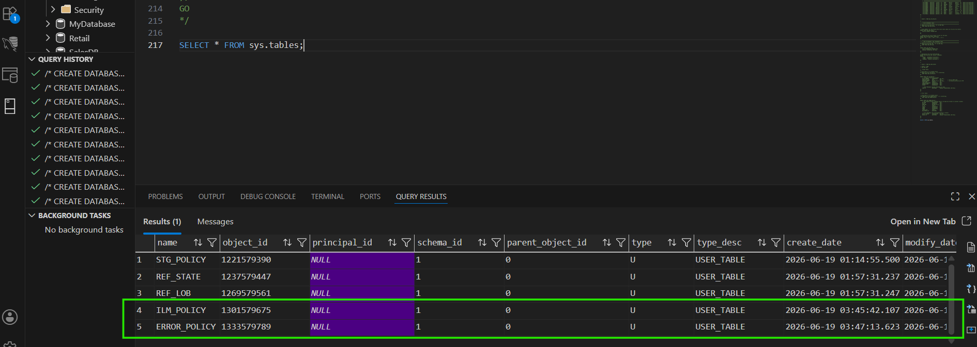

Acceptance Criteria:
Data Validation Assertion and edge case.
1. Grain & Uniqueness Assertions
Objective: Guarantee deterministic deduplication so that only one true record per Policy Number reaches the target.
- Assertion 1 (The Grain): The target table (ILM_POLICY) must contain absolutely no duplicate POLICY_NUMBERs.
- Assertion 2 (The Rule): When multiple records exist in staging for a single policy, the pipeline must isolate and load only the record with the most recent source timestamp.
- Edge Case Addressed (The "Tiebreaker"): If two updates arrive at the exact same millisecond, SQL will normally guess which row to keep, breaking data consistency. This pipeline explicitly handles timestamp collisions by introducing a secondary tie-breaker constraint.
  - Addressed (The NULL Void): In SQL Server, ORDER BY ... DESC forces NULL values to the bottom of the execution order. If a record arrives with a NULL timestamp, the engine will deterministically rank it lower than any record with a valid timestamp, discarding it to protect the target table from un-versioned data.
2. Referential Integrity & Data Routing Assertions
Objective: Ensure invalid categorical data is securely routed to the quarantine zone (ERROR_POLICY), while unmatched non-critical data gracefully defaults to safe values, completely eliminating "silent drops."
- Assertion 1 (Strict Validation): The State Code (ST_CD) must exist in the REF_STATE lookup table. Any unmatched records must be explicitly documented and rejected to the error table.
- Assertion 2 (Graceful Defaulting): The Line of Business (LOB_CD) must be checked against REF_LOB. Unmatched or NULL codes must be successfully loaded into the target table, but overridden with the default value 'UNKNOWN'.
- Edge Cases Addressed (The "Dirty Data" Defense): * State codes often arrive with hidden whitespaces or lowercase letters (e.g., ' tx '). The pipeline forces a TRIM() and UPPER() transformation before attempting the lookup to prevent false-positive rejections.
  - The architecture intentionally utilizes LEFT JOINs for all reference lookups. Using an INNER JOIN would cause invalid states to completely vanish from the pipeline execution (a silent drop).
3. Data Typing & Formatting Assertions
Objective: Prevent fatal pipeline crashes during raw string conversions and ensure strict mathematical accuracy for downstream financial reporting.
- Assertion 1 (Safe Date Casting): The EFFECTIVE_DATE must securely cast from a raw string to a standard calendar date. Any failure to cast must be intercepted and routed to the error table rather than causing a pipeline failure.
- Assertion 2 (Financial Precision & Defaults): The PREMIUM_AMOUNT must enforce a rigid decimal precision. If the source system fails to provide a premium (NULL), the pipeline must mathematically default the value to 0.00 to protect downstream aggregation metrics.
- Edge Cases Addressed (The System Crashers): * Invalid calendar dates (e.g., February 29th on a non-leap year or month 13) naturally crash databases during standard ingestion. The pipeline uses defensive casting to evaluate the date's validity before attempting a hard insert.
  - Empty strings or garbage alphabetical characters arriving in the date field are explicitly flagged as INVALID_DATE_FORMAT and quarantined.
4. Business Logic & Cleansing Assertions
Objective: Standardize free-text formatting, gracefully handle missing human-entry data, and decode operational flags into human-readable dimensions.
- Assertion 1 (String Cleansing): The POLICY_NUMBER must be stripped of all leading and trailing whitespaces before entering the Integrated Layer to ensure accurate reporting aggregations.
- Assertion 2 (Safe Concatenation): The INSURED_NAME must combine the Last Name and First Name fields. If either name is missing, the pipeline must preserve the existing name rather than nullifying the entire field.
- Assertion 3 (Status Decoding): The raw CANCEL_FLG must be strictly mapped. A 'Y' translates to 'CANCELLED', an 'N' translates to 'ACTIVE', and any other unmapped or missing value safely defaults to 'UNKNOWN'.
- Edge Cases Addressed (The Null-Wipeout Defense): * In database architecture, concatenating a valid string with a NULL yields a NULL output. The pipeline uses conditional logic to evaluate the presence of the first and last names independently, ensuring that a missing first name does not accidentally erase a perfectly valid last name from the final target table.

Final table (Post Transformation) :

SELECT * FROM dbo.ILM_POLICY;

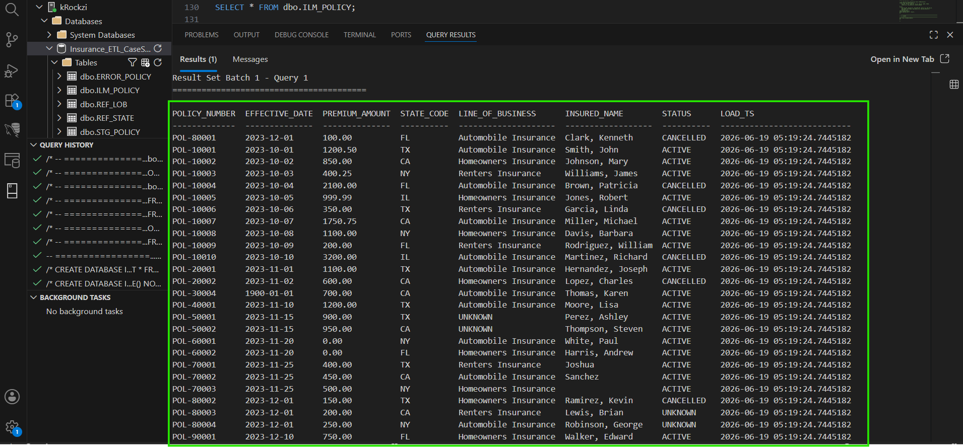

Error Table:
SELECT * FROM dbo.ERROR_POLICY;

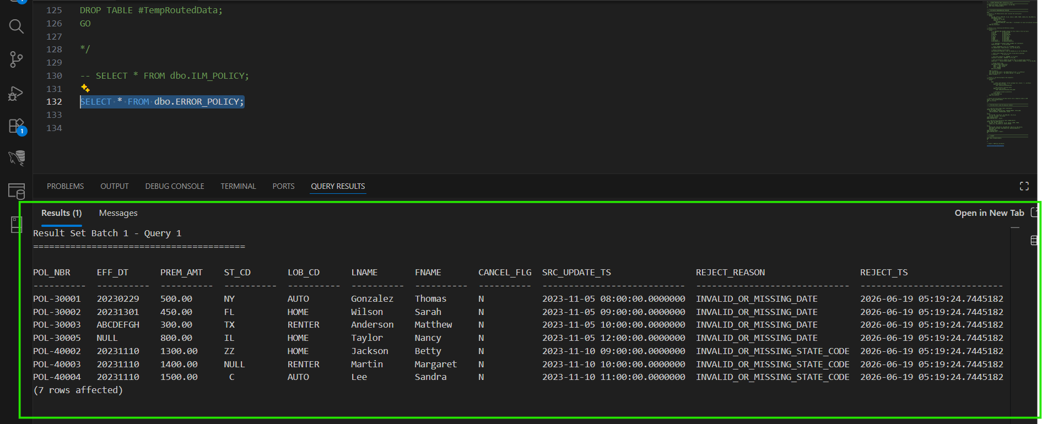

Task 2:
Reconciliation:
Note : The following reconciliation query is designed to be run after the master ETL pipeline .
WITH Source_Distinct AS (
SELECT COUNT(DISTINCT POL_NBR) AS Total_Inbound_Policies
FROM dbo.STG_POLICY
)
SELECT
Total_Inbound_Policies,
(SELECT COUNT(*) FROM dbo.ILM_POLICY) AS Target_Loaded,
(SELECT COUNT(*) FROM dbo.ERROR_POLICY) AS Error_Rejected,

Total_Inbound_Policies - (
(SELECT COUNT(*) FROM dbo.ILM_POLICY) +
(SELECT COUNT(*) FROM dbo.ERROR_POLICY)
) AS Record_Variance
FROM Source_Distinct;
