# JS Advanced Retake Final Exam

# Problem 1. Furniture Store

**Environment Specifics**

Please, be aware that every JS environment may **behave differently** when executing code. Certain things that work in the browser are not supported in **Node.js**, which is the environment used by **Judge**.

The following actions are **NOT** supported:

* **.forEach()** with **NodeList** (returned by **querySelector()** and **querySelectorAll()**)
* **.forEach()** with **HTMLCollection** (returned by **getElementsByClassName()** and **element.children**)
* Using the **spread-operator** (**...**) to convert a **NodeList** into an array
* **append()** in Judge (use only **appendChild()**)**prepend()**
* **replaceWith()**
* **replaceAll()**
* **closest()**
* **replaceChildren()**
* Always turn the collection into a **JS array** (forEach, forOf, et.)

If you want to perform these operations, you may use **Array.from()** to first convert the collection into an array.

**Use the provided skeleton to solve this problem.**

**Note**: You **can't** and you have no permission to **change** directly the given html code (index.html file).

**Write the missing JavaScript code** to make the **Furniture** **Store** work as expected:

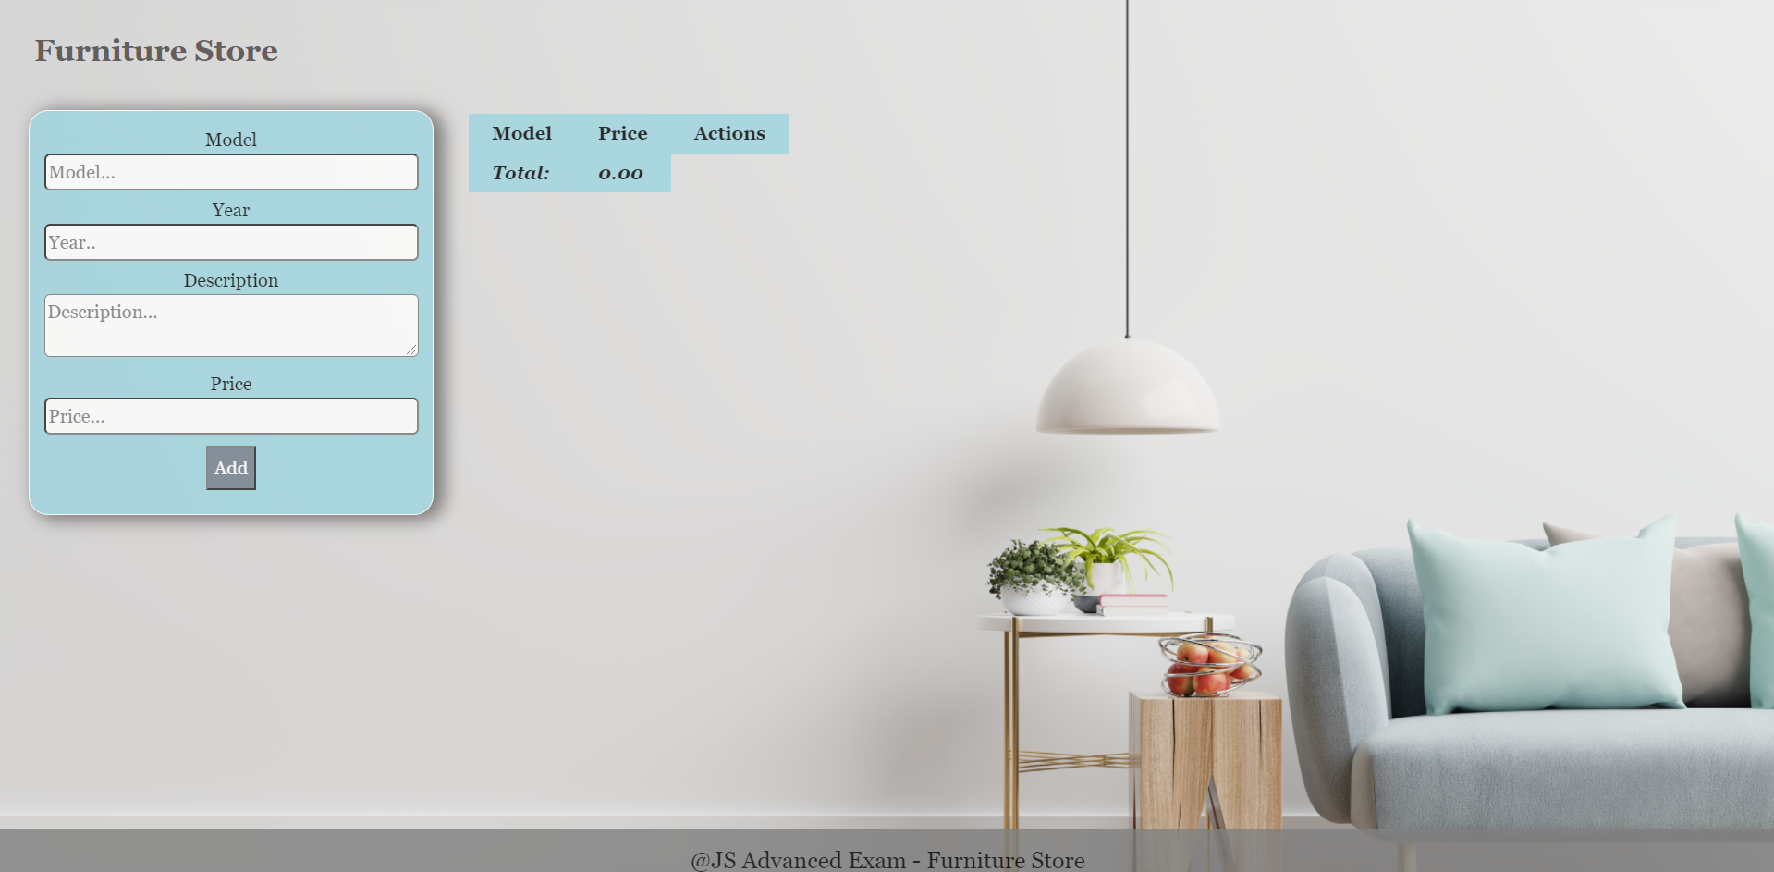

**Your Task**

* A**ll fields (model, year, description, and price)** are **filled with the correct input**
  + **Model and description** are **non**-**empty** **strings**
  + **Year** and **Price** need to be **positive** **numbers**
  + **All fields must be filled**

1. **Getting the furniture information**

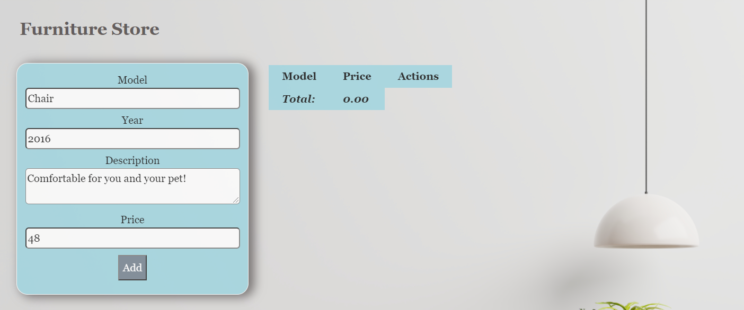

* When you click the “Add” button, the information from the input fields must be added to the table and then clear input fields.
* The table contains **Model, Price of furniture** and **Actions** - **[More information], [Buy it]**. **Price** must be **rounded** to **second** digit after decimal point.

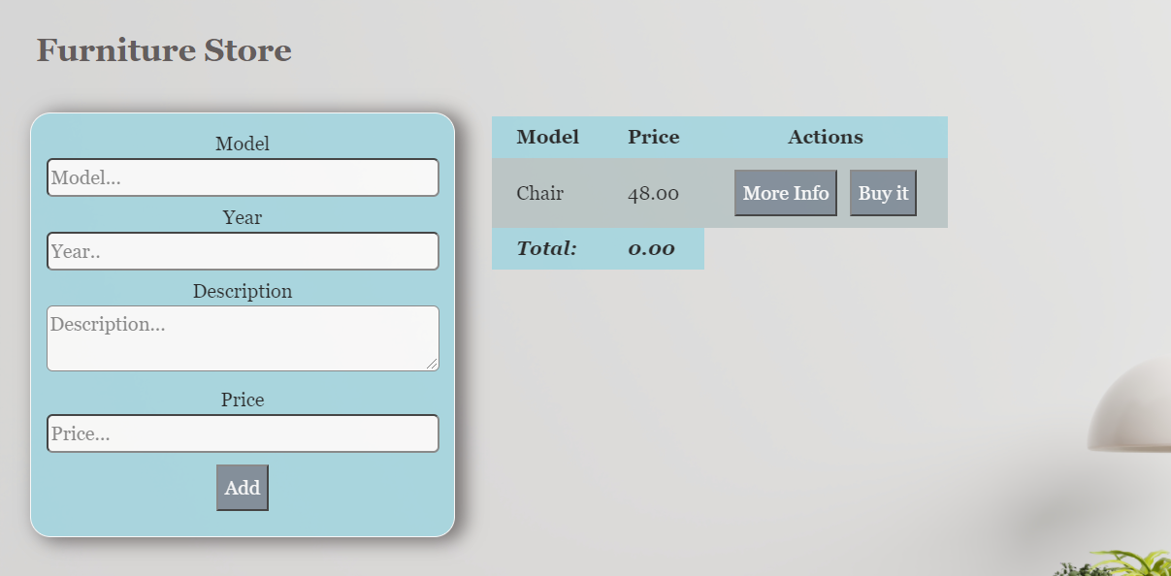

**Each furniture** must be appended to **"furniture-list"** and look like the picture below: 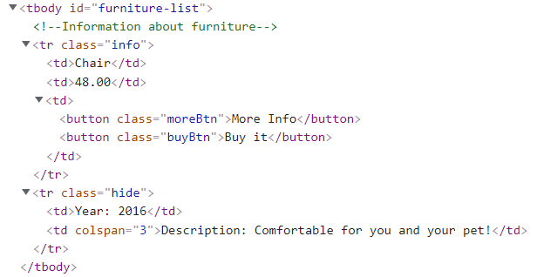

Each furniture has main information line **(Model, Price)** and an additional information line. The additional information line stores **the description and year** of manufacture of the furniture **(hidden until the "More info" button is pressed**)**.**

When the **"More Info"** button is clicked, change button text from **"More Info"** to **"Less Info"** and style display of **"class = hide"** from **"none "** to **"contents".** The second **<td>** must have attribute **colspan** with value **3.** When click **"Less Info"** button is clicked, change button text from **"Less Info"** to **"More Info"** and style from **"contents "** to **"none".**

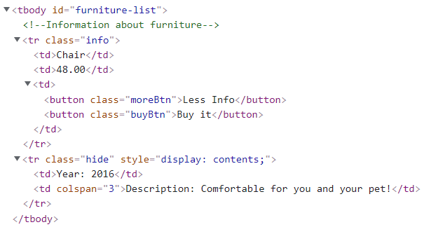

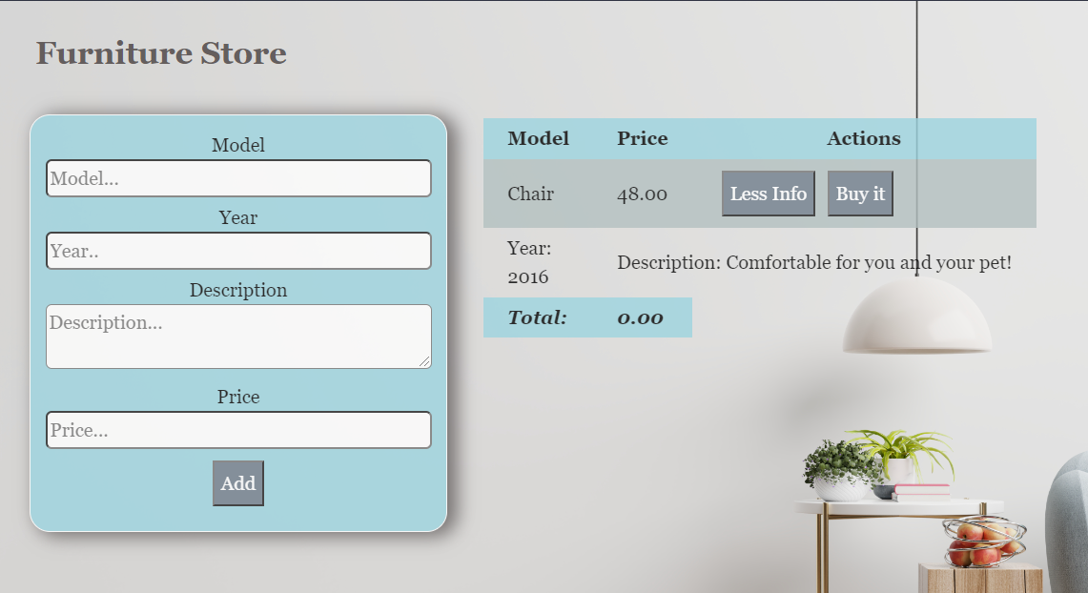

When the **"Buy it"** button is clicked, should have the following **functionality:**

* **The current furniture** must be **removed from the row** in the table
* You need to **change** the **total** profit in **the store.** Take the element with class **"total-price"** **and increase the current total price** **with** the **price of the furniture**.

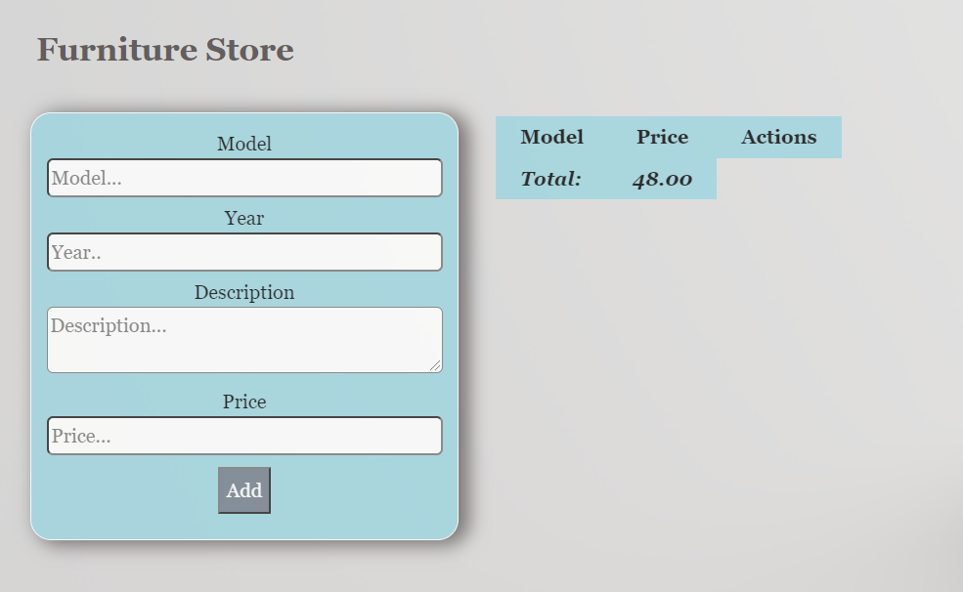

**Submission**

Submit only yours **solve()** function.

*GOOD LUCK… (:*