Exercise: DOM
Problems for in-class lab for the "JS Advanced" Course @SoftUni". Submit your solutions in the SoftUni judge system at https://judge.softuni.bg/Contests/1802/Exercise-DOM

Chat Room
Write a function to create the functionality of a chat room.
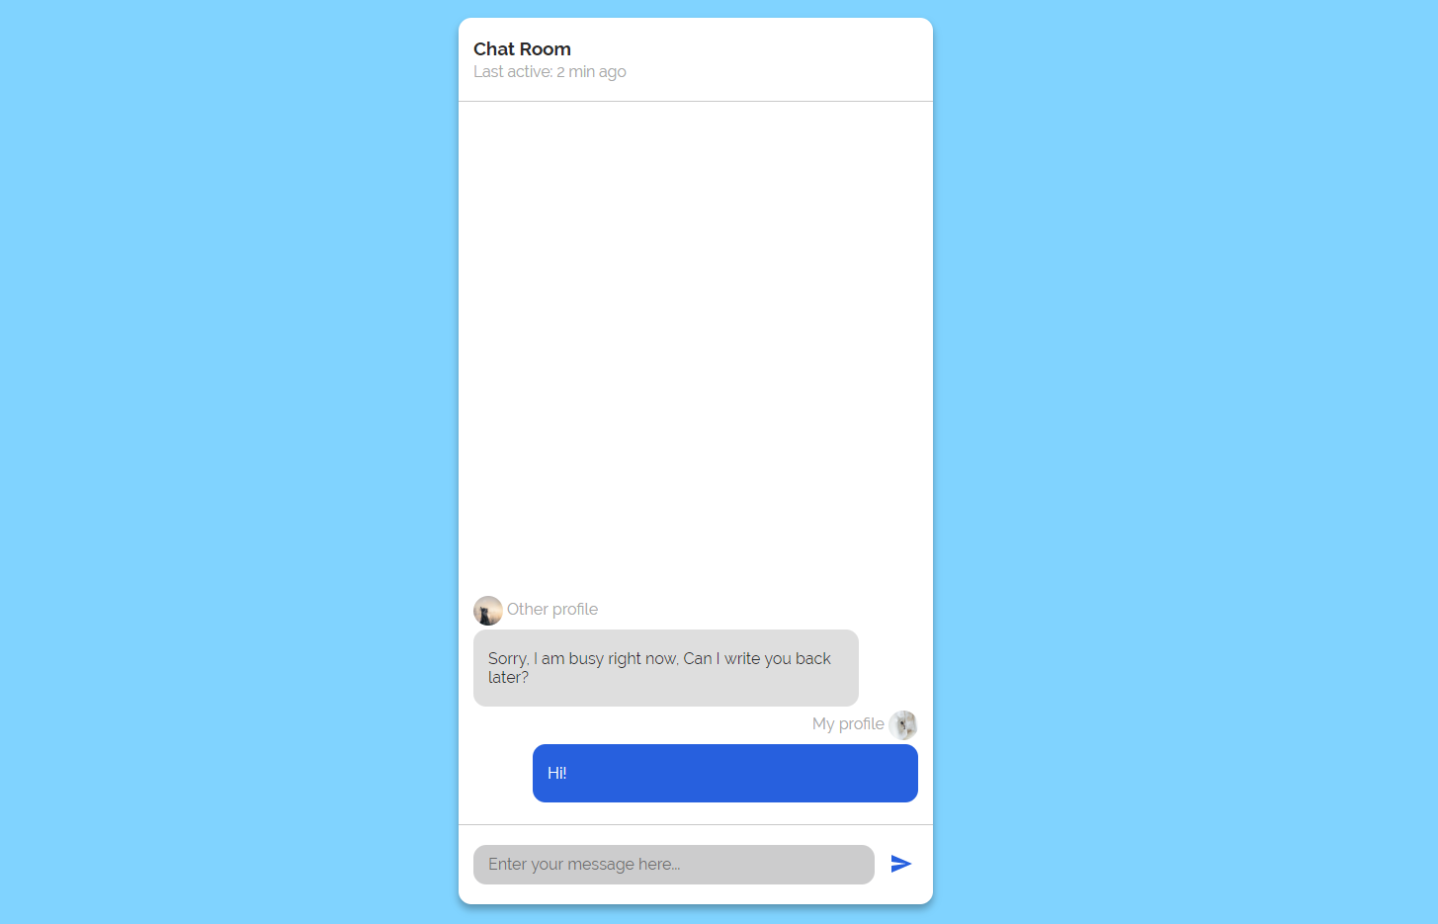
Note: Do not forget to add event listener to the send button!
The new div element with class message my-message should contain the current message that is about to be send.
The current div should be appended to the div with an id="chat_messages".
The input should be cleared on each click of the send button.
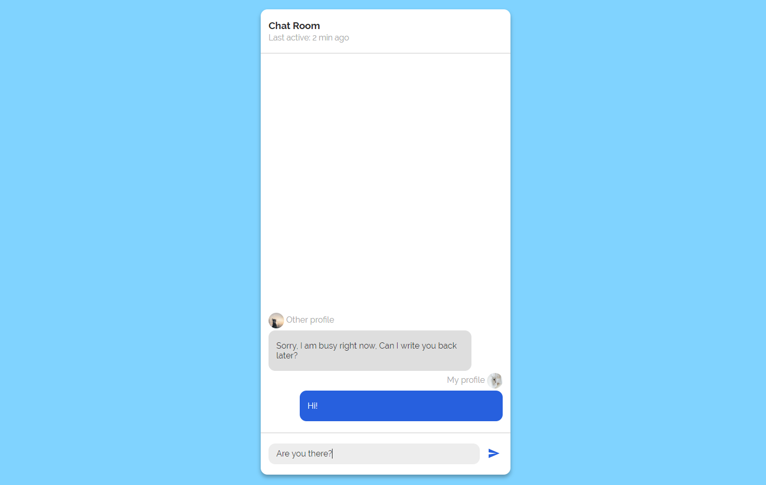
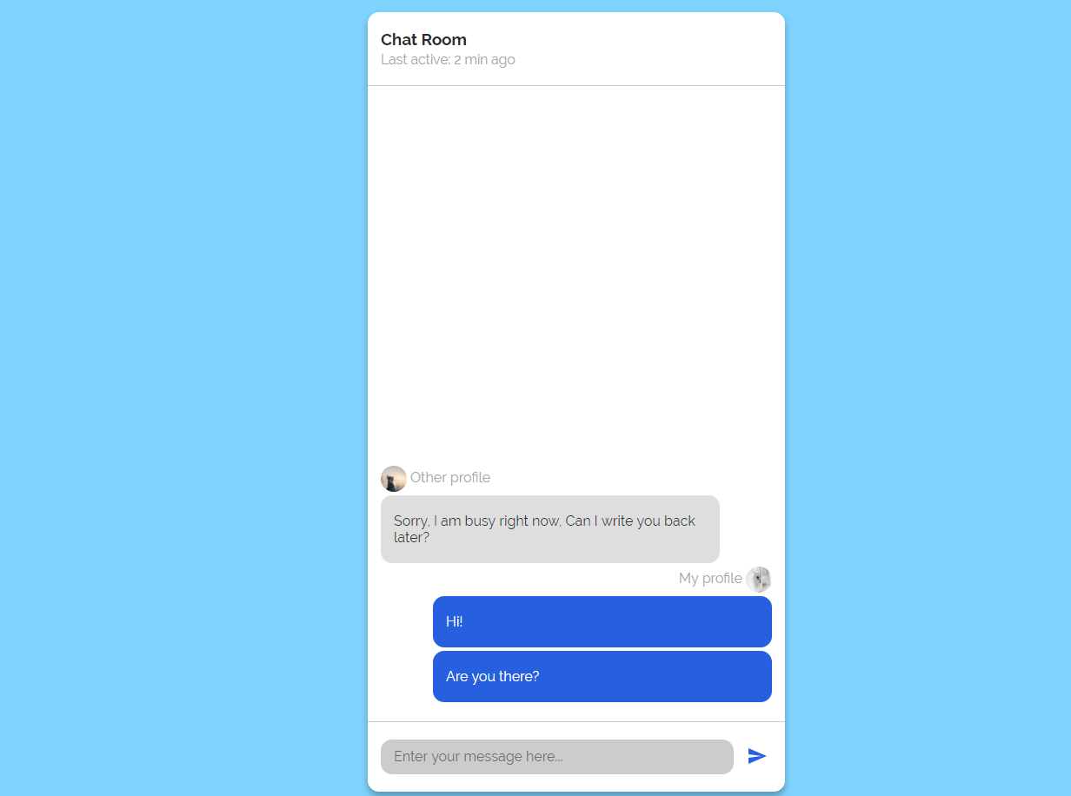

Number Convertor
Write a function that converts a decimal number to binary and hexadecimal.

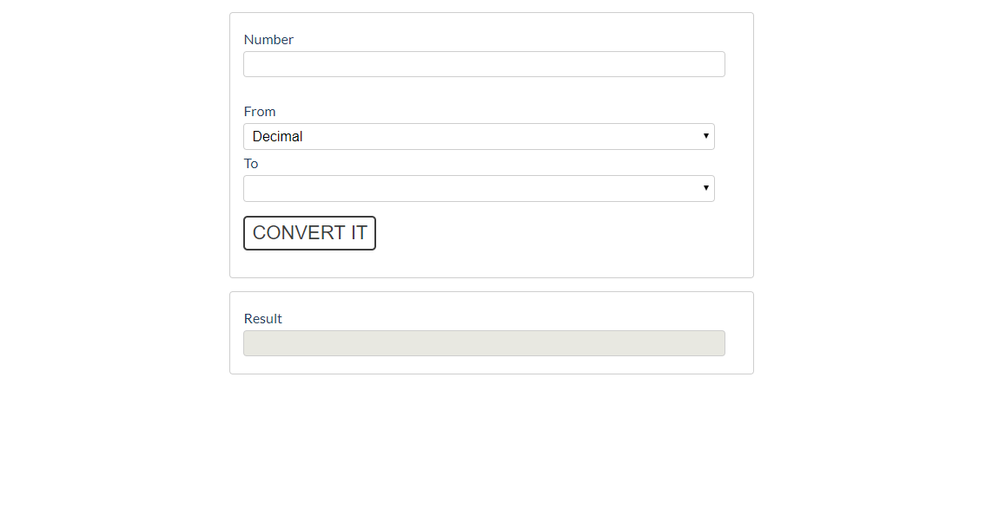
The given number will always be in decimal format. The "From" select menu will only have a
Decimal option, but the "To" select menu will have two options: Binary and Hexadeicmal.
This means that our program should have the functionality to convert decimal to binary and
decimal to hexadecimal.
Note that "To" select menu by default is empty. You have to insert the two options ('Binary' and 'Hexadecimal') inside before continue. Also they should have values ('binary' and 'hexadecimal').
- When the [Convert it] button is clicked, the expected result should appear in the [Result] input field.
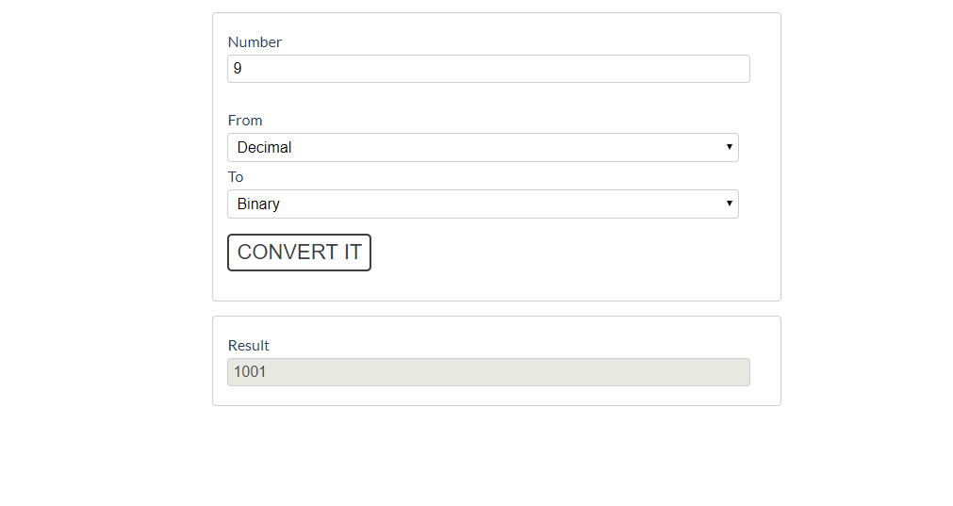
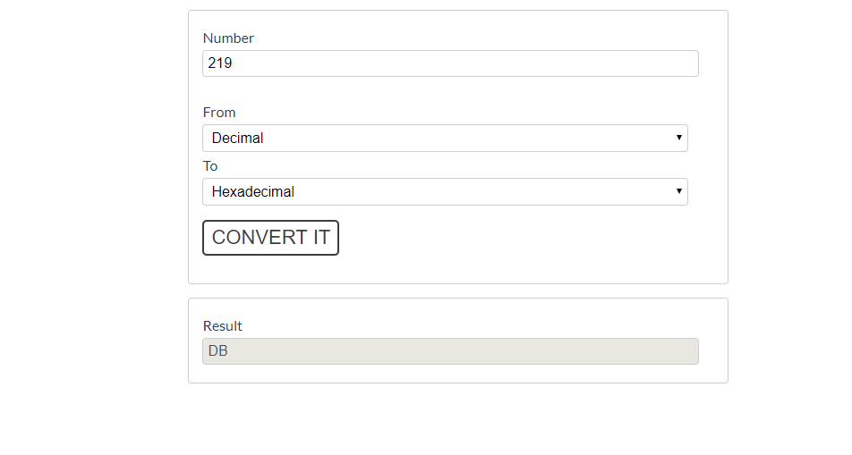

JavaScript Quizz
Write a function that has the functionality of a quiz.
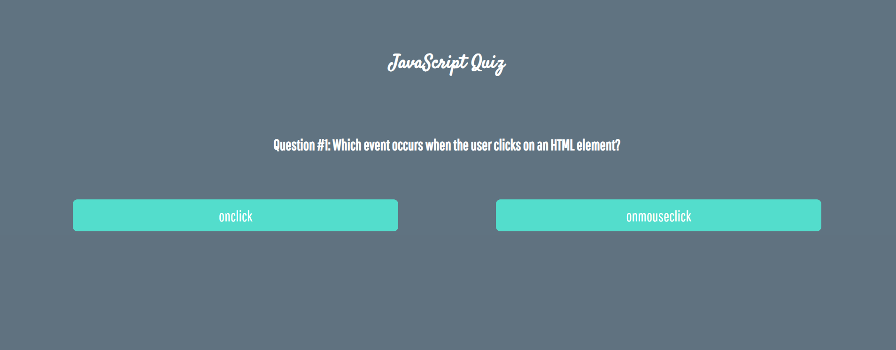
There are three sections that contain one question and 2 possible answers.
The right answer is only one!
When one of the list elements is clicked, the next section must appear (if any…).
After all three questions have been answered, the result div must appear. (Use 'none' and 'block' to hide and show the question sections)
If all questions are answered correctly, you should prin the following message:
"You are recognized as top JavaScript fan!"
Otherwise, just print "You have {rightAnswers} right answers".
The right answers are (onclick, JSON.stringify() and A programming API for HTML and XML documents).

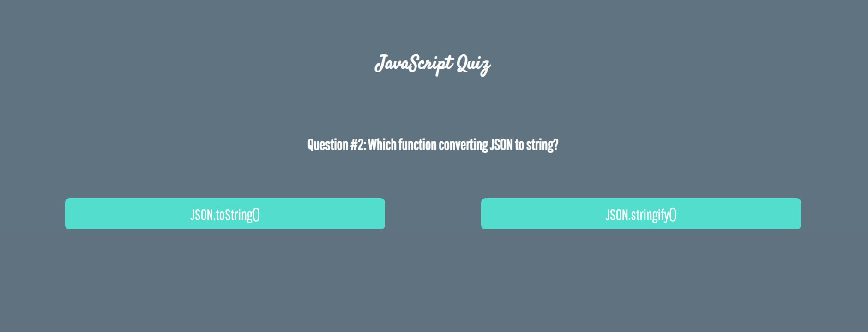
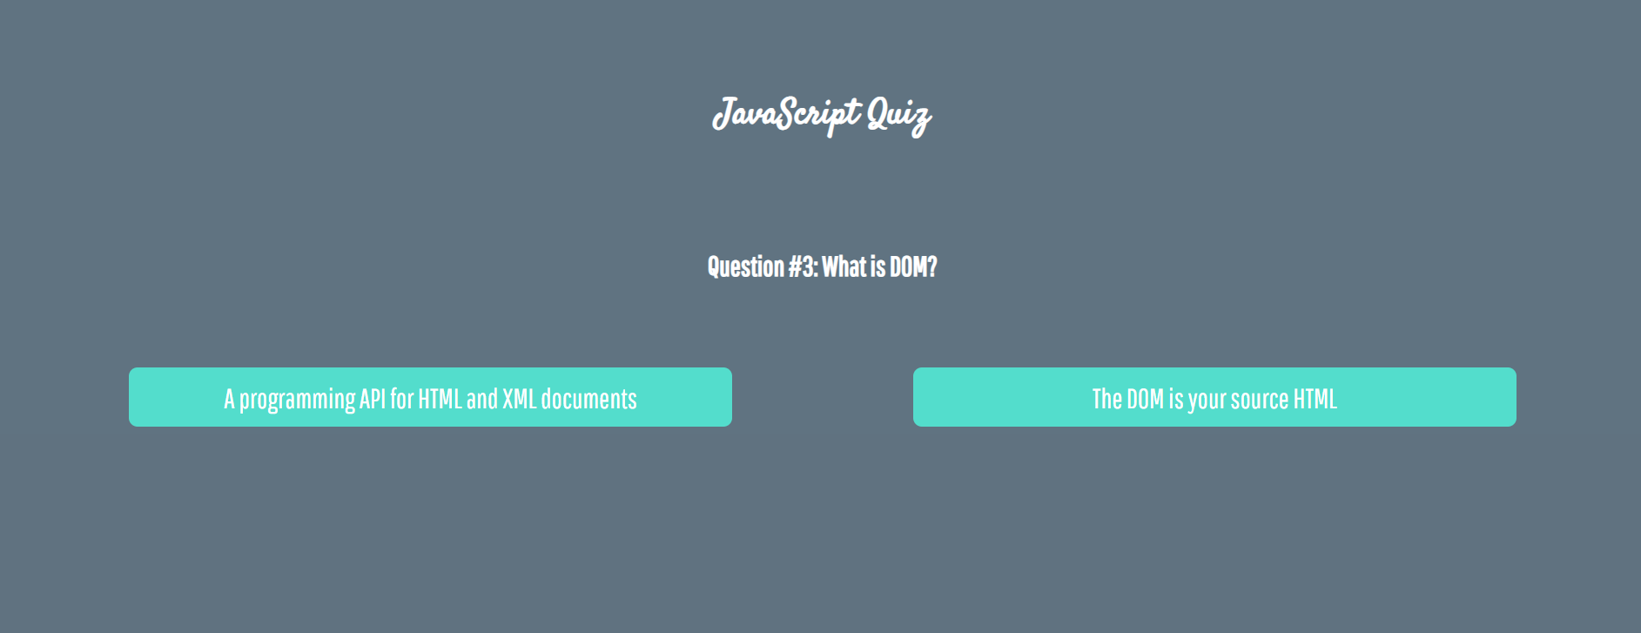



Numpad Calculator
Write a function that implements a calculator that has the following functionalities:
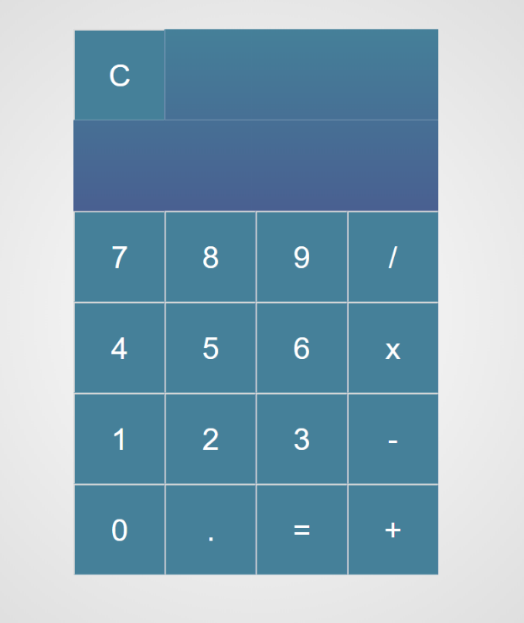
When one of the buttons is clicked, its value should be shown in the "Expression" field (#expressionOutput).
For instance, if we click on the button with value 9, the expected result should be:
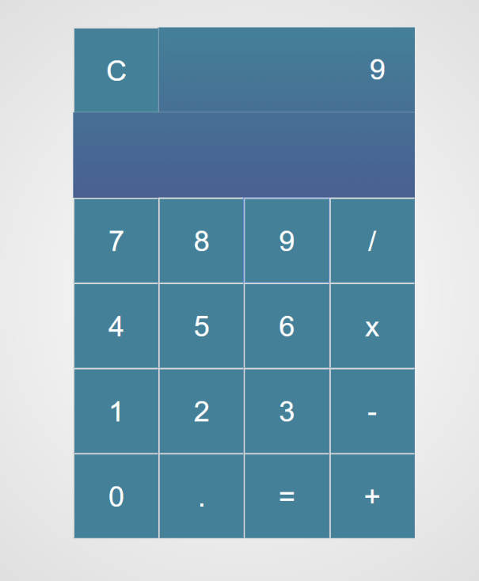
If the current Expression field (#expresisonOutput) contains the whole math expression (left operand, operator and right operand: Example: 9 + 2), the expected result should be:
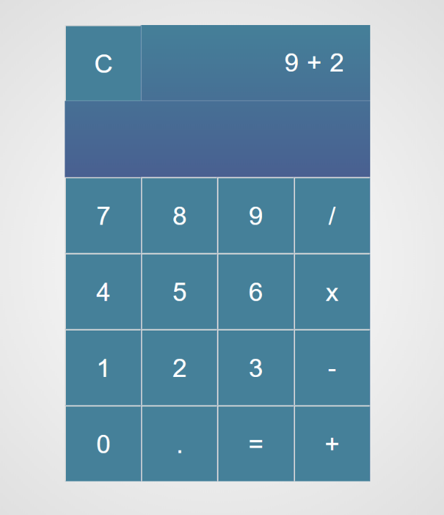
When the equal sign "=" is pressed, the result of that expression should appear in the Result field (#resultOutput)
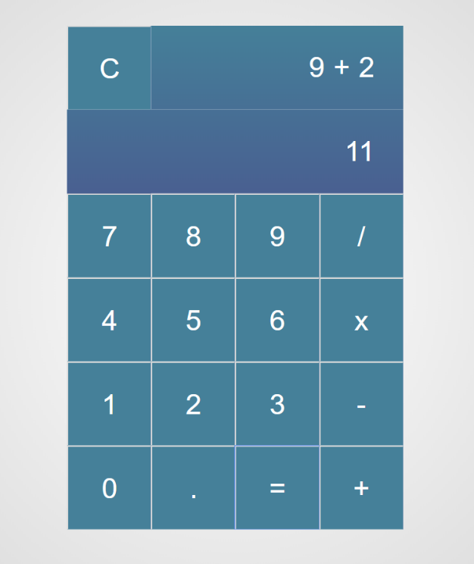
Otherwise, if we create an invalid expression such as "99 +" (without second/right operand) and we hit the equal sign "=", the expected result should be:
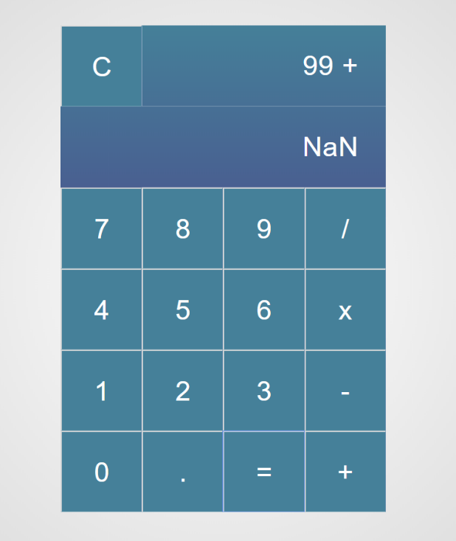

The "Clear" button should clear both Expression and Result fields (#expressionOutput and #resultOutput)
For instance, if we have the following expression:
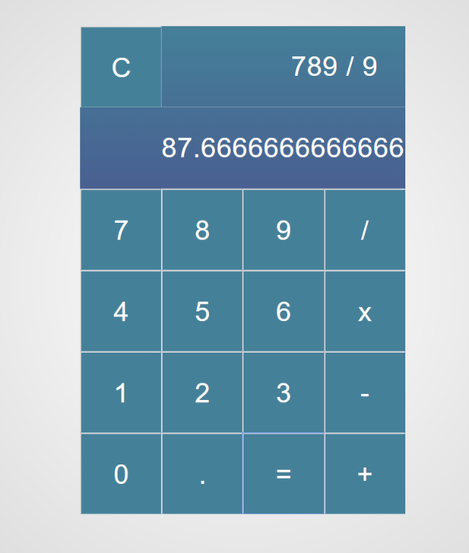
And we press "Clear", the expected result should be:
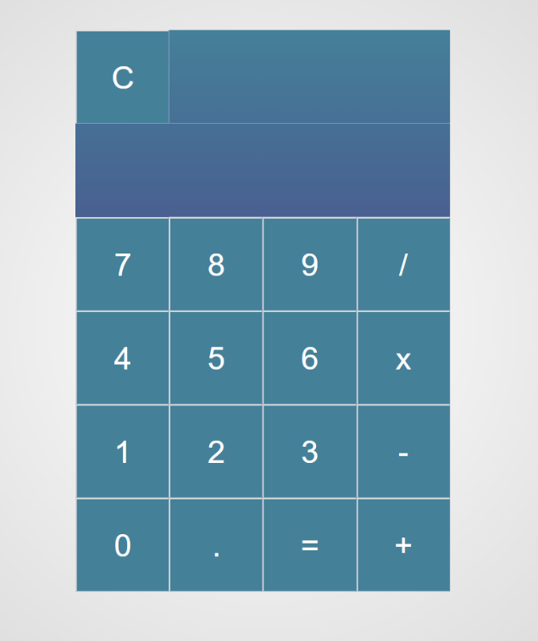

Order the Names
Write a function that orders names alphabetically.
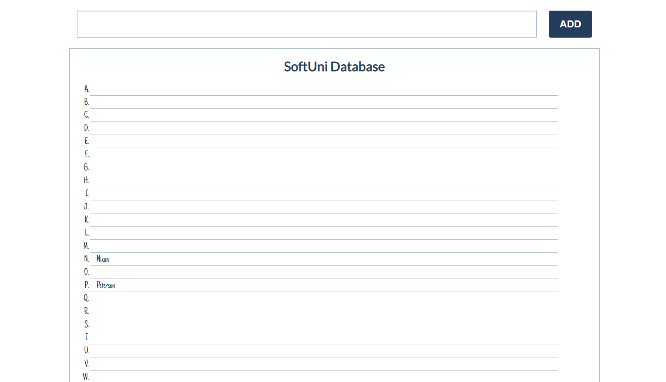
You will receive a name of a student as an input. When the "Register" button is clicked, you should
add the given student name in the SoftUni Database, while keeping the alphabetial order.
For instance, if we register David, his name should appear in the D column.
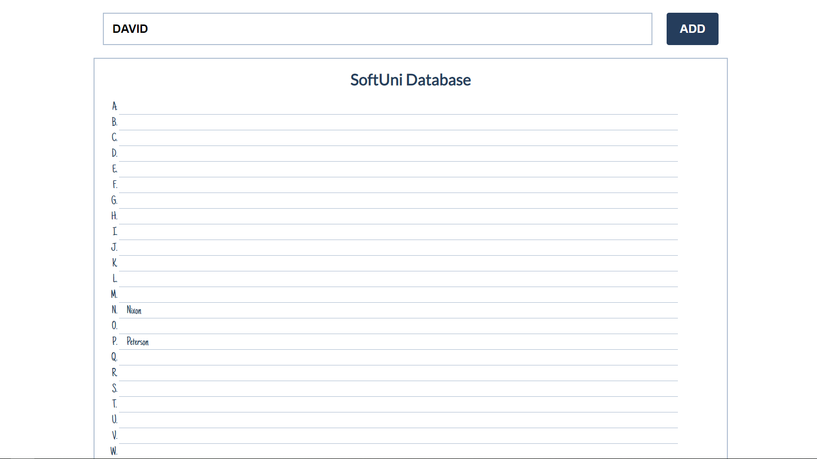

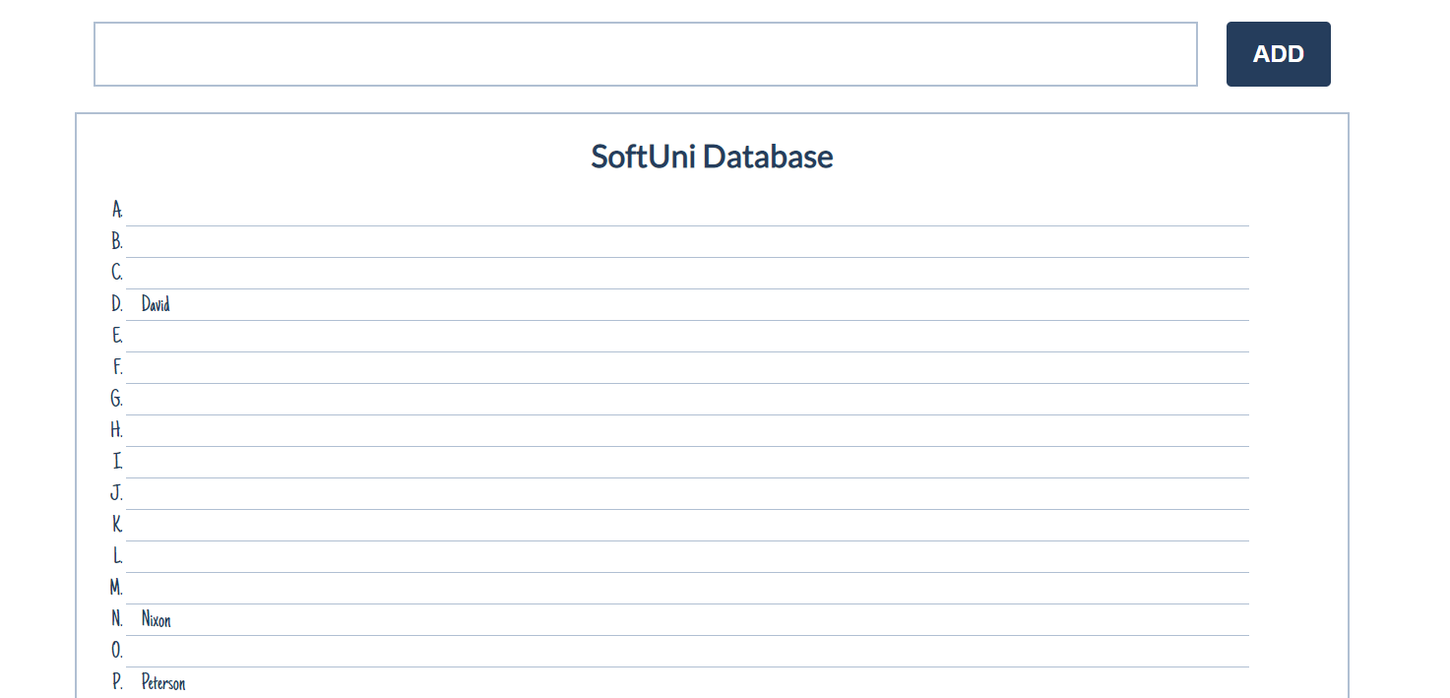
If you receive more than one name with the same starting letter, you should join all names by a
comma and a space (", ").
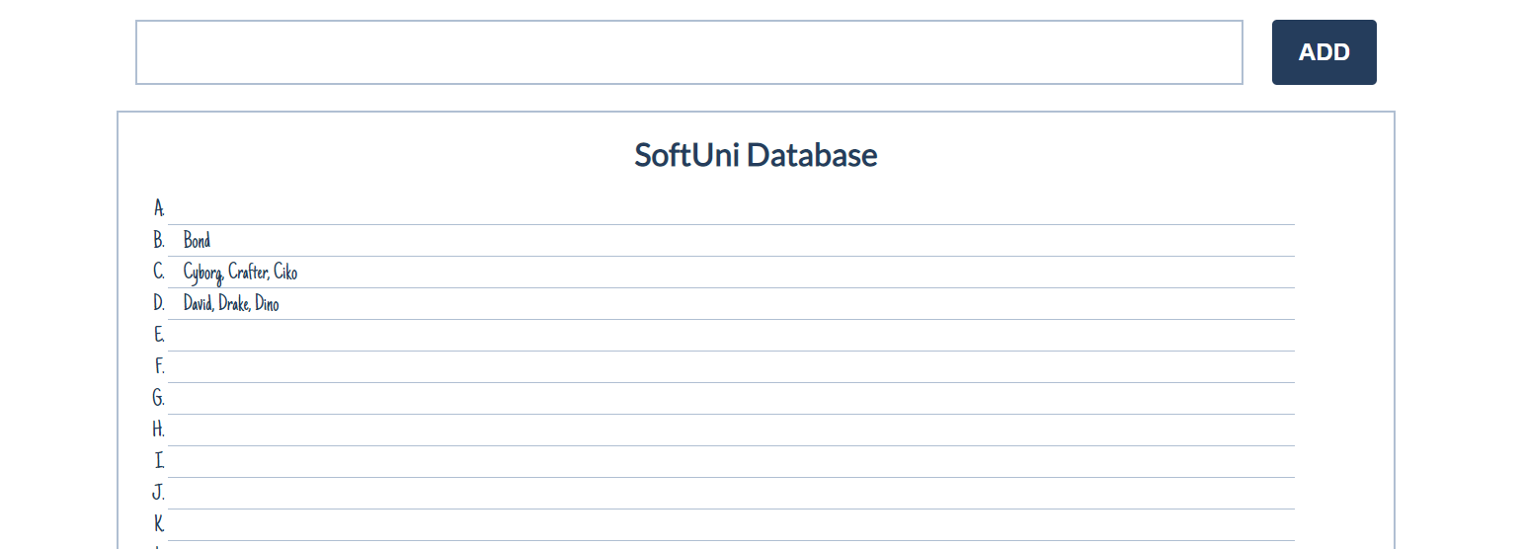

Table – Search Engine
Write a function that searches in a table by given input.
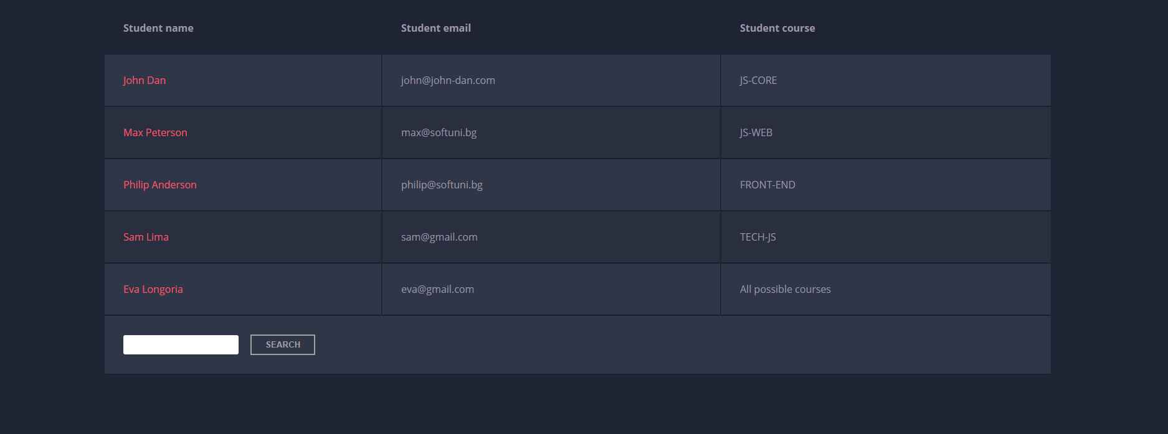
When the "Search" button is clicked, go through all cells in the table except for the first row (Student name, Student email and Student course) and check if the given input has a match (check for both full words and single letters).
If any of the rows contain the submitted string, add a select class to that row. Note that more than one row may contain the given string.
Оtherwise, if there is no match, nothing should happen.
Note: After every search ("Search" button is clicked), clear the input field and remove all already selected classes (if any) from the previous search, in order for the new search to contain only the new result.
For instance, if we try to find eva:
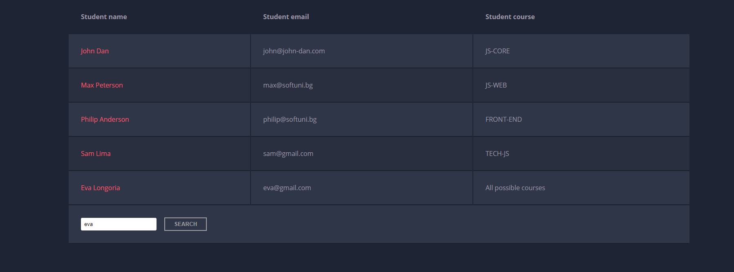
The result should be:
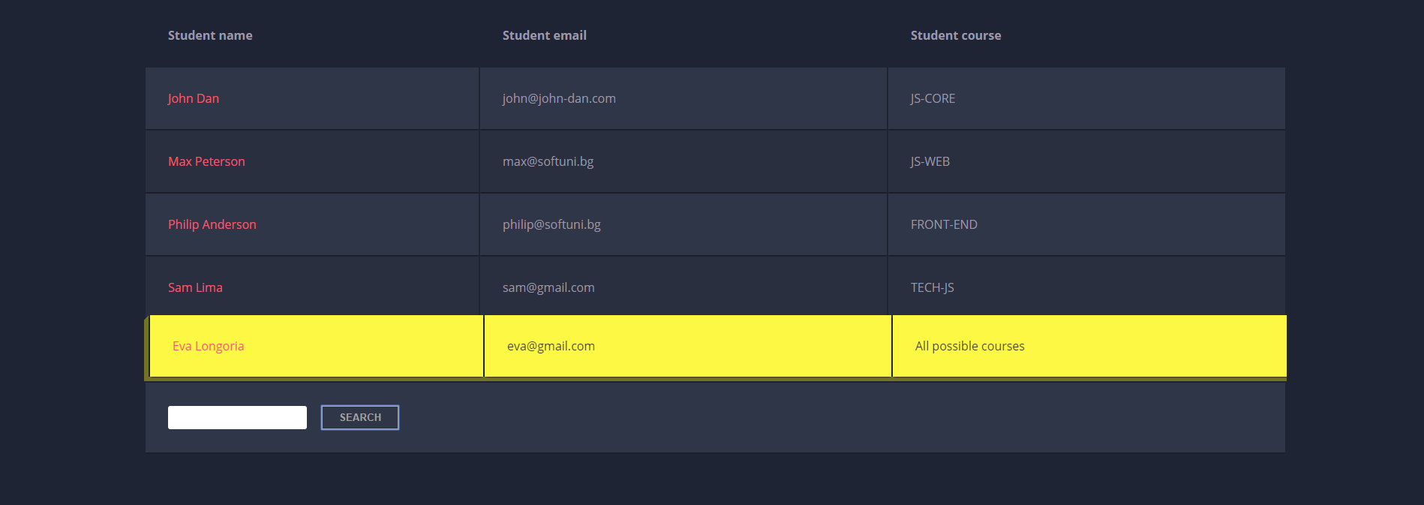
If we try to find all students who have email addresses in softuni domain, the expected result should be:
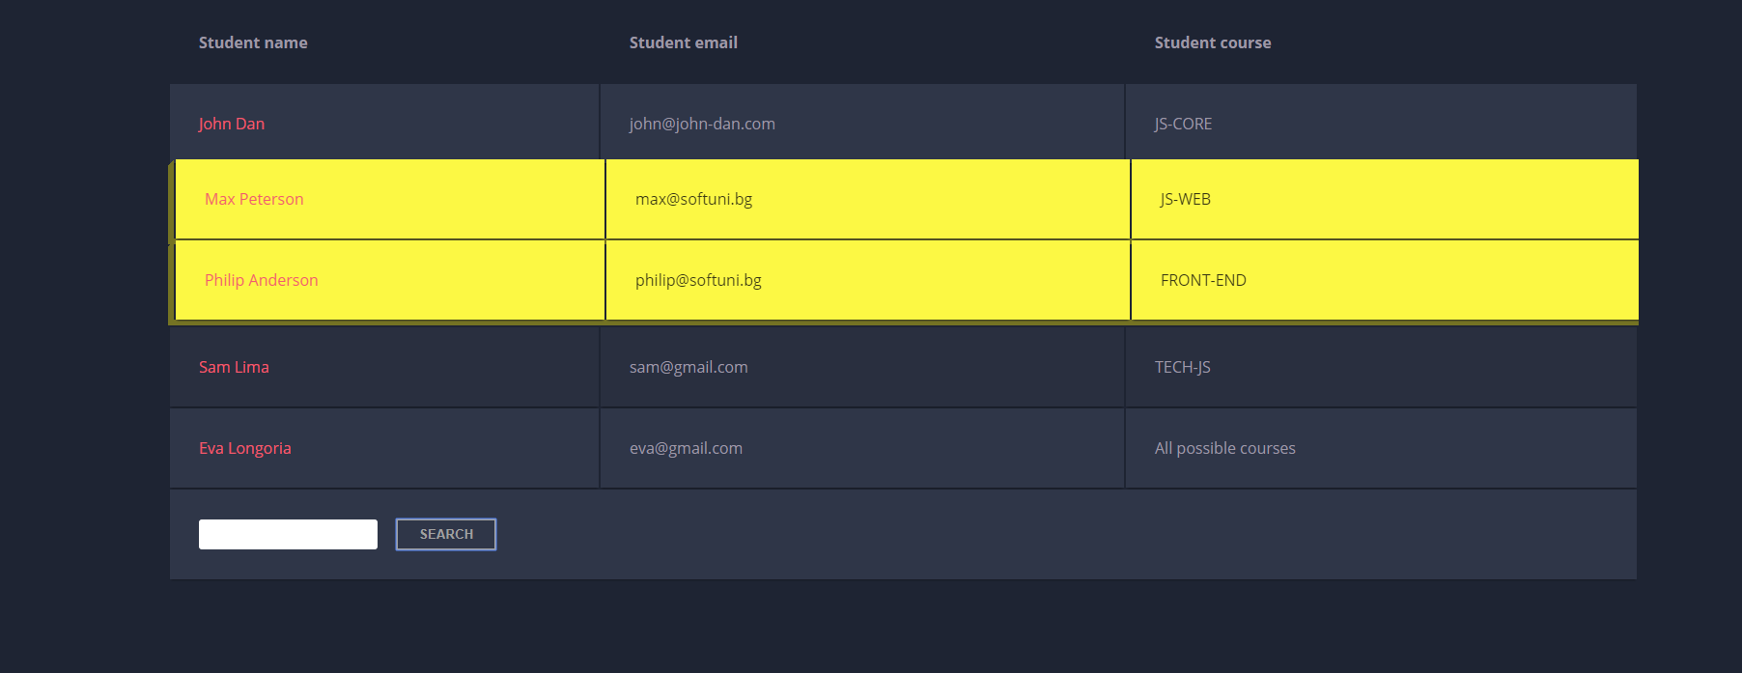

Shopping Cart
You will be given some products that you should be able to add to your cart. Each product will have a name, picture and a price.
When the "Add" button is clicked, append the current product to the textarea in the following format: "Added {name} for {money} to the cart.\n".
When the button "Checkout" is clicked, calculate the total money that you need to pay for the products that are currently in your cart. Append the result to the textarea in the following format:
"You bought {list} for {totalPrice}."
The list should contain only the unique products, separated by ", ". The total price should be rounded to the second decimal point.
Also, after clicking over "Checkout" and every from above is done you should disable all buttons. (You can't add products or checkout again, if once checkout button is clicked)

Examples
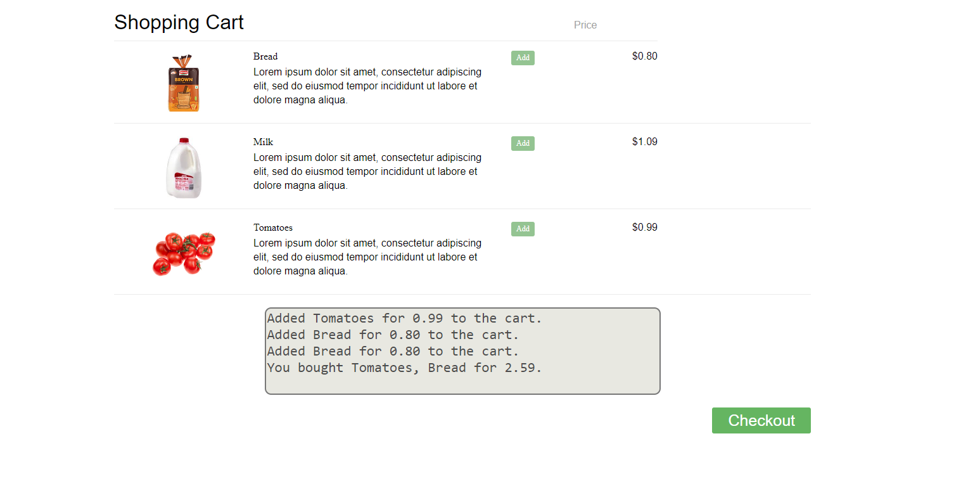

Furniture
You will be given some furniture as an array of objects. Each object will have a name, a price and a decoration factor.
When the "Generate" button is clicked, add a new row to the table for each piece of furniture with image, name, price and decoration factor (code example below).
When the "Buy" button is clicked, get all checkboxes that are marked and show in the result textbox the names of the piece of furniture that were checked, separated by a comma and single space (", ") in the following format: "Bought furniture: {furniture1} {furniture2}…".
On the next line, print the total price in format: "Total price: {totalPrice}" (formatted to the second decimal point). Finally, print the average decoration factor in the format: "Average decoration factor: {decFactor}"

Input Example
[{"name": "Sofa", "img": "https://res.cloudinary.com/maisonsdumonde/image/upload/q_auto,f_auto/w_200/img/grey-3-seater-sofa-bed-200-13-0-175521_9.jpg", "price": 150, "decFactor": 1.2}]

Examples
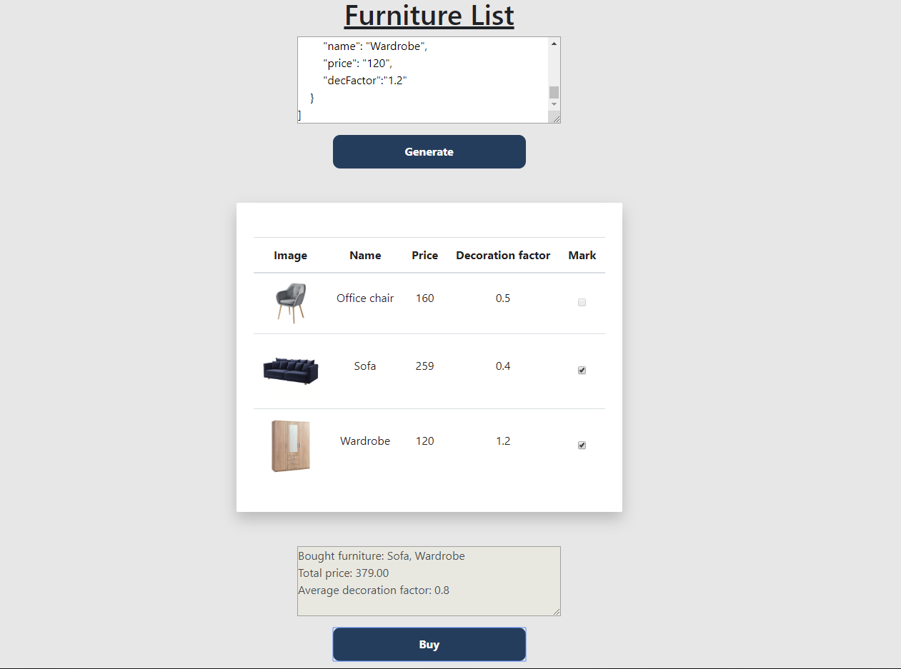
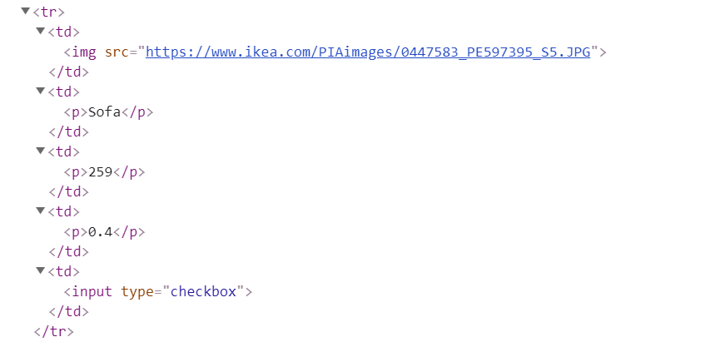

Cards
Write a function which checks cards, shows which one is greater and keeps history of all hands.
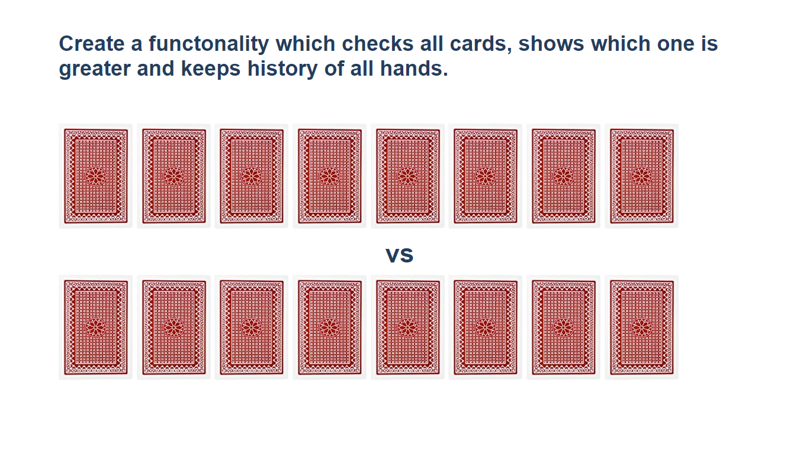
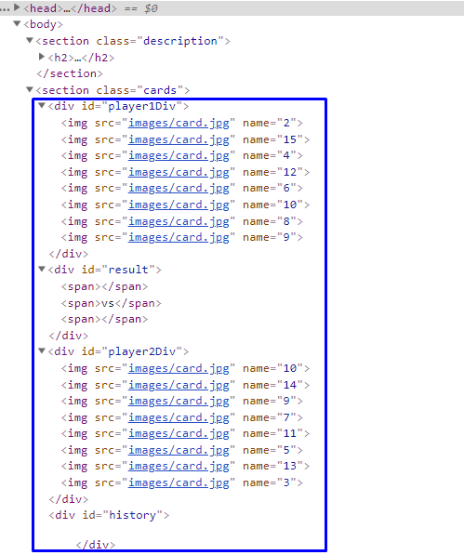
Firstly, add click events to all cards. When one of the cards is clicked, the current background card must be changed with the "whiteCard.jpg" picture (it is given in the skeleton) and the card name should be appended to one of the span elements in the div with id="result".
If a card from the top side is clicked, append the card name to the left span (first empty span), otherwise append the card name to the right span (second/last span).
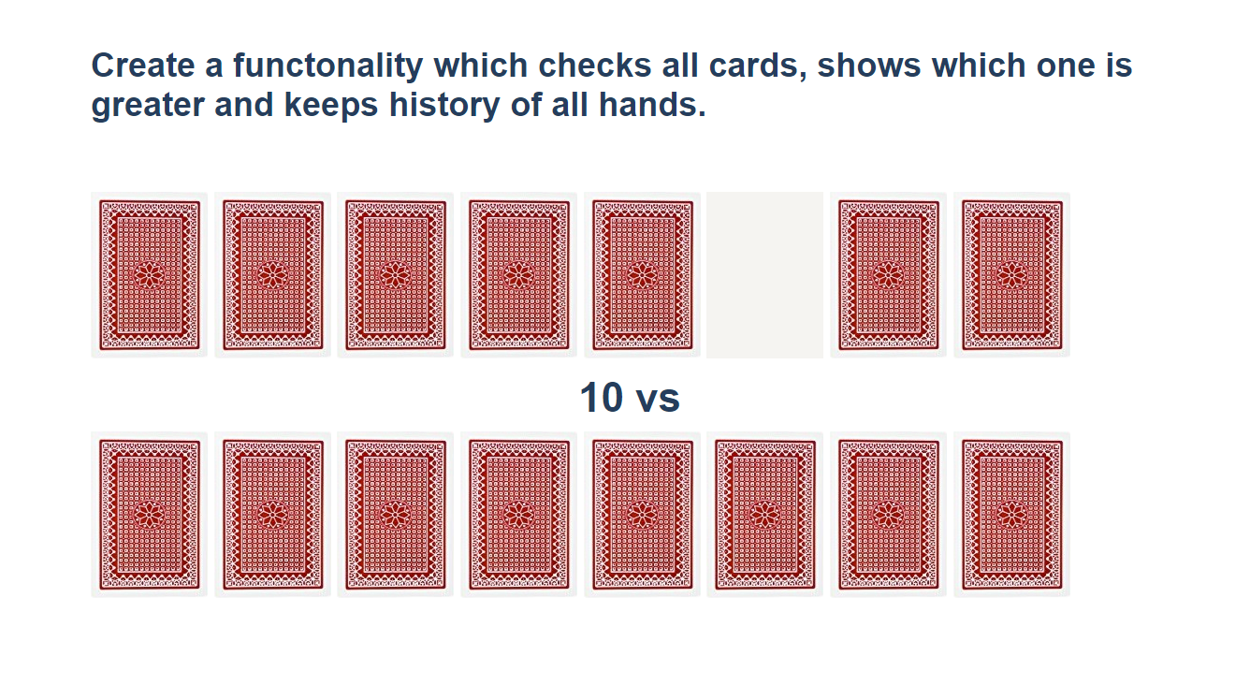
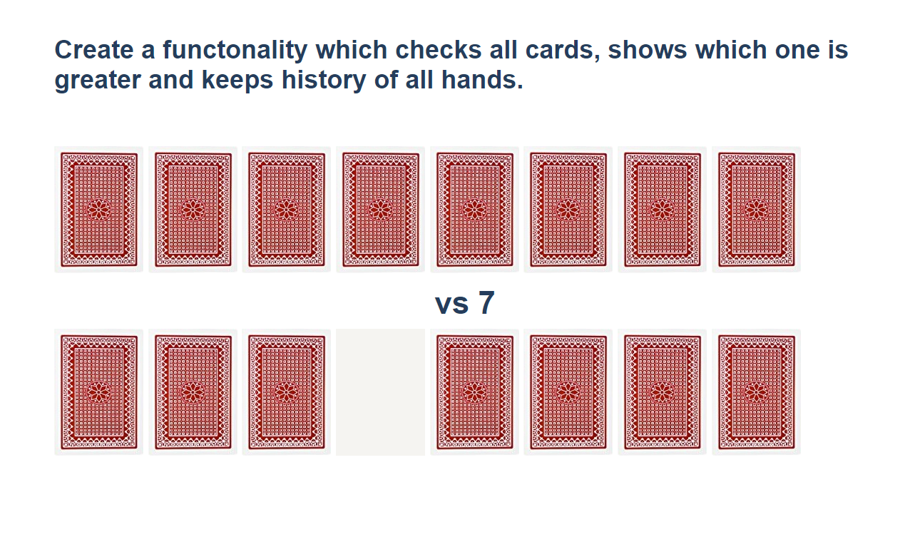
When cards from both sides are selected, check which one is greater. The greater card should have border "2px solid green" and the lower card - "2px solid red".
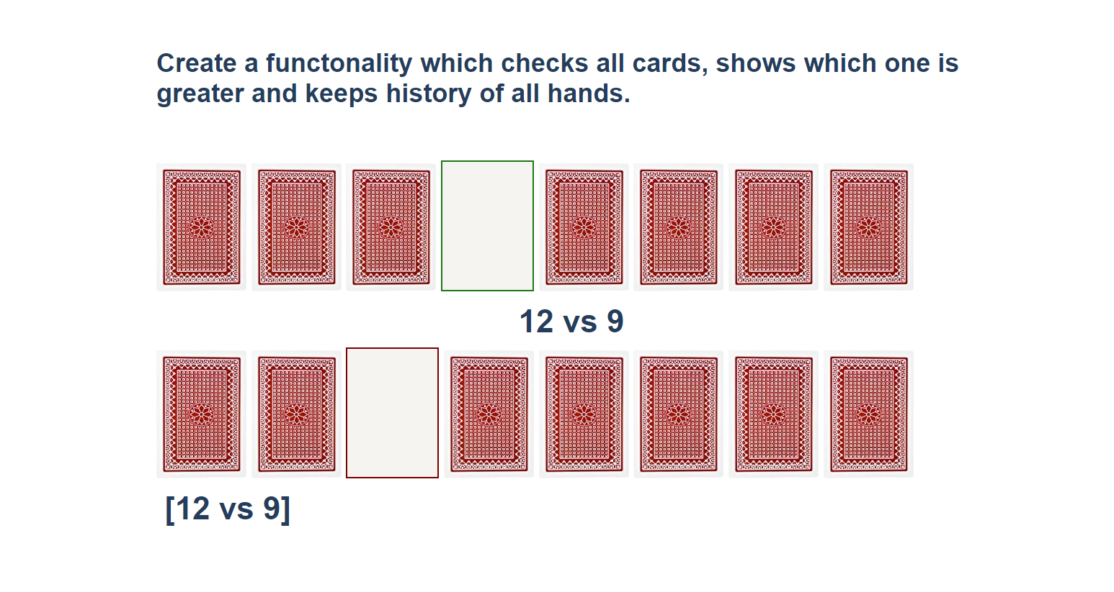
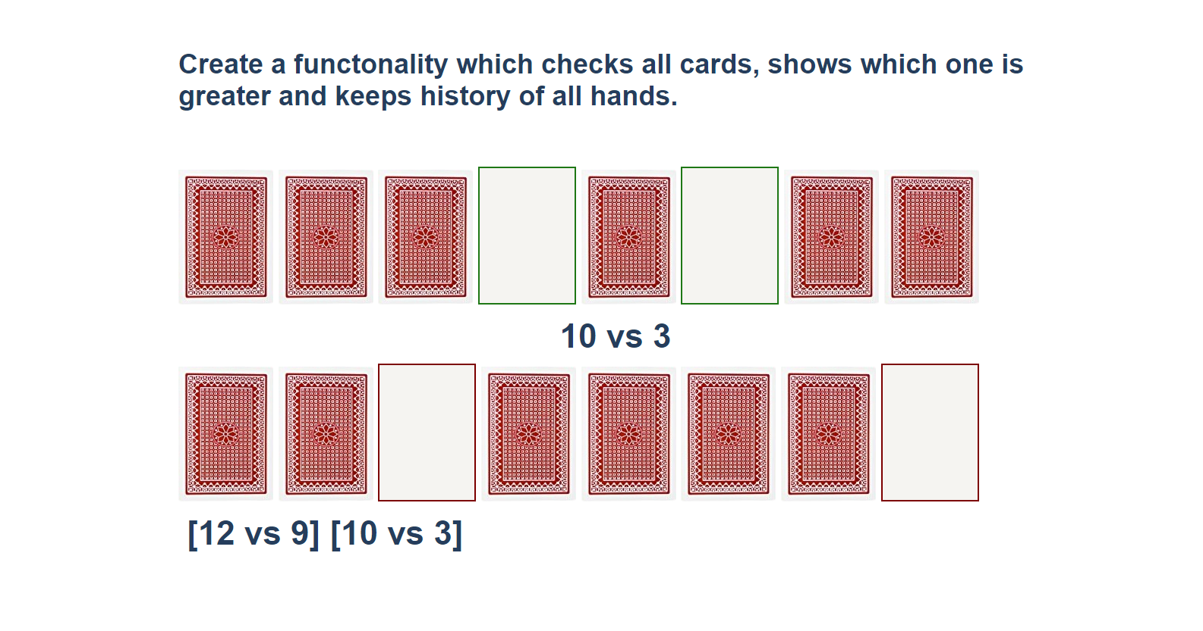
You should clear the span elements which hold the current card names when both are selected, and the winner is selected. After every hand, push the current card names in the history div in the following format:
[{top side card name} vs {bottom side card name} ]
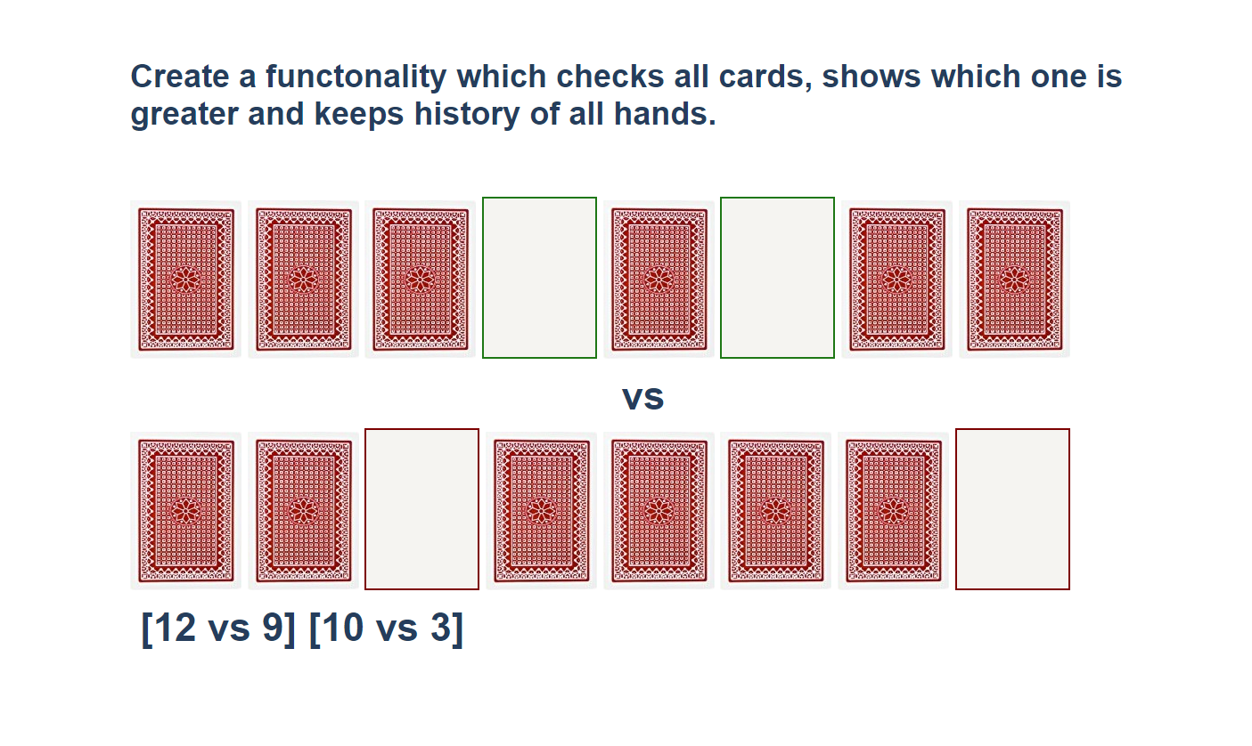

* Sudomu
Write a function that implements SUDOMU (Sudoku inside the DOM).
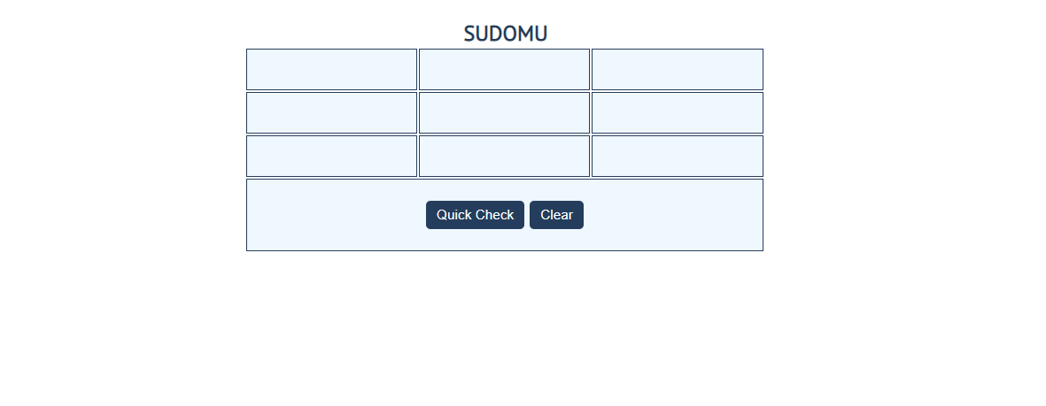
The rules are simple and they are the same as the typical sudoku game (for more information,
click here)
If the table is filled with the right numbers, and the "Quick Check" button is clicked, the
expected result should be:
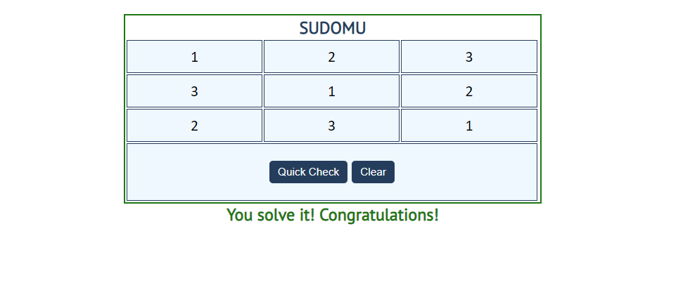
The table borer should be changed to: "2px solid green". The text content of the paragraph
inside the div with an id "check" must be "You solve it! Congratulations!"
The text color of that div must be green.
Otherwise, when the filled table does not solve the sudomu, the result should be:
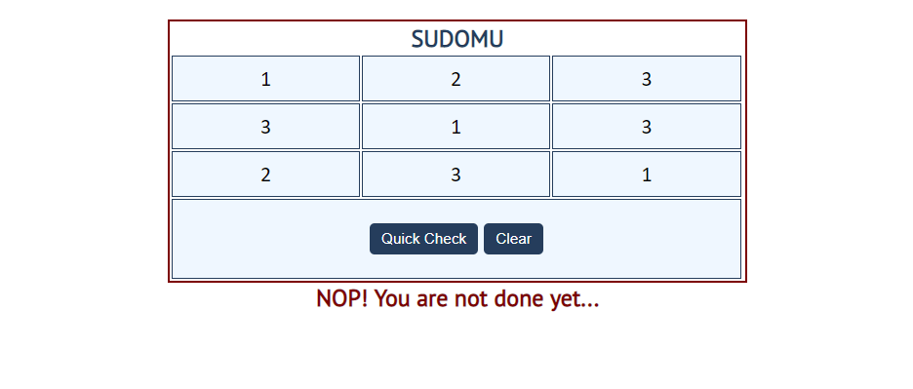
The table border should be changed to: "2px solid red".
The text content of the paragraph inside the div with an id "check" must be:
"NOP! You are not done yet…"
The text color of that div must be red!
The "Clear" button clears the whole SUDOMU (removes all numbers) and the paragraph
which contains the messages. It also removes the table border.


