Lab: Objects and DOM
Problems for in-class lab for the "JavaScript Advanced" course @ SoftUni. Submit your solutions in the SoftUni judge system at https://judge.softuni.bg/Contests/1801/Lab-DOM

Articles List
In this problem, you should create a JS functionality which creates articles and appends them into some article section.
The programs in this language are called scripts. They can be written right in the HTML and executed automatically as the page loads.
Scripts are provided and executed as a plain text. They don't need a special preparation or a compilation to run.
In this aspect, JavaScript is very different from another language called Java.
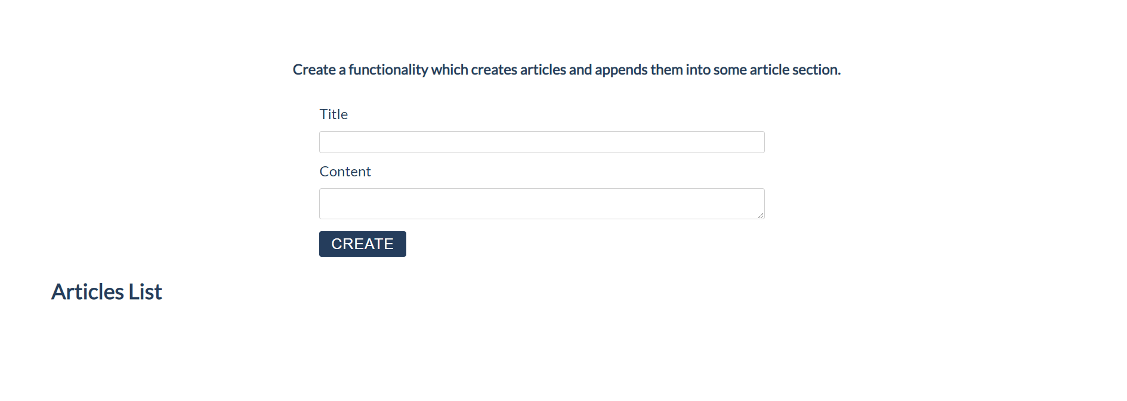

Constraints:
- Title value from the title input should be a heading 3 element <h3>
- Content text from the textarea element should be a paragraph <p>
- Both new created elements (h3 and p) should be appended to a new article element <article>
- The current article element should be appended to the section which has an id articles (#articles)
- You should create new article element only if title and content are not empty
- After the button is pressed you must clear the title value and text value

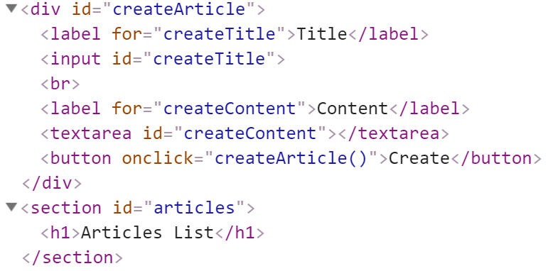

Input:
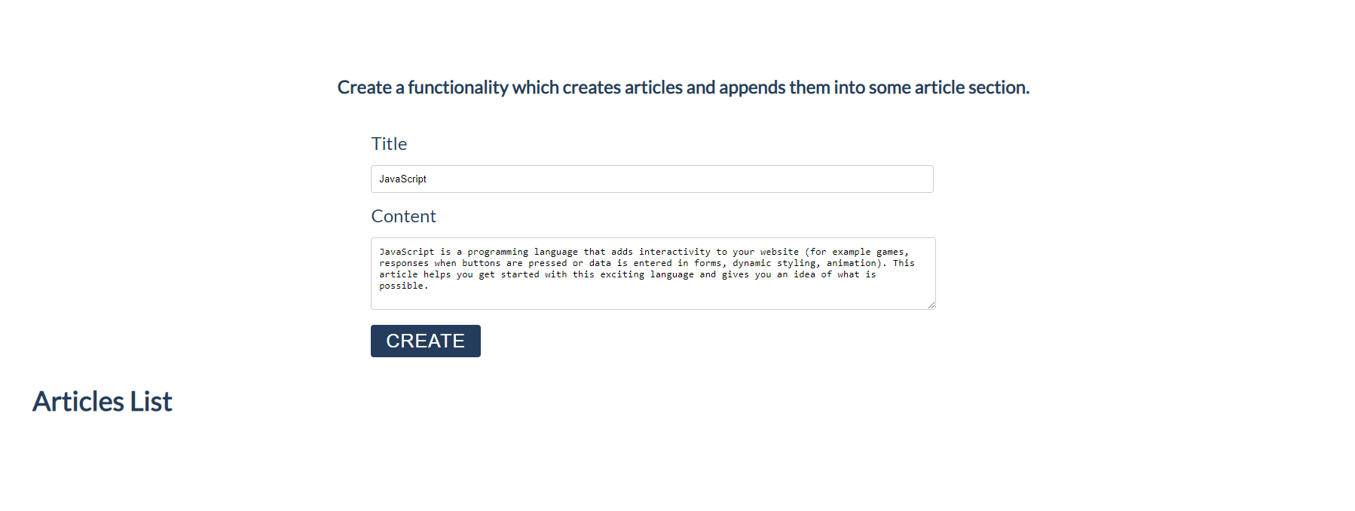

Output:
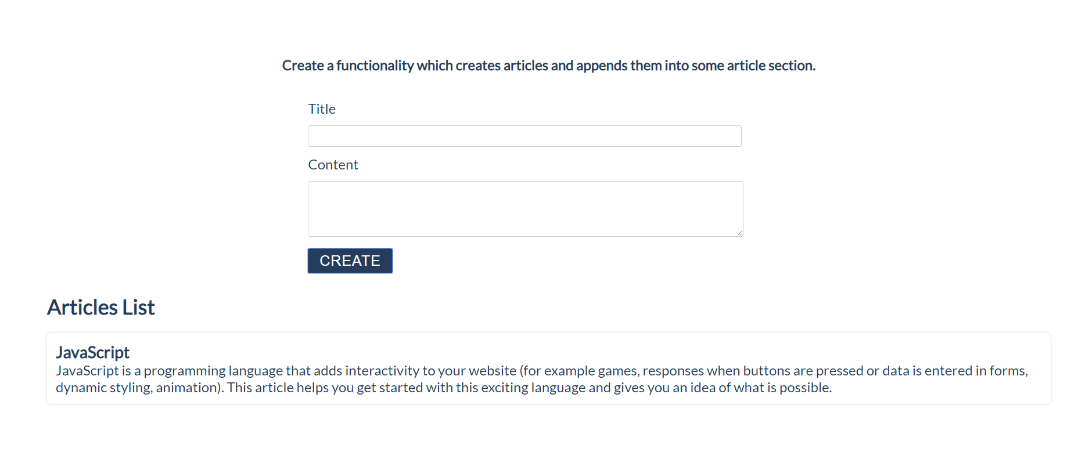
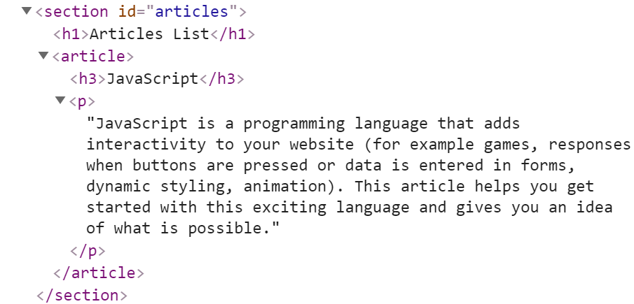

Format the Text
In this problem, you should create a JS functionality which formats the given text into paragraphs.
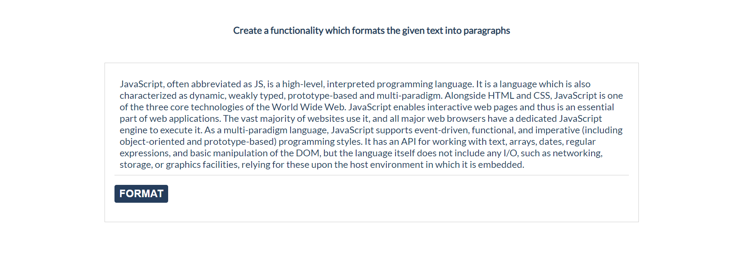
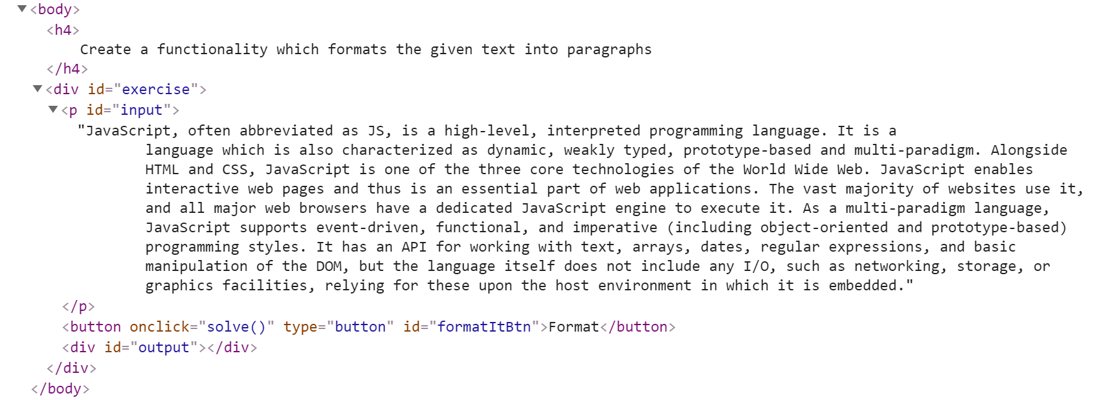
When the [Format] button is clicked, you need to format the text inside the paragraph with an id "input". The formatting is done as follows:
- You need to create a new paragraph element which holds no more than 3 sentences from the given input.
- If the given input contains less or 3 sentences, you need to create only 1 paragraph, fill it with these sentences and append this paragraph to the div with an id "output".
Otherwise, when you have more than 3 sentences in that input paragraph, you need to create enough paragraphs to get all sentences from the input text.
Just remember to restrict the sentences in each paragraph to 3.

Example:
- If the input paragraph contains 2 sentences, you need to create only 1 paragraph with these 2 sentences
- If the input paragraph contains 7 sentences, you need to create 3 paragraphs
- The first paragraph must contain the first 3 sentences
- The second paragraph must contain the other three sentences of the whole text
- The third paragraph will contain only the last sentence, because there are no more sentences in this paragraph
To find out how many sentences there are in the text, simply split the whole text by '.' Also, every sentence must have at least 1 character.
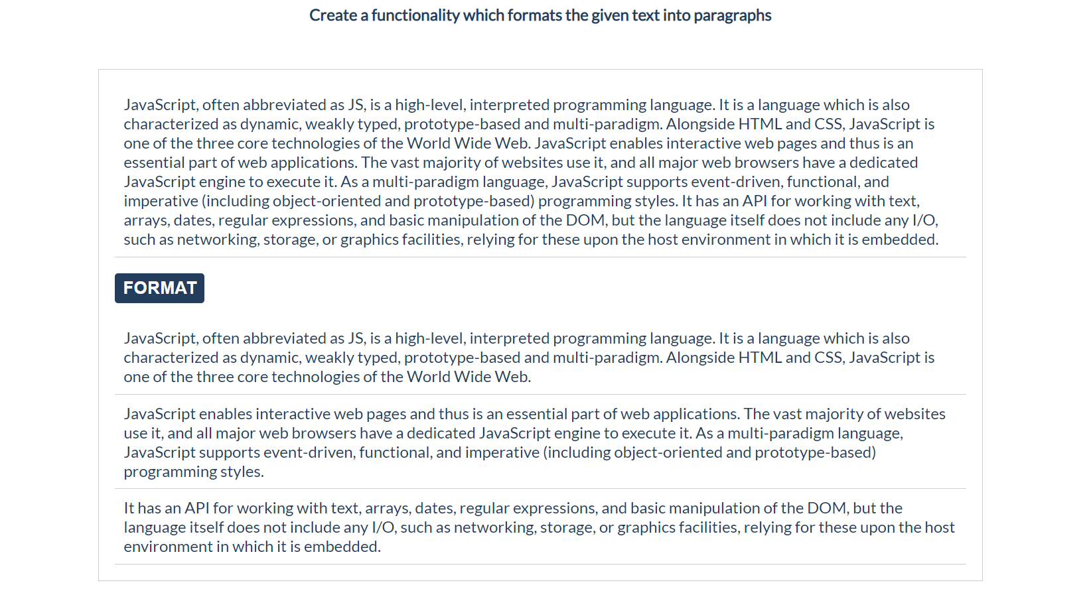
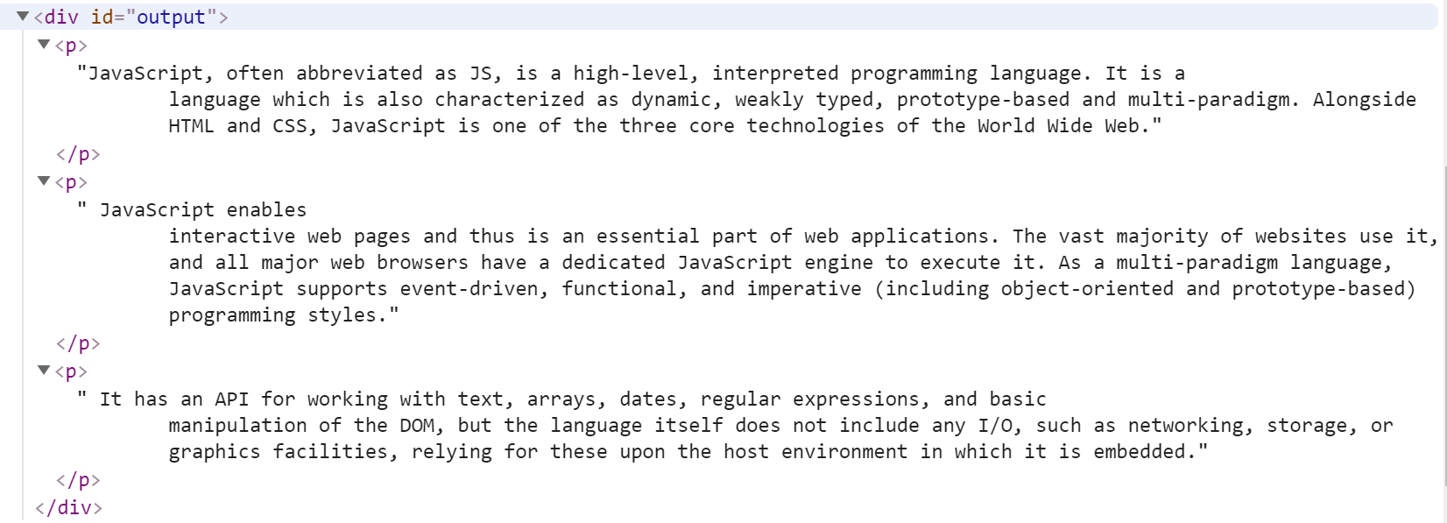

Growing Word
In this problem, you should create a JS functionality which changes the size and the color of a given paragraph on every click.
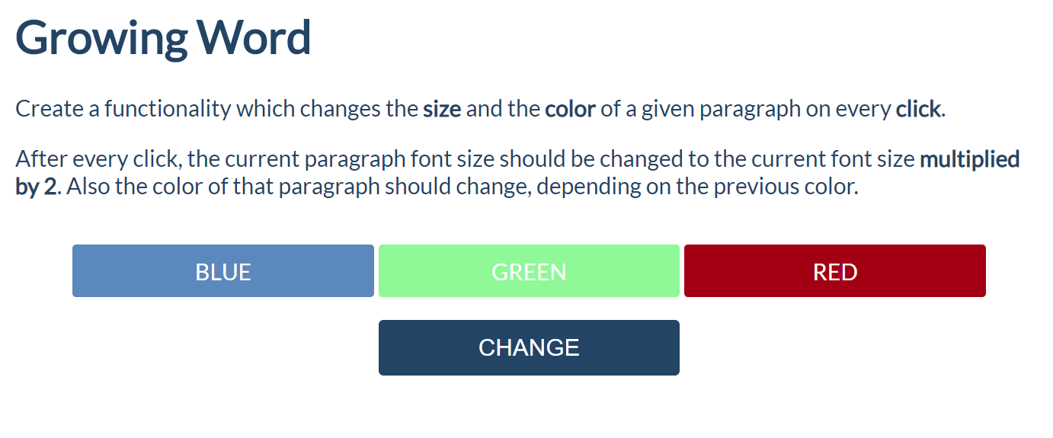
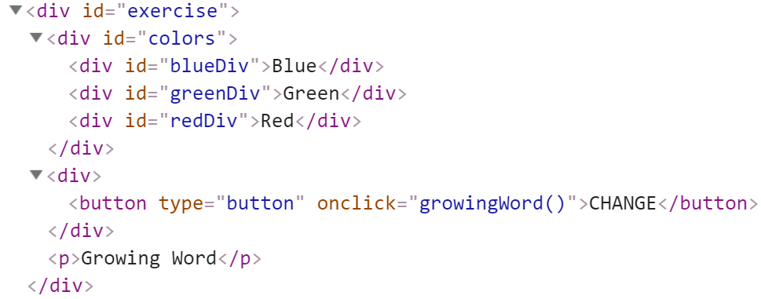
Every time when we click on the [CHANGE] button, the color and the size of the paragraph which contains "Growing Word" should change!
After every click, the current paragraph font size should be changed to the current font size multiplied by 2. Also, the color of that paragraph should change, depending on the previous color.

Example:
- If we click once, the color should be changed to blue and the font size should be 2 (First initial size)
- If we click twice, the color should be changed to green and the font size should be 4 (2 * 2)
- If we click three times, the current color of that paragraph should be changed to red and the font size should be 8 (4 * 2)
- If our paragraph already has a red color, on the next click, the color should turn to blue. Just loop throw these three colors (blue, green, red) again and again and again... while you are clicking on that button.
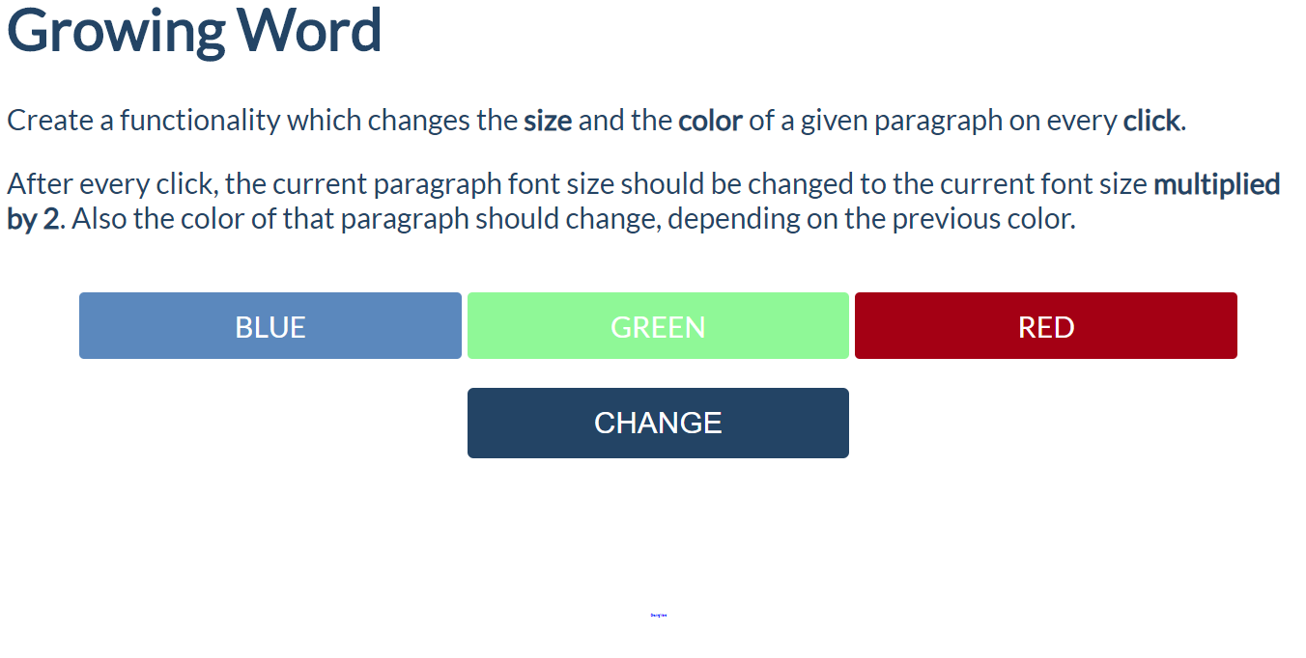
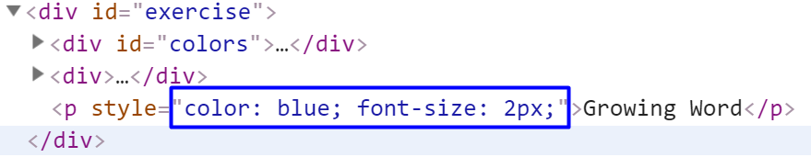

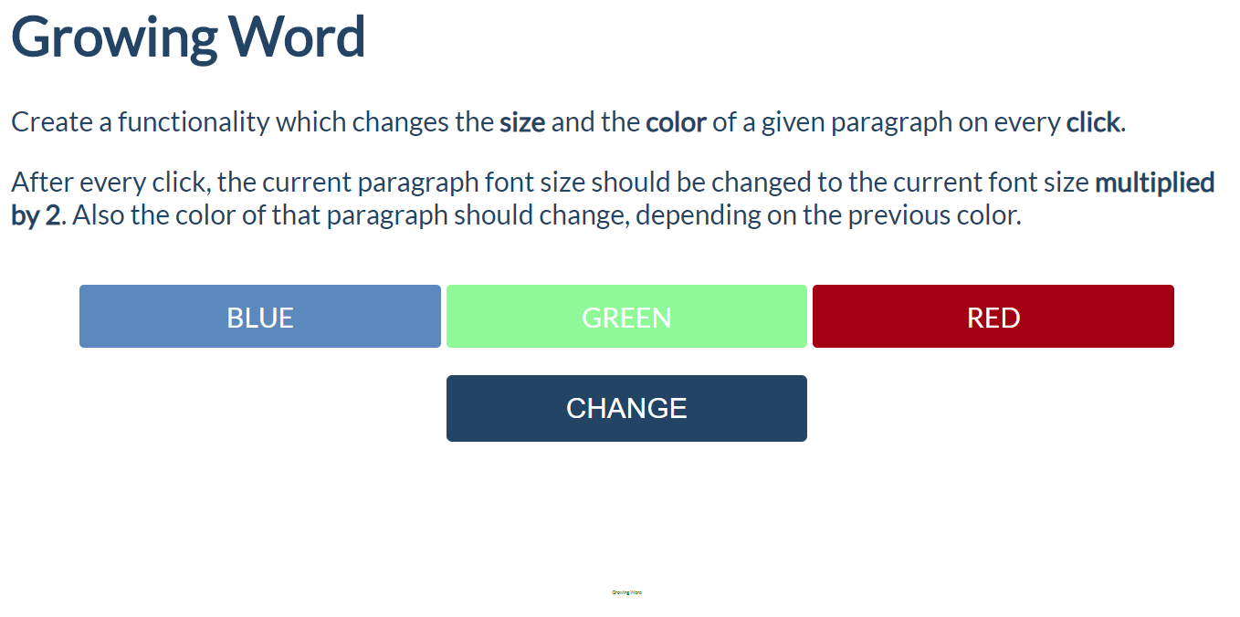
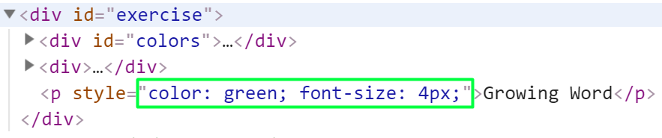
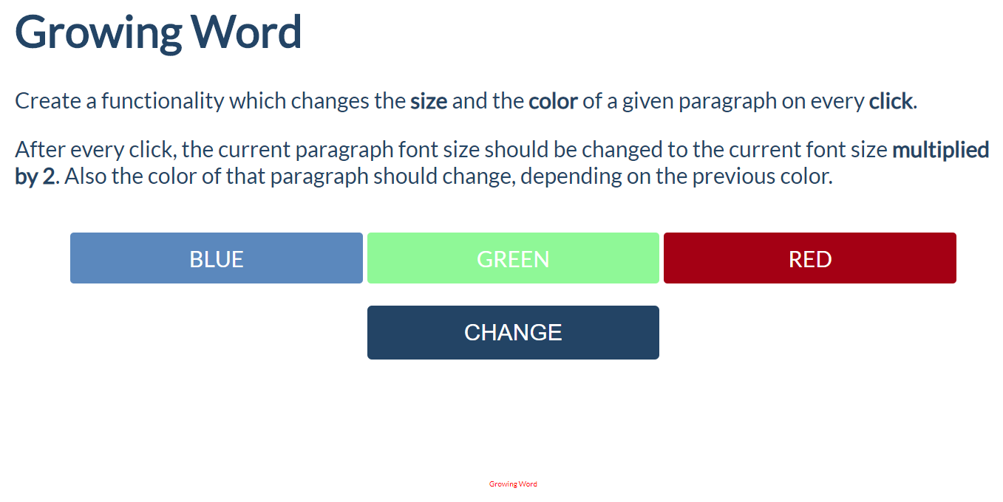
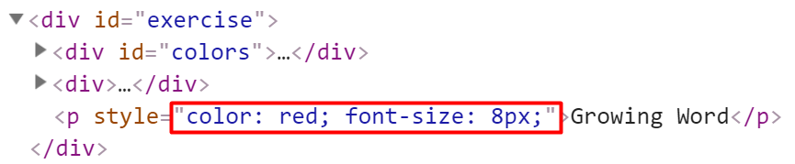

Visited Sites
In this problem, you should create a JS functionality that keeps track of how many times a
specific site has been visited.
For instance, if we click twice on the Gmail link and once on the YouTube link, the expected
result must be:

