**Hull University in association with**

Surname: Tindall

Forename(s): Kai

Signature: _________________________

Date submitted: ____________________

**East Riding College**

**Foundation Degree in Computing**

**ASSIGNMENT COVER SHEET**

**2018/2019 ACADEMIC SESSION**

|  |  |
| --- | --- |
| Reception anonymous marking code |  |

|  |  |  |
| --- | --- | --- |
| **Registration University Number:**  **(Starts with year of registration eg. 200199999):**  **College Number: 20278932** | | |
| **Location:**  **St Marys Walk** | **Tutor: Phil Earls** | |
| **Module:**  **Object Orientated Programming** | | |
| **Assignment Title:** | | **Word Count:** |

|  |
| --- |
| **Under the University scheme for anonymous marking, your name will remain concealed until after your assignment has been marked. Please print your name clearly in the box at the top right hand corner, then sign, fold and seal. *Your student registration number from your student card must be entered clearly in the box provided and written on each sheet of your assignment.*** |

**For work submitted by hand**, read the following statement and sign and date in the box above. This signature is understood as compliance with the statement. **For work submitted online** … read the following statement, complete the details required and attach this document to your work. Submission of this completed form as an attachment to your work will be understood to be equivalent to signing the form in person.

|  |
| --- |
| I declare that the work I am submitting for assessment contains no section copied in whole or in part from any other source unless it is explicitly identified by means of quotation marks, or in the case of very long quotations, by means of wholly indented paragraphs. I declare that I have also acknowledged such quotations by providing detailed references in an approved format. I understand that unidentified and unreferenced copying both constitute plagiarism, which is one of a number of very serious offences under the University of Hull’s Code of Practice on the Use of Unfair Means - www.hull.ac.uk/handbook |

Students submitting work by hand are asked to submit two copies of assignments, one copy of which will be returned after assessment. Students submitting work within Merlin should use the Portfolio and send work to “Submitted Work”. It is advisable, however, to retain a copy of your work as insurance against loss or damage.

Object Orientated Programming

Design Document

Kai Tindall

2020

Table of Contents

1 Scope 4

2 Drawings 5

2.1 Menu Design 5

2.2 Leader Board Design 5

2.3 Level Designs 5

Gate Level 5

Town Level 5

Keep Level 5

2.4 Sprite Designs 5

Squirrels 5

Friendly Archers 5

Enemy Privates 5

Enemy Captains 5

King Squirrel 5

3 Class Diagrams 6

3.1 Squirrels 6

# Scope

This document will deal with the design of the object orientated game I am designing, details of this game and how it will work can be found in more detail in my specification document.

This document will showcase the look of the game and the structure of some of the code. It will also explain some of the choices I have made.

# Drawings

## Menu Design

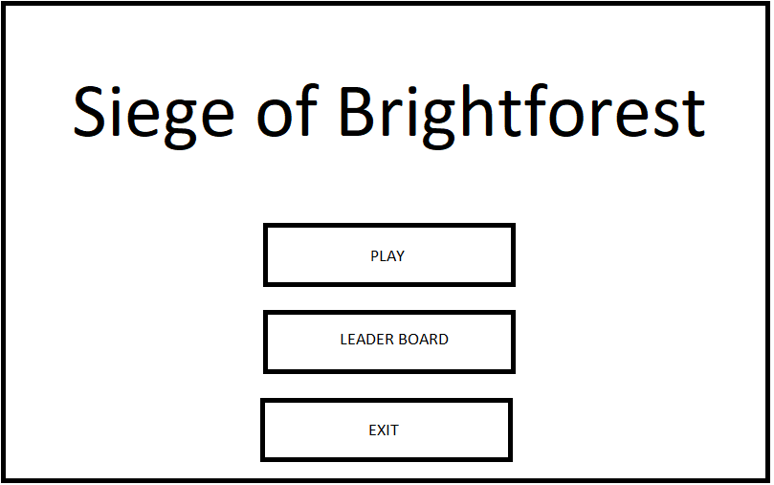

## Leader Board Design

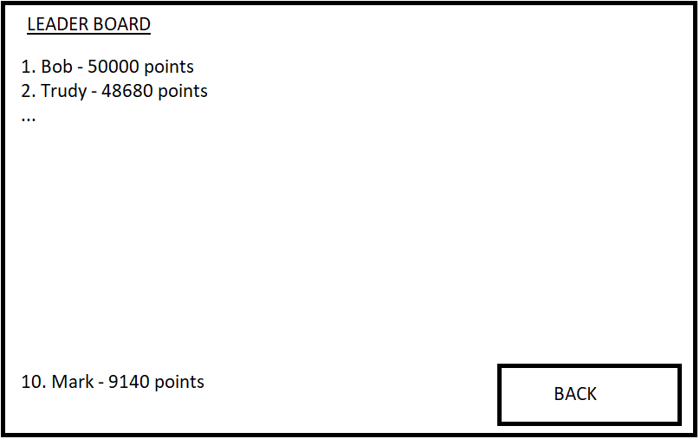

All ten names with scores by their side would be included, however for conciseness I did not put them on the design, which is what the “…” represents.

## Level Designs

Gate Level

Town Level

Keep Level

## Sprite Designs

Squirrels

Friendly Archers

Enemy Privates

Enemy Captains

King Squirrel

# Class Diagrams

## Squirrels