
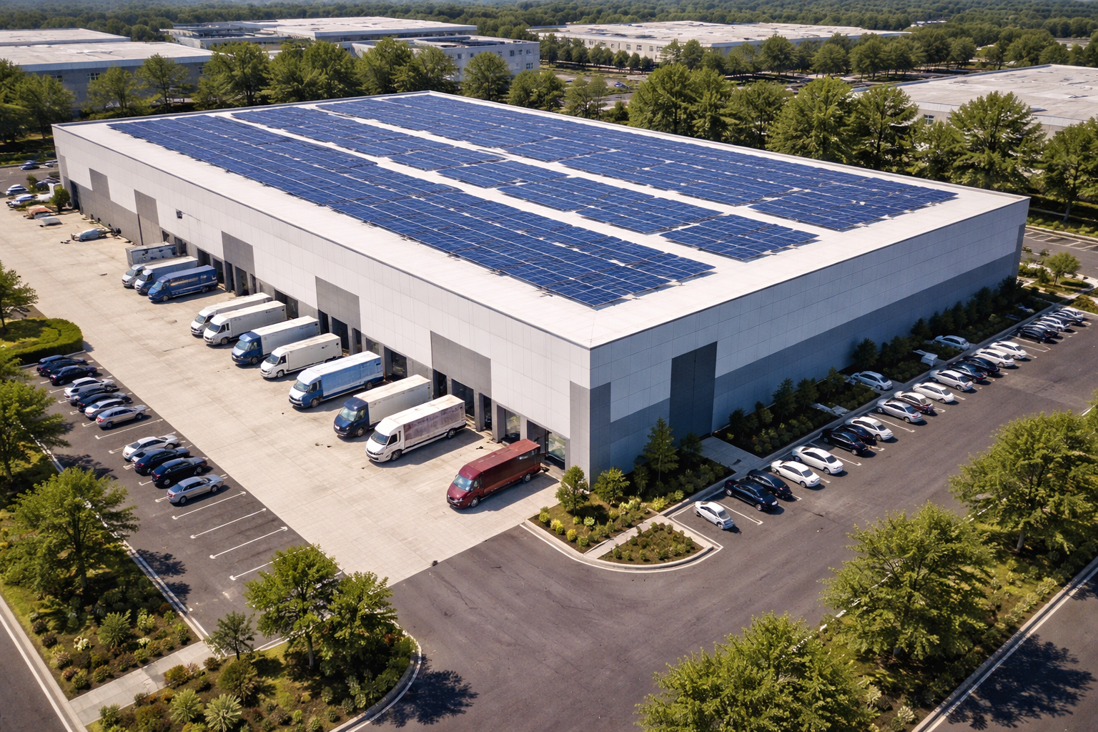
Solar is quickly becoming one of the cheapest new electricity sources for new generation globaly Building new solar generation on Industrial rooftops is one of the est ways to utilize the technology. Not only does the solar take up under utilized roof space but it also generates energy right where the energy is needed. By generating energy where it is used Utilities miniize the need for costly high voltage lines that span for hundreds of kilometers to provide electricity to the major urban industrial areas.
In it’s latest call for new generation Hydro Quebec has recently released an Appel Dd’offres to aquire up to 300 MWs of new solar generation. https://www.hydroquebec.com/achats-electricite-quebec/appels-propositions/2025-01.html.
Scale Cleantech and kWh Quebec are developing this project on behalf of the building sponsor [Dream industrial solar inc]. This project will be part of that competitive bidding process. Bids will be submitted in March 2026 and Projects awarded will be notified in january 2027.
Tel 555.543.5432 www.kwh.quebec\projectsite
Solar in Quebec .
[Project Address]
- Project Size
[kW DC / kW AC

- Planned Construction start
[Spring or Summer 2028/29]

- Developer/Contructor
Scale Cleantech and kWh Quebec

- Building Sponsor/Owner
Dream Industrial Solar

- Electricity Offtake
Hydro Quebec

Project Details
[Project Address]

