Our task is as follows:
Out of 4 PDF files: A.pdf, B.pdf, C.pdf and D.pdf build output pdf file which will contain:

- 1st page of the A.pdf
- pages 3, 4 and 5 of the B.pdf
- 1st page of the C.pdf
- again 1st page of the C.pdf
- all pages of the D.pdf
- 1st page of the D.pdf
and as the last page:
- 1st page of the A.pdf

Below picture shows how the setup looks like in the application

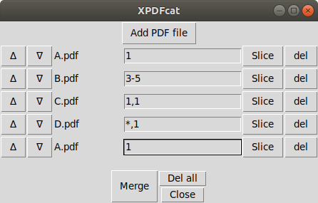

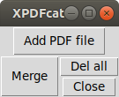

Step 1: Open Xpdfcat.pwy
($ python3 Xpdfcat.pyw )

