Unit 2 Academic Research Papers in Engineering and Science:
Publication, Structure, and Format

Reading Passage 2.1 Publishing an Academic Research Paper
Publishing an academic research paper involves several key steps, beginning with the submission of the manuscript and ending with its publication if it is accepted.
First, researchers submit their paper to an appropriate academic journal or conference that aligns with their field of study. The submission must follow the journal's or conference's formatting and content guidelines.
Once submitted, the paper undergoes screening by the journal editor. If it passes the editor's screening, it is sent to peer review, a process in which experts in the field called reviewers evaluate its quality, originality, and validity. Reviewers provide feedback and recommend whether the paper should be accepted, revised, or rejected.
After the peer review process, the paper may be accepted for publication, rejected, or sent back for revisions according to the editor’s assessment. If major revisions are required, the authors must address the reviewers' comments and resubmit the paper for further evaluation.
For conference papers, if accepted, the work is typically included in the conference proceedings, a collection of research papers presented at the event. If the paper is accepted by a journal, it undergoes further editing before being officially published.
Overall, this process helps ensure the quality of research and contributes to the advancement of knowledge in the academic community.

Comprehension Questions
Read Passage 2.1 and complete the flowchart showing how an academic journal paper is published. Write one word in each blank from the Word Bank (see below).

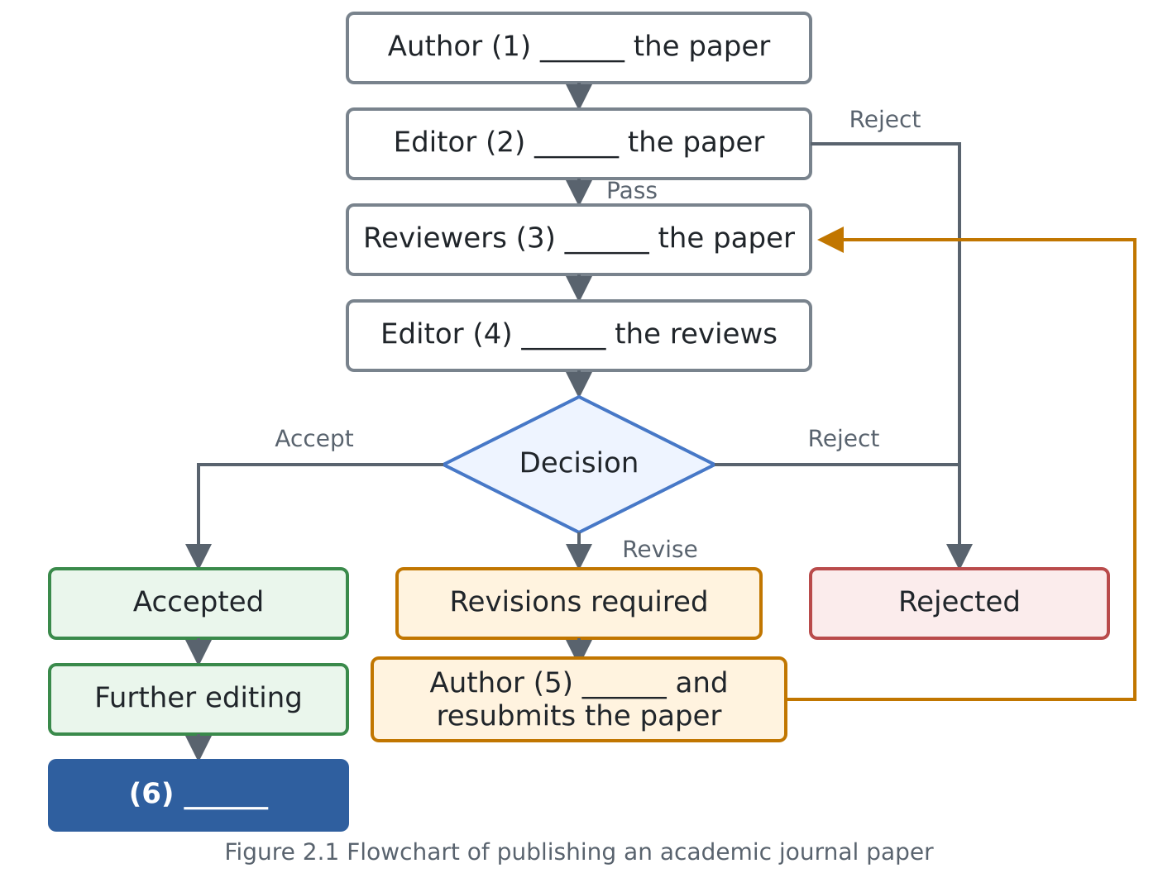

Word Bank: assesses / Published / screens / revises / submits / review

(1) |  | (2)
(3) |  | (4)
(5) |  | (6)

Reading Passage 2.2 Research Paper Structure 論文の基本構造

A typical research paper follows a clear and organized structure. Its exact structure varies by discipline and journal. However, the main body of a scientific or engineering paper commonly follows the IMRaD structure: Introduction, Method, Results, and Discussion. In addition to these four sections, a research paper usually includes other elements, such as a title, author names, affiliations, an abstract, keywords, conclusions, and references. The main elements are as follows:

- Title: It is a concise statement that shows the main topic or research question. It should be specific and informative.
e.g., × Too general: A Study of Solar Panels
(太陽光パネルに関する研究)
○ Specific and informative: Effects of Dust on the Power Output of Solar Panels
(ほこりが太陽光パネルの発電出力に及ぼす影響)
- Authors: This section lists the names of the people who conducted and wrote the research.
- Authors' Affiliations: These are the universities, companies, or research institutions to which the authors belong:
e.g., Shibaura Institute of Technology, Toyota Motor Corporation, or the National Institute of Advanced Industrial Science and Technology (AIST)
(例：芝浦工業大学，トヨタ自動車，産業技術総合研究所)
- Abstract: It is a summary of the entire paper (usually around 150-300 words). It usually includes the purpose, methods, main results, and conclusions of the study.
- Keywords: They are important terms that represent the main topics of the paper. They help readers find the paper in databases:
e.g., photovoltaic systems, energy efficiency, and renewable energy.
(太陽光発電システム，エネルギー効率，再生可能エネルギー)
―― Main Text (本文) ――
- Introduction: This section explains the background and significance of the research, reviews relevant previous studies, and presents the research questions (RQs), objectives, or hypotheses.
- Method: This section describes how the study was conducted. It may include the research design, participants, materials, procedures, and methods of analysis. It ensures that other researchers can replicate the work.
- Results: This section presents the findings of the study, often using tables, graphs, or figures. The findings are usually reported without detailed interpretation.
- Discussion: This section interprets the results and relates them to the research questions and previous studies. It may also explain the implications and limitations of the study and suggest directions for future research.
- Conclusion: This section summarizes the main findings and their broader significance, providing a final perspective on the research.
―― End Matter (本文後の項目) ――
- Acknowledgement: This section recognizes people, organizations, or funding bodies that supported the research but are not listed as authors.
- References: This section lists all the sources cited in the paper according to a specific citation style (e.g., IEEE, APA, MLA, Chicago) See “A. Comparing Citation Styles”.
- Biography: It provides information about an author’s background, affiliations, and research interests. It appears in some journals but is not an essential section of every paper.
- Appendix: It contains supplementary information, such as detailed data, calculations, or additional figures that are not included in the main text.

A. Comparing Citation Styles:
Different academic fields use different citation styles. The examples below show how the same paper is listed in four styles. Notice the differences in author names, the position of the publication year, capitalization, punctuation, and the presentation of page numbers and the DOI (Digital Object Identifier: a unique and permanent code used to identify and find an academic publication online).

1. IEEE (Engineering, Computer Science)*
[1] Z.-H. Lin and S. Smith, “A natural user interface for realistic tactile perception of object surface texture,” in 2017 9th International Conference on Intelligent Human-Machine Systems and Cybernetics (IHMSC), vol. 2, 2017, pp. 370–373, doi: 10.1109/IHMSC.2017.194.
2. APA (Social Sciences)
Lin, Z.-H., & Smith, S. (2017). A natural user interface for realistic tactile perception of object surface texture. In 2017 9th International Conference on Intelligent Human-Machine Systems and Cybernetics (IHMSC) (Vol. 2, pp. 370–373). IEEE. https://doi.org/10.1109/IHMSC.2017.194
3. MLA (Literature, Languages)
Lin, Zih-Hao, and Shana Smith. “A Natural User Interface for Realistic Tactile Perception of Object Surface Texture.” 2017 9th International Conference on Intelligent Human-Machine Systems and Cybernetics (IHMSC), vol. 2, IEEE, 2017, pp. 370–73. https://doi.org/10.1109/IHMSC.2017.194.
4. Chicago (History, Humanities)
Lin, Zih-Hao, and Shana Smith. “A Natural User Interface for Realistic Tactile Perception of Object Surface Texture.” In 2017 9th International Conference on Intelligent Human-Machine Systems and Cybernetics (IHMSC), 2:370–73. IEEE, 2017. https://doi.org/10.1109/IHMSC.2017.194.

* IEEE: The world’s largest technical professional organization. Its publications and standards are widely recognized in engineering and computer science.

B. Worksheet Activity
Use the provided conference paper to complete the “Structure of a Research Paper Worksheet.” Identify its sections and examine how the paper is organized.
- 論文：https://ieeexplore.ieee.org/document/8048178 (有料なのでLMSで配布)
- 掲載元のProceedings：https://ieeexplore.ieee.org/xpl/conhome/8046763/proceeding

C. Comprehension Questions (Homework to be submitted via the LMS)

Reading Passage 2.3 Research Paper Formatting
Properly formatting a research paper according to the required template is crucial for several reasons. First, it ensures consistency, making it easier for readers to navigate and understand the content. Following the template also shows professionalism and attention to detail, which makes the work more credible. Furthermore, journals, conferences, and academic institutions often have specific formatting requirements, and failure to follow them can lead to rejection or delays in publication. Standardized formatting also aids in the peer review process, as it allows reviewers to quickly locate sections and assess the paper's quality. Overall, following the template ensures clarity, professionalism, and compliance with academic standards.

Comprehension Questions
Choose the correct answer.
- Why is consistent formatting helpful to readers?
a. It helps them predict the research results.
b. It makes the paper easier to navigate and understand.
c. It helps them understand every technical term.
- What may happen if authors do not follow the required format?
a. The paper may be rejected, or its publication may be delayed.
b. The paper may appear more professional.
c. The paper may be published more quickly.
- How does standardized formatting help reviewers?
a. It helps them quickly find sections and assess the paper.
b. It guarantees that the paper will be accepted.
c. It helps them decide whether the research topic is original.

