Cloud Architecture Protocol Specification
This standard specifies container hardening and permission bounds.
Security Layer | Policy Rule
Network Proxy | Mutual TLS enforced on port 8443
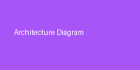

References
[1] NIST Special Publication 800-190, Application Container Security Guide.

