Connected Vehicle Intelligence Hackathon
ORBIT — EV Charge Orchestrator
Solution Document
Field | Value
Submitted by | [Team Name]
Team members & roles | [Name – role – email, for each member]
Problem space chosen | EV charging and battery health for mixed fleets (cost-optimal charging under time-of-use tariffs, stranding prevention, battery state-of-health)
Repository URL | [Link]
Demo video URL (≤ 5 min) | [Link]
Date of submission | [DD/MM/YYYY]

1. Executive Summary
Fleet operators electrifying their vehicles pay peak tariffs when vehicles charge on arrival, strand vehicles that run out of charge between chargers, and notice battery degradation only when a pack fails. ORBIT turns a live stream of vehicle telemetry into charging decisions: it predicts range and battery health, schedules every charge into the cheapest tariff window that still meets the departure time, routes low-charge vehicles to the nearest charger they can actually reach, and raises stranding and battery alerts in under a second.
Key results, all measured on one laptop (Apple M4, Docker Desktop with 10 CPUs):
- Ingestion: 100,384 events/s from 100,000 simulated vehicles into Kafka with zero errors; 3x shift-start bursts absorbed without loss.
- Latency: vehicle visible on the dashboard path within 100 ms at p95; critical alerts within 250 ms; API p95 29 ms and p99 77 ms at 448 requests/s.
- Savings: the dynamic-programming scheduler is 50.5 % cheaper than charge-on-arrival in benchmarks; a live plan charged entirely at ₹6.5/kWh and saved ₹82.80 against the baseline.
- Resilience: broker killed mid-stream for 20 s: 345,994 records buffered, 0 dropped, all consumers recovered.
- Quality: 316 Python tests at 95 % coverage, 39 web tests, 9 Go packages, Testcontainers integration tests, BDD scenarios, chaos test.
What sets it apart: a guard-railed AI agent that can only propose actions a manager approves, with every step audited; pgvector similarity that finds vehicles degrading like a known-bad pack; and profiling-driven engineering that is documented with before and after numbers.

2. Problem Statement & Validation

2.1 Problem Statement
An EV fleet manager needs a way to schedule and route charging across hundreds or thousands of vehicles because uncoordinated charging strands vehicles mid-shift, pays peak tariffs and hides battery degradation until a pack fails, which today costs an estimated 15–30 % of fleet energy spend plus tow-and-lost-shift costs for every stranded vehicle.
Primary user: fleet manager of an EV or mixed fleet.
Secondary stakeholders: fleet finance (energy cost and savings), OEM battery and warranty teams (state of health), drivers (no stranding), auditors (who did what with location data), sustainability teams.

2.2 Evidence & Validation
Evidence / Assumption | Source or Method | What It Shows | Confidence
Commercial time-of-use tariffs differ 2–3x between peak and off-peak | Published Indian commercial EV tariffs; modelled as ₹6.5 / ₹9.0 / ₹12.5 per kWh | Shifting the same kWh into off-peak windows is a direct cost lever | High
Charging on arrival concentrates load in the evening peak | Simulation of 20,000 vehicles with shift patterns | Baseline policy pays peak prices; DP schedule avoids them (50.5 % cheaper) | High (simulated)
A vehicle below 15 % SoC with no reachable charger becomes a strand event | Assumption; validated with Dijkstra on a road graph | Stranding needs road distance, not straight-line distance | Medium
Frequent full charges and DC fast charging accelerate degradation | Battery literature; simulator models a 2 % fast-degrade cohort | SoH-aware planning and early warning add value | Medium
Connected cars produce up to 25 GB/hour by 2030 | McKinsey / S&P (problem statement) | Streaming architecture and edge filtering are necessary | High

Facts versus assumptions: tariff structures and data volumes are sourced; savings, stranding rates and degradation labels come from our simulator and are labelled as such. Validation method: simulation plus back-testing of the scheduler against a charge-on-arrival baseline.
Existing alternatives and why they fall short:
- OEM portals: single brand, no cross-fleet optimisation or tariff-aware scheduling.
- Aftermarket dongles: hardware and install cost; usually no battery-level signals.
- Motorq Fuse: flags issues such as idling and estimates dollar impact; it does not schedule charging under tariffs or depot capacity.
- Charger-network apps: charger-centric rather than fleet-centric; no departure constraints or SoH.

2.3 Impact & Success Metrics
Metric | Baseline Today | Target | How Measured / Estimated
Energy cost per kWh charged | Charge on arrival | −20 % (achieved −50.5 % in benchmark) | Scheduler back-test vs baseline (planner/bench.py)
Strand events per 1,000 vehicles/day | No reachability check | −70 % | STRAND_RISK alert + nearest reachable charger routing
Peak depot load (kW) | Uncoordinated sessions | −30 % (achieved 1,606 → 1,320 kW) | Depot smoothing benchmark, 300 vehicles
Degrading packs found before SoH < 80 % | None | ≥ 90 % recall (achieved 0.95) | SoH model on held-out vehicles
Telemetry to critical alert | n/a | < 5 s (achieved ≤ 250 ms) | orbit_e2e_seconds histogram

Scale of impact: at ₹6 per kWh saved on ~30 kWh per vehicle per day, 10,000 vehicles save roughly ₹18 lakh a day and 100,000 vehicles roughly ₹1.8 crore a day (illustrative, from the measured tariff spread).
Wider impact: fewer stranded vehicles (safety, driver time), lower peak grid load, longer battery life, and audited, privacy-masked use of location data (DPDP, GDPR).

3. Solution Description

3.1 Solution Overview & User Journey
ORBIT is a web console backed by a streaming platform. Vehicles stream telemetry; ORBIT keeps a live picture of every vehicle, watches for risk, and plans charging. The manager sees the fleet on a map, gets alerts, opens a vehicle, and plans or approves charges.
User journey:
- A vehicle reports its state of charge every second (two OEM formats, normalised into one schema).
- Ingest validates, de-duplicates and normalises the event; the state service updates the live map; the alert service checks rules.
- A vehicle drops below 20 %: LOW_SOC; below 15 % with no charger within road range: STRAND_RISK, on the console in under a second.
- The manager opens the vehicle: range forecast, nearest reachable chargers, and a "Plan charge" form.
- The planner routes to the best reachable charger (Dijkstra) and schedules the charge into the cheapest tariff slots before departure (dynamic programming); the plan shows cost, baseline and savings.
- Or the manager asks the agent "which vehicles should charge tonight?"; the agent proposes a re-plan that the manager approves, and approval creates the plans.
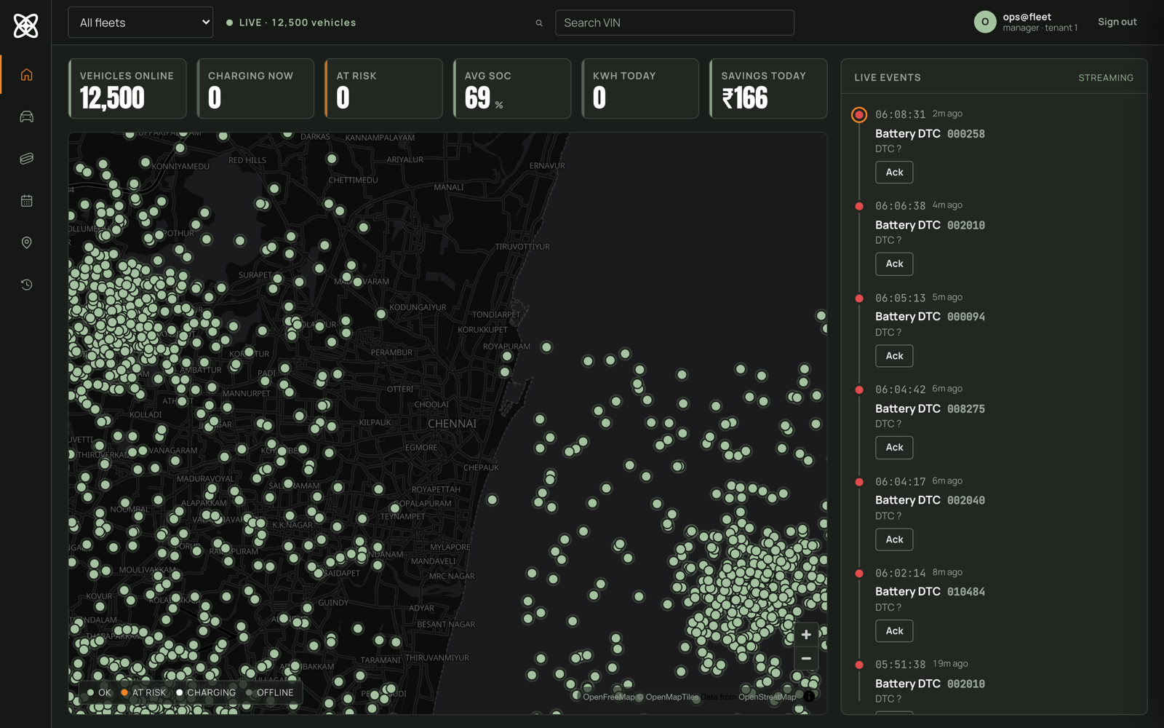
Figure 1. Live fleet console: 12,500 vehicles streaming, KPI tiles and the live event rail (real stack, not mock data).
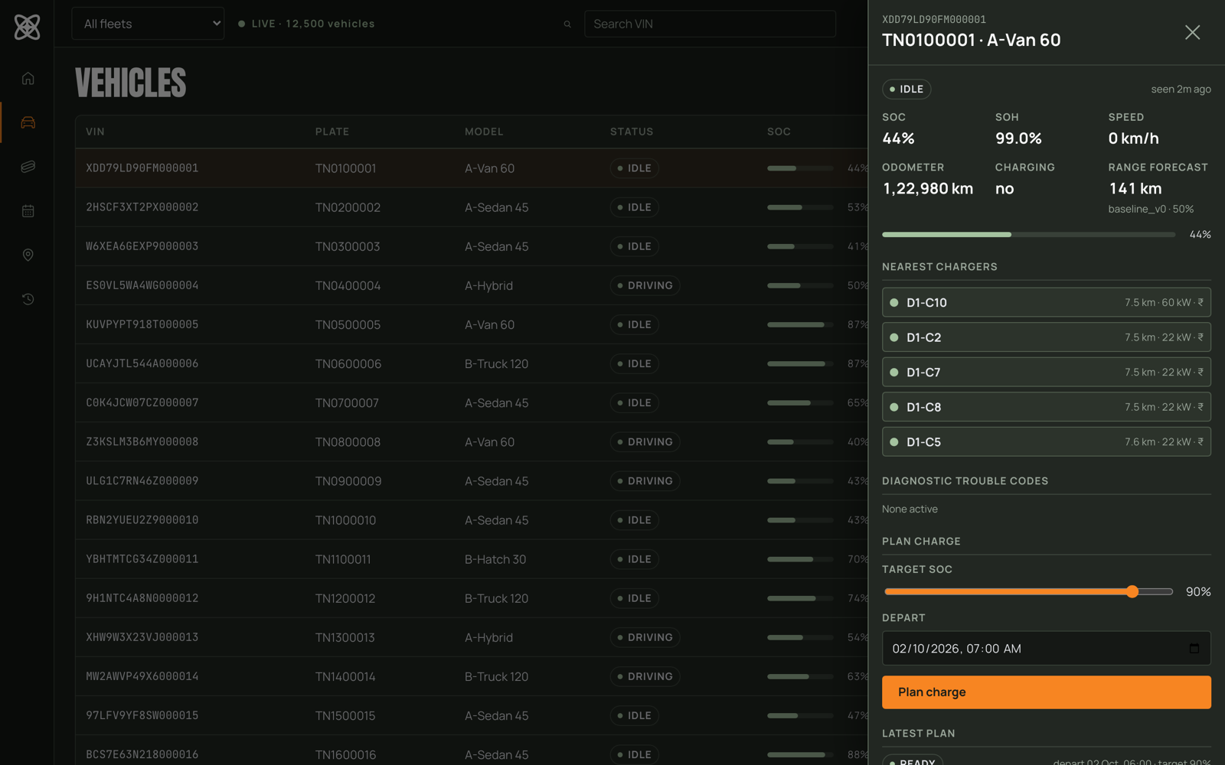
Figure 2. Vehicle drawer: state, model-based range forecast, nearest reachable chargers, and a READY charging plan.

3.2 Key Value Proposition
Customer job: keep every vehicle charged for its next departure at the lowest energy cost, without exceeding depot capacity.
Pain relieved: no more peak-tariff charging on arrival, no surprise strandings, no manual spreadsheet scheduling.
Gain created: per-vehicle cost-optimal schedules with a stated saving, road-aware stranding prediction, battery-health early warning with "vehicles like this one", and an assistant that acts only with approval.
Differentiation: optimisation and routing on live data rather than reports after the fact; brand-agnostic through OEM adapters; every decision explainable (savings, path, rationale) and audited.

3.3 Innovative Ideas
- Savings-first scheduling: every plan carries its own counterfactual (charge-on-arrival cost), so finance sees savings per plan, per day and per fleet. Evidence: 50.5 % cheaper in benchmark; live plan ₹187.20 vs ₹270.00.
- Approval-gated agent: the agent can read fleet data but can only create PENDING actions; a manager approval runs the same plan-creation path as the UI, and every query, tool call and answer is audited. Evidence: 20/20 golden questions pass, 0 ungrounded numbers.
- Degradation look-alikes: a 32-dimension battery-profile embedding in pgvector finds the five vehicles degrading most like a given one. Evidence: fast degraders are each other's nearest neighbours in tests; HNSW index, tenant-scoped.

4. Feature List
Status reflects the code in the repository; video timestamps are added after recording.
ID | Feature | User Story | Priority | Status | Code Path | Video
F-01 | 100K-vehicle simulator (bursts, duplicates, out-of-order, malformed) | As an engineer I want realistic load so that the platform is tested at scale | Must | Done | simulator/ | [mm:ss]
F-02 | Validated, de-duplicated, multi-OEM ingestion with back-pressure | As a platform team I want one canonical event so that every service reads one format | Must | Done | services/ingest/, common/adapters.py | [mm:ss]
F-03 | Live vehicle state and map | As a fleet manager I want to see every vehicle now so that I can act | Must | Done | services/state/, web/src/pages/FleetConsole.tsx | [mm:ss]
F-04 | Stranding, low-SoC, SoC-drop, SoH and battery-DTC alerts | As a fleet manager I want early warnings so that no vehicle strands | Must | Done | services/alert/ | [mm:ss]
F-05 | Nearest reachable charger (Dijkstra) | As a dispatcher I want chargers I can actually reach so that I route safely | Must | Done | services/planner/domain/graph.py | [mm:ss]
F-06 | Cost-optimal schedule under time-of-use tariff (DP) | As finance I want the cheapest charging that meets departure so that costs drop | Must | Done | services/planner/domain/schedule.py | [mm:ss]
F-07 | Depot capacity smoothing | As a depot manager I want to stay under grid capacity so that we avoid demand charges | Should | Done | services/planner/domain/depot.py | [mm:ss]
F-08 | Secure REST API + WebSocket (OAuth2/JWT, RBAC, RLS, keyset, rate limit) | As a customer I want secure access so that only my tenant's data is visible | Must | Done | services/api/ | [mm:ss]
F-09 | Web console (map, vehicles, schedule Gantt, alerts, reports, agent) | As a fleet manager I want one screen for the fleet so that I can decide fast | Must | Done | web/ | [mm:ss]
F-10 | Range and SoH models vs baselines | As a manager I want accurate range so that plans are realistic | Should | Done | services/ml/ | [mm:ss]
F-11 | pgvector "similar degradation" search | As a battery engineer I want look-alike vehicles so that I can inspect them early | Should | Done | services/ml/embeddings.py, db/migrations/0004_ml.sql | [mm:ss]
F-12 | Approval-gated AI agent with audit trail | As a manager I want to ask questions and approve actions so that I save time safely | Should | Done | services/api/orbit_api/agent/ | [mm:ss]
F-13 | Privacy: location masking, retention, right to erasure, access audit | As an auditor I want compliant data handling so that we meet DPDP and GDPR | Must | Done | api/masking.py, routers/privacy.py, audit.py | [mm:ss]
F-14 | Observability: metrics, logs, traces, Grafana dashboards | As SRE I want to see throughput and lag so that I can troubleshoot | Must | Done | infra/observability/ | [mm:ss]
F-15 | Parquet lake + batch analytics | As an analyst I want history cheaply so that I can report over months | Must | Partial | services/archiver/ (lake written; DuckDB/Spark reports planned) | [mm:ss]
F-16 | Carbon report per route | As sustainability I want emissions per route so that we can cut them | Could | Planned | — | —

5. Solution Architecture (High-Level Design)

5.1 Architecture Overview
System context (C4 level 1): fleet managers, finance and auditors use ORBIT over HTTPS and WebSocket; OEM clouds (simulated) send telemetry over MQTT/Kafka; an OIDC identity provider issues JWTs; the Claude API backs the agent; S3-compatible object storage holds the Parquet lake. Mermaid sources: docs/architecture/c4-context.mmd, c4-container.mmd, er.mmd and two sequence diagrams.
Containers (C4 level 2), with the protocol on each hop:
From → To | Protocol | Purpose
Simulator → Kafka telemetry.raw | Kafka (lz4, key = VIN); MQTT 8883 option via EMQX | 100K events/s, two OEM payload formats
Kafka → ingest → telemetry.canonical / dlq | Kafka consumer group, batched send | Validate, normalise, de-duplicate
canonical → state → Redis | Kafka → Redis pipelines | Latest state per VIN, geo index, partial summaries
canonical → alert → alerts topic, Postgres, Redis pub/sub | Kafka, SQL, pub/sub | Rules, < 5 s critical alerts
canonical → archiver → Timescale, MinIO/S3 | COPY, S3 API | Hot store and Parquet lake
API → plans.requested → planner → Postgres, plans.ready | Kafka, SQL | Dijkstra + DP scheduling
Browser ↔ API | HTTPS (REST), WebSocket | Console, live updates
API agent → Claude API | HTTPS | Tool-use loop (offline mode without a key)

Data flow of one event, with measured latency: vehicle → Kafka raw → ingest (≤ 50 ms p95 from vehicle timestamp) → canonical → state in Redis (≤ 100 ms p95) → WebSocket push (throttled to one per vehicle per 2 s); in parallel alert rule → Postgres + pub/sub (≤ 250 ms).

5.2 Technology Stack & Justification
Layer | Choice | Why This, and What You Rejected
Ingestion / Messaging | MQTT (EMQX) at the edge; Kafka protocol (Redpanda in dev, managed Kafka in cloud) | Partitioned, replayable log with per-VIN ordering; rejected RabbitMQ (no replay, weaker key ordering) — ADR-001
Stream / Batch Processing | Python asyncio consumer services; Parquet + DuckDB/Spark for batch | Simple, testable, horizontally scalable via consumer groups; rejected Flink for now (operational weight) — ADR-005
Relational / NoSQL / Cache / Search / Vector | PostgreSQL 16 + TimescaleDB + pgvector; Redis 7; MinIO/S3 | One CP engine for 3NF core, time series and vectors; Redis as AP cache; rejected Cassandra + Qdrant (three engines, same value at this scale) — ADR-002
Backend / Frontend | FastAPI (asyncpg, raw SQL repositories); React 18 + TypeScript + MapLibre + Recharts | Async, OpenAPI for free, fast iteration; rejected Spring Boot for team speed and an ORM to keep SQL explicit and N+1-free
ML / AI | scikit-learn (HistGradientBoosting, GradientBoosting), pgvector HNSW; Anthropic SDK tool-use loop | Explainable, fast models that beat baselines; agent with allowlisted tools and approval gate
Infrastructure / CI-CD / Observability | Docker Compose, Helm, Terraform (AWS + GCP), GitHub Actions; Prometheus, Grafana, Loki, Tempo, OpenTelemetry | Same chart on any Kubernetes; open standards, no vendor lock-in

5.3 Data Architecture
ER diagram (docs/architecture/er.mmd): tenant, oem, vehicle_model, depot, fleet, vehicle, driver, driver_assignment, charger, tariff, tariff_slot, charging_plan, charging_slot, charging_session, alert, subscription, user_account, audit_log, battery_health, agent_action — in third normal form. Deliberate denormalisation: telemetry stores vin (no join on the write path); alert.payload is JSONB (one table for all alert types); live vehicle state is a JSON document in Redis; charging_plan and battery_health carry tenant_id (filled by trigger) so row-level security applies without joins.
Data | Store | CAP | Reason
Fleet, vehicle, plans, slots, sessions, subscriptions, audit, agent actions | PostgreSQL (RLS) | CP | Ownership and money need ACID and tenant isolation
Raw and canonical telemetry stream | Kafka | AP, durable | Replay, decoupling, at-least-once with idempotent consumers
Latest state, geo index, summaries, rate limits, range coefficients | Redis | AP | Sub-millisecond reads; rebuildable from Kafka
Telemetry, hot 30 days | TimescaleDB hypertable | CP | Range queries, compression, continuous aggregates
Telemetry, warm and cold | Parquet on S3/MinIO | AP | Cheap, scannable, lifecycle tiers
Battery-profile embeddings | pgvector (HNSW) | CP | Similarity co-located with vehicle rows

Capacity at 100,000 vehicles, 1 event/s each: 100K events/s (300K/s bursts); ~1 KB JSON, ~250 B Avro, ~60 B compressed Parquet. Kafka key = VIN, 48 partitions; hypertable chunked hourly and space-partitioned by VIN (16); Parquet partitioned dt/hour/tenant. Hot 30 days in Timescale (compressed after 24 h), warm 90 days in S3 Standard-IA, cold to Glacier Instant Retrieval, expiry at 2 years (Terraform lifecycle rules).
Query | Before (ms) | After (ms) | Change Made
Alert feed, page 50 for a tenant | 89.4 | 0.55 | OFFSET → keyset on (ts, id) with composite index
Open CRITICAL alerts per tenant | 122.2 | 1.16 | Partial index WHERE acked_ts IS NULL (index-only scan)
Vehicle page with model and OEM | 10.9 | 2.9 | N+1 correlated subqueries → one join + keyset index
Latest state of every vehicle in a fleet | 804 | < 1 | Moved to Redis projection (MGET) — ADR-004

5.4 Deployment View
Kubernetes via the Helm chart in infra/helm/orbit: one Deployment per service with HPA (ingest 3–12, state 2–8, alert 2–8, archiver 2–6, API 3–20 replicas), PodDisruptionBudgets, a default-deny NetworkPolicy, non-root read-only containers, an Ingress for /api, /api/v1/ws and the web app, and secrets from Kubernetes Secrets fed by External Secrets (Vault or a cloud secret manager). Terraform provisions AWS (EKS, MSK, RDS, ElastiCache, S3 with lifecycle and KMS) and a GCP parity skeleton (GKE Autopilot, Cloud SQL, Memorystore, GCS); both validate.
Cloud-agnostic approach: application code uses only the Kafka protocol, Postgres, Redis and the S3 API. Moving clouds changes only values-aws.yaml or values-gke.yaml; locally, docker compose runs the same images.

6. Low-Level Design

6.1 Layering & Separation of Concerns
Every Python service uses hexagonal (ports and adapters) layering: domain/ holds pure logic with no I/O, application/ orchestrates use cases against Protocol ports, infrastructure/ holds Kafka, Redis, Postgres and S3 adapters, and __main__.py wires them. This keeps the algorithms unit-testable with fakes (95 % coverage) and lets us swap stores without touching rules.
Layer | Responsibility | Must Not
Presentation / API | HTTP, WebSocket, validation, auth checks, DTO mapping (orbit_api/routers, schemas) | Contain business rules or SQL
Application / Service | Use cases, transactions, orchestration (e.g. plan_vehicle.py, plan_requests.py) | Depend on a specific database or broker
Domain | Entities and rules (rules.py, schedule.py, graph.py, state.py) | Import framework or infrastructure code
Infrastructure | Repositories, broker clients, caches (postgres.py, redis_store.py, kafka.py) | Leak vendor types into the domain

contracts/ db/ simulator/{cmd,internal} web/{src,public}
services/{common,ingest,state,alert,archiver,planner,ml,api}/{orbit_*,tests}
infra/{helm,terraform,observability} tests/{acceptance,load,chaos,sql,agent_eval} docs/{adr,architecture,screenshots}

6.2 Design Principles Applied
- SOLID: repositories behind Protocol interfaces (dependency inversion) so tests use fakes; one service per concern (single responsibility); OEM adapters registered at runtime (open/closed).
- 12-Factor: configuration only from the environment (orbit_common/config.py); stateless processes; disposable containers that exit on fatal errors and are restarted.
- Idempotency: (VIN, seq) idempotency key, rolling Bloom filter, unique index on (vin, seq, ts), seq-monotonic Redis writes, rebalance-safe commits.
- Fail-fast and least privilege: Pydantic validation at the edge; orbit_app database role subject to RLS; non-root containers with dropped capabilities.

6.3 Design Patterns Used
Pattern | Problem It Solves in Your System | Location in Code
Adapter | Maps each OEM payload (flat ISO / nested imperial epoch) to one canonical event | services/common/orbit_common/adapters.py
Repository | Hides SQL behind interfaces; tests use in-memory fakes | services/api/orbit_api/repositories/
Strategy | LLM agent vs deterministic offline agent behind one interface | services/api/orbit_api/agent/
CQRS | Writes go through Kafka and Postgres; reads of live state come from the Redis projection | services/state/, api/state.py
Observer / pub-sub | State and alerts pushed to WebSocket clients per tenant | Redis events:{tenant}, routers/ws.py
Retry with backoff | Planner waits for a plan row published before its INSERT commits | planner/application/plan_vehicle.py
Back-pressure | Ingest pauses partitions when producer buffers are full; simulator blocks on full buffer | ingest/application/runner.py, simulator/internal/transport

6.4 Interfaces, Contracts & Runtime Flows
REST and WebSocket contract: contracts/api.md and docs/openapi.json (versioned /api/v1, RFC 7807 errors, opaque keyset cursors, 100 requests/min per user). Event schemas: contracts/telemetry.canonical.v1.avsc (Avro, backward-compatible, add-only optional fields), contracts/topics.yaml (topics, keys, partitions, retention), contracts/oem-formats.md, contracts/redis.md.
Sequence diagrams: docs/architecture/seq-alert.mmd (event to alert to acknowledgement) and seq-broker-failure.mmd (broker down: producer buffers, consumers resume from committed offsets, duplicates removed). Duplicate events are dropped by the Bloom filter and again by the unique index; an unknown OEM format goes to telemetry.dlq.

6.5 Algorithms & Data Structures
Problem | Algorithm | Complexity | Scale Tested
Nearest reachable charger | Dijkstra with early exit on a 60×60 road lattice | O((V′+E′) log V′) | 0.20 ms median, 40 chargers, k = 5
Cost-optimal schedule | DP over (15-min slot, 1 % SoC bucket, 3 power levels) | O(T·S·P) | 2.27 ms for 96 × 101 × 3
Depot capacity | Greedy slack-first smoothing (heuristic; exact is NP-hard) | O(passes·T·V) | 300 vehicles: 1.0 ms, 1,606 → 1,320 kW
Trip and stop segmentation | Single-pass change-point detector | O(n) | 100,000 samples in 41 ms
VIN validation | Regex + ISO 3779 check digit (cached) | O(1) | Every event
DTC parsing | Regex [PCBU][0-3][0-9A-F]{3} | O(n) | Every event
Dedupe at 100K/s | Two-generation rolling Bloom filter, p = 0.1 % | O(k) | 3.8 µs/event; FP < 0.5 %
Top-K fault codes | Count-Min sketch + bounded heap | O(d) | Metric orbit_dtc_topk
End-to-end plan | Dijkstra + DP per vehicle | — | 10,000 vehicles in 14.9 s (1.49 ms each)

Pseudocode, full complexity notes and a write-up of a quadratic slowdown found and fixed by the 10,000-vehicle benchmark are in docs/algorithms.md.

7. Non-Functional Requirements & Performance Benchmarks
NFR | Target (Case Study) | Achieved | How Measured
Ingest throughput | 100K+ events/s | 100,384 events/s to Kafka, 0 errors; 3x bursts generated at ~299K/s | Simulator counters, 20 s window
End-to-end latency | < 2 s dashboard; < 5 s critical alert | State ≤ 100 ms p95; alert ≤ 250 ms | orbit_e2e_seconds histograms, 30 s window
API latency | p95 < 200 ms; p99 < 500 ms | p95 29 ms, p99 77 ms at 448 req/s | tests/load/api_latency.py, 300 users, 60 s
Resilience | Recovers after broker/pod failure | Broker killed 20 s: 0 records dropped, 7/7 consumers up | tests/chaos/kill_broker.sh
Availability | 99.9 %, no single point of failure | Stateless replicas, PDBs, HPA, restart policies; single broker in dev | Helm chart design

Load test setup: one laptop (Apple M4, Docker Desktop 10 CPUs, 8 GB); full stack in docker compose. Producer and broker sustain 100K/s; the Python stream tier processes ~24K (ingest), ~18K (state) and ~30K (alert, archiver) events/s per core, so 100K/s end to end needs about 19 cores — a cluster deployment sized in docs/benchmarks.md. The live demo runs 20K events/s with consumer lag under one second.
Engineering from measurements: profiling raised state throughput from ~5K to ~18K events/s (single JSON SET instead of a 14-field HSET), ingest from ~12K to ~24K per replica (batched sends, cached VIN checks), and fixed a 1-partition topic, a rebalance crash loop, producer data loss during outages, and a commit-before-response race.

8. Security & Compliance
Threat (STRIDE) | Control
Spoofed device sends fake data (S) | mTLS per device on EMQX, VIN bound to certificate; VIN check digit and schema validation
Replayed or duplicated events (T) | Per-vehicle seq, Bloom de-duplication, unique index, seq-monotonic state writes, timestamp skew check
Cross-tenant data access (I) | tenant_id only from the verified JWT; Postgres row-level security on every tenant table; tenant-prefixed Redis keys; integration test proves isolation
API flood / burst (D) | Redis token bucket (100/min per user), Kafka buffering, ingest back-pressure, HPA
Prompt injection makes the agent act (E) | Tool allowlist, tenant injected server-side, tool output marked untrusted data, approval required for any write, full audit

- Authentication and authorisation: OAuth2/OIDC JWT (RS256 via JWKS in production, HS256 dev issuer locally); roles admin, manager, finance, auditor; Postgres RLS by tenant.
- Encryption and secrets: TLS at the ingress, SASL/TLS to managed Kafka, KMS-encrypted RDS and S3; secrets via External Secrets; .env never committed; gitleaks in CI.
- Privacy (GDPR, DPDP Act 2023): driver names stored masked and licences hashed; finance and auditor roles see location rounded to ~1 km; telemetry retained 30 days hot then tiered; right-to-erasure endpoint masks the driver, removes assignments and writes an ERASURE audit row; every privileged data access is audited.
- AI safety: manager/admin only; 5 tool calls, 7 model calls and a $0.10 cost cap per query; 1,000-character question limit; refusal of injection-looking input in offline mode; AGENT_QUERY, AGENT_TOOL and AGENT_ANSWER audit rows.

9. Test Strategy
Test Type | Tools | No. of Tests | Coverage / Result | In CI?
Unit | pytest, vitest, go test | 316 Python, 39 web, 9 Go packages | 95 % Python line coverage; all pass | Yes
Integration & Contract | Testcontainers (Redpanda, Timescale, Redis); contract tests on payloads | 7 (4 stream pipeline, 3 API/RLS) | All pass against real containers | Yes
Acceptance (BDD) | behave | 6 scenarios (5 run, 1 marked WIP) | 5/5 pass, 8 of 8 consecutive runs | Yes
Performance / Load / Soak | Go simulator, Python load generator, k6 scripts | Producer 100K/s; API 300 users | p95 29 ms, p99 77 ms | Nightly
Security | Semgrep, Trivy, OWASP ZAP baseline, gitleaks | Workflow jobs | Configured in CI; not executed locally | Yes
Compliance & Chaos | pytest (audit, erasure), chaos script | Audit/erasure tests; broker kill | Chaos PASS: 0 records dropped | Nightly

Edge cases covered: duplicate (VIN, seq), out-of-order events, future timestamps, unknown OEM format, invalid VIN, out-of-range values, broker outage, consumer-group rebalance, Redis loss (state rebuilt from Kafka), plan published before its row commits, infeasible charging targets, cross-tenant access, prompt injection.
Reports: tests/reports/ (coverage, chaos.json, api_latency.json, EXPLAIN plans); docs/benchmarks.md summarises them.

10. Observability
Every service exposes Prometheus metrics (events in/out, drops by reason, batch latency, end-to-end latency, consumer lag, planner duration, top fault codes), writes structured JSON logs (shipped to Loki by Promtail), and propagates OpenTelemetry traces to Tempo. Grafana dashboards are provisioned from infra/observability/grafana/dashboards (Ingest & Stream; API & Planner). Start with make obs or make run.
Troubleshooting a latency spike: check the consumer-lag panel to find which group is behind; compare events-in against the simulator rate to tell a burst from a slowdown; open the end-to-end latency histogram for that service; filter Loki logs by service and level for errors (for example commit failures during a rebalance); follow a trace from ingest to alert in Tempo. This is how we found the single-partition topic and the rebalance crash loop.

11. AI / ML Component
Purpose: the range model decides whether a vehicle can reach a charger and how much to charge; the SoH model flags packs heading below 80 %; embeddings find vehicles degrading the same way. Rules alone use nominal range times SoC, which ignores driving style and degradation (11.9 km error versus 2.9 km).
Data and features: per-vehicle features from TimescaleDB (SoC trajectory, km, kWh, speed profile, temperature, fast-charge ratio, odometer, model). Labels are synthetic and follow the simulator's physics; the split is by vehicle (SHA-256 of VIN) with a leakage check that fails on overlap.
Model | Metric | Model | Baseline
Remaining range | MAE | 2.93 km | 11.94 km
Remaining range | MAPE | 2.30 % | 9.81 %
SoH in 30 days | MAE | 0.11 pts | 0.27 pts
SoH in 30 days | Recall, SoH < 80 % | 0.95 | 0.60
SoH in 30 days | Precision, SoH < 80 % | 0.94 | 1.00

Model and agent design: HistGradientBoosting and GradientBoosting (scikit-learn); 32-dimension L2-normalised embeddings in pgvector with an HNSW index and tenant-scoped search; per-vehicle range coefficients published to Redis so the API serves forecasts without loading a model. The agent uses seven read tools and one write tool (propose_replan → PENDING actions only); it runs a Claude tool-use loop when ANTHROPIC_API_KEY is set and a deterministic offline router otherwise.
Evaluation: held-out vehicles (1,201) for the models; 20 golden questions for the agent: 20/20 pass and 0 answers contain numbers absent from tool results (offline mode; LLM mode tested with a fake client).
Guardrails and cost: live run published 97,434 battery-health rows with embeddings and 97,434 range coefficients; training 4.5 s, scoring 100K vehicles 0.35 s. Agent: offline $0 and 5–30 ms; LLM estimate ~$0.015 and 3–8 s per question, capped at $0.10. Limitation: metrics show recovery of simulated physics, not real-world accuracy.

12. Architecture Decisions, Risks & Future Enhancements
ADR | Decision | Consequence
ADR-001 | Kafka protocol (Redpanda dev, managed Kafka prod) over RabbitMQ | Replay and per-VIN ordering; consumers must be idempotent
ADR-002 | PostgreSQL + TimescaleDB + pgvector over Cassandra + Qdrant | One CP engine; single-writer ceiling mitigated by batching and sampling
ADR-003 | Telemetry AP / at-least-once; plans, billing, audit CP | Bursts and outages become lag, never loss; dashboards may be seconds stale
ADR-004 | Redis latest-state projection with TTL and seq-monotonic writes | Sub-ms reads; time-based invalidation; DB stays source of truth for history
ADR-005 | Python asyncio consumers now, Flink later | Simple and testable; ~20–30K events/s per core, so 100K/s needs more replicas

Risks and technical debt:
- 100K events/s end to end needs ~19 cores for the stream tier; measured on a laptop only at 20K/s live.
- ML labels are synthetic; real OEM data is needed to claim real-world accuracy.
- Agent LLM mode untested against the live API (no key available); offline mode is the default.
- Security scans (Semgrep, Trivy, ZAP) are configured in CI but were not run locally; the stranding BDD scenario needs a deterministic simulator injection.
- Running the full stack needs ~20 GB free host disk; during development the disk filled twice, which led to retention caps and a preflight check.
Next three steps from prototype to pilot:
- Connect one real OEM feed through a new adapter and retrain the range model on real trips.
- Deploy to EKS with Terraform and Helm, run the 100K/s load and soak tests on the cluster, and move the alert service to Flink if windows grow.
- Pilot with one depot: compare a month of planned versus actual energy cost and strand events.

13. Demo Video (5 Minutes Maximum)
Time | Segment | What to Show
0:00 – 0:30 | Problem | A fleet manager paying peak tariffs and a vehicle about to strand; the 2–3x tariff spread
0:30 – 1:00 | Solution | "Every vehicle charged, on time, at the lowest tariff" — landing page and console
1:00 – 3:00 | Live Demo | Live map; a LOW_SOC or STRAND_RISK alert arriving; open the vehicle; nearest reachable chargers; plan a charge and show ₹ savings; ask the agent and approve its proposal
3:00 – 4:15 | Under the Hood | Architecture; Grafana lag and throughput; kill the broker and show 0 records dropped; API latency numbers
4:15 – 5:00 | Impact & Next Steps | 50.5 % cheaper charging, < 250 ms alerts, 95 % test coverage; pilot plan; team

Video link: [URL]

14. Repository Checklist
- README: problem, architecture, quick start, environment variables, test commands, known issues — done.
- One-command run: make run (preflight disk check, then docker compose with simulator and observability) — done.
- Structure: service folders plus /docs, /infra and /tests — done.
- CI pipeline: .github/workflows/ci.yml (lint, type check, unit, integration, Go, web, security scans, images, acceptance, Terraform and Helm validation) and nightly load and chaos — configured.
- Hygiene: .env ignored, .env.example provided, secrets only from the environment — done; commits from all members — team to confirm.
- Final tag: v1.0-submission — to be created at code freeze.

15. Conclusion
- Key learnings: measure before optimising — every large gain came from a profile or a failed test, not a guess; chaos and acceptance tests found real defects that unit tests could not.
- Strengths: complete loop from telemetry to an approved, cost-optimal action; tenant isolation enforced in the database; honest, reproducible benchmarks.
- Challenges solved: single-partition topic, rebalance crash loop, producer loss during outages, plan published before commit, read-your-writes on POST, summary over-counting across replicas, and two host-disk exhaustion incidents.

16. Declarations
- Open-source components: listed with versions in docs/sbom.json (112 Python, 51 Go, 91 web runtime packages). Main components and licences: PostgreSQL (PostgreSQL), TimescaleDB (Timescale License for the community edition image), pgvector (PostgreSQL), Redis 7 (BSD-3 in 7.2 and earlier; RSALv2/SSPL from 7.4), Redpanda (BSL 1.1), EMQX (Apache-2.0 in 5.x open source; BSL from 5.9), MinIO (AGPL-3.0, used via the Bitnami legacy image), FastAPI, aiokafka, asyncpg, scikit-learn, React, MapLibre GL (BSD-3), Recharts (MIT), franz-go (BSD-3), Grafana, Loki, Tempo (AGPL-3.0), Prometheus (Apache-2.0). Licences should be confirmed against the exact versions before any commercial use.
- AI tools used: Claude Code (Anthropic) was used as a coding assistant for scaffolding, implementation, tests, profiling and documentation; the team reviewed the design and results. The product's agent uses the Anthropic Claude API when a key is configured.
- Data: all data is synthetic, generated by the repository's simulator and seed script; no real personal or vehicle-owner data is used. Brand imagery in the UI is limited to abstract illustrations and icons; no third-party logos are shipped.

17. Appendix
- docs/PLAN.md — full plan; docs/DESIGN.md — design system; docs/adr/ — five ADRs.
- docs/architecture/ — C4 context and container, ER, sequence diagrams (Mermaid).
- docs/benchmarks.md, docs/sql-optimisation.md, docs/algorithms.md, docs/ml.md, docs/agent.md, docs/threat-model.md.
- docs/screenshots/live/ — screenshots of the running system; tests/reports/ — test evidence.
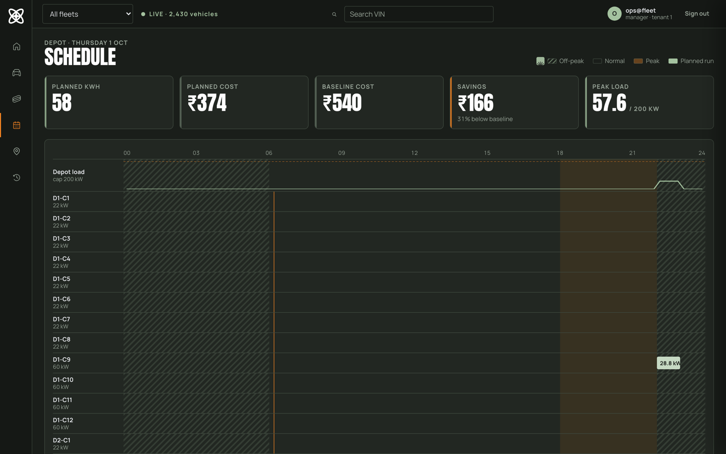
Figure 3. Depot schedule: charging sessions per charger against tariff bands and depot capacity.

