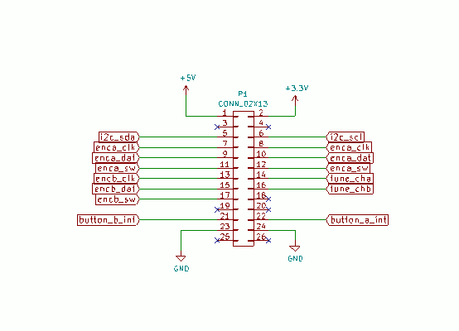
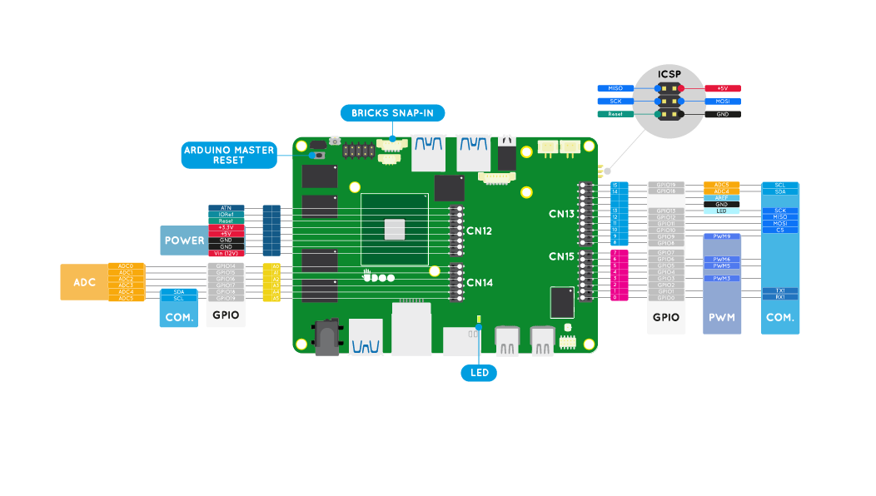

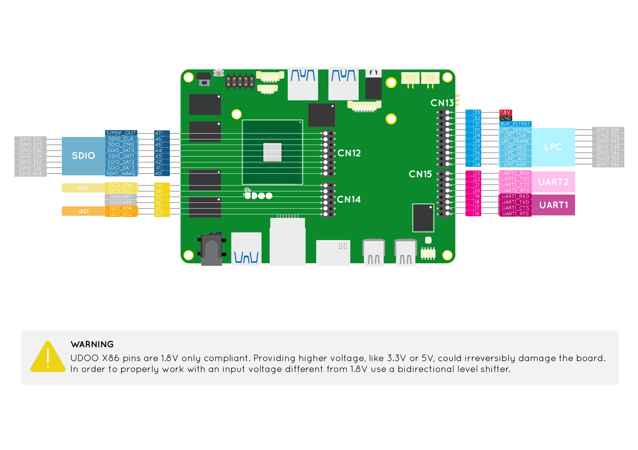

10 inch length ribbon cable DB9 female to IDC 10 pin female

Pin mapping

DB9 female -> IDC10 female
1 -> 1
2 -> 3
3 -> 5
4 -> 7
5 -> 9
6 -> 2
7 -> 4
8 -> 6
9 -> 8

