Qasim Farooq

19591

Mern – III

Softoo Bootcamps

Assignment 1

<!DOCTYPE html>

<html lang="en">

<head>

<meta charset="UTF-8" />

<meta http-equiv="X-UA-Compatible" content="IE=edge" />

<meta name="viewport" content="width=device-width, initial-scale=1.0" />

<link rel="stylesheet" href="https://cdnjs.cloudflare.com/ajax/libs/font-awesome/6.2.0/css/all.min.css"/>

<title>Assignment 1.1</title>

<style>

.rating {

margin: 40px 12px;

border: none;

float: left;

}

.rating > label {

color: #90A0A3;

float: right;

}

.rating > label:before {

margin: 5px;

font-size: 2em;

font-family: FontAwesome;

content: "\f005";

display: inline-block;

}

.rating > input {

display: none;

}

.rating > input:checked ~ label,

.rating:not(:checked) > label:hover,

.rating:not(:checked) > label:hover ~ label {

color: #F79426;

}

.rating > input:checked + label:hover,

.rating > input:checked ~ label:hover,

.rating > label:hover ~ input:checked ~ label,

.rating > input:checked ~ label:hover ~ label {

color: #FECE31;

}

body {

background-color: #0b1342;

}

.span{

padding-left: 22px;

margin-top: 87px;

background-color: #20243d;

border-radius: 12px;

height: 359px;

max-width: 293px;

padding-top: -24px;

}

.lpi{ height: 38px;

width: 37px;

padding: 8px 9px;

border-color: white;

border-width: 1px;

margin-left: -33px;}

.lp{padding-right: 47px;

/\* margin-left: 0px; \*/

display: flex;

flex-direction: row;

align-content: flex-start;

justify-content: space-between;

align-items: center;}

.row{display: flex;

flex-direction: row;

flex-wrap: nowrap;

justify-content: center;}

.pr{

display: inline-flex;

flex-direction: row;

align-items: baseline;

align-content: center;

justify-content: space-between;

}

button{padding-top: 11px;

padding-bottom: 7px;

padding-left: 88px;

background-color: black;

margin-left: 13px;

text-align: center;

color: #ffc107;

padding-right: 88px;

margin-top: -18px;

font-size: 22px;

border-radius: 16px;}

</style>

</head>

<body>

<div class="container" style="padding: 32px 42px; ;">

<div class="row">

<div class="span">

<figure class="card" >

<img class="lpi"src="star.jpg" style="border-radius:50%;">

<div class="text">

<pre><h4 style="margin-left: -28px ;color:#fff ;font-family:verdana;">How Did we do?</h4></pre>

<p style="color:gray ;margin-left: -28px ;">Please let us know how did we do support us give the rating below </p>

</div>

</figure>

<div class="rating">

<input type="radio" id="star5" name="rating" value="5" />

<label class="star" for="star5" title="Awesome" aria-hidden="true"></label>

<input type="radio" id="star4" name="rating" value="4" />

<label class="star" for="star4" title="Great" aria-hidden="true"></label>

<input type="radio" id="star3" name="rating" value="3" />

<label class="star" for="star3" title="Very good" aria-hidden="true"></label>

<input type="radio" id="star2" name="rating" value="2" />

<label class="star" for="star2" title="Good" aria-hidden="true"></label>

<input type="radio" id="star1" name="rating" value="1" />

<label class="star" for="star1" title="Bad" aria-hidden="true"></label>

</div>

<button type="submit" >Submit</button>

</div>

</div>

</div>

</html>

Output: -

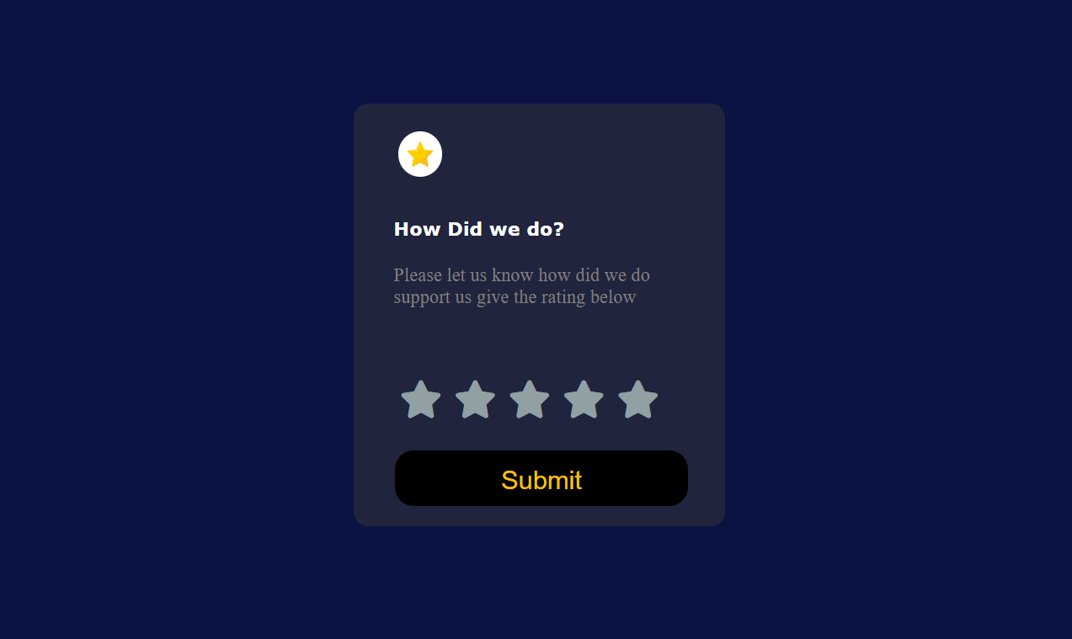

1.3

<!DOCTYPE html>

<html lang="en">

<head>

<meta charset="UTF-8" />

<meta http-equiv="X-UA-Compatible" content="IE=edge" />

<meta name="viewport" content="width=device-width, initial-scale=1.0" />

<link rel="stylesheet" href="https://cdnjs.cloudflare.com/ajax/libs/font-awesome/6.2.0/css/all.min.css"/>

<title>Assignment 1.3</title>

<style>

body {

background-color: #0b1342;

}

.span{

background-color: #20243d;

border-radius: 12px;

height: 510px;

max-width: 273px;

}

.pbi{

margin: -4px -28px;

border-radius: 6px;

height: 240px;

width: 250px;

/\* padding: 0px 0px; \*/

border-color: white;

border-width: 1px;

}

.lpi{ height: 38px;

width: 37px;

padding: 8px 9px;

border-color: white;

border-width: 1px;

margin-left: 10px;}

.lp{padding-right: 47px;

/\* margin-left: 0px; \*/

display: flex;

flex-direction: row;

align-content: flex-start;

justify-content: space-between;

align-items: center;}

.row{display: flex;

flex-direction: row;

flex-wrap: nowrap;

justify-content: center;}

.pr{

display: inline-flex;

flex-direction: row;

align-items: baseline;

align-content: center;

justify-content: space-between;

}

</style>

</head>

<body>

<div class="container" style="padding: 32px 42px; ;">

<div class="row">

<div class="span">

<figure class="card" >

<img src="cry.jpg" class="pbi" alt="">

<div class="text">

<pre><h3 style="margin-left: -28px ;color:#fff ;font-family:verdana;">Equilibrium #3422</h3></pre>

<p style="color:gray ;margin-left: -28px ;">Our equilibrium provides blah blah</p>

</div>

</figure>

<div class="pr"><i class="fa-brands fa-ethereum" style="color: aqua; margin-left: 10px;"></i><h5 style="padding-left: 1px; color: aqua;">0.04 ETH</h5> <pre style="margin-left:92px; color: gray;"><i class="fa-solid fa-clock" style="color:grey ;"></i> 3days left</pre></div>

<hr style="color: gray;

width: 89%;

text-align: center;">

<div class="lp"> <img class="lpi"src="my.jpg" style="border-radius:50%;"> <p>Creation of</p><h5 style="color:white ;">Qasim Farooq</h5> </div>

</div>

</div>

</div>

</html>



<!DOCTYPE html>

<html lang="en">

<head>

<meta charset="UTF-8" />

<meta http-equiv="X-UA-Compatible" content="IE=edge" />

<meta name="viewport" content="width=device-width, initial-scale=1.0" />

<link rel="stylesheet" href="style14.css">

<title>Assignment 1.4</title>

<style>

</style>

</head>

<body>

<div class="container" style="padding: 32px 42px; ;">

<div class="row">

<div class="span">

<figure class="card" >

<img src="pi.jpg" style="border-radius: 50%;" class="pbi" alt="">

<div class="text">

<h4>Report For</h4>

<h1>Qasim Farooq</h1>

</div>

</figure>

<h5 style="color: rgb(22, 20, 20)">Daily</h5>

<h5 style="color: white">Weekly</h5>

<h5 style="color: rgb(22, 20, 20)">Monthly</h5>

</div>

<div class="row2">

<div class="span2">

<figure class="card2">

<div class="text2">

<div class="dots">

<h3>Work</h3> <h2 style="margin-left: 177px; color: rgb(248, 248, 248);" >...</h2></div>

<h1>24 Hrs</h1>

<h4>Last Week 72 Hrs</h4>

</div>

</figure>

</div>

<div class="span2">

<figure class="card2">

<div class="text2">

<div class="dots">

<h3>Play</h3> <h2 style="margin-left: 177px; color: rgb(248, 248, 248);" >...</h2></div>

<h1>24 Hrs</h1>

<h4>Last Week 72 Hrs</h4>

</div>

</figure>

</div>

<div class="span3" >

<figure class="card2">

<div class="text2">

<div class="dots">

<h3>Work</h3> <h2 style="margin-left: 177px; color: rgb(248, 248, 248);" >...</h2></div>

<h1>24 Hrs</h1>

<h4>Last Week 72 Hrs</h4>

</div>

</figure>

</div>

<div class="span4">

<figure class="card2">

<div class="text2">

<div class="dots">

<h3>Study</h3> <h2 style="margin-left: 177px; color: rgb(248, 248, 248);" >...</h2></div>

<h1>24 Hrs</h1>

<h4>Last Week 72 Hrs</h4>

</div>

</figure>

</div>

<div class="span2">

<figure class="card2">

<div class="text2">

<div class="dots">

<h3>Swim</h3> <h2 style="margin-left: 177px; color: rgb(248, 248, 248);" >...</h2></div>

<h1>24 Hrs</h1>

<h4>Last Week 72 Hrs</h4>

</div>

</figure>

</div>

<div class="span4">

<figure class="card2">

<div class="text2">

<div class="dots">

<h3>Cook</h3> <h2 style="margin-left: 177px; color: rgb(248, 248, 248);" >...</h2></div>

<h1>24 Hrs</h1>

<h4>Last Week 72 Hrs</h4>

</div>

</figure>

</div>

</div>

</div>

</div>

</body>

</html>

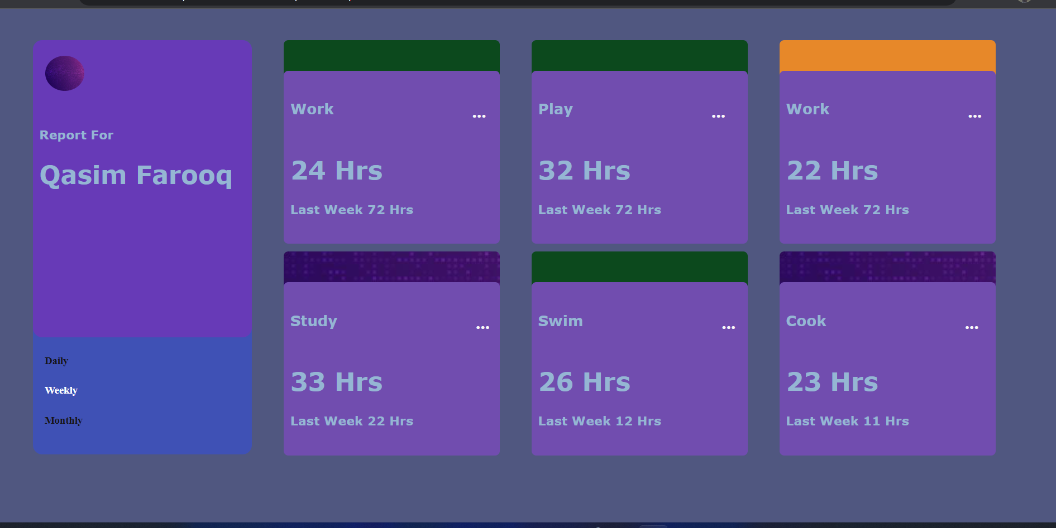

<!DOCTYPE html>

<html>

<head>

<link rel="stylesheet" href="https://cdnjs.cloudflare.com/ajax/libs/font-awesome/6.2.0/css/all.min.css" integrity="sha512-xh6O/CkQoPOWDdYTDqeRdPCVd1SpvCA9XXcUnZS2FmJNp1coAFzvtCN9BmamE+4aHK8yyUHUSCcJHgXloTyT2A==" crossorigin="anonymous" referrerpolicy="no-referrer" />

<style>

.switch {

position: relative;

display: inline-block;

width: 36px;

height: 18px;

}

.switch input {

opacity: 0;

width: 0;

height: 0;

}

.slider {

position: absolute;

cursor: pointer;

top: 0;

left: 0;

right: 0;

bottom: 0;

background-color: #ccc;

-webkit-transition: .4s;

transition: .4s;

}

.slider:before {

position: absolute;

content: "";

height: 13px;

width: 13px;

left: 4px;

bottom: 3px;

background-color: white;

-webkit-transition: .4s;

transition: .4s;

}

input:checked + .slider {

background-color: #2196F3;

}

input:focus + .slider {

box-shadow: 0 0 1px #2196F3;

}

input:checked + .slider:before {

-webkit-transform: translateX(26px);

-ms-transform: translateX(26px);

transform: translateX(16px);

}

.slider.round {

border-radius: 34px;

}

.slider.round:before {

border-radius: 50%;

}

.span{

background-color: #d1d3dd;

border-radius: 12px;

height: 286px;

max-width: 417px;

margin-left: 34%;

margin-top: 5%;

}

.rang{display: flex;

flex-direction: row;

justify-content: center;

align-content: center;

/\* margin-top: 29px; \*/

padding-top: 1px;

/\* width: 126px; \*/}

.up{

display: flex;

flex-direction: row;

align-content: center;

align-items: center;

}

.mp{

display: flex;

flex-direction: row;

flex-wrap: nowrap;

align-items: center;

justify-content: space-around;

}

body{

background-repeat: no-repeat;

background-image: url("pi.jpg");

background-size: cover;

}

i{color: green;

padding-left: 16px;

text-decoration-color: black;

padding-top: 19px;}

</style>

<meta name="viewport" content="width=device-width, initial-scale=1"></head>

<body >

<div class="utxt" style="display: flex;

flex-direction: column;

align-items: center;

margin-top: 39px;">

<h3 style="color: azure; font-family:Georgia, 'Times New Roman', Times, serif; margin-bottom: -42px;">Traffic Based Pricing</h3> <br>

<h6 style="color:azure ;">Signup for 30 days trial no credit card required</h6> </div>

<div class="span">

<div class="up"> <h4 style="padding-left: 24px;

color: grey;

padding-right: 80px;">100k Page Reviews </h4> <h1>$16.00</h1> <h3>/ month</h3></div>

<div class="rang">

<label for="customRange1" class="form-label"> </label>

<input style="width: 327px;" type="range" class="form-range" id="customRange1">

</div>

<div class="mp" > <h5 style=" padding-left: 144px;">Monthly Billing</h5>

<label class="switch">

<input type="checkbox">

<span class="slider round"></span>

</label>

<h5>yearly Billing</h5>

</div>

<div class="lp"> <i class="fa-solid fa-check"></i>100% access <br><i class="fa-solid fa-check"></i>Email Reports

<button style=" color: beige;

margin-left: 105px;

border: rebeccapurple;

border-radius: 6px;

background-color: #001360;

height: 33px;

width: 108px;">Start my trial</button>

</div>

</div>

</body>

</html>

