Object Dragging in the Scenegraph

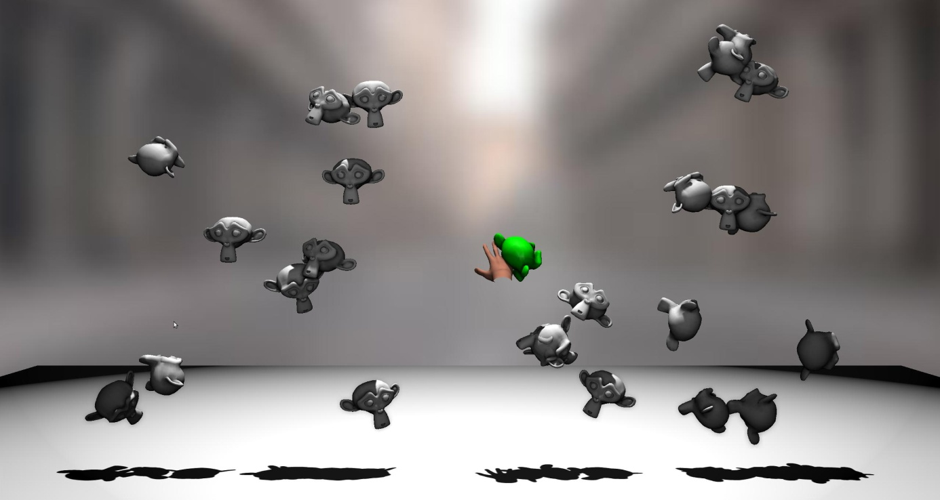

Figure 1: Several target objects are placed randomly in the scene. A virtual hand can be used to drag objects to new positions. Objects in selection range are highlighted in green.

For this assignment three different implementations of object dragging (see Figure 1) within the scenegraph shall be realized. The class *ManipulationManager* provides the three functions *start_dragging()*, *object_dragging()*, and *stop_dragging()*, that are executed at different stages during the dragging process. Include your specific implementations here for the three different dragging realizations.

How to start?

* Copy the *04_object_dragging* folder from */opt/vr_exercises/WS_16_17* to a local repository
* Review the dragging strategies presentation (doc/2016-VR-Lab-04-Object-Dragging-Strategies_Presentation)
* Execute the application by running ./start.sh in a terminal
* Proceed with the assignments

Assignment Tasks (no grading):

1. Implement dragging strategy 1 – re-configuration of the node structure in the scenegraph.
2. Implement dragging strategy 2 – successive application of tool-object offset. Additional fields can be added to any scenegraph node. Every target node (monkey geometry node) already received such an additional matrix field (*DraggingOffsetMatrix* in file *lib/Scene.py*). Use this field to store the necessary offset matrix between tool and the dragged object.
3. Implement dragging strategy 3 – successive application of relative movement input of the hand cursor.
4. Check and ensure that your different dragging implementations are compatible with viewpoint navigation (WASD on keyboard).