MINISTRY OF EDUCATION AND SCIENCE OF UKRAINE
NTU "Dnipro Polytechnic"
Institute of Electric Power Engineering
Faculty of Information Technology
Department of PZKS

REPORT
from laboratory work #2
disciplines "Development of microservice systems in the Golang language"

Performed by: Art. c. 122-20-04
Shcherbatyuk Artem Oleksiyovych
Checked by: Assoc. Reuta O.V

Topic: Go routines and channels
Goal: 1) Learn how to use goroutines
2) Learn to work with channels

Task 2
“CSV Concurrent Sorter” is a CLI application that allows sorting of its input presented as CSV-text.
Technical details
Using the “CSV Sorter” from the Task 1, extend it with the following required features:
1. The application has additional option -d dir-name that specifies a directory where it must read input files from. All files in the directory must have the same format. The output stays the same, it is a one file with sorted content from all input files.
  - 2. Processing must be implemented concurrently based on pipeline.
  - The pipeline includes two stages:
  - • Reading - read input and sent it line by line further.
  - • Sorting - add received lines into the Tree.

  - 3. The application outputs the result when the input ends up.
  - 4. The project includes Unit tests covering the unit that builds the Tree.

Optional features (not required but appreciated):
1. Add signal processing that allows to gracefully stop the application when the user interrupts it pressing Ctrl-C. The interrupted application must write the current result.
2. If your application supports two types of algorithms, include to the project benchmarks comparing usages of these algorithms.

Program code:
Link to the GitHub repository:
https://github.com/kaaamich/GoLang/tree/main/2_Laba/Main.go

The results:

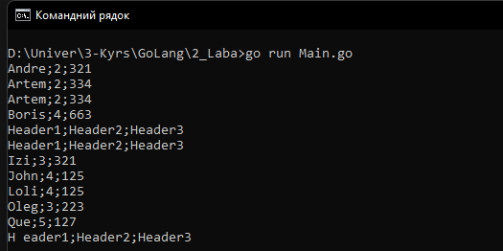

Fig. 1 – Input and output data

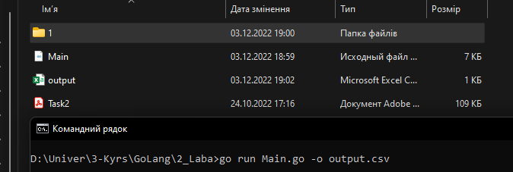

Fig. 2 – The input is output to a file

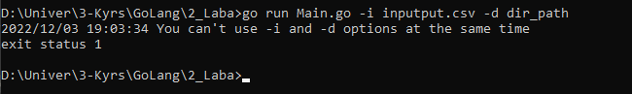
Fig. 3 – Using options simultaneously

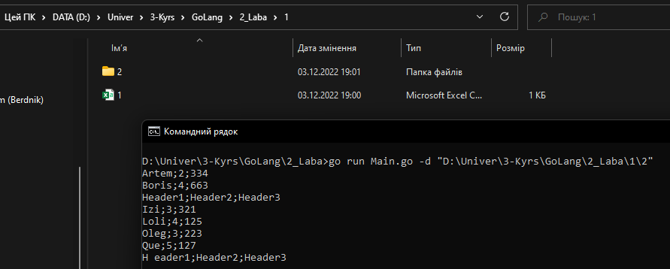

Fig. 4 – Recursive search for files according to the specified path
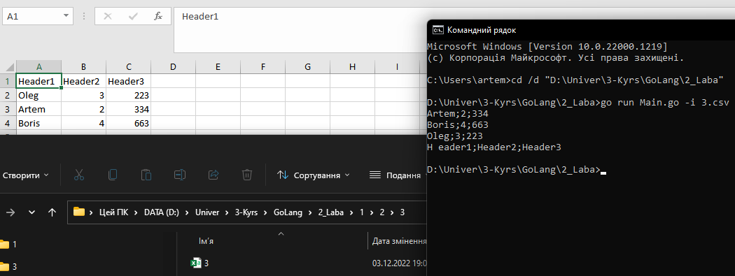
Fig. 5 – Sorting a specific file

Conclusion:
Significantly improved Go language skills, including general knowledge of the language's syntax. Using channels and goroutines, a pipeline is built that performs the operations specified by the condition. Received practical skills of working with channels; learned how to synchronize goroutine work (correct sending/receiving data from channels). I got the experience of breaking one task (conveyor link) into parts. Having chosen the tree sorting algorithm, I significantly optimized the operation of the program.

