Team Members:
Karthikeya R Shervegar | 35192827
Nathan Hunt | 33936224
Pin-Chung Huang | 35195717
Will Schoenfeld | 32501152

Project topic: Robotic Manipulator with Visual Language Action Models (VLA)
1. Motivation
Most robotic manipulators are still programmed through explicit trajectories or task-specific scripts. Humans communication is more like "move the red bottle to the left side of the table" and expect the intent to be understood.
Vision-Language-Action (VLA) models close this gap by mapping raw camera input and a natural-language instruction directly to low-level robot actions, removing the need for hand-engineered perception and planning pipelines for each new task. The catch is size. State-of-the-art open VLA models like OpenVLA run at 7B parameters, built on a vision encoder plus an LLM backbone. That's roughly 14GB in bf16 before accounting for activations and KV cache, well beyond what fits on many of the embedded or single-GPU systems actually mounted on a manipulator. If VLAs are going to move from research demos to real deployed robots, they need to run under realistic memory budgets without giving up the instruction-following behaviour that makes them useful in the first place.
2. Design Goals
- Understanding the VLA architecture end-to-end vision encoding, language conditioning, and the action tokenization/decoding scheme to perform safe compression.
- Fitting the model in 16GB at inference time, including activations, static weights and keeping acceptable accuracy.
- Closing the loop in simulation language with instruction in, manipulator trajectory out, task success or failure observed
- Quantifying the compression trade-off with report memory, inference latency, and task success together.

3. Deliverables
- Compressed model. The 7B VLA model reduced to run within a 160B memory envelope, through quantization and/or pruning/distillation, with accuracy, memory, and latency benchmarked against the uncompressed baseline. As a contingency plan we might use LLaVA-VLA directly
- Simulated pick-and-place system. A pick-and-place environment built in a robotic simulator, with the compressed VLA integrated into the control loop and evaluated on language-conditioned manipulation tasks.

4. System Blocks
The system has two halves: an offline compression pipeline that produces the deployed model, and a runtime control loop that uses it.

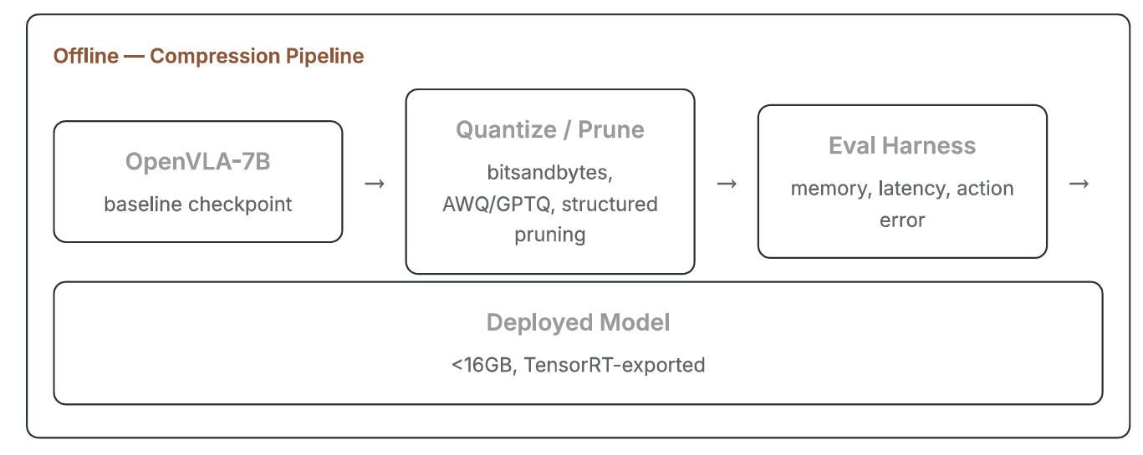
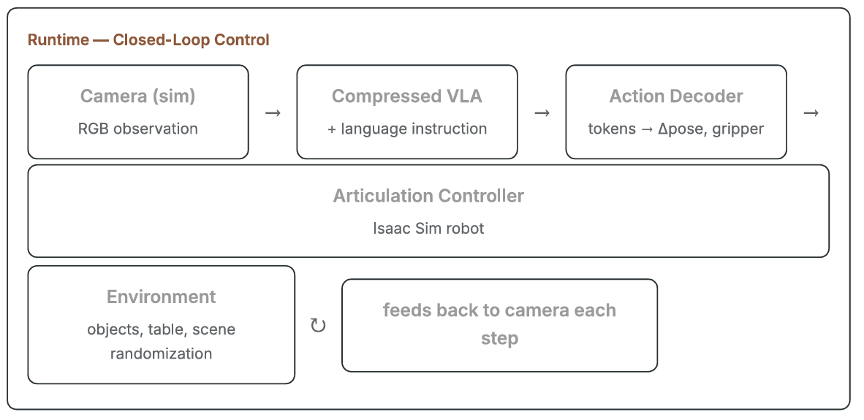

5. Hardware / Software Requirements Hardware
• GPU with 16GB VRAM for compression experiments
• Workstation capable Of running Isaac Sim (check NVIDIA's system requirements)
• NVIDIA Isaac Sim
• Python, PyTorch, Hugging Face Transformers
• OpenVLA codebase
• bitsandbytes, AutoGPTQ / AWQ for quantization
• TensorRT (or TensorRT-LLM) for export/deployment
6. Team Responsibilities
Ping | Quantization / pruning experiments; memory—latency-accuracy eval  harness; final deployed model export.
Karthik | Isaac Sim scene, robot and object setup, task/scene randomization,  camera configuration.
Nathan | Closed-loop wiring between the compressed VLA and the simulator;  action decoding; control-loop timing.
Will | Task success metrics, ablations across compression settings,  generalization tests, final report.

7. Timeline
Today: Week 4 | Project proposal submission
Week 5 | Study OpenVLA architecture and the improved-baseline reference; install Isaac Sim, OpenVLA codebase, and compression tooling.
Week 6 | uncompressed OpenVLA inference baseline (offline); build the Isaac Sim pick-and-place scene and camera setup in parallel.
Targeted completion: Week 7(Midterm) | Quantization (8-bit 4-bit), evaluate action-prediction accuracy against logged trajectories, not just perplexity; iterate toward the 160B target.
Might shift to LLaVA-VLA
Wire the compressed model into the Isaac Sim control loop; resolve action decoding, timing, and
any embodiment/camera mismatches.
Targeted completion: week 12 | Ablations & final experiments  Compile the memory, latency, success trade-off curve across compression configurations.

8. References
OpenVLA: An Open-Source Vision-Language-Action Model
https://arxiv.org/pdf/2406.09246
Rethinking the Practicality Of Vision-Language-Action Models: A Comprehensive
Benchmark and an Improved Baseline
arxiv.org/pdf/2602.22663
github.com/OpenHelix-Team/LLaVA-VLA
NVIDIA Isaac Sim
github.com/isaac-sim/IsaacSim
NVIDIA — Training Healthcare Robots From Scratch: Model Flywheel / Deploy
docs.nvidia.com — 03-deploy.html

