 | Academic year: 2023 - 2024  Written Partial Exam
Module: Object-Oriented Design and Java Programming  Grades: 3B1  Duration: 1 hour  Number of pages: 6 |  | Documents Allowed: No  Internet Allowed: No  Date: 16-03-2024  Time: 11:00 a.m.
Please answer on the exam sheet.
Exercise I: MCQ (4pts)
Only one answer is correct.
- Given this class, what is the correct statement to implement a parameterized constructor that initializes x and y?

- public Mobile (int x, int y) {
x=x;
this.y=y;
}
- public Mobile (int x, int y) {
super();
this.y=y;
}
- public Mobile (){
super;
}
- public Mobile (int x, int y ) {
this.x=x;
this.y=y;
}

- What is the output of this program ?

- true true
- false false
- true false
- false true

- Based on this code:

Which of the following definitions in C2 is a correct overriding of the method “meth” of class C1 and not an overloading?

- public int meth (String s, int n) {return super.meth(s, n * 2) + 10;}
- public int meth (int n, String s) {return super.meth(s, n * 2) + 10;}
- public int meth (String s, int n, int n2) {return super.meth(s, n*2) + n2;}
- public float meth (String s, int n) {return super.meth(s, n * 2) + 10;}

- Based on this code, the variable "name" can be accessed directly from:

- any class
- only the Student class
- Any class in the package “entities”
- any class that inherits from the Student class

Exercise II: Problem (16 pts)
Copy the code onto the exam sheet.
As part of an academic project, you are tasked with developing a program in Java that implements a gym, relying on the class diagram provided and following the instructions given (TODO) by your supervisor.

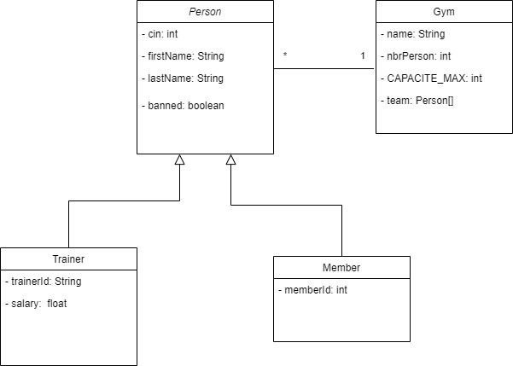
Nb: Respect the Java Naming Rules (Conventions).
PS-1: The use of the collections (List, Set and Map) is strictly prohibited.
PS-2: Note that all the attributes of all classes have the "private" access level.

- TODO 1 (1pt): The "Person" class should allow inheritance only for the "Trainer" and "Member" classes.
- TODO 2 (1pt): Implement the constructor that takes all attributes as a parameter.
- TODO 3 (1pt): Implement the "toString()" method (Don't forget annotations and naming rules)
- TODO 4 (1pt): Declare the method "public void showLabel( )" knowing that it must be redefined in all child classes and not in the Person class.
Person Class
TODO 1
public................................................ class Person ................................................................ {

private int cin;
private String firstName, lastName;
private boolean banned;
/* Getters and Setters are already implemented */
TODO 2
.....................................................................................................................................................

TODO 3
.....................................................................................................................................................

TODO 4
.....................................................................................................................................................
}

- What is the signature of the accessor(getter) of the "banned" attribute, knowing that it is of type boolean? (0.5pt)
...........................................................................................................................

- TODO 5 (0.5 pt): The "Trainer" class can be extended.
- TODO 6 (1pt): Implement the constructor that takes all attributes as a parameter.
- TODO 7 (2pts): Implement salary and trainerId getters and setters knowing that salary must be greater than or equal to 0 and trainerId is not empty.
- TODO 8 (0.5pt): Redefine the "public void showLabel( )" method, knowing that for a trainer, it displays the message "I'm a professional trainer" (Don't forget to add the appropriate annotation)

Trainer Class
TODO 5
public.......................................... class Trainer ..................................................................... {

private String trainerId;
private float salary;

TODO 6
.....................................................................................................................................................

TODO 7
.....................................................................................................................................................

TODO 8
.....................................................................................................................................................
}

- TODO 9 (0.5pt): The "Member" class cannot be extended.
- TODO 10 (1.5pts): Redefine the "equals(Object obj)" method according to the member's cin and ID.
- TODO 11 (0.5pt): Redefine the "public void showLabel( )" method, knowing that for a member, it displays the message with the memberId. (Don't forget to add the appropriate annotation)

Example: "I'm a member and my id is 123A45"
- TODO 12 (1.5pt): Implement the "toString( )" method that reuses the same method of the Person class
Member Class
TODO 9
public.................................... class Member ............................................................ {

private String memberId;

/* constructors, getters and setters are already implemented */

TODO 10
.....................................................................................................................................................

TODO 11
.....................................................................................................................................................

TODO 12
..................................................................................................................................................... }

- TODO 13 (0.5pt): Complete the declaration of CAPACITE_MAX which is set to 30 and then add the necessary instruction to declare a set that includes coaches and members and which is called "team".
- TODO 14 (1pt): Create the parameterized constructor that takes as a parameter that initializes the number of members to 0 and creates the group of "team" people.
- TODO 16 (2pt): The "public void getStatistics( )" method is used to display the number of members and the number of coaches in the team. Banned people will not be considered.
Example: This gym has 20 members and 4 trainers
Gym Class
public class Gym {
private String name;
private int nbrPersons;

/* Getters, setters are already implemented */

TODO 13
private String name;
private .............................. int CAPACITE_MAX ............................................................;
...................................................................................................................................................

TODO 14
......................................................................................................................................................

TODO 15
public void getStatistics( ) {
...................................................................................................................................................... }

