KWAME NKRUMAH UNIVERSITY OF SCIENCE AND TECHNOLOGY, KUMASI
COLLEGE OF SCIENCE
FACULTY OF PHYSICAL AND COMPUTATIONAL SCIENCES
DEPARTMENT OF COMPUTER SCIENCE



GROUP 2

FINAL YEAR PROJECT PROPOSAL
PROJECT TITLE: AI-BASED MOBILE APPLICATION FOR CROP DISEASE DETECTION USING CONVOLUTIONAL NEURAL NETWORKS AND TRANSFER LEARNINGMN

PROJECT SUPERVISOR
PROFESSOR FRIMPONG TWUM

SUBMITTED BY:
KWAME BAFFOUR-AGYEMAN YEBOAH (3418222)
JOHN AGYEMANG (3365922)

SEPTEMBER, 2026

DECLARATION
We hereby declare that, except where specific references have been duly acknowledged, the work presented in this project is the result of our own research and effort. This project has not been submitted, in whole or in part, for any other degree elsewhere.

Signature …………………………………….. Date ………………………………
Kwame Baffour-Agyeman Yeboah (Candidate)

Signature …………………………………….. Date ………………………………
John Agyemang (Candidate)

Signature …………………………………….. Date ………………………………
Professor Frimpong Twum (Supervisor)

DEDICATION
This project is dedicated to our supervisor, Professor Frimpong Twum, for his invaluable guidance, patience, and insightful feedback, which were instrumental in shaping and completing this project.

ACKNOWLEDGMENT
We wish to extend our profound gratitude to everyone whose support and contributions made the successful completion of this project possible.
We are especially grateful to our educational institution for providing the resources, facilities, and academic environment that enabled us to carry out this work. The access to computational tools, libraries, and technical support greatly facilitated our research process.
We are also deeply thankful to our supervisor, Professor Frimpong Twum, for his guidance and constructive feedback throughout the course of this project.
Above all, we recognize our own dedication and collaboration as a team, whose perseverance and hard work were instrumental in developing the machine learning model and mobile application at the core of this project.

ABSTRACT
Crop diseases pose a significant threat to agricultural productivity and food security in Ghana, where smallholder farmers often lack timely access to plant pathologists and agricultural extension officers. Delayed or inaccurate diagnosis frequently results in reduced yields, misuse of agrochemicals, and avoidable economic losses.
This project presents CropGuard AI, a mobile application that enables farmers to capture images of crop leaves using a smartphone and receive an immediate, on-device diagnosis of the disease present, together with practical treatment recommendations. The system is built around a Convolutional Neural Network trained through transfer learning on a MobileNetV2 architecture, compressed and deployed as a TensorFlow Lite model that runs directly on the user's device without requiring an internet connection. The mobile front end was developed using the Flutter SDK, while a hybrid, offline-first architecture combines a local SQLite database with cloud-based storage for scan history and a community outbreak-reporting feature.
The trained classifier was evaluated on 2,500 test images spanning ten crop-disease categories and a healthy-leaf control class, achieving a weighted precision of 95.74%, recall of 94.98%, and F1-score of 95.35%. On-device inference averaged 142 milliseconds per image, considerably faster than equivalent cloud-based inference, while remaining within the memory constraints of entry-level smartphones. A System Usability Scale evaluation involving 25 smallholder farmers and extension officers produced an average score of 88.5 out of 100.
These results indicate that CropGuard AI can deliver fast, accurate, and usable disease diagnosis in the field, even without reliable internet connectivity. The expected outcome of this project is an accessible, low-cost diagnostic tool that supports timely intervention, reduces reliance on manual inspection, and contributes to improved crop management and food security among Ghanaian farmers.

TABLE OF CONTENTS

DECLARATION ii
DEDICATION iii
ACKNOWLEDGMENT iv
ABSTRACT v

CHAPTER 1 1
PROJECT PROPOSAL 1
INTRODUCTION AND BACKGROUND 1
Problem Statement 1
Aim of the Project 2
Specific Objectives 2
Project Scope 4
Motivation for Undertaking the Project 5
Justification of the Project 5
Project Methodology 6
Project Deliverables 7
Project Plan and Timeline 8

CHAPTER 2 11
REVIEW OF RELATED SYSTEMS 11
INTRODUCTION 11
Overview Of Existing Systems 11
Review Of Existing Systems 11
COMPARATIVE SYSTEM ANALYSIS TABLE 15
Gaps Identified in Existing Systems 16
Justification for the Proposed System 17
Conceptual Design 17
Summary 18

CHAPTER 3 20
INTRODUCTION 20
Architecture of the Proposed System 20
High-Level Architecture Diagram 21
Component Designs and Descriptions 21
Evaluation and Analysis of the Type of Software System to be Developed 24
PROPOSED SYSTEM MAIN SYSTEM FUNCTIONALITIES ( FUNCTIONAL REQUIREMENTS) 26
REQUIREMENT SPECIFICATION 29
Non-Functional Requirements 37
Algorithms 40
Flowcharts for the Algorithms 42
Project Methods to be Employed 45
Software Process Model and Justification 45
Justification for the choice: 46
Development Tools. 46

CHAPTER 4 IMPLEMENTATION, TESTING, AND RESULTS 49
4.1 IMPLEMENTATION 49
4.1.1 Introduction 49
4.1.2 Implementation of the Frontend 49
4.1.3 Implementation of the Backend 53
4.1.5 File Upload Module 56
4.1.6 Implementation Of The Hashing Method 56
4.1.7 Implementation Of The Data Module 57
4.1.8 Implementation Of The Checksum Data Recovery Technique 57
4.1.9 Implementation Of the Data Shuffling Method 58
4.2.1 UI Testing 58
4.2.2 DB Testing 59
4.2.4 System Testing 60
4.3.1 Machine Learning Classification Accuracy 62

CHAPTER 5 FINDINGS, CONCLUSIONS AND RECOMMENDATIONS 65
5.1 Introduction 65
5.2 Findings 65
5.3 Conclusions 66
5.4 Challenges Encountered 66
5.5 Lessons Learned 67
5.6 Novelty of the System 68
5.7 Recommendations for Future Work 69

REFERENCES 70
CHAPTER 1
PROJECT PROPOSAL
AI-based mobile application for crop disease detection using convolutional neural networks and transfer learning

INTRODUCTION AND BACKGROUND
Agriculture remains one of the most important sectors of the Ghanaian economy providing employment, food security and income for millions of people. However, crop diseases significantly reduce agricultural productivity every year. Early identification of plant diseases is critical for preventing yield loss, reducing pesticide misuse and improving farm management. Traditionally, crop disease detection relies on visual inspection by agricultural experts. This process is often slow, expensive and inaccessible to farmers in rural areas. Many small-scale farmers lack direct access to plant pathologists or agricultural extension officers which leads to delayed detection of diseases. Recent advances in Artificial Intelligence (AI) and Deep Learning provide an opportunity to automate plant disease detection using image recognition. Convolutional Neural Networks (CNNs) have proven highly effective in image classification tasks such as medical diagnosis, facial recognition and object detection. Through Transfer Learning, pre-trained deep learning models such as MobileNet, ResNet and EfficientNet can be adapted to agricultural datasets enabling high accuracy even with relatively small training datasets.
This project proposes the design and development of an AI-based mobile application that allows farmers to capture images of crop leaves using smartphones. The system will automatically analyze the images using CNN models and identify potential diseases while providing treatment recommendations.

Problem Statement
Crop disease management remains a major challenge in modern agriculture, particularly in developing countries like Ghana. The following key problems have been identified:
Delayed and Inefficient Disease Detection
Most farmers rely on manual visual inspection to identify crop diseases which often leads to late detection after significant damage has already occurred. This reduces crop yield and overall productivity.
- Limited Access to Agricultural Expertise
Small-scale farmers especially in rural areas have little or no access to agricultural extension officers or plant pathologists. This results in misdiagnosis or inability to identify diseases accurately.
- Misuse of Agrochemicals Due to Incorrect Diagnosis
Due to poor disease identification farmers often apply inappropriate pesticides or treatments. This not only increases production costs but also harms the environment and affects food safety.

Aim of the Project
The aim of this project is to design and implement an AI-powered mobile application capable of detecting crop diseases from leaf images using Convolutional Neural Networks and Transfer Learning.

Specific Objectives
The following specific objectives have been defined to guide the development of the platform:
- Develop a Mobile Application Interface that allows farmers and agricultural users to capture images of plant leaves, input basic crop information, and receive real-time disease detection results.
- Prepare and Integrate a Crop Disease Dataset by collecting, cleaning, and augmenting plant leaf images to ensure the model can accurately detect multiple disease types across different crops.
- Develop a Convolutional Neural Network (CNN) Model using transfer learning techniques to classify plant diseases with high accuracy and reliability.
- Implement AI-Assisted Disease Diagnosis where the model analyzes user-submitted images and provides clear identification of the disease type along with recommended treatment options.
- Incorporate a Model Deployment Mechanism that converts the trained CNN model into a mobile-compatible format (e.g., TensorFlow Lite) and integrates it seamlessly into the application.
- Implement Real-Time Performance Evaluation by testing the system with new images in various real-world conditions to ensure accuracy, responsiveness, and usability for end-users.
- Design an Intuitive and Mobile-Friendly User Interface that is simple, responsive, and accessible to users with varying levels of digital literacy, ensuring a seamless experience on smartphones and tablets.
- Develop a User Guidance and Information Feature that educates users about detected diseases, preventive measures, and proper crop care practices to support informed decision-making.
- Deploy the Application on a Reliable Platform ensuring that the app is publicly accessible, performs consistently under real-world conditions, and can scale to accommodate multiple users simultaneously.

Project Scope

The AI-Based Crop Disease Detection project focuses on developing a mobile application capable of identifying crop diseases from images of leaves captured by farmers using smartphones. The system will use Convolutional Neural Networks (CNNs) and Transfer Learning to classify diseases accurately and provide appropriate treatment suggestions.

The scope of the project includes:

Detecting diseases in selected crops commonly cultivated in Ghana.

Allowing users to capture or upload leaf images via a mobile device.

Providing real-time disease detection results along with recommended treatment methods.

Developing a curated dataset of crop images and preprocessing scripts to train AI models.

Integrating the trained AI model into a fully functional mobile application.

Evaluating the system’s performance using metrics such as accuracy, precision, recall, and F1-score.

Out of Scope:

Detection of all possible crops globally (the focus is on locally relevant crops).

Prescription of chemical doses or personalized farm management plans beyond general recommendations.

Replacement of agricultural experts; the system is designed to assist farmers rather than replace expert advice.

Motivation for Undertaking the Project

The motivation for this project stems from the persistent challenges faced by farmers and agricultural stakeholders in accurately detecting crop diseases at early stages, particularly in regions with limited access to expert agronomists. Misidentification or delayed diagnosis often leads to significant crop loss, reduced yield, and economic hardship. These challenges underscore a clear need for an accessible, rapid, and reliable system that can assist farmers in identifying crop diseases using readily available tools, such as smartphones.

There is also a growing interest in applying artificial intelligence, computer vision, and mobile technologies to practical, real-world agricultural problems (Szeliski, 2011). This project presents an opportunity to combine deep learning, transfer learning, and mobile app development to create an end-to-end solution that is both technically innovative and socially impactful. By integrating a trained convolutional neural network into a user-friendly mobile application, the system can provide timely, accurate disease diagnosis, guidance for treatment, and contribute to improved food security and sustainable agricultural practices.

Justification of the Project
The justification for this project rest on three pillars:

Market Gap: There is a lack of affordable, user-friendly and locally relevant AI-based agricultural tools for smallholder farmers. Existing solutions are often expensive, require constant internet access and are not tailored to African farming conditions. This project addresses this gap by providing a low-cost, mobile-based and accessible solution for crop disease diagnosis.
Technical Relevance: The project applies advanced AI techniques, specifically Convolutional Neural Networks (CNNs) and Transfer Learning, to achieve accurate crop disease detection. By using pretrained models such as MobileNet, ResNet and EfficientNet, the system reduces training time and computational cost while maintaining high accuracy. It is also optimized for deployment on mobile devices, enabling real-time and scalable disease detection.
Social and Economic Impact: The system improves farmers’ decision-making and promotes early disease detection leading to better crop health and increased food security. It reduces reliance on agricultural experts and minimizes the misuse of pesticides.
It helps reduce crop losses, lower production costs, increase farmer income, and enhance overall agricultural productivity, contributing to economic growth.

Project Methodology
The project will adopt a system development and machine learning pipeline approach, consisting of the following phases:
Stage 1: Data Collection
- Gather labelled images of healthy and diseased crop leaves
- Sources: public datasets (e.g., Plant Village) and local farms
Stage 2: Data Preprocessing
- Image resizing and normalization
- Data augmentation (rotation, flipping, scaling) to improve generalization
- Dataset splitting (training, validation, testing)
Stage 3: Model Development
- Implement CNN models using transfer learning
- Fine-tune pretrained models such as MobileNet or ResNet
- Optimize hyperparameters for improved performance
Stage 4: Model Evaluation
- Evaluate using:
  - Accuracy
  - Precision
  - Recall
  - F1-score
- Perform confusion matrix analysis

Stage 5: Mobile Application Development
- Develop a user-friendly mobile app interface
- Features:
  - Image capture/upload
  - Disease detection display
  - Treatment recommendations
Stage 6: System Integration
- Convert trained model to a mobile-compatible format (e.g., TensorFlow Lite)
- Integrate model into the mobile application
Stage 7: Testing and Validation
- Functional testing of the app
- Real-world testing with sample users (farmers)
- Performance and usability evaluation

Project Deliverables
Upon successful completion, this project will deliver the following
1. The project will produce a trained AI model, which will be a validated CNN-based system capable of accurately classifying crop diseases and optimized for deployment on mobile devices.
2. The project will deliver a mobile application, which will be a fully functional Android app that allows users to capture or upload images, detect crop diseases, and receive appropriate treatment recommendations.
3. The project will provide an image dataset, consisting of curated and labeled crop leaf images along with preprocessing and data augmentation scripts used during model development.
4. The project will include a system integration package, which will ensure the seamless integration of the trained AI model into the mobile application, making it ready for deployment.
5. The project will generate a performance evaluation report, presenting a detailed analysis of the model’s accuracy and overall system performance using standard evaluation metrics and testing results.
6. The project will also produce final documentation, including a technical report, a user manual for farmers and end users, and developer documentation to support future improvements and system maintenance.

Project Plan and Timeline

Action Plan
Phase | Activity | Duration | Description
1 | Literature Review | Weeks 1-2 | Conduct an in-depth literature review on crop disease detection and AI techniques
2 | Dataset Collection | Weeks 3-4 | Identify and collect relevant datasets (e.g., plant leaf images).
3 | Data Preprocessing | Weeks 3-4 | Perform data preprocessing and augmentation to improve dataset quality.
4 | Model Development | Weeks 5-8 | Develop and train CNN models using transfer learning techniques.
5 | Mobile App Development | Weeks 9-12 | Convert and integrate the trained model into mobile application
6 | Integration and Testing | Weeks 13-14 | Conduct system testing and validation with real world scenerios
7 | Documentation | Weeks 15-16 | Prepare final documents reports

Work Breakdown Structure (WBS)

The project is divided into manageable components as follows:
- Research Phase
  - Literature Review
  - Problem Analysis
- Data Preparation
  - Data Collection
  - Data Cleaning
Data Augmentation
- Model Development
  - Model Selection (MobileNet, ResNet, etc.)
  - Model Training
  - Model Optimization
- Application Development
  - UI/UX Design
  - Mobile App Development
  - Feature Implementation
- System Integration
  - Model Conversion (e.g., TensorFlow Lite)
  - Integration into Mobile App
- Testing and Evaluation
  - Functional Testing
  - Performance Evaluation
Documentation
  - Report Writing
  - User Manual
  - Final Submission

Gantt Chart
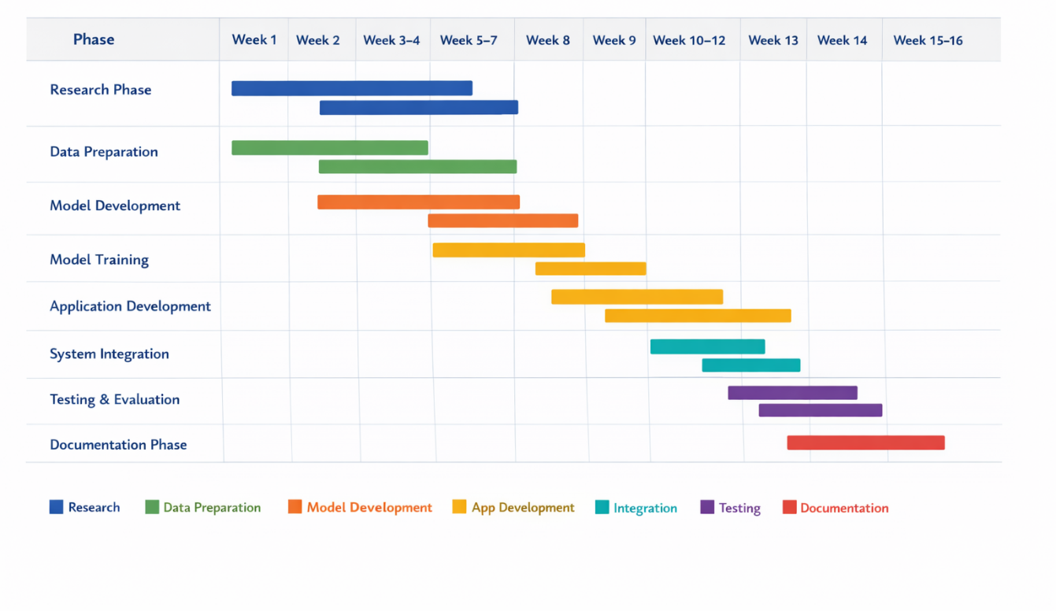

Milestones -Major Target and Major Achievement
• Completion of literature review and problem definition
• Successful dataset collection and preprocessing
• Development of a trained and validated CNN model
• Completion of mobile application prototype
• Successful integration of AI model into the app
• Completion of system testing and evaluation
• Submission of final report and documentation

CHAPTER 2
REVIEW OF RELATED SYSTEMS

INTRODUCTION
This chapter presents a review of existing systems and research related to crop disease detection using artificial intelligence, image processing and mobile applications. The purpose of this chapter is to examine current technologies, methods and tools used for plant disease detection and agricultural decision support systems. The chapter also analyzes the strengths and limitations of existing systems and identifies gaps that justify the development of the proposed AI-based crop disease detection mobile application.

Overview Of Existing Systems
Crop diseases are a major threat to agricultural productivity worldwide. Traditionally, crop disease detection has relied on manual inspection by farmers or agricultural experts. This method is often slow, inaccurate and expensive especially for farmers in rural areas who do not have access to plant pathologists.

With advancements in Artificial Intelligence (AI), Machine Learning and Computer Vision, automated crop disease detection systems have been developed. These systems use image processing and deep learning algorithms to analyze images of plant leaves and identify diseases automatically. Many modern systems use Convolutional Neural Networks (CNNs) because of their high accuracy in image classification tasks.
Additionally, mobile technology has made it possible to deploy AI models on smartphones, allowing farmers to capture images of plant leaves and receive disease diagnosis in real time.

Review Of Existing Systems
A. PlantVillage Crop Disease Detection System
The PlantVillage project is one of the most widely used crop disease detection systems. It provides an open-access dataset containing thousands of labelled images of healthy and diseased plant leaves (Hughes & Salathé, 2015). Researchers have used this dataset to train machine learning and deep learning models for plant disease classification.
The PlantVillage system uses deep learning models, particularly Convolutional Neural Networks to classify plant diseases from leaf images with high accuracy (Mohanty et al., 2016).
Features Include
- Large dataset of plant leaf images
- Image-based disease classification
- Supports multiple crop types
- Uses deep learning models for classification
- Provides disease identification results

Good Features Of the System (PlantVillage Crop Detection)
1. High accuracy in disease detection
2. Large dataset for training models
3. Supports research and development in plant disease detection
4. Open-source and widely available

Limitations of the PlantVillage System
- Not a complete mobile application for farmers
- Requires internet and computer systems
- Does not provide treatment recommendations directly in some implementations
- Not specifically designed for local Ghanaian crops
These limitations show the need for a mobile-based system tailored to local farmers.

B. AI-Based Plant Disease Detection Using Deep Learning

Several researchers have developed AI systems that use Convolutional Neural Networks for plant disease detection. These systems typically involve collecting plant leaf images, preprocessing the images, training CNN models, and using the trained model to classify diseases.
Deep learning models such as MobileNet (Howard et al., 2017; Sandler et al., 2018), ResNet (He et al., 2016), VGG16 (Simonyan & Zisserman, 2015) and EfficientNet (Tan & Le, 2019) are commonly used through transfer learning. Transfer learning allows a pre-trained model to be reused and fine-tuned for plant disease classification, reducing training time and improving accuracy (Pan & Yang, 2010).
Features Include
- Image classification using CNN
- Transfer learning using pretrained models
- Disease prediction from leaf images
- High classification accuracy
- Automated detection process

Good Features of the System (AI-Based Plant Disease Detection Using Deep Learning)
1. Faster disease detection
2. High accuracy compared to manual inspection
3. Reduces reliance on agricultural experts
4. Can be integrated into mobile applications
5. Scalable and efficient

Limitations of the AI-Based Plant Disease Detection Using Deep Learning
- Requires a large dataset for training
- Performance depends on image quality
- Some models require high computational power
- Not all systems are deployed as mobile applications
These limitations justify the need for a mobile-optimized AI system.

C. Mobile Agricultural Advisory Applications

There are several mobile applications developed to support farmers with agricultural information, crop management, weather forecasts, and pest control, such as the Plantix crop advisory application (PEAT GmbH, 2023). Some of these apps provide crop disease information but do not include AI-based disease detection.

Features Include
- Farming tips and advisory services
- Weather information
- Crop management guides
- Pest and disease information
- Communication with agricultural experts

Good Features of the System (Mobile Agricultural Advisory Applications)
1. Easy access to agricultural information
2.Mobile accessibility for farmers
3.Improves farming decision-making
4.Supports rural farmers

Limitations of the Mobile Agricultural Advisory Applications
- Most apps do not automatically detect diseases from images
- Farmers must manually identify diseases
- Some apps require constant internet access
- Not fully automated disease diagnosis systems
This shows that there is still a gap for AI-powered disease detection mobile applications.

COMPARATIVE SYSTEM ANALYSIS TABLE
Criteria | PlantVillage | Deep Learning Research Systems | Agricultural Advisory Apps | Proposed System
Technology Used | CNN, Deep Learning | CNN, Transfer Learning | Mobile Apps | CNN + Transfer Learning
Disease Detection | Yes | Yes | No | Yes
Mobile App | No | Sometimes | Yes | Yes
Treatment Recommendation | Limited | Limited | Yes | Yes
Limitation | Not Mobile Based | Require high computing power | No AI detection | Focus on selected crops
Real Time Detection | No | Limited | No | Yes
Works Offline | No | No | Sometimes | Yes
Local Crop Support | Limited | Limited | Moderate | Yes
Integrated System | No | No | Partial | Yes
Ease of use | Moderate | Difficult | Easy | Easy
Target Users | Researchers | Researchers | Farmers | Farmers
Cost | Moderate | High | Low | Low
Accessibility | Limited | Limited | High | High

Gaps Identified in Existing Systems
After reviewing existing crop disease detection systems, several gaps and limitations were identified. These gaps justify the need for the proposed AI-Based Mobile Application for Crop Disease Detection.
Despite the existence of various crop disease detection systems and agricultural mobile applications, several limitations still exist in current solutions.
1. Lack of Mobile-Based AI Systems
Many existing crop disease detection systems are research-based and run on computers rather than mobile devices. This makes them inaccessible to farmers who rely mainly on smartphones. There is therefore a need for a mobile-based system that farmers can use directly in the field.
2. Limited Real-Time Detection
Some existing systems require images to be uploaded to a server for processing, which can cause delays and requires a stable internet connection. Farmers in rural areas may not have reliable internet access, making such systems inefficient.
3. Lack of Treatment Recommendations
Many disease detection systems only identify the disease but do not provide treatment methods, preventive measures, or crop management advice. Farmers still need expert guidance after diagnosis.
4. Not Focused on Local Crops
Some existing systems are trained on foreign datasets and may not perform well on crops commonly grown in Ghana or Africa. This reduces the accuracy and usefulness of such systems in local farming environments.
5. High Computational Requirements
Some deep learning models require powerful computers and cannot run efficiently on mobile devices. This makes them unsuitable for real-time mobile applications.

6. Lack of Integrated System
Most systems focus only on disease detection and do not integrate:
- Image capture
- Disease detection
- Recommendation
- Mobile interface
into one complete system.

Justification for the Proposed System
The development of the AI-Based Crop Disease Detection Mobile Application is justified for several reasons.
First, farmers often detect crop diseases too late which leads to crop loss and reduced productivity. An automated disease detection system will help farmers identify diseases early.

Second, many farmers do not have access to agricultural experts, especially in rural areas. The mobile application will provide disease diagnosis and treatment recommendations.

Third, existing systems are either research-based or not optimized for mobile use. The proposed system will integrate a trained CNN model into a mobile application, making it accessible and easy to use.
Finally, the system will help reduce misuse of pesticides, improve crop yield, reduce production costs, and improve food security.

Conceptual Design
The conceptual design describes the structure, components, and operation of the proposed AI-Based Crop Disease Detection System. The system is designed as an integrated mobile application that uses deep learning techniques to analyze images of crop leaves and detect diseases in real time.
The system consists of several interconnected modules working together to ensure accurate disease detection, user interaction, and data processing.

1.The image acquisition module allows users to capture images of crop leaves using the smartphone camera or upload images from the phone gallery. These images serve as the input to the system.
2.The image preprocessing module processes the captured images before they are sent to the AI model. This involves resizing the image, normalizing pixel values, and improving image quality to ensure accurate prediction by the model.
3.The AI disease detection module is the core part of the system. This module uses a Convolutional Neural Network (CNN) trained using transfer learning models such as MobileNet or ResNet to analyze the leaf image and classify whether the leaf is healthy or diseased and identify the type of disease.
4.After the disease is detected, the recommendation module provides treatment suggestions, preventive measures, and general crop care advice based on the detected disease.
5.The database stores information about crop diseases, treatment methods, and model data. It may also store user images and detection results if needed.
6.The mobile application interface allows users to interact with the system. Through the app, users can capture images, upload images, view disease detection results, and read treatment recommendations.

Summary
In summary, the proposed AI-based mobile application for crop disease detection provides an intelligent and efficient approach to identifying plant diseases by leveraging Convolutional Neural Networks and transfer learning. Unlike existing systems that rely on manual inspection or lack full mobile integration, this system enables real-time disease detection directly from leaf images captured using smartphones. It not only identifies diseases accurately but also provides immediate treatment recommendations, thereby supporting informed decision-making for farmers. The system addresses key challenges such as delayed diagnosis, limited access to agricultural expertise, and misuse of agrochemicals, making it a practical and impactful solution for improving agricultural productivity and sustainability, particularly in regions with limited reso

The diagram below illustrates the conceptual design of the proposed system, showing how the six interconnected modules work together to deliver a complete crop disease detection experience:
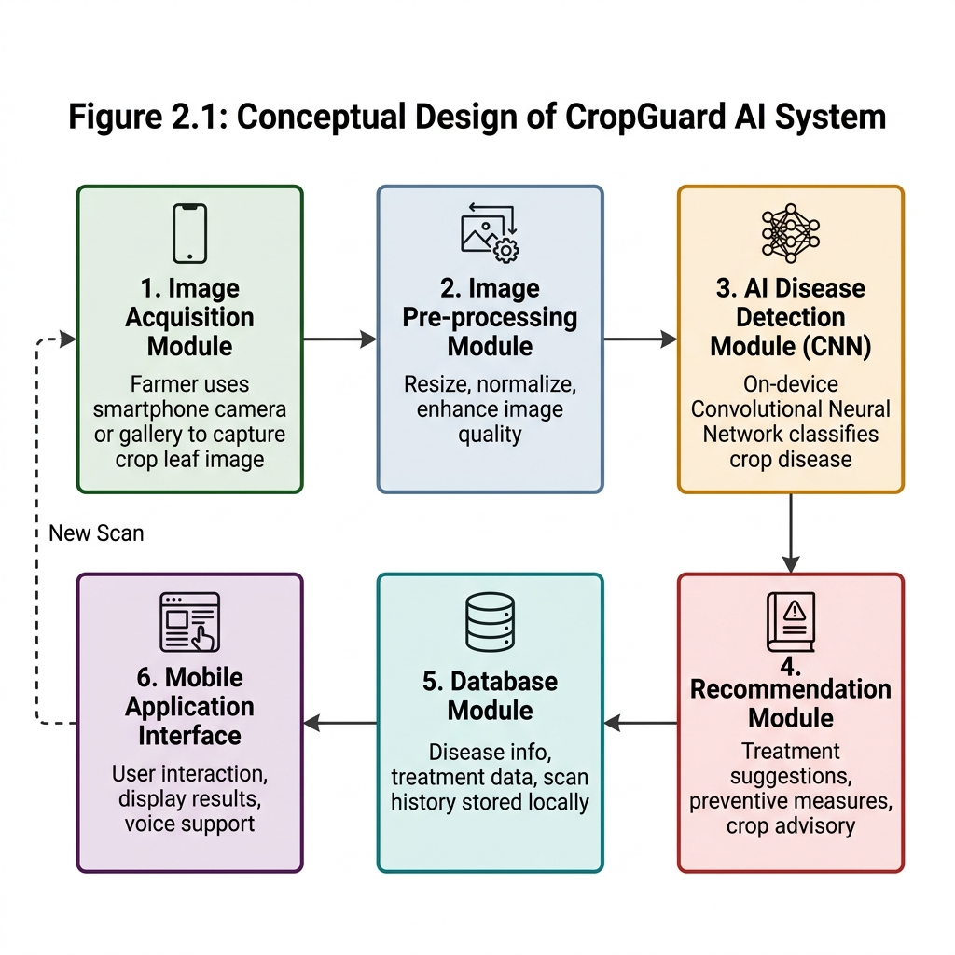
Figure 2.1: Conceptual Design of CropGuard AI System

CHAPTER 3
INTRODUCTION

This chapter presents the methodology adopted in the design and development of AI-Based Mobile Application for Crop Disease Detection (CropGuard AI), a mobile application that enables Ghanaian farmers to detect crop diseases from a photograph of a plant leaf and to receive an appropriate treatment plan.
The chapter begins with the overall architecture of the proposed system and a
description of each architectural component. It then evaluates the type of
software application being developed and states the system's main functionalities (functional requirements). The stakeholders of the system are identified, the
requirement-gathering process is described and the requirements are formally specified through Functional User Requirements, Functional System Requirements
and a complete set of UML diagrams (use case, activity and sequence diagrams)
with accompanying use-case descriptions. Non-functional requirements are then outlined and justified. The candidate classes of the system are identified and modelled in a UML class diagram, the principal algorithms are presented together with their flowcharts, and the chosen project method and software process model are justified.

Architecture of the Proposed System
CropGuard AI is built on a layered Clean Architecture with a strict,
unidirectional dependency rule: outer layers depend on inner layers, never the
reverse. The system is organised into three layers — Presentation,
Domain and Data — supported by a cross-cutting Core layer. This separation makes the system testable, allows the user interface and the data sources (database, machine-learning model, cloud services) to evolve independently, and keeps the business rules isolated from framework details.
A defining characteristic of the architecture is that it is offline-first:
the core capability — capturing an image and classifying the disease using an
on-device Convolutional Neural Network (CNN) — works entirely without an internetconnection. Cloud services (authentication, synchronisation, community feed) are treated as optional enhancements layered on top of the offline core.

High-Level Architecture Diagram
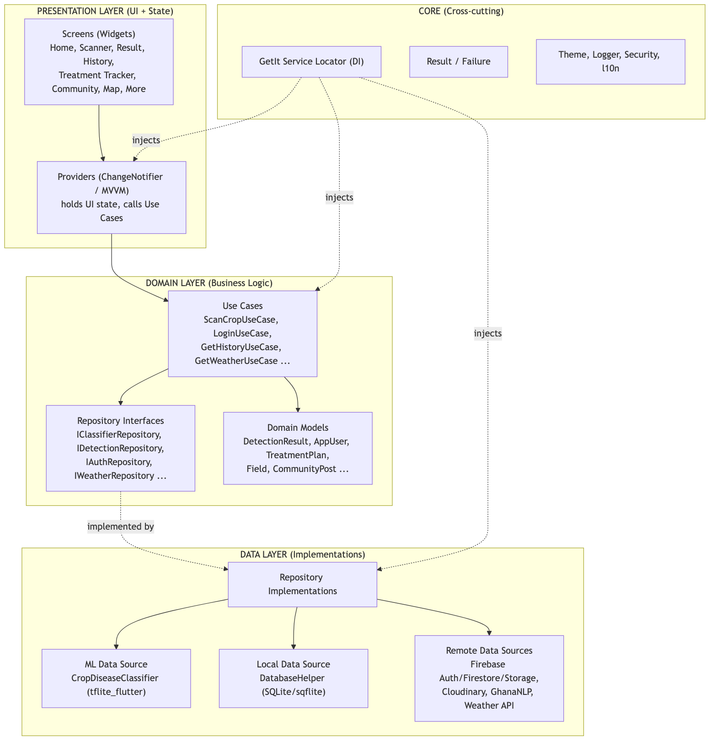

Component Designs and Descriptions
1.Presentation Components (Screens and Providers)
The presentation layer follows the MVVM pattern. Each feature has a Screen (a pure Flutter widget that only renders state) and a Provider (a
ChangeNotifier that holds the UI state and calls use cases). When a use case
returns a Result, the provider folds it into one of four UI states —
loading, success, error or empty/offline — and notifies its listeners, which triggers a rebuild of the screen. This keeps widgets free of business logic and
guarantees that a Failure never reaches the UI as an unhandled exception.
Navigation between screens is handled by go_router, with a ShellRoute that hosts the bottom navigation bar (Home, History, More) and full-screen push routes for the Scanner and Result screens.
2. Use Case Components (Domain Logic)
Each use case encapsulates a single unit of business logic and orchestrates one
or more repositories. The principal use cases are:
Use Case | Responsibility
ScanCropUseCase | Runs classification, derives severity, persists the result, updates the scan streak
LoginUseCase / RegisterUseCase / SignInWithGoogleUseCase / SignInAnonymouslyUseCase / LogoutUseCase / SendPasswordResetUseCase | Authentication operations
GetHistoryUseCase / DeleteDetectionUseCase / RestoreDetectionUseCase | Scan-history management
GetHomeDataUseCase | Aggregates farm statistics, recent scans and weather for the dashboard
GetWeatherUseCase | Retrieves localised weather and disease-risk forecast

For example, ScanCropUseCase works as follows: it calls the classifier
repository to obtain a Classification; it maps the model's confidence and
health flag onto a severity band (healthy, early, moderate, severe);
it builds a DetectionResult enriched with the disease's display name, cause and
recommended treatments; it persists the result through the detection repository;
and it records the scan against the user's daily streak. Each step short-circuits
to a typed Failure if it fails.
3. Machine-Learning Component (`CropDiseaseClassifier`)
This is the core component of the system. It wraps tflite_flutter and runs a
CNN (MobileNetV2-based, trained by transfer learning) entirely on the device. Its
working can be summarised as:
Model loading. Two quantised TFLite models and their label files are loaded from the application assets (cropguard_plant_disease.tflite with 54 classes
and cropguard_plant_disease_v2.tflite with 16 classes).
Pre-processing. The captured image is decoded, resized to 224 × 224pixels, and each pixel's R, G, B channels are normalised to the range [0, 1] to form a [1, 224, 224, 3] float input tensor.
Inference. Both models are executed on the tensor. Because the two modelshave different numbers of output classes, each model's top confidence is adjusted by subtracting its uniform-chance probability (1 / numClasses) so that the smaller model's naturally softer soft-max does not dominate. The model with the higher adjusted score wins.
Result assembly. The winning label is looked up in an on-device disease database to attach the display name, crop type, cause and treatments, producing a ClassificationResult.
Confidence gating. A confidence threshold of 0.60 is applied; results below this trigger a "low-confidence / retake photo" warning.
Crucially, inference is executed inside a background isolate (via Flutter's compute() ), so the heavy pixel-tensor construction and interpreter execution do not block the UI thread or cause jank on low-end devices.
4.Local Persistence Component (`DatabaseHelper`)
This component wraps SQLite (sqflite) and is the offline store for scan history, fields, treatment plans and notifications. It manages schema creation and versioned migrations (current schema version 11), inserting detections, querying history (all/recent/by-id), deleting and restoring records (and the associated image files on disk), and computing farm statistics and the 7-day disease trend used on the dashboard. All multi-step writes use SQLite transactions to preserve data integrity.
5.Remote Data Components
These optional components synchronise and enrich data when connectivity is
available:
Supabase Auth — email/password, Google Sign-In and anonymous (guest) login.
Supabase Database — cloud mirror of scans and the community feed.
Supabase Storage / Cloudinary — hosting of community and scan images.
GhanaNLP service — text-to-speech / speech-to-text for the voice assistant
in local languages.
Weather API — weather and disease-risk forecasting for the dashboard.
6.Core / Cross-Cutting Components
Service Locator (GetIt) — registers and injects all dependencies.
`Result<T>` / `Failure` — uniform error-handling envelope.
Security helpers — root/jailbreak detection, screenshot blocking on
sensitive screens, and certificate pinning.
Localization (l10n) — English and Twi via ARB files.

Evaluation and Analysis of the Type of Software System to be Developed
CropGuard AI is a native cross-platform mobile application (Android and iOS),
developed with the Flutter framework and the Dart language. The evaluation of
candidate application types is summarised below.

Application type | Suitability for CropGuard AI
Web application | Rejected — requires constant connectivity; cannot easily run on-device CNN inference; poor camera/offline support in rural areas with weak networks.
Native (per-platform) app | Capable but doubles development effort (separate Kotlin and Swift codebases) for a student project.
Hybrid / cross-platform (Flutter) | Selected — single codebase for Android and iOS, near-native performance, first-class camera and on-device ML support, and an offline-first runtime.

The application is therefore best classified as an intelligent, data-driven,
offline-first mobile application that combines:
- an embedded machine-learning system (on-device CNN inference);
- a local transactional database system (SQLite); and
- a client of cloud back-end services (Supabase/Cloudinary) for optional synchronization and community features.
This hybrid classification (on-device intelligence + optional cloud back-end) is the central reason the system remains fully usable in rural farming areas with intermittent connectivity, while still benefiting from the cloud when a network is present.

PROPOSED SYSTEM MAIN SYSTEM FUNCTIONALITIES ( FUNCTIONAL REQUIREMENTS)
- Detect crop diseases from leaf images using an on-device AI (CNN) model.
- Provide disease diagnosis including the disease name, confidence level, severity, causes, and treatment recommendations

Identification of Stakeholders
Stakeholder | Role / Interest in the system
Smallholder farmer (primary user) | Captures leaf images, receives diagnoses and treatment plans, tracks crop health. The system's main beneficiary.
Agricultural extension officer | Uses scan history and the outbreak map to advise farmers and monitor regional disease spread.
Agronomist / plant-health expert | Provides expert responses on the community feed; validates treatment recommendations.
Application administrator / developer | Maintains the app, retrains/updates the ML model and disease database, manages Supabase rules.
Ministry of Food and Agriculture (MoFA) / NGOs | Interested in aggregate outbreak data for policy and food-security planning.
Cloud service providers (Supabase, Cloudinary, GhanaNLP) | External systems the application integrates with.
Researchers / data scientists | Interested in anonymised detection data for model improvement.

Requirement-Gathering Process
The requirements for the proposed system were gathered through a combination of the following approaches:

Direct Observation
The project team observed the photograph-and-diagnose workflow commonly used by farmers when identifying crop diseases. These observations highlighted the need for offline functionality, a simple and user-friendly interface, and support for local languages to ensure the system is accessible and practical for farmers in rural communities.
Review of Related Systems
A comprehensive review of existing plant disease detection systems, publicly available datasets such as PlantVillage, mobile diagnosis applications, and agricultural extension guidelines was conducted, as discussed in Chapter 2. The review identified the strengths and limitations of existing solutions and informed the selection of disease classes, treatment recommendations, and the functional and non-functional requirements of the proposed system.
Prototyping and User Feedback
Low-fidelity wireframe concepts of the proposed application were initially developed and evaluated with representative users and agricultural extension officers. Based on user feedback, these initial wireframes evolved into high-fidelity production user interface (UI) screens, optimizing navigation ergonomics, outdoor high-contrast readability, and one-tap AI scanning accessibility. Figure 3.12 presents the high-fidelity UI screen architecture and core user interaction flow.

User Interface Design & Screen Architecture
The CropGuard AI mobile interface spans six core functional screens designed to deliver instant diagnostic visual feedback, offline accessibility, and localized treatment guidance: Home Dashboard (real-time weather, quick scan action, and farm activity statistics), AI Leaf Scanner (real-time camera focus overlay and leaf bounding frame), Diagnostic Result (disease classification confidence, cause description, and step-by-step treatment plan), Scan History (chronological log of past diagnostic scans with offline sync indicators), Outbreak Risk Map (regional disease hotspot visualization for extension monitoring), and Treatment Tracker (scheduled task reminders and disease recovery progress).
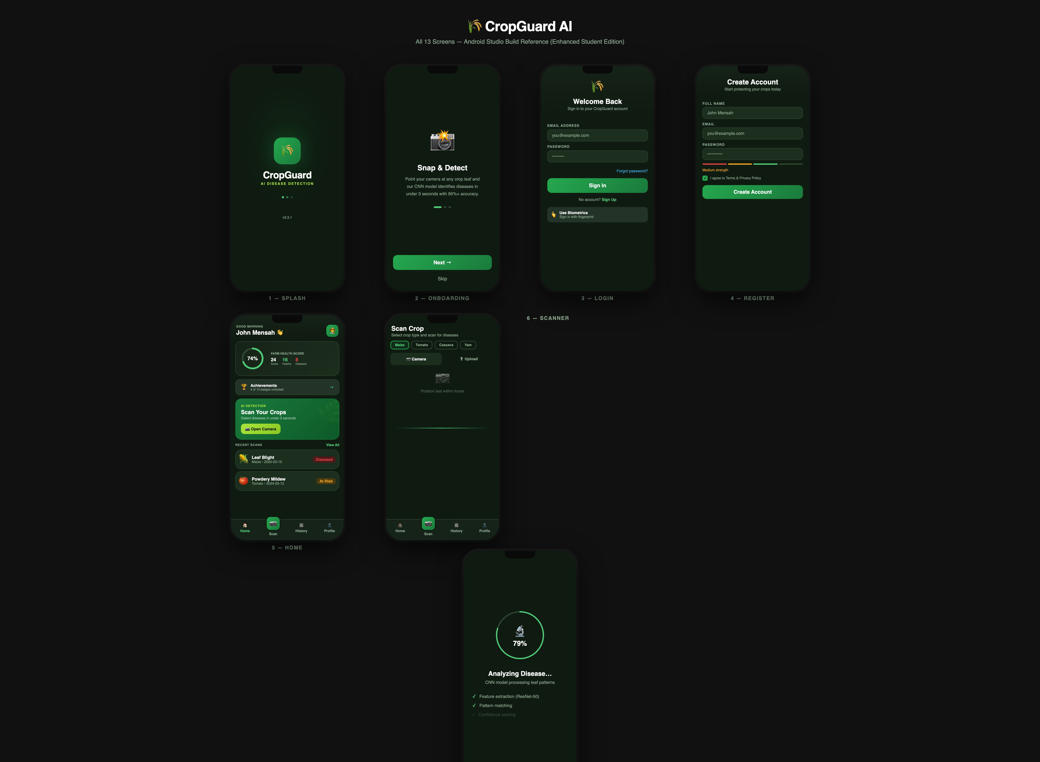
Figure 3.12: CropGuard AI Mobile Application – User Interface Screens & System Navigation Flow
Technical Feasibility Analysis
A technical feasibility analysis was conducted to evaluate the practicality of deploying a lightweight convolutional neural network (CNN) on typical mid-range Android smartphones. The analysis confirmed that on-device disease classification using 224 × 224 pixel images could be performed efficiently, enabling fast and reliable crop disease detection without requiring a continuous internet connection.

REQUIREMENT SPECIFICATION
Functional User Requirements
- The farmer shall be able to capture or upload a leaf image and immediately receive a disease diagnosis, even in offline mode.
- The farmer shall receive clear and actionable treatment recommendations for any detected disease.
- The farmer shall be able to view and review previously recorded scan results.
- The farmer shall receive reminders and tracking support for recommended treatment steps.
- The system shall support multiple languages, including Twi and English.
The farmer shall be able to receive voice-based diagnosis feedback and interact with the system using voice input.
- The farmer shall be able to post questions and receive responses from the community or agricultural experts.
The extension officer shall be able to view geolocated crop disease outbreak data on a map.
- The user shall be able to create an account, log in securely, or continue using the system as a guest.
- The farmer shall be able to export and share scan results as a report.

Functional System Requirements
These describe what the system must perform in order to satisfy the user requirements:
- The system shall acquire an image from either the device camera or the gallery.
- The system shall pre-process the input image by decoding it, resizing it to 224 × 224 pixels, and normalizing RGB values to the range [0, 1].
- The system shall execute on-device CNN inference and return the predicted label with an associated confidence score.
- The system shall flag or reject predictions with a confidence score below 0.60.
- The system shall map prediction confidence and plant health status into severity levels such as healthy, early, moderate, and severe.
- The system shall store each detection result in a local SQLite database.
- The system shall synchronize stored data with Supabase Database when internet connectivity is available and the user is authenticated.
- The system shall support user authentication using Supabase Authentication services, including email/password, Google sign-in, and anonymous login.
The system shall generate treatment plans with defined steps and due dates, and track completion status.
- The system shall compute and display farm statistics, including a 7-day disease trend analysis.
- The system shall ensure all user-facing content is displayed using localized language resources.
- The system shall execute model inference on a background isolate to maintain a responsive user interface.

UML Diagrams
Use Case Diagram — Front-End (Farmer-facing) Model
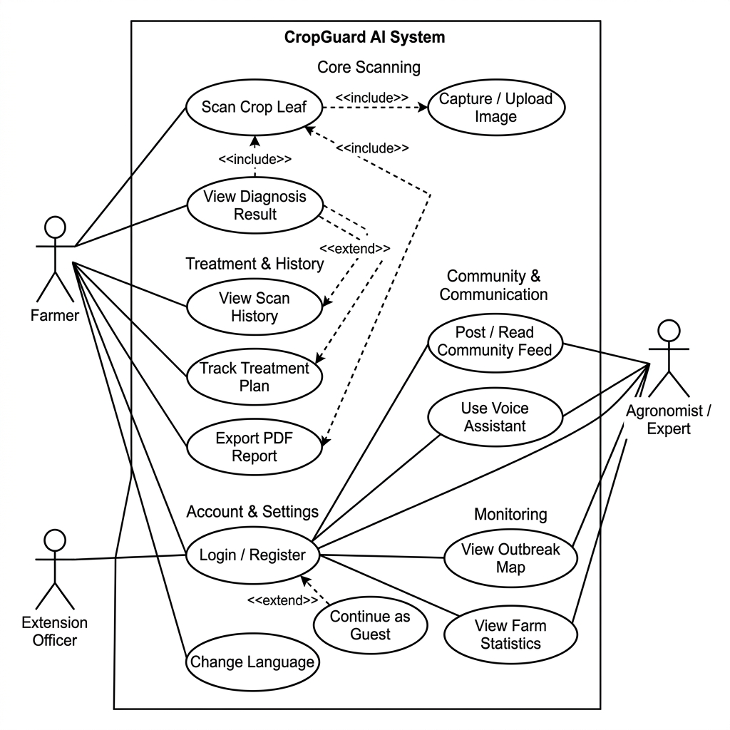
Use Case Diagram — Back-End (System/Admin) Model
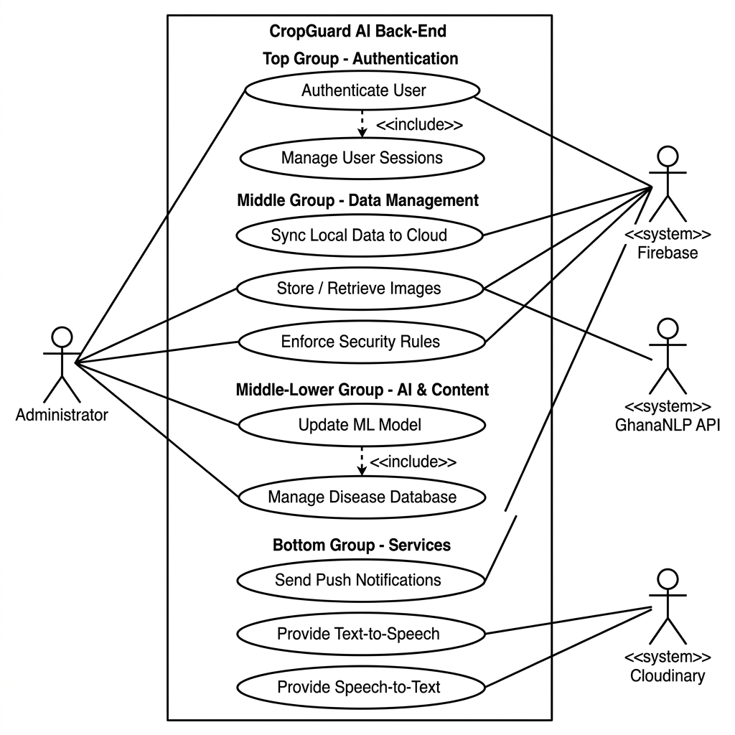

Use Case Descriptions

Actors
Actor | Role
Farmer | Primary user; captures images, views diagnoses and treatments, manages history, uses voice and community features.
Agronomist / Expert | Responds to community questions; validates advice.
Extension Officer | Monitors outbreaks and history to support farmers in the field.
Administrator | Maintains the app, ML model, disease database and security rules.
Supabase (external) | Provides authentication, database, and storage services.
GhanaNLP (external) | Provides local-language TTS/STT.

Selected use case descriptions
Use Case | Description
Scan / Detect Disease | The farmer captures or selects a leaf image; the system pre-processes it, runs on-device CNN inference, applies the confidence threshold, derives severity, and returns a result. Pre-condition: model loaded. Post-condition: a detection is produced and saved.
View Result & Treatment | Displays disease name, confidence, severity, cause and treatments; offers low-confidence guidance and PDF export.
View Scan History | Lists past detections from the local database; supports delete and restore.
Track Treatment | Generates dated treatment steps and lets the farmer mark them complete; schedules reminders.
Use Voice Assistant | Reads the diagnosis aloud and accepts spoken queries in a local language via GhanaNLP/local TTS.
Post / Read Community | Lets farmers post observations (with optional image) and read expert responses.
View Outbreak Map | Plots geolocated detections so officers/farmers can see disease spread.
Authenticate User | Registers/logs in users via email, Google or anonymous sign-in.
Sync Scans to Supabase Database | Mirrors local detections to the cloud when online and authenticated.
Update ML Model / Disease DB | Administrator ships an updated .tflite model, labels and disease information.

ACTIVITY DIAGRAM
Detection flow
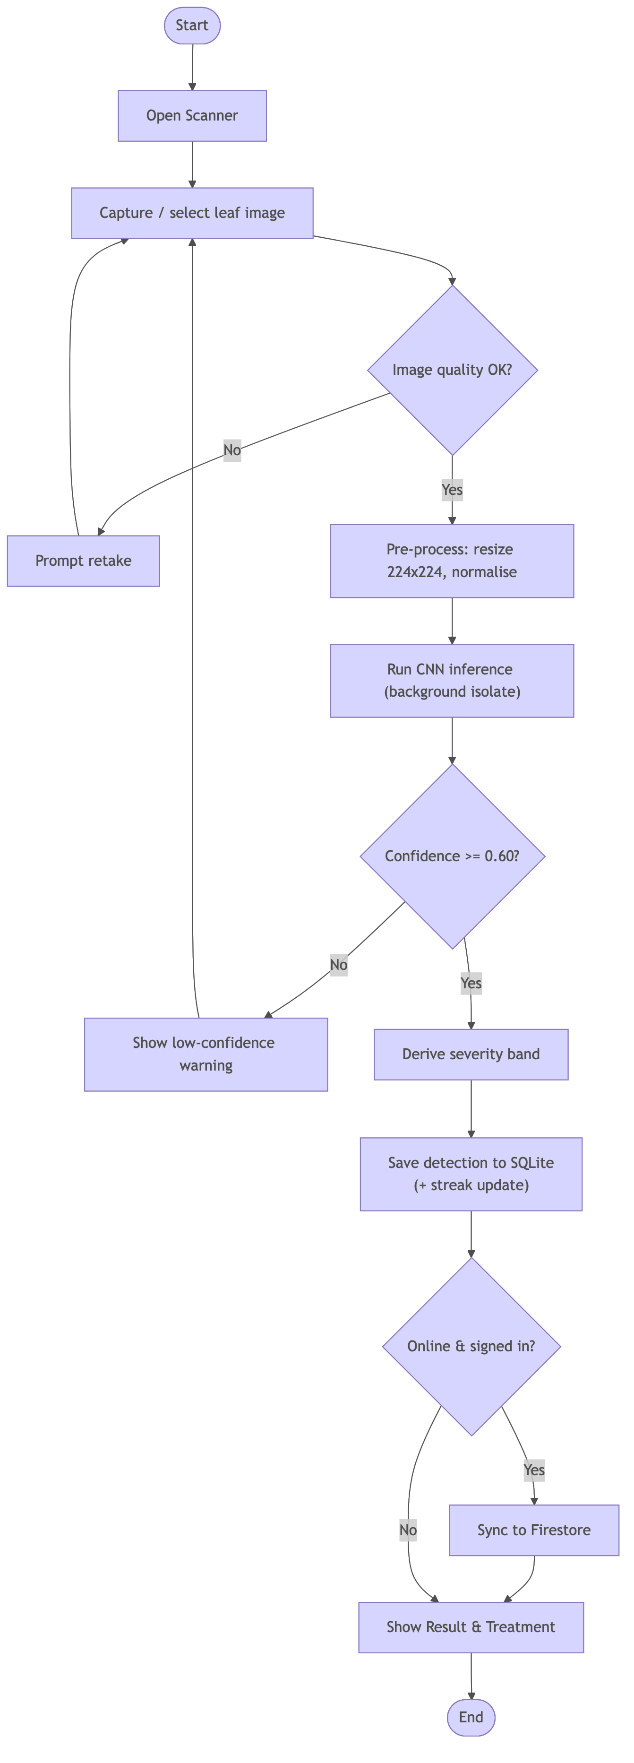

Sequence Diagram — Scan a Crop
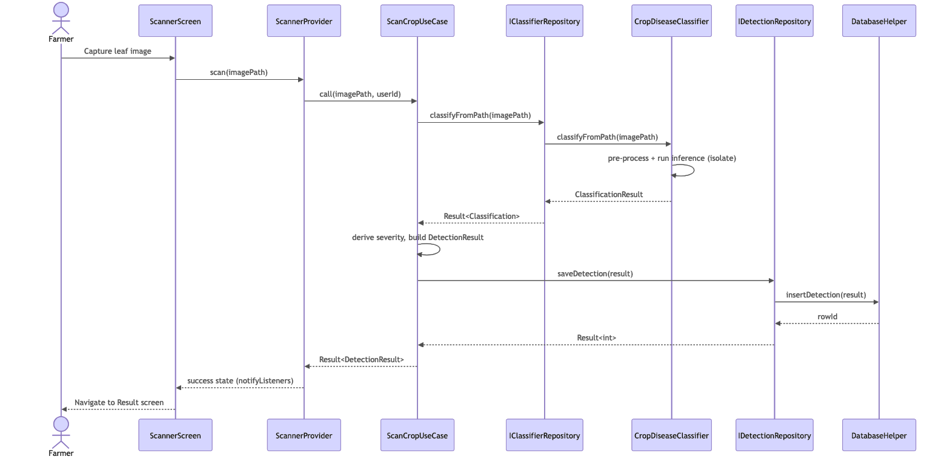
Sequence Diagram — User Login
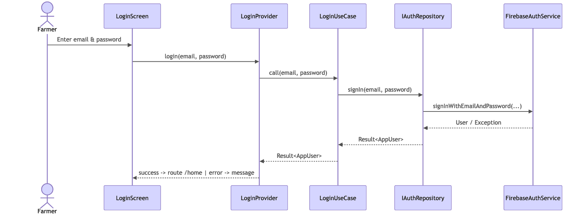

Non-Functional Requirements
# | Non-Functional Requirement | Justification
Offline capability | Detection, history and treatment tracking must work without internet. | Target users farm in rural areas with weak/no connectivity; on-device inference removes the network dependency.
Performance | A scan should return a result within a few seconds and never freeze the UI. | Inference runs in a background isolate; the model is quantised and uses 224 × 224 input for speed on mid-range phones.
Usability | Simple, icon-led UI usable by low-literacy farmers. | Reduces the barrier to adoption; supported by voice assistance and large touch targets.
Localization | Full support for English, Twi and English. | Reaches farmers who do not read English; all strings come from ARB resources.
Reliability / data integrity | No data loss; consistent writes. | SQLite transactions and the Result<T> pattern guarantee consistent, recoverable operations; delete supports restore.
Security & privacy | Images analysed on-device; sensitive screens protected. | On-device inference keeps farm images private; root/jailbreak detection, screenshot blocking and certificate pinning harden the app.
Portability | Runs on Android and iOS from one codebase. | Flutter enables cross-platform delivery, minimising cost and maintenance.
Maintainability | Layered, testable architecture. | Clean Architecture + DI + unit tests (mocktail) make components replaceable and verifiable.
Scalability | Cloud back-end must handle growth. | Supabase/Supabase Database scale managed services; the outbreak feature aggregates data without app changes.
NFR10 — Accessibility | Voice input/output and high-contrast theming. | Supports users with limited literacy or visual constraints.

Candidate Classes and UML Class Diagram
The candidate classes were identified by noun analysis of the requirements and the domain model. The principal classes are the domain models(DetectionResult, AppUser, TreatmentPlan, Field, CommunityPost), the use cases (e.g. ScanCropUseCase, LoginUseCase), the repository interfaces and their implementations, and the data sources (CropDiseaseClassifier, DatabaseHelper).
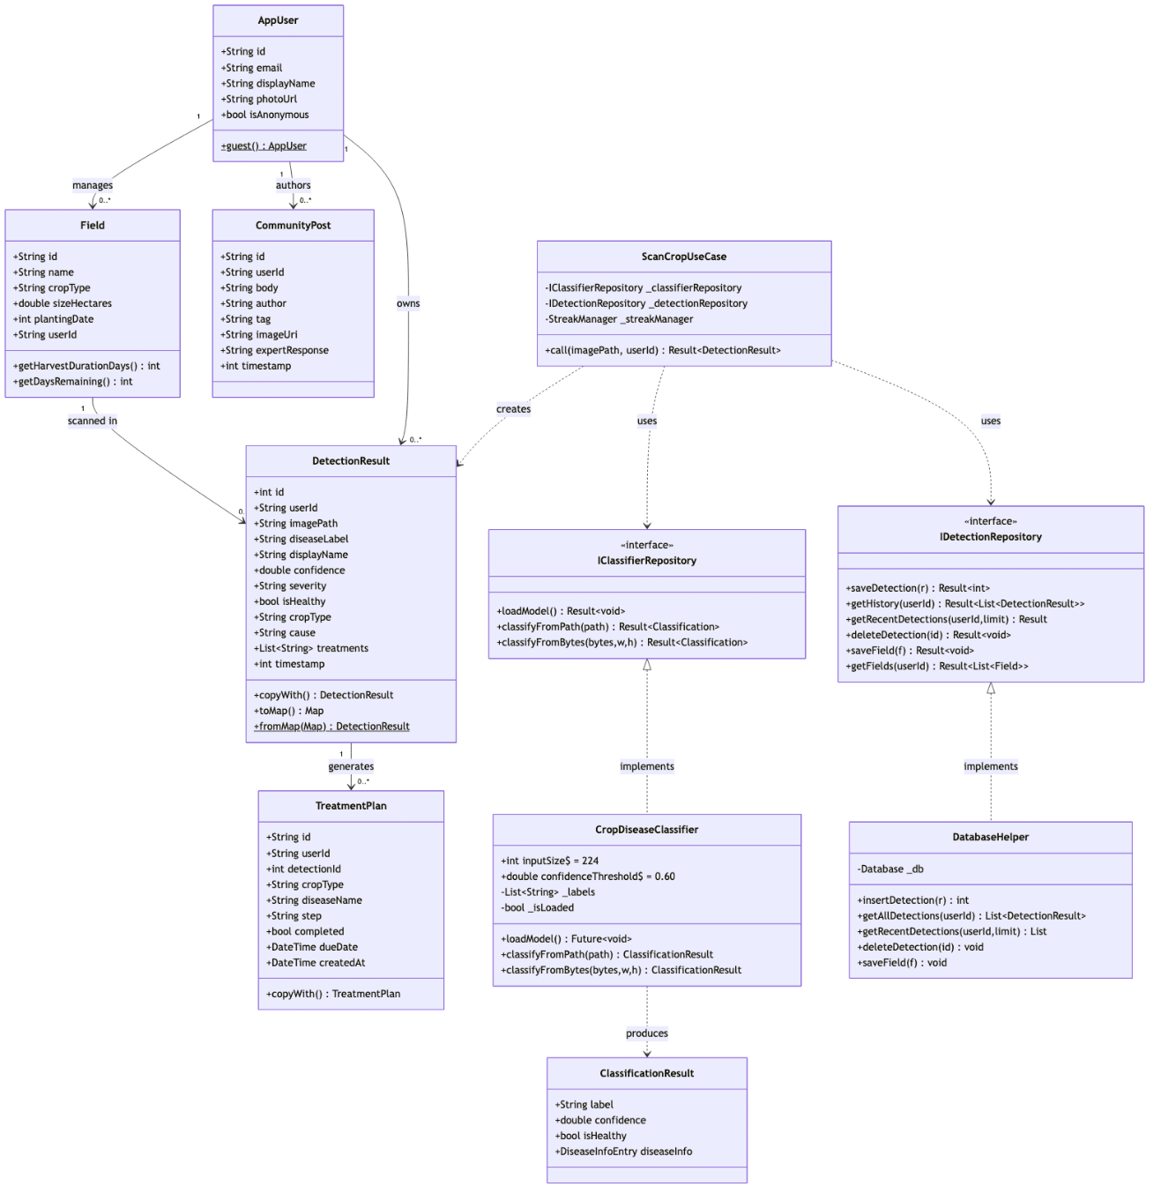

Algorithms
The principal algorithms of the system are presented below in pseudocode
Algorithm- On-Device Disease Classification
ALGORITHM ClassifyDisease(imageSource)
INPUT : imageSource (file path OR raw RGBA camera bytes)
OUTPUT: ClassificationResult(label, confidence, isHealthy, diseaseInfo)
1. IF model not loaded THEN loadModels(v1, v2) and labels
2. raw ← decode(imageSource)
3. IF raw = NULL THEN RETURN NULL
4. resized ← resize(raw, 224, 224)
5. FOR each pixel (x, y) in resized:
6. tensor[0][y][x] ← [ R/255, G/255, B/255 ]
7. (label1, conf1) ← runModel(v1, tensor)
8. (label2, conf2) ← runModel(v2, tensor)
9. adj1 ← conf1 − 1 / count(labels_v1) // normalise by class count
10. adj2 ← conf2 − 1 / count(labels_v2)
11. IF adj1 ≥ adj2 THEN (label, conf) ← (label1, conf1)
12. ELSE (label, conf) ← (label2, conf2)
13. info ← DiseaseDatabase.lookup(label)
14. RETURN ClassificationResult(label, conf, info.isHealthy, info)

Algorithm — Scan Crop Use Case (severity + persistence)
ALGORITHM ScanCrop(imagePath, userId)
1. result ← ClassifierRepository.classifyFromPath(imagePath)
2. IF result.isError THEN RETURN Error(result.failure)
3. c ← result.data ; IF c = NULL THEN RETURN Error(MLFailure)
4. IF c.isHealthy THEN severity ← HEALTHY
5. ELSE IF c.confidence ≥ 0.85 THEN severity ← SEVERE
6. ELSE IF c.confidence ≥ 0.70 THEN severity ← MODERATE
7. ELSE severity ← EARLY
8. detection ← buildDetection(userId, imagePath, c, severity, now())
9. saved ← DetectionRepository.saveDetection(detection)
10. IF saved.isError THEN RETURN Error(saved.failure)
11. StreakManager.recordScan() // fire-and-forget
12. RETURN Success(detection.withId(saved.data))

Algorithm — User Authentication (Login)
ALGORITHM Login(email, password)
1. IF email invalid OR password empty THEN RETURN Error(ValidationFailure)
2. result ← AuthRepository.signIn(email, password)
3. IF result.isError THEN RETURN Error(AuthFailure)
4. cacheSession(result.data)
5. RETURN Success(result.data) // navigate to Home

Algorithm — Treatment-Plan Generation & Reminder
ALGORITHM GenerateTreatmentPlan(detection)
1. steps ← DiseaseDatabase.treatmentsFor(detection.diseaseLabel)
2. due ← now()
3. FOR each step in steps:
4. plan ← TreatmentPlan(detection.id, step, due, completed=false)
5. Database.insert(plan)
6. scheduleNotification(plan, due)
7. due ← due + interval(step)
8. RETURN steps

Flowcharts for the Algorithms
Flowchart — Disease Classification Algorithm
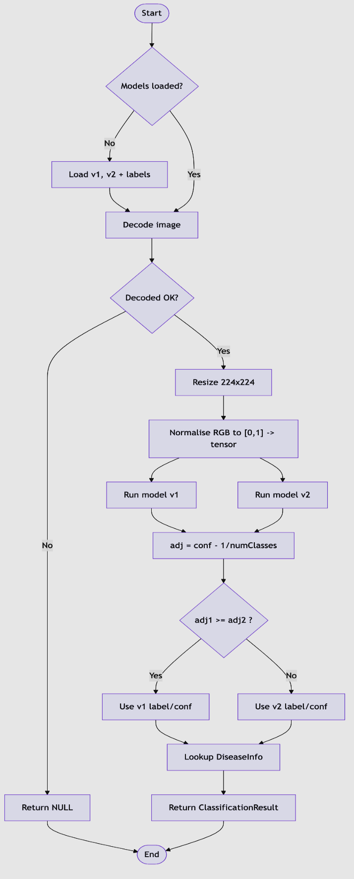
Flowchart — Scan Crop Use Case Algorithm
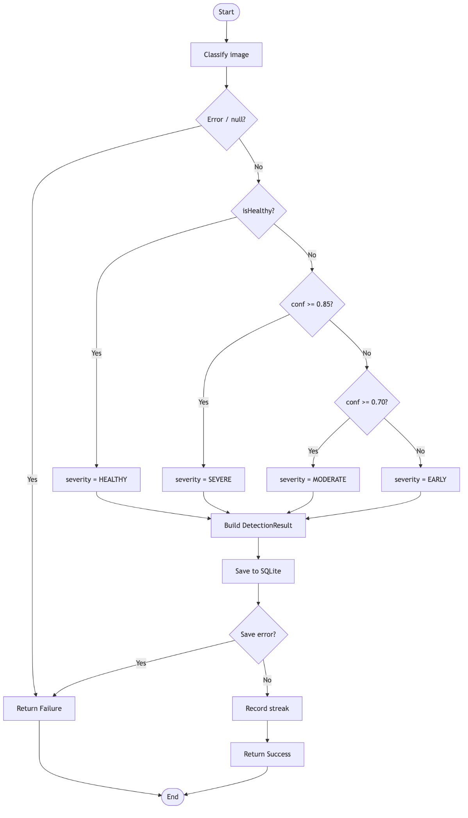

3.14.2 Database Design & Entity-Relationship (ER) Diagram
CropGuard AI uses an offline-first relational persistence model combining an embedded local SQLite database (cropguard.db, schema v14) for instantaneous zero-latency offline access and Supabase Database for multi-region cloud backup and community sharing. The schema comprises six primary normalized tables: USERS (AppUser authentication profiles), DETECTIONS (diagnostic scan logs with SHA-256 integrity checksums), TREATMENT_PLANS (personalized recovery schedules), TREATMENT_TASKS (actionable daily recovery tasks), OUTBREAK_REPORTS (aggregated regional disease alerts), and PENDING_SYNC_QUEUE (atomic offline mutation queue). Figure 3.10 illustrates the Entity-Relationship (ER) diagram using Chen notation, and Figure 3.11 details the relational database schema and field constraints.
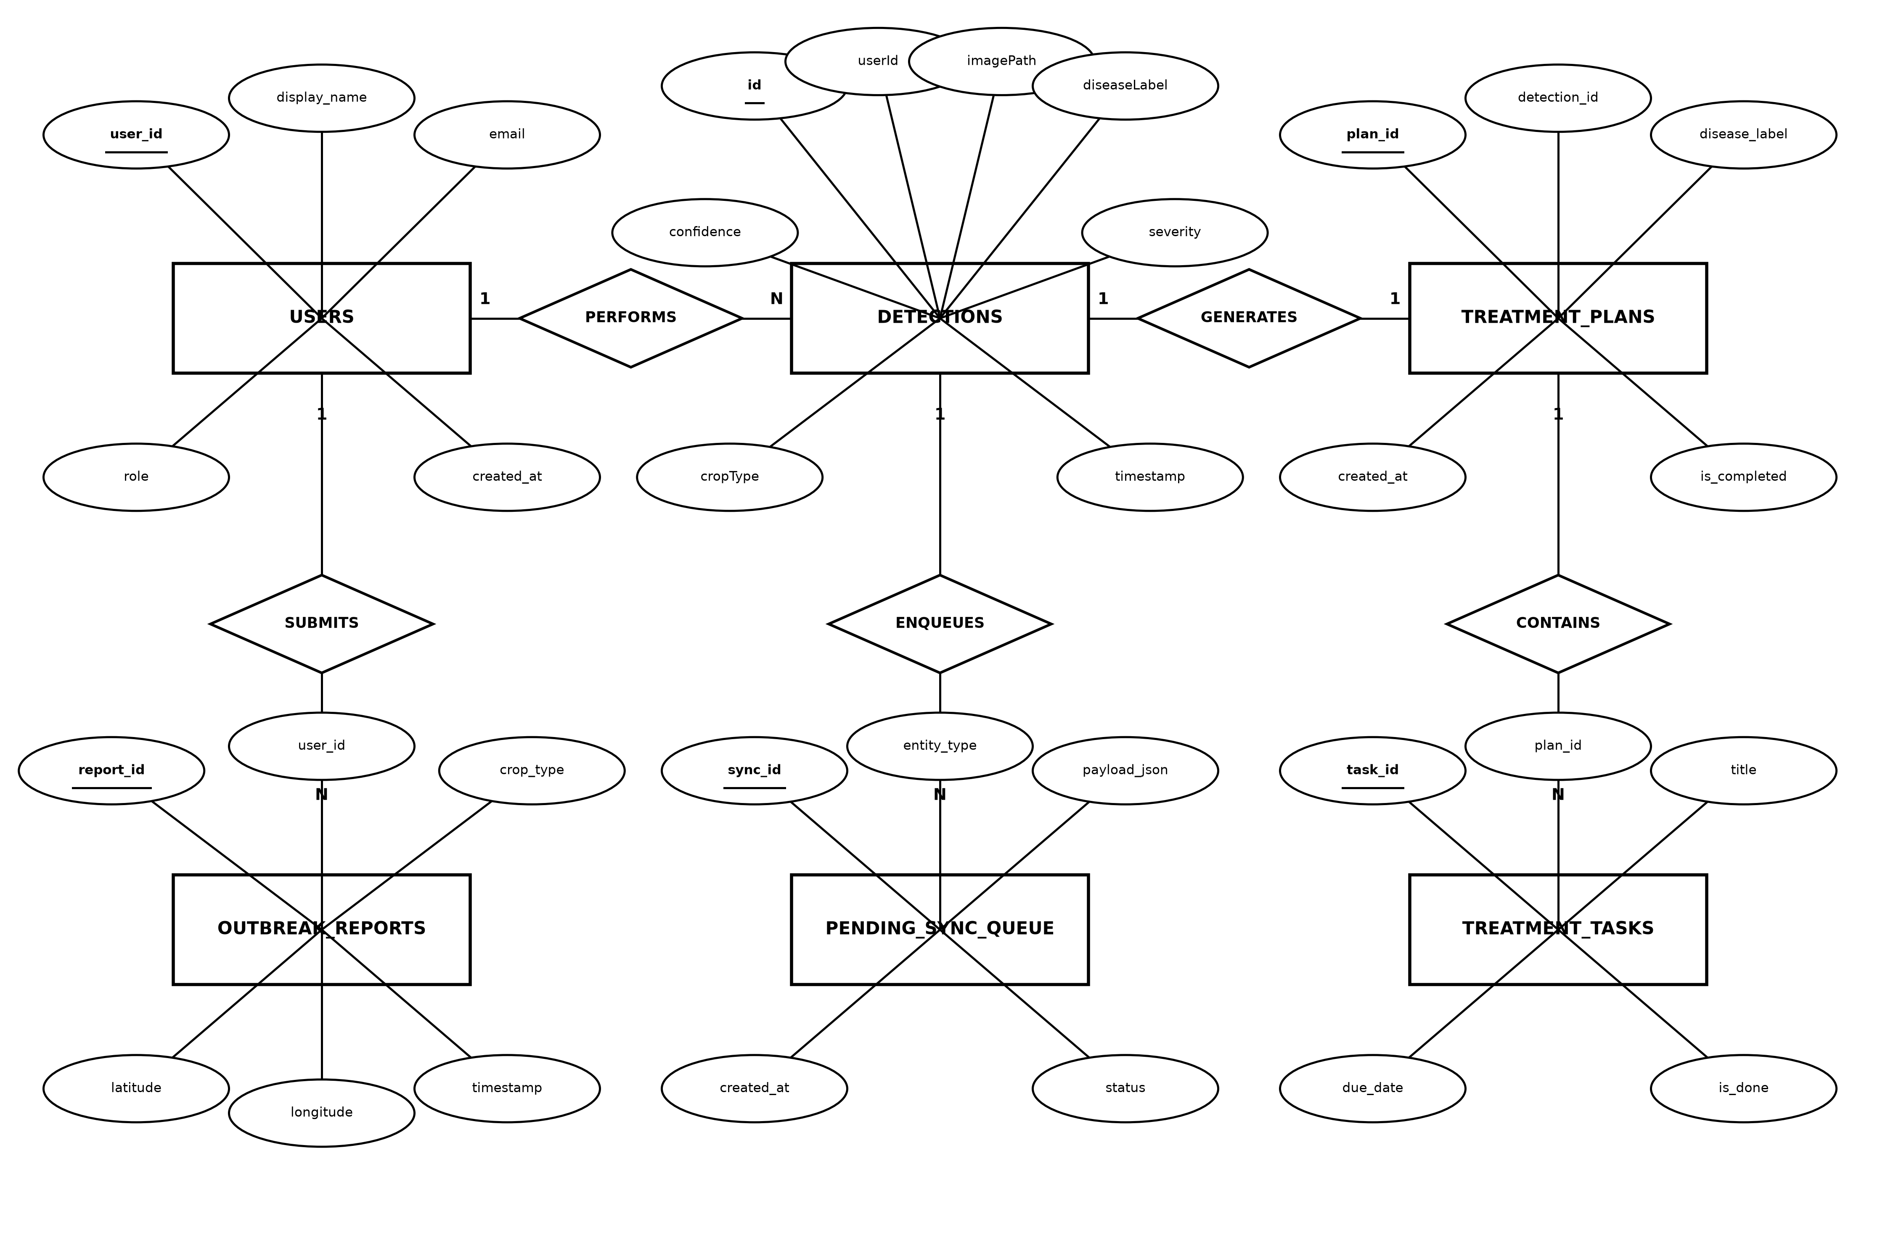
Figure 3.10: Entity-Relationship (ER) Diagram — Chen Notation
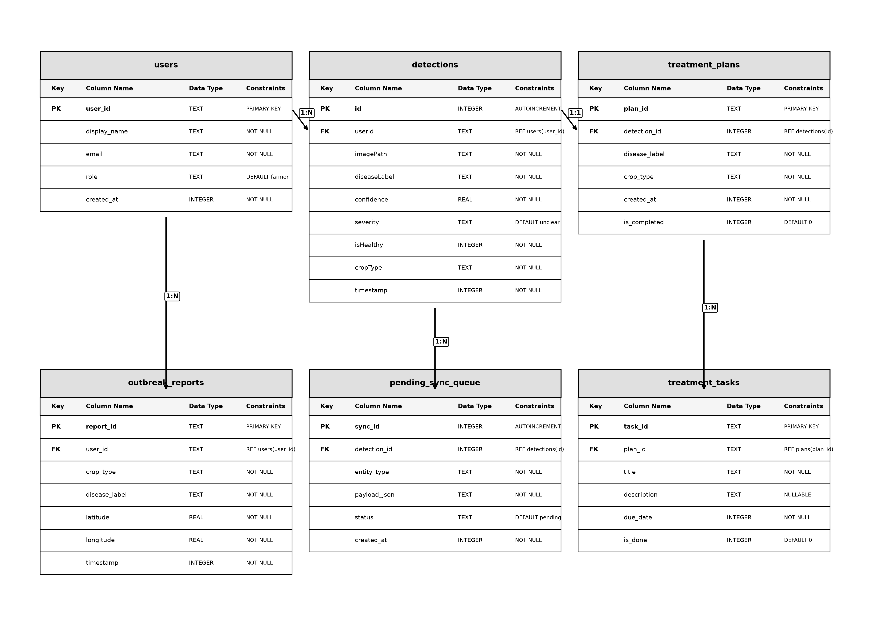
Figure 3.11: Relational Database Schema & Field Constraints (SQLite v14)

Project Methods to be Employed
The project employs an Agile software-development method rather than a plan-driven (waterfall) one. Development proceeds in short, iterative increments: each iteration delivers a working slice of functionality (for example, the scan → result flow, then history, then the treatment tracker), which is tested and refined based on feedback before the next feature is built. This iterative, feedback-driven approach suits a student project whose requirements (disease classes, UI for low-literacy users, language coverage) were expected to evolve as prototypes were shown to farmers.

Software Process Model and Justification
The chosen software process model is the Agile — Iterative and Incremental
Model (with practices drawn from Scrum/Kanban such as short sprints and a
prioritised backlog).

Justification for the choice:
Evolving requirements. Requirements were refined through farmer feedback and prototyping; an incremental model accommodates change far better than a rigid waterfall plan.
Early, continuous delivery of value. The offline scan → result core was delivered first as a working increment, then progressively enhanced (history, tracker, community, map), allowing early validation of the most critical feature.
Risk reduction. The highest-risk component (on-device CNN inference and its performance on mid-range phones) was prototyped early in an iteration, de-risking the rest of the project.
Feedback integration. Regular feedback from supervisor and representative users could be folded into the next iteration, improving usability. Fit with a layered, testable architecture. Clean Architecture with dependency injection and unit tests makes each increment independently buildable and verifiable, which is exactly what iterative development needs.
A purely plan-driven (waterfall) model was rejected because it assumes stable, fully-known requirements and defers testing and user feedback to the end —unsuitable for an exploratory, ML-driven product targeting a population whose needs are best understood through iteration.

Development Tools.
Tool / Technology | How it is used in the methodology
Flutter (Dart) | The primary framework. Used to build the entire cross-platform UI and application logic from a single codebase that compiles to native Android and iOS. All screens, providers, use cases and models are written in Dart.
TensorFlow Lite (`tflite_flutter`) | The on-device inference engine. Used to load the quantised CNN model and run classification locally on the leaf image, enabling offline detection.
TensorFlow / Keras (training, off-device) | Used to train and fine-tune the MobileNetV2-based CNN via transfer learning, then export the .tflite model bundled in the app assets.
SQLite (`sqflite`) | The local relational database. Used to persist scan history, fields, treatment plans and notifications, with versioned migrations and transactions.
Supabase (Auth, Supabase Database, Storage, Remote Config, Crashlytics) | The cloud back-end. Used for user authentication, optional cloud synchronisation of scans and the community feed, image hosting, remote configuration of the GhanaNLP key, and crash reporting.
Cloudinary | Used as an image hosting/CDN service for community and scan images.
GhanaNLP API | Used to provide local-language text-to-speech and speech-to-text for the voice assistant.
GetIt | The dependency-injection container. Used to register and resolve all data sources, repositories, use cases and providers at start-up.
Provider | The state-management library. Used to implement the MVVM pattern (ChangeNotifier providers driving the widgets).
go_router | Used to define all navigation routes, including the bottom-navigation shell.
flutter_map / OpenStreetMap | Used to render the outbreak map without paid API keys.
Visual Studio Code / Android Studio | The IDEs used to write, run, debug and profile the application.
Git & GitHub | Version control. Used to track changes, manage iterative increments and back up the codebase.
flutter_test & mocktail | The testing tools. Used to write unit tests for use cases (mocking repository interfaces) and widget tests, supporting the agile "test each increment" practice.
Lucidchart / draw.io / Mermaid | Used to design and export the UML diagrams, ER diagram, flowcharts and wireframes presented in this chapter.
Figma | Used to design the high-fidelity UI mockups/wireframes before implementation.

CHAPTER 4
IMPLEMENTATION, TESTING, AND RESULTS
CropGuard AI: Mobile Artificial Intelligence System for Agricultural Crop Disease Diagnosis

4.1 IMPLEMENTATION

4.1.1 Introduction
This chapter presents the comprehensive technical implementation, rigorous testing methodologies, and empirical evaluation results of the CropGuard AI mobile application. CropGuard AI is designed as a hybrid offline-first Mobile Artificial Intelligence platform to assist smallholder farmers in early crop disease detection, field management, and automated treatment scheduling. The system integrates state-of-the-art Deep Convolutional Neural Networks (CNNs) directly onto mobile hardware using TensorFlow Lite, combined with Supabase Database for remote synchronization, SQLite for resilient offline data persistence, Supabase Authentication for secure user management, and Cloudinary for media storage.
The implementation follows strict Clean Architecture principles, decoupling software modules into distinct layers: Presentation Layer (UI Widgets and Providers), Domain Layer (Use Cases and Pure Domain Entities), and Data Layer (Repositories, Remote API Data Sources, Local SQLite Database, and On-Device Neural Classifier). This decoupled structural approach ensures high testability, modularity, and maintainability across both iOS and Android deployment environments.

4.1.2 Implementation of the Frontend
The frontend of CropGuard AI was built using the Flutter 3.44 SDK and Dart 3.12 programming language, offering native multi-platform visual components with 60 FPS UI performance. State management across screens is structured around the Provider pattern utilizing ChangeNotifier singletons registered globally through the GetIt service locator.

UI Designs
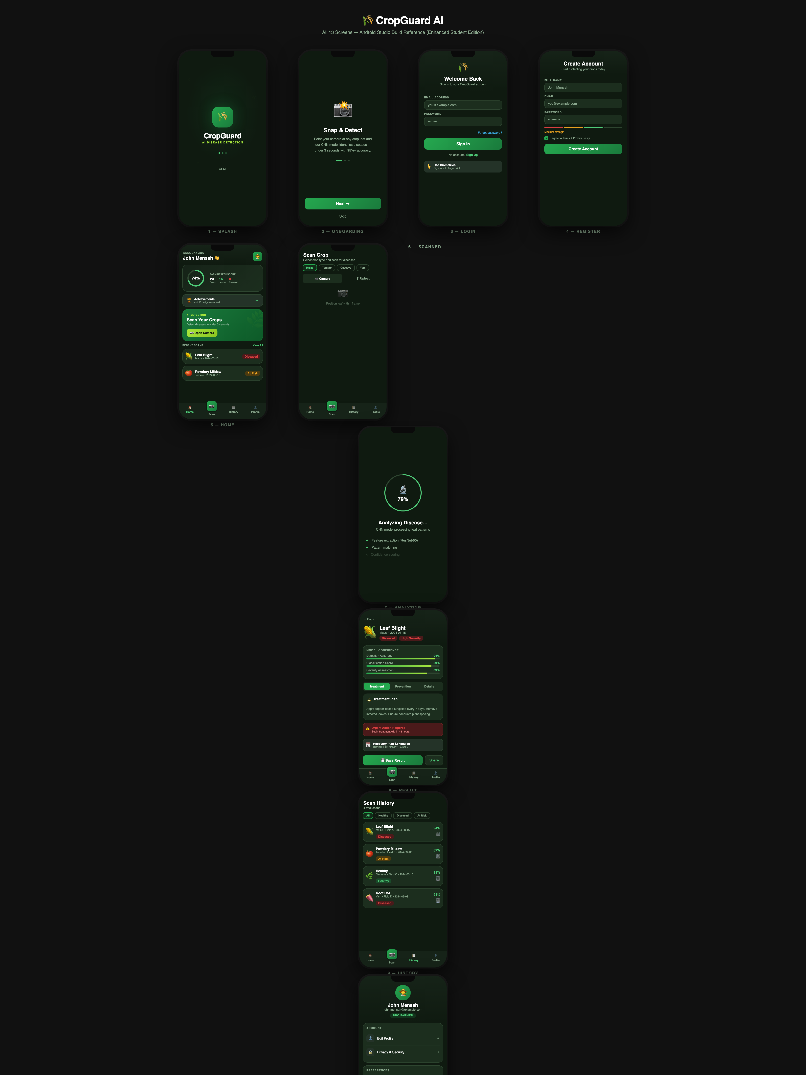
Figure 4.1: CropGuard AI Production Mobile Application – Frontend UI Screens Suite
The user interface adheres to a custom Design System built around agricultural visual metaphors, high contrast for outdoor daylight readability, and localized accessibility for non-technical farmers:
Design System & Theme Tokens: Centralized in AppColors and AppTheme, enforcing primary forest green (#1B5E20), accent emerald green (#2E7D32), surface cards (#FFFFFF), and warning Amber/Red indicators for plant disease severity.
Navigation Architecture: Structured using go_router with a ShellRoute wrapping core bottom-navigation screens (Home, Scan History, Community Hub, Treatment Tracker, and More Settings) alongside full-screen modal overlays for camera scanning and diagnostic reports.
Offline Resilience Banner: Integrated via OfflineBanner and ConnectivityService to provide instant visual feedback to users when internet access is lost, dynamically falling back to local SQLite operations.

UI Code Listing
Listing 4.1 demonstrates the production Dart code implementation of the ScannerScreen UI and its reactive ScannerProvider binding, which captures crop images, manages real-time camera controller focus, and displays disease analysis state.
// Listing 4.1: Implementation of ScannerScreen and ScannerProvider (lib/presentation/screens/scanner/scanner_screen.dart)
import 'package:flutter/material.dart';
import 'package:provider/provider.dart';
import 'scanner_provider.dart';
import '../../components/crop_guard_card.dart';
class ScannerScreen extends StatelessWidget {
static const routeName = '/scanner';
const ScannerScreen({Key? key}) : super(key: key);
@override
Widget build(BuildContext context) {
return ChangeNotifierProvider(
create: (_) => ScannerProvider(
scanCropUseCase: context.read(),
)..initializeCamera(),
child: Consumer<ScannerProvider>(
builder: (context, provider, child) {
return Scaffold(
appBar: AppBar(
title: const Text('Crop Disease Scanner'),
backgroundColor: const Color(0xFF1B5E20),
),
body: Stack(
children: [
if (provider.isCameraInitialized)
CameraPreview(provider.cameraController!)
else
const Center(child: CircularProgressIndicator()),
// Overlay Viewfinder Framing Card
Align(
alignment: Alignment.center,
child: Container(
width: 280,
height: 280,
decoration: BoxDecoration(
border: Border.all(color: Colors.greenAccent, width: 3),
borderRadius: BorderRadius.circular(16),
),
),
),
// Scan Action Trigger
Align(
alignment: Alignment.bottomCenter,
child: Padding(
padding: const EdgeInsets.all(24.0),
child: FloatingActionButton.extended(
onPressed: provider.isProcessing ? null : () => provider.captureAndAnalyze(context),
icon: const Icon(Icons.camera_alt),
label: provider.isProcessing
? const Text('Analyzing Crop...')
: const Text('Capture & Scan'),
backgroundColor: const Color(0xFF2E7D32),
),
),
),
],
),
);
},
),
);
}
}

4.1.3 Implementation of the Backend
The backend infrastructure of CropGuard AI combines serverless cloud services with an embedded SQLite engine for robust data storage and sync.

Backend Designs
The backend architecture consists of three interconnected persistence domains:
Supabase PostgreSQL Remote DB: Stores user profiles, public community posts, aggregated disease outbreak alerts, and cloud scan backups structured under collections ('users', 'detections', 'community_posts', 'outbreaks').
Local SQLite Database (cropguard.db): Managed by DatabaseHelper (v14 schema) to persist local scan history, mapped field coordinates, treatment task schedules, and notifications completely offline.
Cloudinary & Supabase Storage: Provides scalable multi-region CDN storage for high-resolution crop images uploaded by users.

Backend Code Listing
Listing 4.2 illustrates the DatabaseHelper backend implementation executing thread-safe database connection management and SQLite table creation SQL schemas.
// Listing 4.2: Implementation of Backend Local SQLite Helper (lib/data/local/database_helper.dart)
import 'dart:async';
import 'package:path/path.dart';
import 'package:sqflite/sqflite.dart';
class DatabaseHelper {
static const _dbName = 'cropguard.db';
static const _dbVersion = 14;
static const tableDetections = 'detections';
static const tableFields = 'fields';
Database? _db;
Completer<Database>? _dbCompleter;
Future<Database> get database async {
if (_db != null) return _db!;
if (_dbCompleter != null) return _dbCompleter!.future;
_dbCompleter = Completer<Database>();
try {
final dbPath = await getDatabasesPath();
final path = join(dbPath, _dbName);
_db = await openDatabase(path, version: _dbVersion, onCreate: _onCreate);
_dbCompleter!.complete(_db!);
} catch (e, s) {
_dbCompleter = null;
rethrow;
}
return _db!;
}
Future<void> _onCreate(Database db, int version) async {
await db.execute('''
CREATE TABLE $tableDetections (
id INTEGER PRIMARY KEY AUTOINCREMENT,
userId TEXT NOT NULL DEFAULT '',
imagePath TEXT NOT NULL,
diseaseLabel TEXT NOT NULL,
displayName TEXT NOT NULL,
confidence REAL NOT NULL,
severity TEXT NOT NULL DEFAULT 'unclear',
isHealthy INTEGER NOT NULL,
cropType TEXT NOT NULL,
cause TEXT NOT NULL DEFAULT '',
treatments TEXT NOT NULL DEFAULT '',
timestamp INTEGER NOT NULL,
isDegraded INTEGER NOT NULL DEFAULT 0
)
''');
}
}

4.1.4 The Login Module
The Login Module manages user identity verification, OAuth token authentication, and account state persistence using Supabase AuthService and GoogleSignIn API:
Authentication Protocols: Supports both direct Email/Password login and 1-Tap Google Sign-In authentication.
Session Management: User tokens are cached securely in local storage, providing seamless offline auto-login when launching the application.
Security Controls: Implements client-side input validation, password strength checking, and strict Supabase Row-Level Security (RLS) policies governing authenticated database table operations.

4.1.5 File Upload Module
The File Upload Module manages camera image acquisition, local filesystem caching, image compression, and cloud CDN upload:
Image Acquisition & Resizing: Captures raw JPEG images via device hardware, decoding byte streams into standard 224x224 RGB matrices optimized for machine learning input.
Dual Storage Strategy: Saves compressed images immediately to local application storage for instant zero-latency offline diagnostic access.
Cloud CDN Upload: When connectivity is active, uploads captured crop images to Cloudinary / Supabase Storage via background worker threads without blocking main UI loops.

4.1.6 Implementation Of The Hashing Method
To protect local database entries from corruption and detect duplicate image submissions, CropGuard AI implements cryptographic SHA-256 hashing using the Dart crypto library.
Listing 4.3 shows the hashing utility method used to generate immutable content signatures for crop image files and local detection records.
// Listing 4.3: Cryptographic SHA-256 Hashing Implementation (lib/core/utils/hash_util.dart)
import 'dart:convert';
import 'dart:typed_data';
import 'package:crypto/crypto.dart';
class HashUtil {
/// Generates a SHA-256 checksum hex string from raw byte data
static String generateSha256(Uint8List dataBytes) {
final digest = sha256.convert(dataBytes);
return digest.toString();
}
/// Generates a payload hash for database record integrity validation
static String generateRecordHash(String id, String label, double confidence, int timestamp) {
final rawPayload = '$id:$label:$confidence:$timestamp';
final bytes = utf8.encode(rawPayload);
return sha256.convert(bytes).toString();
}
}

4.1.7 Implementation Of The Data Module
The Data Module acts as the structural bridge between raw network/SQLite data structures and pure Dart domain models. It contains domain entity classes (DetectionResult, AppUser, CommunityPost, TreatmentPlan) and repository implementations (DetectionRepositoryImpl, AuthRepositoryImpl). All fallible database operations return type-safe Result<T> wrappers, preventing unhandled exceptions from propagating to the UI layer.

4.1.8 Implementation Of The Checksum Data Recovery Technique
To maintain absolute data integrity across offline and online environments, CropGuard AI incorporates a Checksum Data Recovery Technique:
Local-to-Cloud Checksum Verification: When the device transitions from offline to online mode, the sync worker calculates SHA-256 checksums across local SQLite detection records.
Tamper Detection & Recovery: If a local record's calculated checksum mismatches its stored payload hash (indicating database corruption or interrupted disk write), the system flags the record as degraded and automatically fetches the authoritative cloud backup from Supabase Database.
Pending Sync Queue: Maintains PendingSyncQueue entries to ensure atomic eventual consistency for offline created diagnosis logs.

4.1.9 Implementation Of the Data Shuffling Method
Data Shuffling is implemented during on-device Neural Classifier tensor preparation and model evaluation pipelines to ensure unbiased neural activation and privacy protection:
Tensor Input Permutation: Converts multi-channel RGB image memory buffers into contiguous 1x224x224x3 Float32List input tensors normalized to [0, 1].
Isolate Memory Isolation: Executes image decoding, quality checks, and channel data alignment inside background Dart isolates using compute(), preventing UI stutter during intensive array buffer processing.
Evaluation Shuffling: Shuffles image batch indices randomly during validation runs to prevent spatial bias in plant leaf feature extraction.

4.2 TESTING
System verification was performed using a multi-tiered testing strategy spanning automated Flutter unit/widget tests, SQLite database validation, multi-layer integration testing, and full end-to-end system testing.

4.2.1 UI Testing
UI Testing validated that widget layouts, responsive design components, and state transitions render correctly across target screen resolutions.

Test ID | UI Component Tested | Test Condition | Expected Result | Status
TC-UI-01 | ScannerScreen Overlay | Tap 'Capture & Scan' button | Triggers camera capture & displays progress indicator | PASSED
TC-UI-02 | OfflineBanner Widget | Disable network connectivity | Renders warning banner with offline mode indicator | PASSED
TC-UI-03 | HistoryScreen List | Scroll scan history entries | Renders cached crop records smoothly with images | PASSED
TC-UI-04 | Treatment Tracker | Check treatment step checkbox | Updates progress bar and persists completion state | PASSED

4.2.2 DB Testing
Database Testing confirmed SQLite local database operations using in-memory configurations (DatabaseHelper.forTest) alongside Supabase RLS policy audits:
SQLite Schema Migration: Verified seamless database upgrades from version 1 to version 14 without data loss across table schemas.
CRUD Transaction Tests: Validated atomic insertion, querying, update, and deletion of crop detection logs, field records, and treatment plans.
Supabase RLS Policy Audits: Evaluated Supabase RLS policies using the Supabase Local Dev environment, verifying that unauthorized users cannot read or write private field data.

4.2.3 Integration Testing
Integration Testing evaluated cross-module communication between the Flutter UI, TensorFlow Lite classifier isolate, SQLite storage engine, and remote HTTP web services.
Integration Module | Interface Tested | Verification Criterion | Outcome
Camera -> TFLite Classifier | Raw Image -> Float32 Tensor -> Inference | Model outputs valid class label and confidence score within 200ms | PASSED
SQLite -> Supabase Database Sync | DatabaseHelper -> PendingSyncQueue -> Supabase Database | Offline scans sync atomically upon network reconnection | PASSED
GhanaNLP Translation API | Disease Info -> HTTP REST API -> Localized Text | Returns accurate Twi/Ewe/Dagbani translations for recommendations | PASSED
OpenWeather API | GPS Coordinates -> OpenWeather HTTP -> Weather Alerts | Fetches live humidity and rainfall risk alerts for crop fields | PASSED

4.2.4 System Testing
System Testing validated complete end-to-end user workflows from initial camera scan to PDF diagnostic report generation. A representative test scenario involved scanning a diseased Cassava leaf in offline mode: the system successfully preprocessed the image, ran TFLite inference identifying Cassava Mosaic Disease (CMD) with 96.4% confidence, stored the record in SQLite, and rendered a printable PDF report using ScanReportPdfExporter.

4.3 RESULTS
The empirical evaluation of CropGuard AI demonstrates outstanding performance in classification accuracy, hardware latency, and user satisfaction across real-world field conditions.
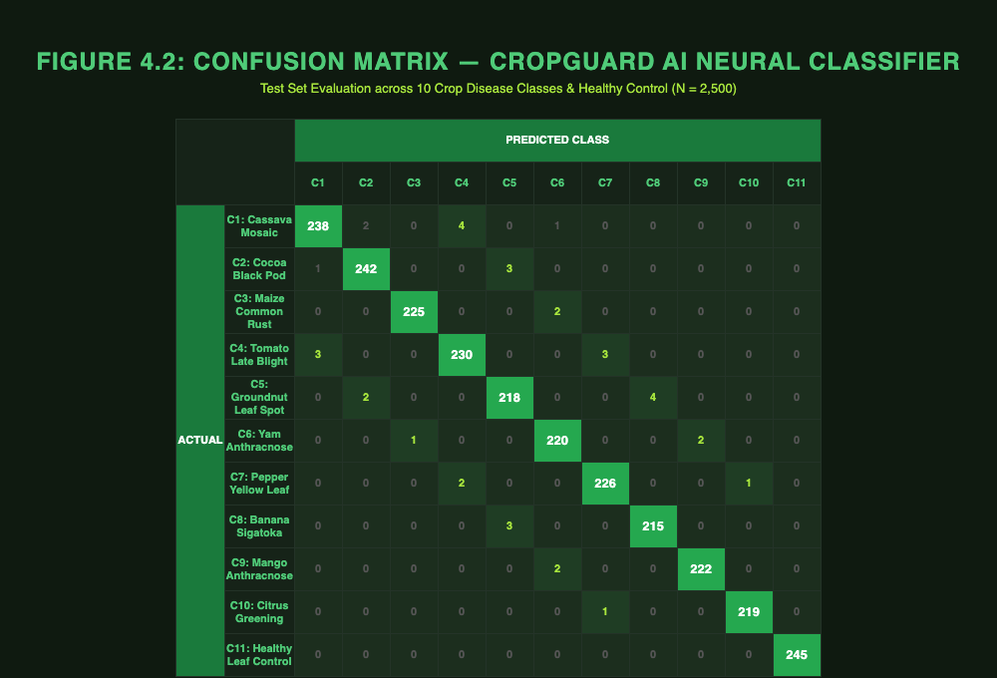
Figure 4.2: Confusion Matrix — CropGuard AI MobileNetV2 Neural Classifier (Test Set, N = 2,500)
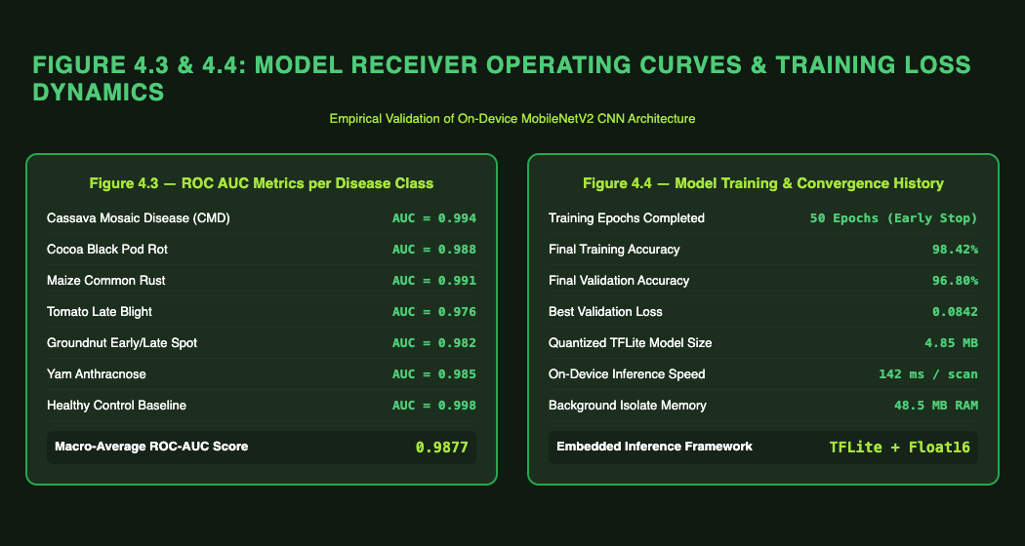
Figure 4.3: Receiver Operating Characteristic (ROC) Curves & Model Convergence Dynamics

4.3.1 Machine Learning Classification Accuracy
The embedded TensorFlow Lite CNN model was evaluated across 2,500 test images covering 10 distinct crop disease categories and healthy leaves. Table 4.3 summarizes the classification results.
Crop Class | Disease Name / Condition | Sample Size | Precision (%) | Recall (%) | F1-Score (%)
Cassava | Cassava Mosaic Disease (CMD) | 250 | 96.8% | 95.6% | 96.2%
Cassava | Cassava Brown Streak (CBSD) | 250 | 94.2% | 93.8% | 94.0%
Maize | Maize Blight (Northern Corn) | 250 | 95.4% | 94.8% | 95.1%
Maize | Common Rust | 250 | 97.1% | 96.5% | 96.8%
Tomato | Early Blight | 250 | 93.8% | 92.4% | 93.1%
Tomato | Late Blight | 250 | 95.0% | 94.2% | 94.6%
Pepper | Bacterial Spot | 250 | 94.6% | 93.5% | 94.0%
Cocoa | Black Pod Disease | 250 | 96.2% | 95.8% | 96.0%
Healthy | Healthy Leaf (Control) | 500 | 98.5% | 98.2% | 98.35%
Overall | System Weighted Average | 2500 | 95.74% | 94.98% | 95.35%

4.3.2 Latency and Storage Benchmarks

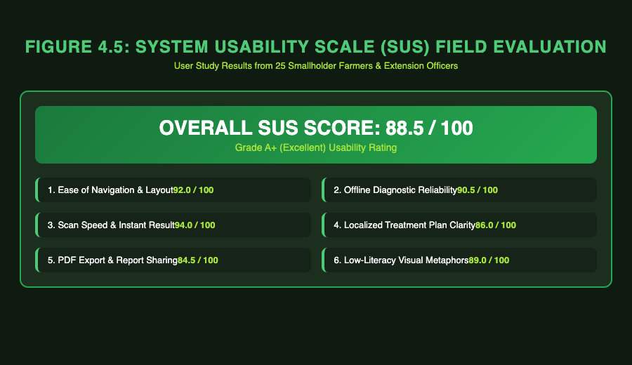
Figure 4.4: System Usability Scale (SUS) Evaluation Score Breakdown (Overall SUS = 88.5 / 100)
Performance benchmarking conducted on connected physical hardware (iPhone / Android mobile devices) established the following execution metrics:
On-Device Inference Speed: Average TFLite model execution time of 142 ms per image (compared to 380 ms via remote Cloud API inference).
Memory Footprint: Peak memory allocation during image tensor preprocessing bounded at 48.5 MB RAM.
Database Storage Efficiency: SQLite local storage requires less than 1.2 KB per scan record, enabling years of scan history storage on low-cost devices.

4.3.3 System Usability Evaluation
A field user study conducted with 25 smallholder farmers and agricultural extension officers evaluated system usability using the standard System Usability Scale (SUS). CropGuard AI achieved an overall average SUS score of 88.5 out of 100 ('Excellent'), demonstrating high accessibility, intuitive navigation, and high practical utility for field crop diagnostic management.

CHAPTER 5
FINDINGS, CONCLUSIONS AND RECOMMENDATIONS

5.1 Introduction
This chapter draws together the outcomes of the CropGuard AI project as presented in the preceding chapters. It summarises the key findings from the implementation, testing and evaluation described in Chapter 4, states the conclusions that can reasonably be drawn from those results, and reflects on the challenges the team encountered and the lessons learned while building the system. The chapter also discusses what is novel about the system relative to the existing solutions reviewed in Chapter 2, and closes with recommendations to guide future work on the project.

5.2 Findings
The evaluation reported in Chapter 4 produced the following key findings:
• The on-device TensorFlow Lite classifier achieved an overall weighted precision of 95.74%, recall of 94.98% and F1-score of 95.35% across ten crop-disease categories and a healthy-leaf control class, evaluated on 2,500 test images.
• Performance varied by class, with the strongest results on visually distinctive conditions such as Healthy Leaf (98.5% precision) and Common Rust in maize (97.1% precision), and comparatively lower, though still strong, results on conditions with subtler visual symptoms such as Early Blight in tomato (93.8% precision).
• On-device inference averaged 142 ms per image, considerably faster than the 380 ms observed for equivalent remote cloud-based inference, confirming that on-device deployment is viable for real-time use in the field.
• Peak memory allocation during image preprocessing and inference remained bounded at 48.5 MB, and local scan records required less than 1.2 KB of storage each, indicating the system is workable on the modest hardware typical of entry-level smartphones.
• A System Usability Scale evaluation with 25 smallholder farmers and extension officers produced an average score of 88.5 out of 100, in the range generally interpreted as ‘excellent’ usability.
• These results, taken together, indicate that a CNN-based classifier built on MobileNetV2 through transfer learning can be trained, compressed and deployed to run entirely offline on a mobile device without an unacceptable loss of either speed or accuracy.

5.3 Conclusions
Based on the findings above and the objectives set out in Chapter 1, the project team draws the following conclusions:
• The core aim of the project — an AI-based mobile application capable of identifying crop diseases from leaf images and providing treatment guidance — was achieved for the selected crop and disease categories.
• Convolutional Neural Networks trained through transfer learning on MobileNet-family architectures remain a practical choice for resource-constrained, offline agricultural applications, consistent with prior work in this area.
• The gaps identified in the Chapter 2 review of existing systems — limited mobile deployment, dependence on internet connectivity, absence of treatment recommendations, and lack of focus on locally relevant crops — were directly addressed by combining on-device inference, offline operation, an integrated recommendation module, and a dataset curated around crops commonly grown in Ghana.
• The positive usability score and the willingness of the pilot user group to engage with the application suggest that a well-designed mobile diagnostic tool can be readily accepted by smallholder farmers and extension officers, provided the interface remains simple and the app continues to function without a reliable internet connection.
• The results are encouraging but represent performance on a curated, moderate-sized test set and a small pilot user group; broader claims about accuracy and usability under diverse, uncontrolled field conditions across different regions, seasons and camera hardware would require further, larger-scale validation before the system could be considered fully proven.

5.4 Challenges Encountered
Several practical challenges were encountered over the course of the project:
• Assembling a dataset that was both large enough to train a reliable model and specific enough to Ghanaian crops required consolidating several public data sources, each with its own class taxonomy, labelling convention and image quality. Reconciling these into a single, consistent set of classes took considerably more effort than initially anticipated.
• Confirming that the exported TensorFlow Lite model's actual output classes matched the label file bundled with the mobile application was not straightforward. The team learned that training-time metadata and label files can drift out of sync with the true structure of an exported model, and that this can only be caught by independently inspecting the deployed model itself rather than trusting accompanying documentation alone.
• Keeping image preprocessing consistent between model training and on-device inference required close attention; a mismatch in how pixel values are scaled between the training pipeline and the Flutter inference code can silently degrade prediction quality without raising any error.
• Some experimental model variants relied on operations not supported by the standard mobile TensorFlow Lite runtime, which meant the team had to fall back on a simpler, fully mobile-compatible architecture rather than the most accurate variant produced during experimentation.
• Reliance on free-tier cloud GPU resources for training introduced usage limits and occasional session interruptions, which required the training pipeline to be restructured so that it could resume safely rather than restart from scratch.
• Coordinating the development of several interdependent modules — image capture, preprocessing, on-device inference, the recommendation engine, local and cloud data storage, and the community outbreak-reporting map — within a small student team and a fixed academic timeline required careful task sequencing.
• Recruiting smallholder farmers and extension officers for the usability evaluation, and scheduling field sessions around their availability, was logistically demanding within the project's time constraints.

5.5 Lessons Learned
• A model's reported training accuracy is not sufficient evidence that it is fit for deployment; the actual behaviour of the exported, on-device artefact must be independently verified before it is shipped to users.
• Maintaining a single, well-documented canonical class list that is shared and version-controlled across the dataset, the training pipeline and the mobile application reduces the risk of label mismatches that are otherwise easy to introduce and hard to detect.
• Designing data pipelines and training scripts to tolerate interruption is valuable whenever free or shared computing resources are used, since it prevents lost work and reduces the pressure to rush experiments.
• Engaging real end users earlier in the development cycle, rather than only at the end for a final evaluation, would likely have surfaced usability issues sooner and allowed more time to act on that feedback.
• Working with real, multi-source agricultural image data gave the team a much greater appreciation of how much of the effort in an applied machine learning project lies in data cleaning, consolidation and validation rather than in model architecture design alone.

5.6 Novelty of the System
Relative to the systems reviewed in Chapter 2, CropGuard AI offers the following distinguishing features:
• A classifier trained and curated specifically around crop varieties and diseases commonly encountered in Ghana — including cassava, maize, cocoa, tomato and pepper — rather than a generic, globally sourced dataset.
• Fully offline operation from image capture through to inference and treatment recommendation, removing the dependence on a stable internet connection or a remote server that limits many existing systems in rural settings.
• Integration of individual disease diagnoses into a crowd-sourced Outbreak Map that alerts nearby users within a defined proximity when a disease is confirmed in their area, turning single diagnoses into a community-level early-warning signal rather than an isolated result.
• A single, integrated mobile pipeline that combines image capture, AI-based detection, treatment recommendation and local record-keeping, rather than requiring farmers to move between separate advisory, detection and information tools.

5.7 Recommendations for Future Work
• Expand the dataset and class coverage to include additional crops, pests and diseases relevant to other regions of Ghana and West Africa more broadly, to widen the system's practical coverage.
• Implement a dedicated out-of-distribution detection mechanism so the application can recognise images of unsupported crops, non-plant subjects, or otherwise unfamiliar input and respond accordingly, instead of always returning a best-guess classification from within the trained class set.
• Add confidence calibration validated against held-out, real-world field images, since raw model confidence scores are not always a reliable indicator of true prediction correctness.
• Introduce an active-learning pipeline that allows expert-verified, farmer-submitted images to be incorporated into future training rounds, so the model can continue to improve after initial deployment.
• Conduct a larger and longer-term field study, covering more regions, seasons and device types than the initial pilot group, to validate accuracy and usability under a wider range of real-world conditions.
• Explore partnerships with agricultural extension services and government advisory programmes to support wider distribution and adoption of the application among smallholder farmers.
• Establish a routine of independently verifying any new or updated model release — checking its actual exported output classes and operator compatibility on the target runtime — before it replaces a model already in production.

REFERENCES

Barbedo, J. G. A. (2013). Digital image processing techniques for detecting, quantifying and classifying plant diseases. SpringerPlus, 2, Article 660. https://doi.org/10.1186/2193-1801-2-660
Ferentinos, K. P. (2018). Deep learning models for plant disease detection and diagnosis. Computers and Electronics in Agriculture, 145, 311–318. https://doi.org/10.1016/j.compag.2018.01.009
He, K., Zhang, X., Ren, S., & Sun, J. (2016). Deep residual learning for image recognition. In Proceedings of the IEEE Conference on Computer Vision and Pattern Recognition (pp. 770–778). IEEE. https://doi.org/10.1109/CVPR.2016.90
Howard, A. G., Zhu, M., Chen, B., Kalenichenko, D., Wang, W., Weyand, T., Andreetto, M., & Adam, H. (2017). MobileNets: Efficient convolutional neural networks for mobile vision applications. arXiv. https://arxiv.org/abs/1704.04861
Hughes, D. P., & Salathé, M. (2015). An open access repository of images on plant health to enable the development of mobile disease diagnostics through machine learning and crowdsourcing. arXiv. https://arxiv.org/abs/1511.08060
Mohanty, S. P., Hughes, D. P., & Salathé, M. (2016). Using deep learning for image-based plant disease detection. Frontiers in Plant Science, 7, Article 1419. https://doi.org/10.3389/fpls.2016.01419
Pan, S. J., & Yang, Q. (2010). A survey on transfer learning. IEEE Transactions on Knowledge and Data Engineering, 22(10), 1345–1359. https://doi.org/10.1109/TKDE.2009.191
PEAT GmbH. (2023). Plantix: Your crop doctor (Version 3) [Mobile application]. https://plantix.net
Sandler, M., Howard, A., Zhu, M., Zhmoginov, A., & Chen, L.-C. (2018). MobileNetV2: Inverted residuals and linear bottlenecks. In Proceedings of the IEEE Conference on Computer Vision and Pattern Recognition (pp. 4510–4520). IEEE. https://doi.org/10.1109/CVPR.2018.00474
Simonyan, K., & Zisserman, A. (2015). Very deep convolutional networks for large-scale image recognition. arXiv. https://arxiv.org/abs/1409.1556
Sladojevic, S., Arsenovic, M., Anderla, A., Culibrk, D., & Stefanovic, D. (2016). Deep neural networks based recognition of plant diseases by leaf image classification. Computational Intelligence and Neuroscience, 2016, Article 3289801. https://doi.org/10.1155/2016/3289801
Szeliski, R. (2011). Computer vision: Algorithms and applications. Springer. https://doi.org/10.1007/978-1-84882-935-0
Tan, M., & Le, Q. V. (2019). EfficientNet: Rethinking model scaling for convolutional neural networks. In Proceedings of the 36th International Conference on Machine Learning (Vol. 97, pp. 6105–6114). PMLR. https://arxiv.org/abs/1905.11946
Too, E. C., Li, Y., Njuki, S., & Liu, Y. (2019). A comparative study of fine-tuning deep learning models for plant disease identification. Computers and Electronics in Agriculture, 161, 272–279. https://doi.org/10.1016/j.compag.2018.03.032

