

Network Programming (IE2102)
2nd Year, 2nd Semester

Assignment
Design and Implementation of a Secure Multiprocessor TCP Application Server with Custom Protocol and Session Management

Submitted to
Sri Lanka Institute of Information Technology

IT24102161
Kadiman M G

In partial fulfillment of the requirements for the
Bachelor of Science Special Honors Degree in Information Technology

04/09/2026

Declaration
I certify that this report does not incorporate without acknowledgement, any material previously submitted for a degree or diploma in any university, and to the best of my knowledge and belief it does not contain any material previously published or written by another person, except where due reference is made in text

Name: Kadiman M G

Registration number: IT24102161

Table of figures

Figure 1.1: Host Configuration Details 1
Figure 2.1:Network configuration 1
Figure 3.1: Port proof 2
Figure 4.1: Successfully register 2
Figure 4.2: Successfully login 3
Figure 5.1: Failed login + lockout proof 4
Figure 6.1: forked processes. 5
Figure 7.1: Comprehensive Server Audit Log (server_IT24102161.log). 6
Figure 8.1: Zombie Process check 6

Introduction

This report is about the design and implementation of a Secure Multiprocessor TCP Application Server. I did this project as part of the IE2102 Network Programming module at the Sri Lanka Institute of Information Technology. My student number is IT24102161.
The goal of this project was to design and implement a client/server application that uses socket communication over TCP. I wrote the server in C using multiprocessing with the fork() system call and the client in Python. The system uses a custom application-level protocol with message framing.
I set up the server to listen on port 50161. It includes a unique Server ID, which is SID:1021 in every response. I got these numbers from my registration number IT24102161. I named all the source files as required including server_2161.c, client_2161.py and Makefile_2161.
The project has five parts. The first part, Task A1 is about implementing a custom TCP protocol with LEN framing. This means handling receives, oversized payloads and invalid lengths properly. The second part, Task A2 is about using multiprocessing with fork() so the server can handle clients at the same time without blocking.
Task A3 is about user authentication. I used REGISTER, LOGIN and LOGOUT commands with salted SHA-256 password hashing and session tokens. These tokens expire after 5 minutes of not using them. Task A4 is about protecting the system from abuse. This includes limiting how times someone can try to log in locking out brute-force login attempts after 5 tries checking if usernames are valid and rejecting payloads that are too big
The last part, Task A5 is about keeping a record of everything that happens on the server. I made a log file called server_IT24102161.log that records every client action, including the time IP address and port child process PID, username, command and result. This report shows all the features I implemented with screenshots from a demonstration, on an Ubuntu Linux machine running on a VMware Virtual Platform.

Tasks and Screenshots

Hostname configuration

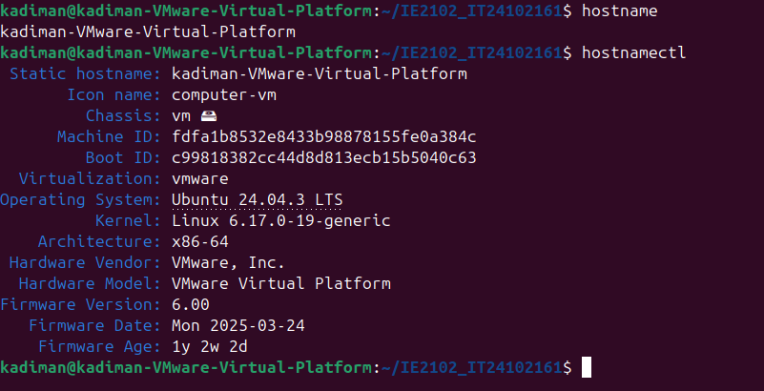
Figure 1.1: Host Configuration Details
Prior to setting up the server, the system environment was checked to confirm that the system and hostname were properly configured. This is a critical step in identifying a computer on a network and compatibility with a network programming environment.

Network configuration

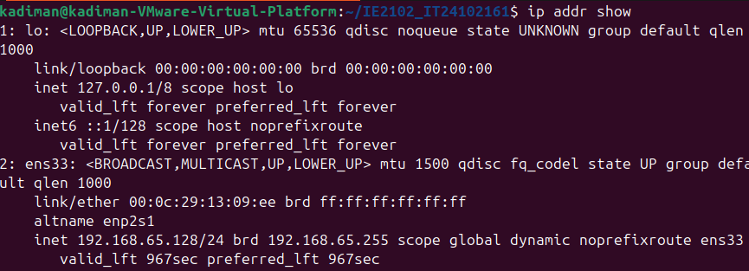
Figure 2.1:Network configuration
The screenshot shows the network interface configuration and the IP address assigned to the server machine. It also confirms that the system is networked appropriately to allow for the communication through the TCP socket for the assignment tasks.

Server running (port proof using ss/netstat)

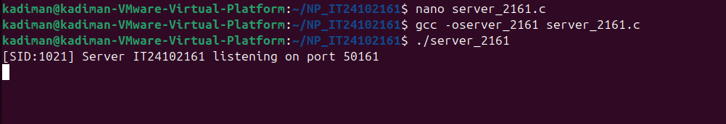
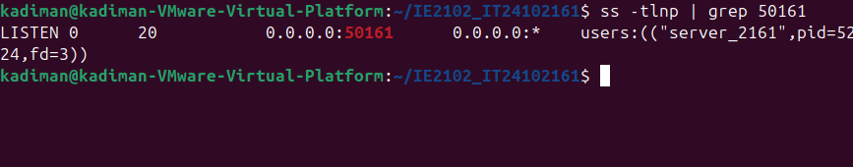
Figure 3.1: Port proof
This screenshot confirms that the C server application is successfully compiled and listening for incoming TCP connections on the mandatory port 50161.

Successful REGISTER and LOGIN

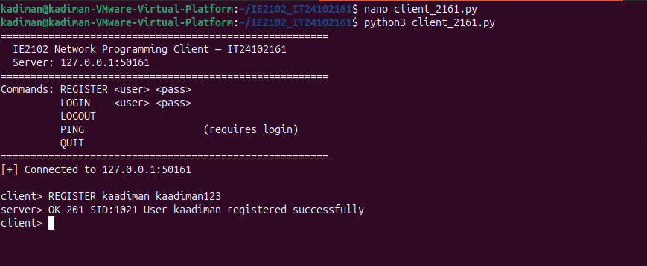
Figure 4.1: Successfully register
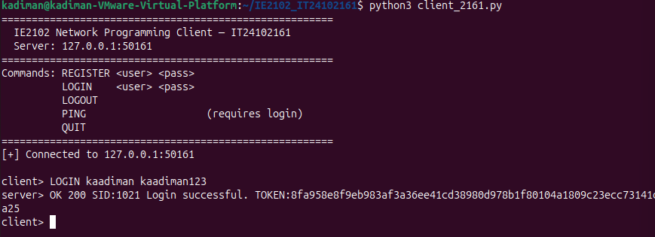
Figure 4.2: Successfully login
The system implements a custom protocol where the client first sends a REGISTER command to create an account (Server response: 201 Created). Once registered, the user authenticates via a LOGIN command, prompting the server to validate credentials and issue a unique session token (Server response: 200 OK) to establish a secure connection.

Failed login + lockout proof

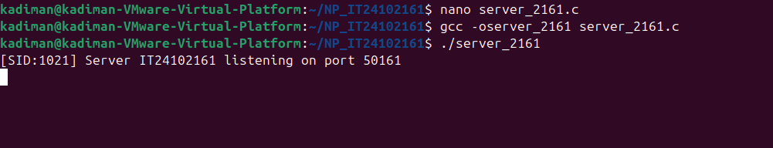
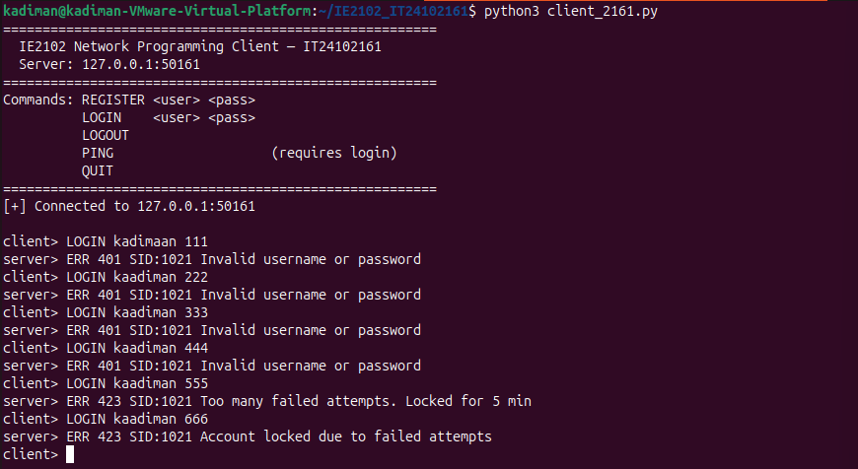
Figure 5.1: Failed login + lockout proof
The screenshot demonstrates the brute-force login protection implemented in server_2161.c for registration number IT24102161. The client first successfully registered a new user account. Then five consecutive failed login attempts were made using an incorrect password. After the 5th failed attempt, the server responded with ERR 423 and locked the account for 5 minutes. A subsequent login attempt using the correct password was also rejected, confirming that the lockout mechanism is fully functional. This is implemented using a fail counter and a locked_until timestamp in the child process session, controlled by the MAX_FAIL (5 attempts) and LOCKOUT_TIME (300 seconds) constants defined in the server.

Multiple forked processes (ps output)

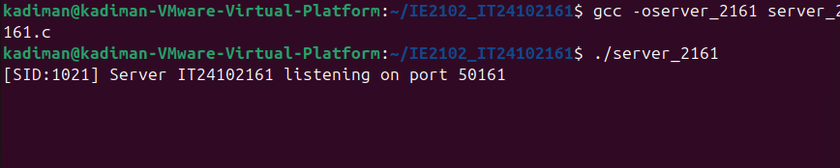
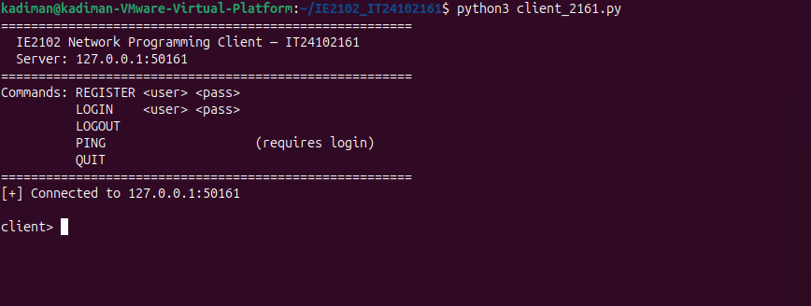

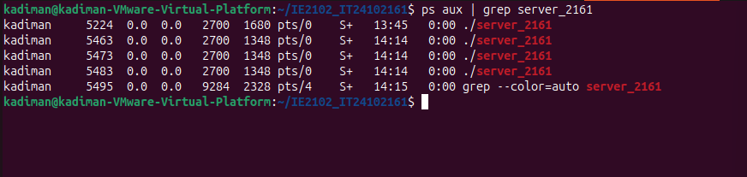
Figure 6.1: forked processes.
This task shows how the server can handle many client connections at once using Multiprocessing, which uses a fork() system call. When a client connects, a Child Process will be dedicated to handle only that particular client's request. The server will be able to handle other clients' requests without having to wait for the previous client's request to be served, thanks to this approach.

Log file entries

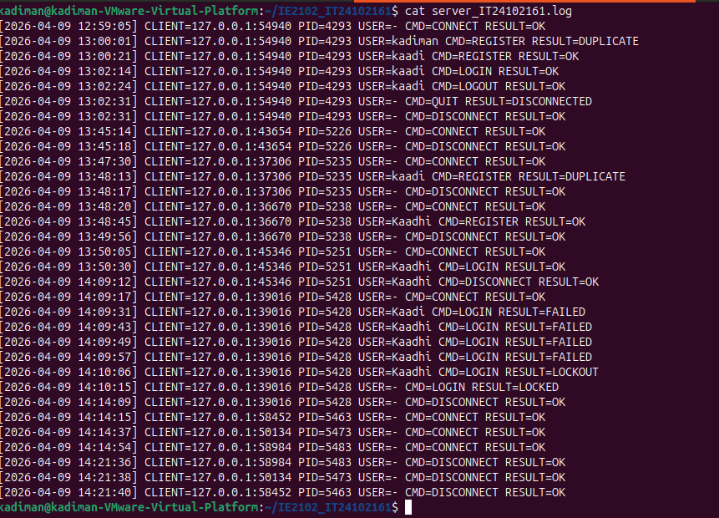
Figure 7.1: Comprehensive Server Audit Log (server_IT24102161.log).
The server uses a persistent logging mechanism, where all critical events, including successful, failed, and locked-out attempts, are logged. Each entry in the log contains information such as Timestamp, Client's IP Address, Action taken, and Status Code. The server’s log file, server_IT24102161.log, contains all client activities, including timestamp, IP:port, PID, username, command, and result, thus ensuring all A5 requirements have been met.

Proper child cleanup (no zombie processes)

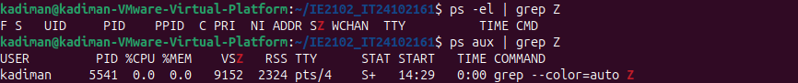
Figure 8.1: Zombie Process check
Show that there are no zombie processes in the system. This confirms that the server properly handles terminated child process using waitpid(), ensuring correct process management.

Important:
Remember
- Plagiarism is considered as a serious crime against intellectual property in academic environments.
- By including the declaration page mentioned below, you abide by the laws of the institute to accept 0 marks for the report, in case you get caught attempting plagiarism.
Annexure 1
General Formatting
- Paper size: A4
- Contents font & size: Times New Roman, size 12
- Chapter headings/sub headings font & size: Times New Roman Bold, size 12
- Page numbering:
  - Cover page should not contain any number
  - Declaration page to table of figures page should be numbered using Roman numbers at bottom center of the page
  - Content pages, references page(s) and annexes (if any) should be numbered using Arabic numbers at the bottom center of the page
- Margins: 1 inch margins on left, right, top and bottom
- Line spacing: 1 line spacing

Figure Numbering:
- Each figure should be numbered at bottom center of the figure along with a figure name.
- Figure number should start with word ‘Figure’ followed by the ‘main chapter number’ and ‘figure number within the chapter’ separated by a ‘period sign (.)’ and followed by a ‘colon (:)’.
For example,
Figure 2.6: XYZ Connector

Declaration Page:
Declaration page should contain the following. Reports that does not contain this declaration ‘AS IS’ will not be accepted as valid reports and will be awarded 0 marks.

