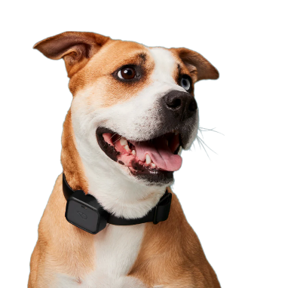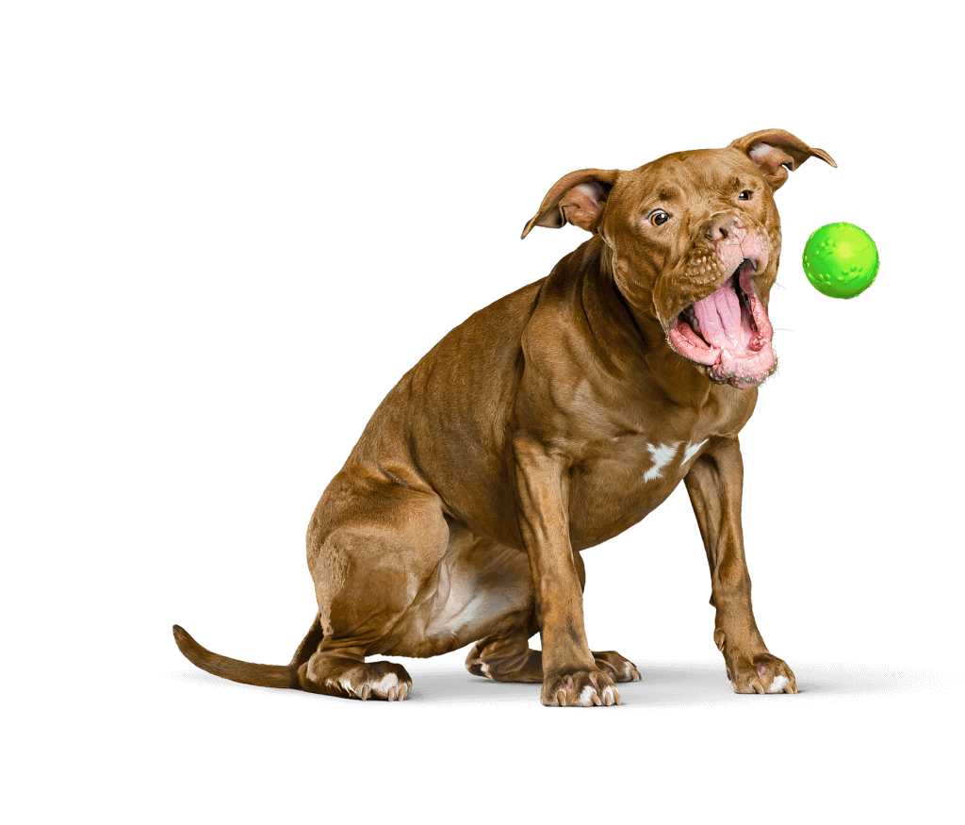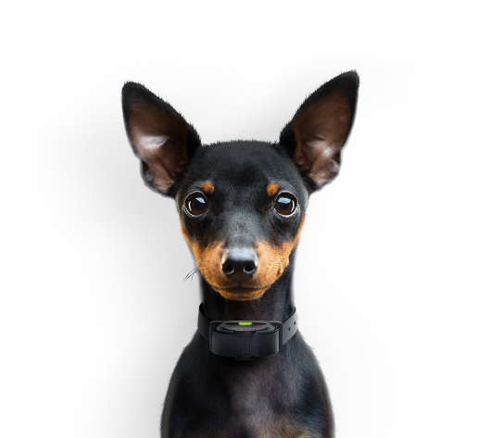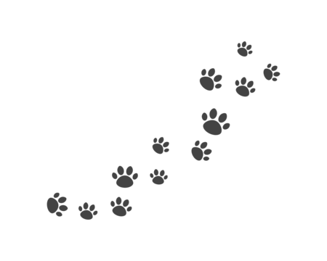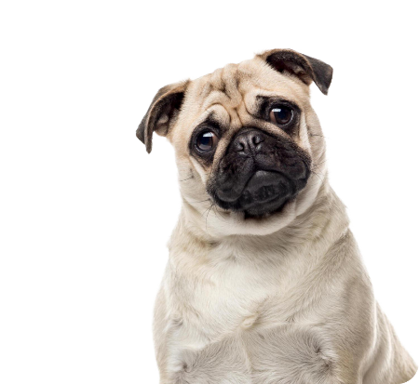

**Introduction**

**Conclusions**

**Acknowledgments**

**Further information**

**Literature cited**

**Materials and methods**

**Results**

**Marius Skjold Bjerg, Victoria Raunholt Egholm, Lasse Jensen, Thomas Kaae**

**To Dog or not to Dog**