
baajit
your little life companion
For neurodivergent brains wired different
User Manual · v1.1.1

1. Welcome — Landing Page
Every time you open Baajit, you'll be welcomed by two onboarding screens. These introduce the app and set the tone — gentle, warm, and no pressure.

Landing page artwork — the Baajit rabbit in its happy place
Page 1 shows the Baajit rabbit with a welcome message: "Hey there! I'm here to help you manage your day without the overwhelm." Tap How it works → to continue.
Page 2 shows your daily flow — six gentle steps from Mood Check-in through to Dashboard — with a reminder that there's no strict order. Skip what you don't need.
Tap Let's go! 🐰 to enter the app.

2. Mood Check-in
The first thing Baajit asks each day is how you're feeling. This helps the app adapt its suggestions to match your emotional state.
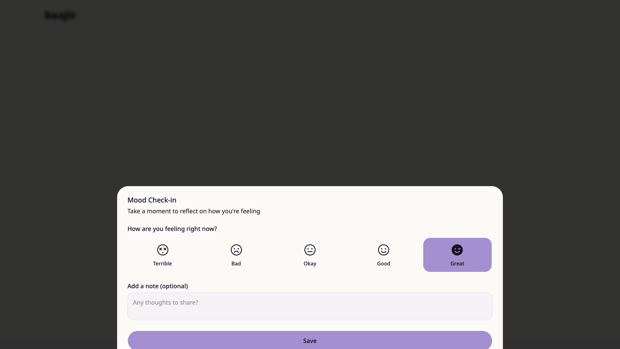
Mood Check-in — choose from Terrible, Bad, Okay, Good, or Great
Select your mood by tapping one of the five options. You can also add an optional note in the text field below to capture what's on your mind.
Tap Save to log your mood and continue to the app.

3. Energy Check-in
"How's your battery today?" — Baajit checks in on your energy level so it can suggest tasks that actually match how you feel right now.
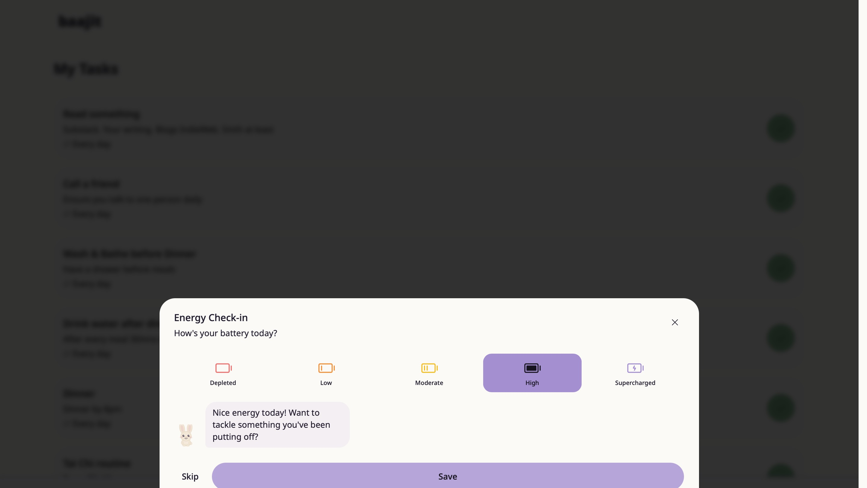
Energy Check-in — five levels from Depleted to Supercharged
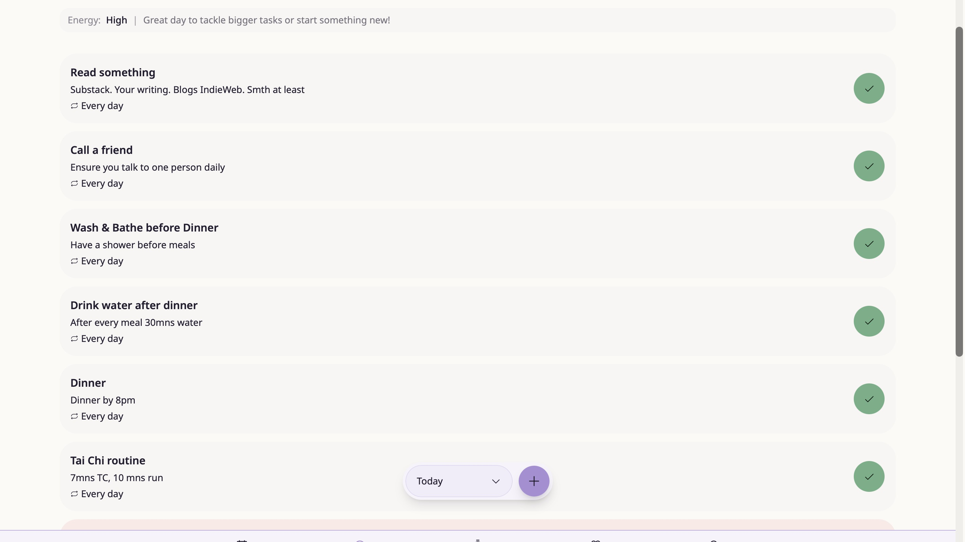
Selecting High energy — your rabbit responds with a personalised suggestion
Choose from Depleted, Low, Moderate, High, or Supercharged. When you select a level, your rabbit reacts with an energy-aware message. Tap Save to continue, or Skip if you'd rather not check in today.

4. My Tasks
My Tasks is your main hub. It shows everything you need to do today — tasks you've created and habits scheduled for today — all in one clean list.
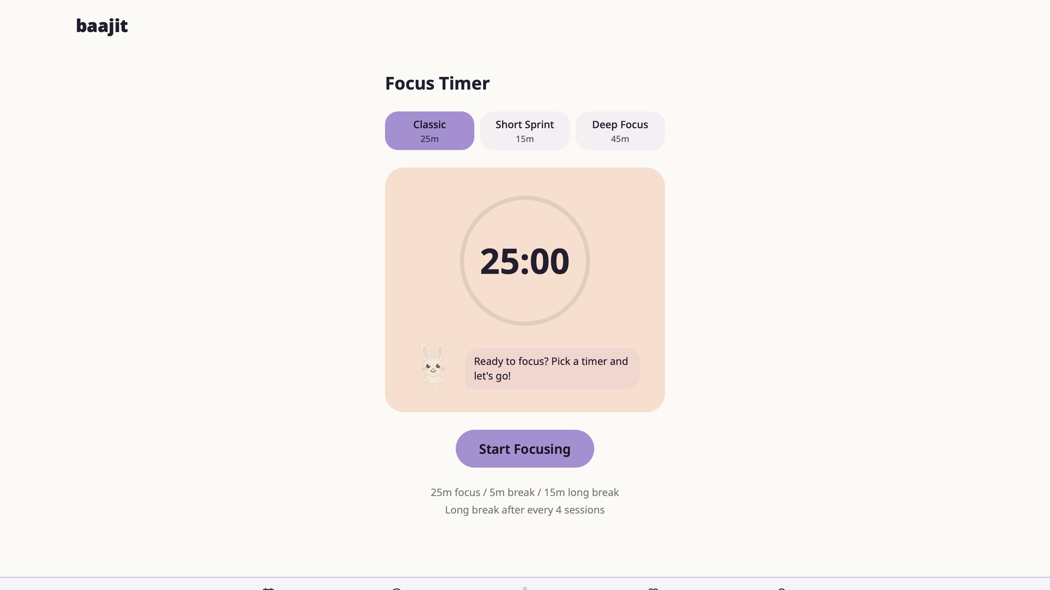
Empty state — your rabbit encourages you to add your first task
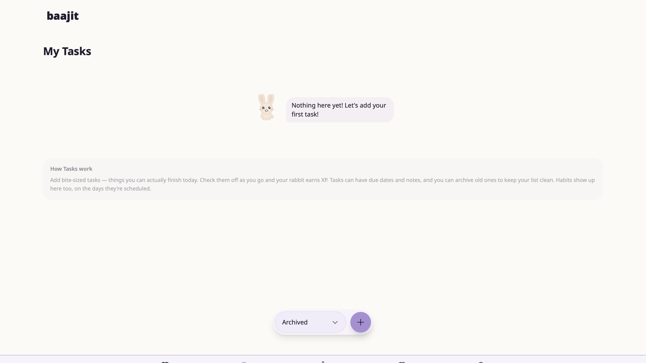
Tasks view with energy banner and a full task list
Each task shows its title, description, and recurrence. Tap the green circle on the right to mark a task complete — your rabbit will appear in a party hat to celebrate!
Use the filter at the bottom to switch between Today, Completed, and Archived views. Tap the + button to add a new task.
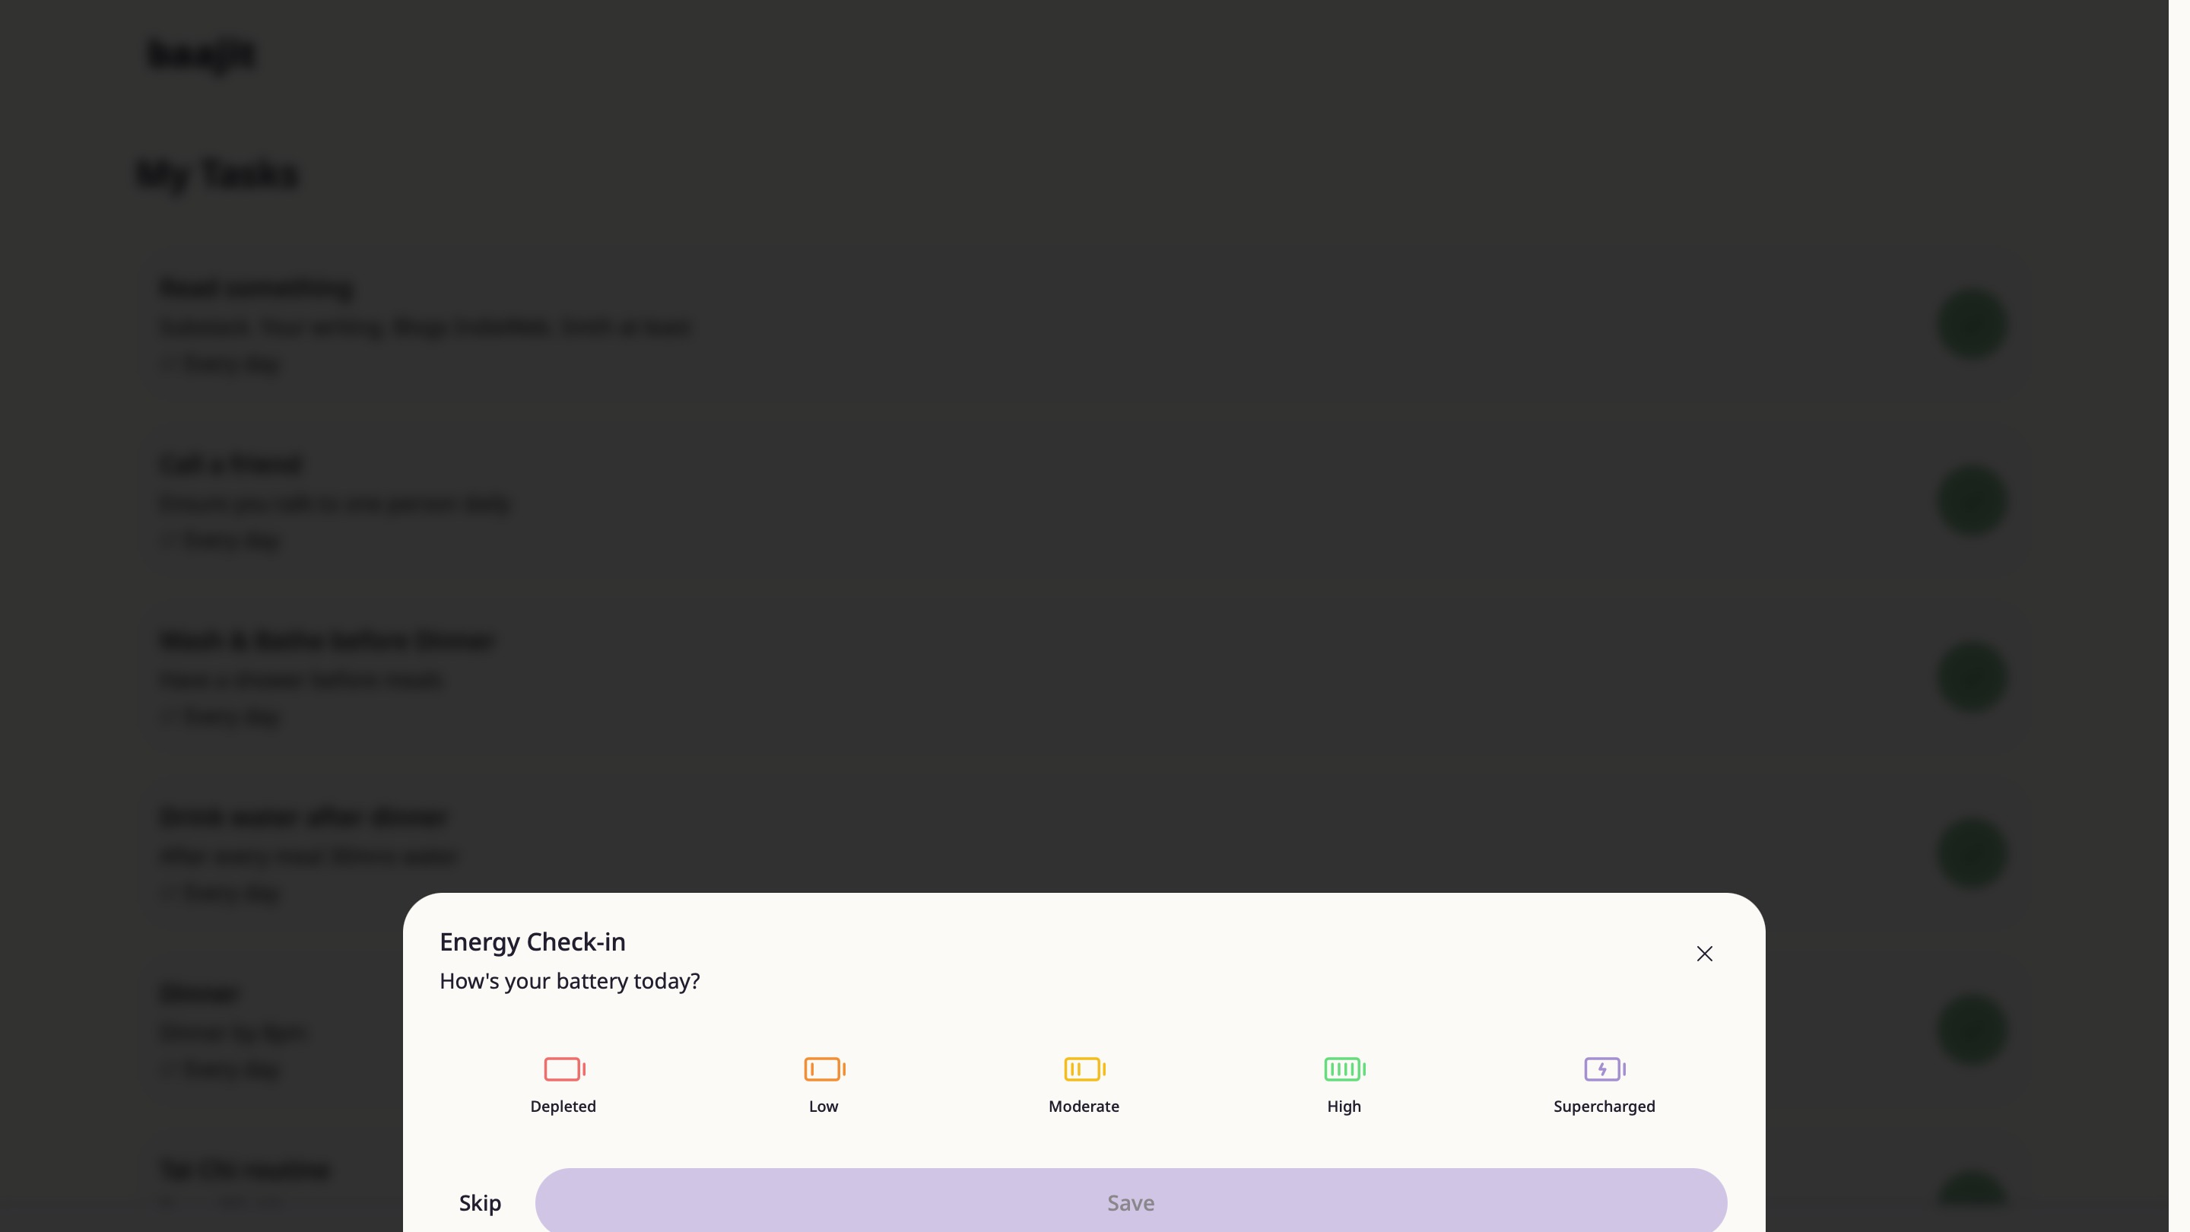
Full task list — all your daily habits and tasks in one place

5. Focus Timer
When you're ready to work, the Focus Timer gives you a distraction-free space. No complicated setup — pick a duration and press go.
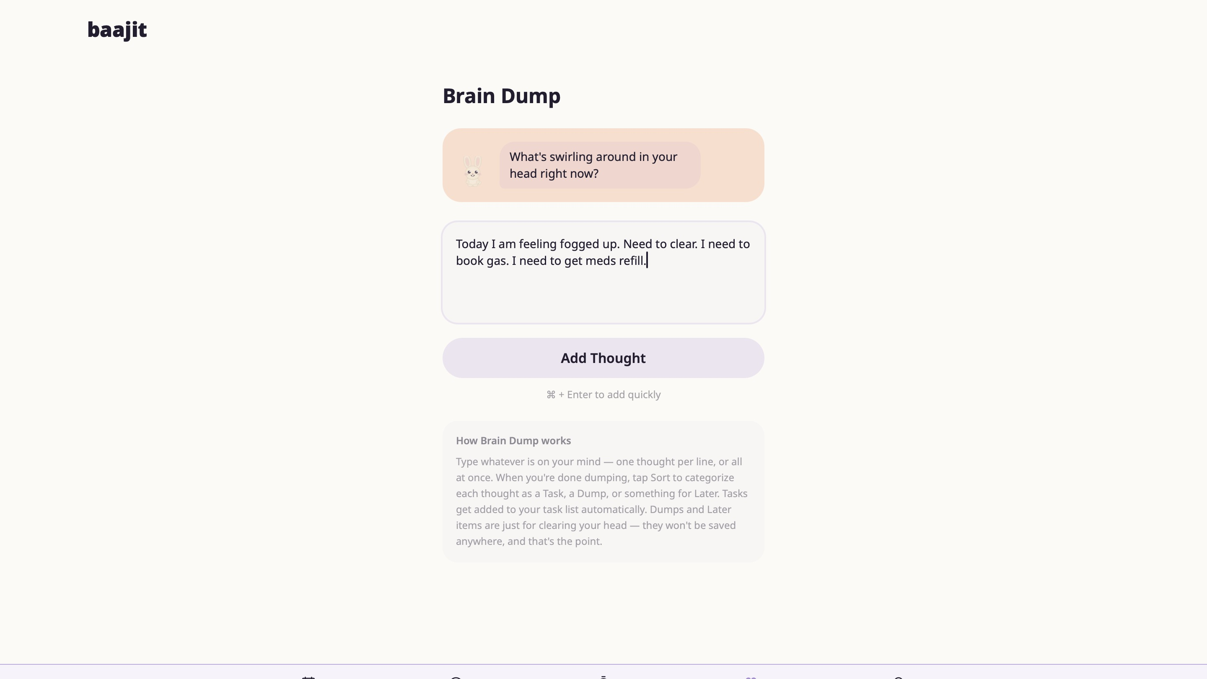
Focus Timer — Classic 25m, Short Sprint 15m, or Deep Focus 45m
Choose from three presets: Classic (25 min), Short Sprint (15 min), or Deep Focus (45 min). Your rabbit cheers you on with a message before you start.
Tap Start Focusing to begin. Each completed session earns your rabbit XP.

6. Brain Dump
When thoughts are swirling and you can't focus, Brain Dump gives you a safe place to empty your mind — fast, with no pressure to organise anything yet.
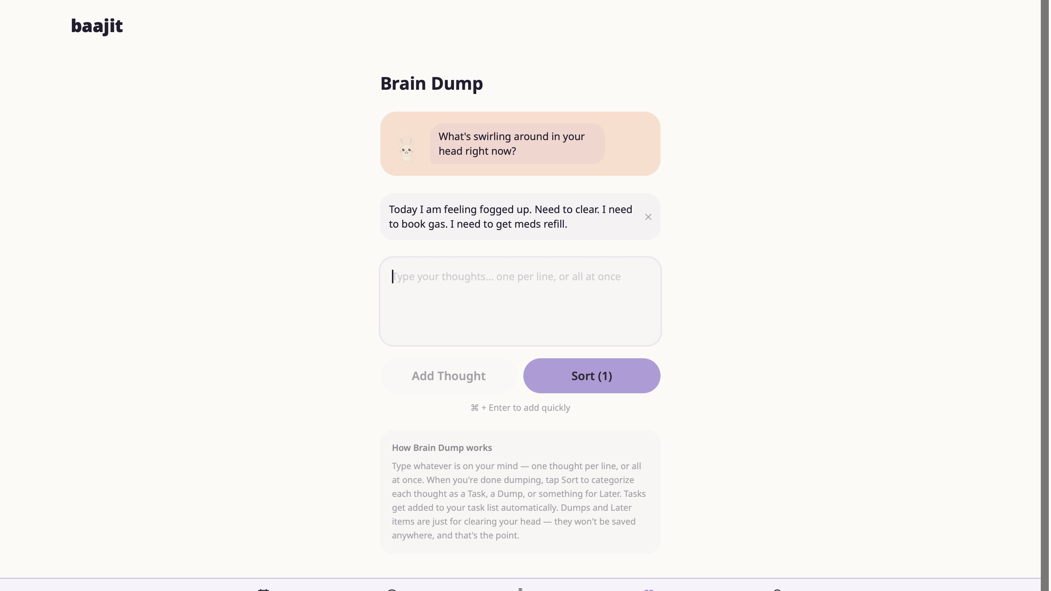
Brain Dump — type whatever is on your mind
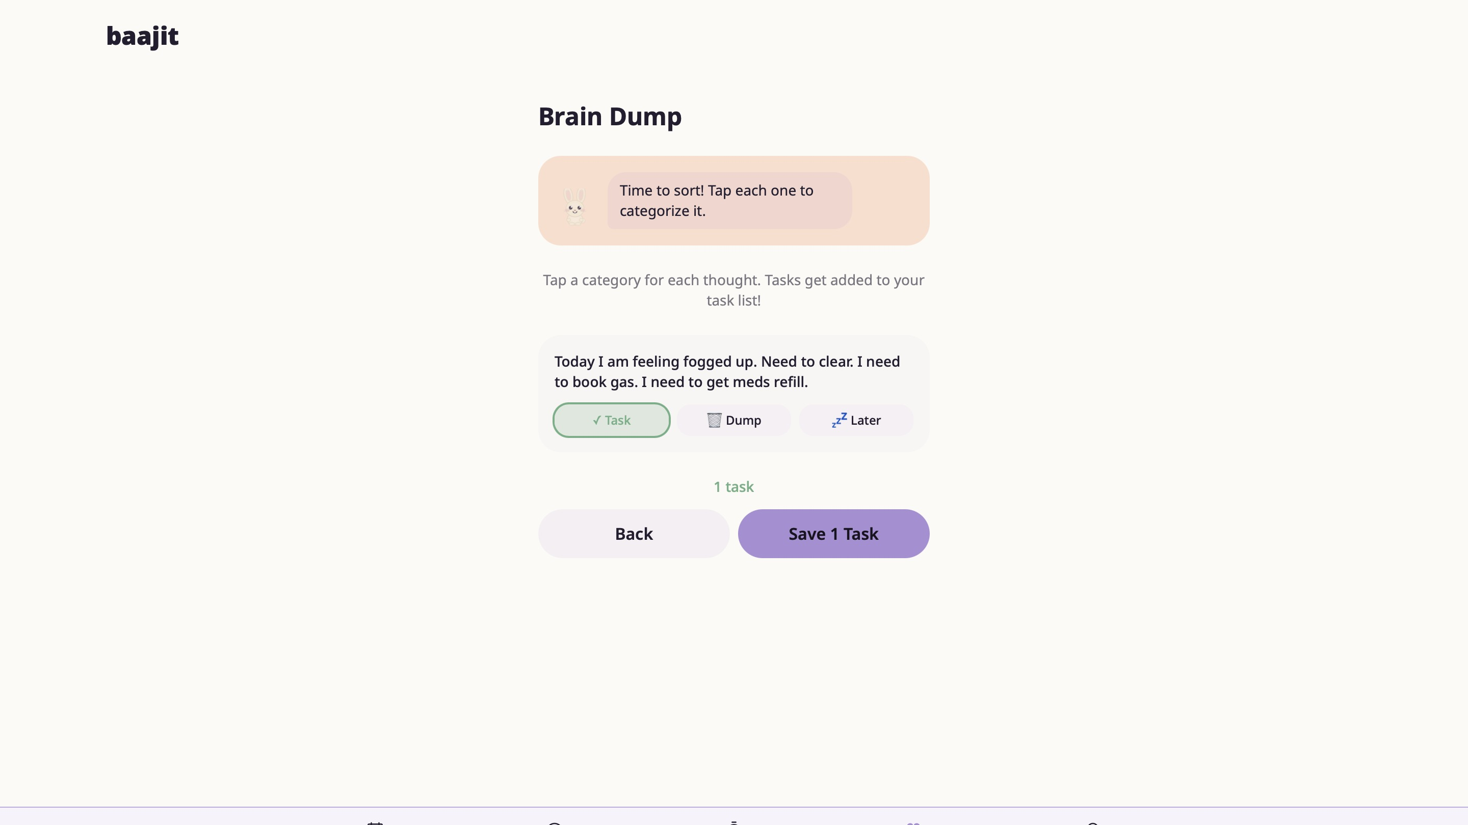
Once added, thoughts appear as cards with a Sort option
Type freely — one thought per line or all at once. Tap Add Thought to capture it. When you're ready, tap Sort to categorise each thought.
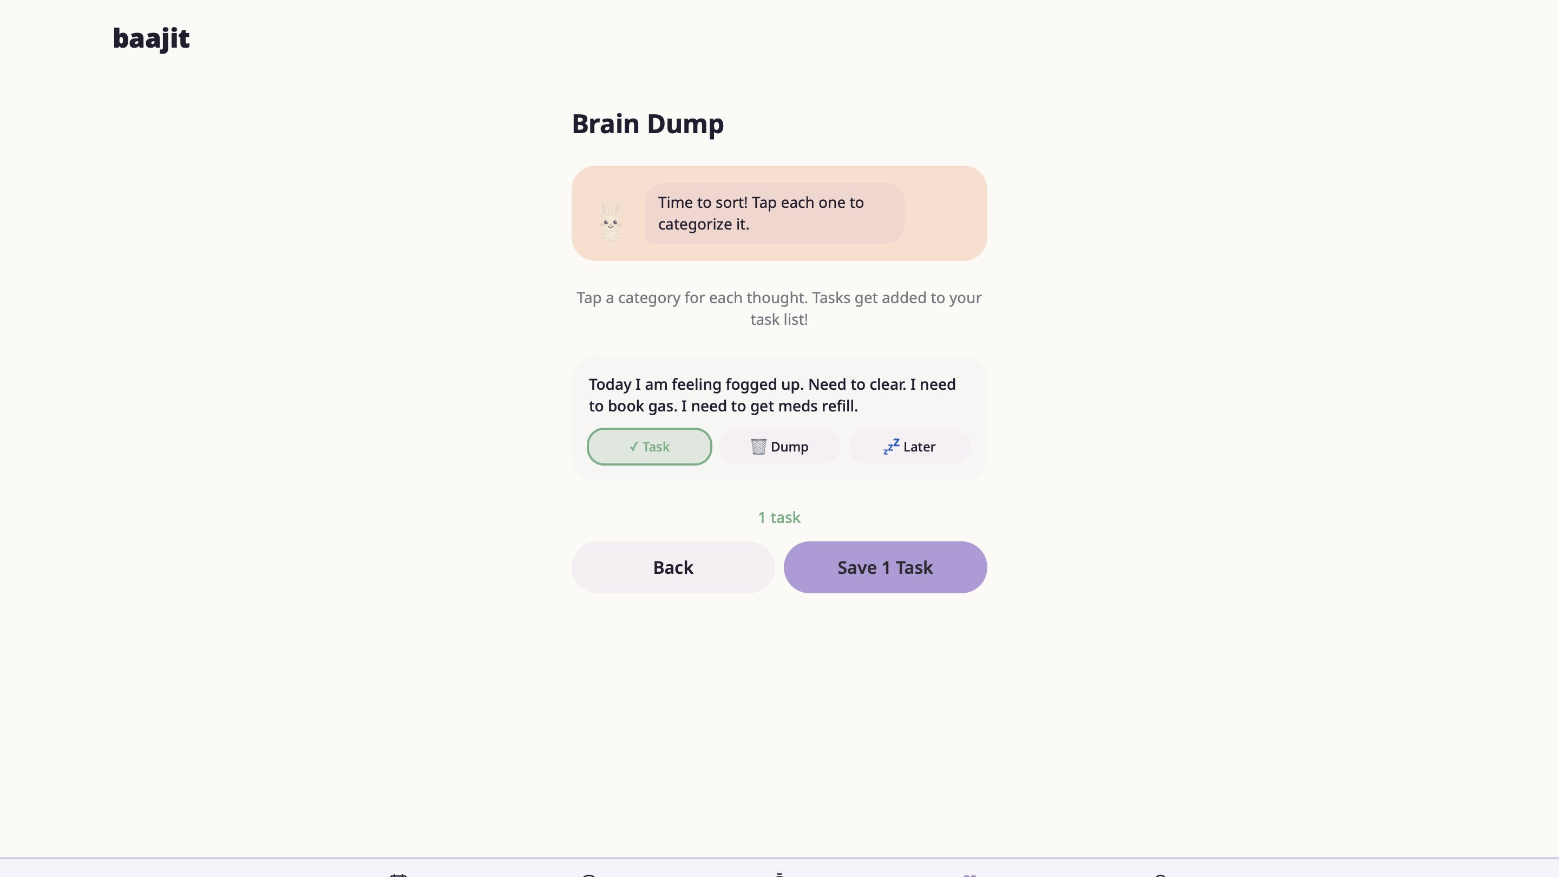
Sort mode — tag each thought as a Task, Dump, or Later
In Sort mode, tap Task to add it to your task list, Dump to clear it from your head, or Later to set it aside. Tasks are added to My Tasks automatically. Tap Save to finish.

7. Navigation
The bottom navigation bar gives you access to all five main sections of Baajit at any time:
- Calendar — view tasks and habits across the week
- Tasks — your main daily hub
- Focus — distraction-free timer
- Dump — brain dump and thought sorting
- Profile / Dashboard — your rabbit, XP, and activity overview

No strict order. Skip what you don't need. Baajit adapts to you — not the other way around. 🐰

