Purpose:

1. Popular artist – ARTIST – got it – favorite artist – christina Aguilera + patti austin
   1. Superstar
   2. Artist
   3. Singer
   4. Singer-songwriter

CLASSIFIER:favorite

CLASSIFIER:artist

CLASSIFIER:singer

CLASSIFIER:singer-songwriter

CONCEPT:favorite _w

CONCEPT_RULE:(AND,"_c{artist _w}", "favorite")

1. Popular song/album – SONG_ALBUM -> got it – popular album
   1. Album
   2. Record
   3. Track
   4. Hit
   5. Collection
2. Trend in music – MUSIC_TREND
   1. Music
   2. Good
   3. Great
   4. Genre
3. Trend in consumer taste – CONSUMER_TREND ->got it
   1. Good
   2. Great
   3. Want
   4. Love
4. Popular genre

CLASSIFIER:singer

CLASSIFIER:singer-songwriter

CLASSIFIER:best

Favourite Artist: Christina Aguilera

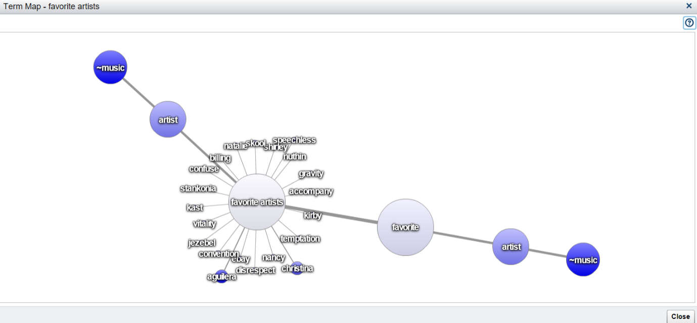

Most Popular