GekayRealEstate
A Project Report
Submitted in partial fulfillment of the
Requirements for the award of the Degree of
BACHELOR OF SCIENCE (COMPUTER SCIENCE)
By
Manish
Class: T.Y.B.Sc. (Computer Science) - TYCS
2026012040(510515147)
Under the esteemed guidance of
Asst. Prof. Saba Ansari
Head of Department

DEPARTMENT OF COMPUTER TECHNOLOGY
J. K. COLLEGE OF SCIENCE AND COMMERCE (AUTONOMOUS)
Affiliated to University of Mumbai
NAVI MUMBAI, 400701
MAHARASHTRA
2026-27

ABSTRACT
Real estate discovery, listing dissemination, and client lead management have historically relied on manual and fragmented communication systems such as paper directories, print classifieds, static registers, and ad-hoc phone calls. These legacy approaches result in substantial inefficiencies, including delayed information exchange, high susceptibility to transcription errors, lack of verified property specifications, and severe friction in tracking client inquiries and broker responsibilities.
GekayRealEstate is a full-featured, web-based real-estate management system engineered with Python and the Django framework. The platform provides a centralized, reliable digital architecture tailored for property seekers, registered users, realtors, and system administrators. Visitors can seamlessly discover and inspect properties through rich visual galleries, structural specifications (bedrooms, bathrooms, square footage, lot size, garage capacity), pricing indicators, and assigned broker profiles.
Built on Django's Model-View-Template (MVT) architecture, the system employs SQLite for structured relational data persistence, HTML5/CSS3/JavaScript with Bootstrap for a responsive, modern interface, and Pillow for image processing and media handling. Core functional modules include multi-criteria property search and filtering (by keywords, city, state, bedrooms, and maximum budget), authenticated user management with CSRF defense, an authenticated user inquiry history dashboard, automated email alerts upon lead capture, and a comprehensive Django administration portal for administrative control.
Developed under the Waterfall Software Development Life Cycle (SDLC) model, the system underwent rigorous verification covering functional test suites, boundary condition tests, authentication checks, duplicate inquiry prevention, and database integrity validation. The resulting application establishes a scalable, production-ready solution that modernizes real estate marketing and customer inquiry management.
Keywords: Real Estate Management, Django 5.2, Python 3.14, SQLite, Bootstrap, Realtors, Property Inquiry, User Dashboard, MVT Architecture.

ACKNOWLEDGEMENT
I would like to express my profound gratitude and sincere appreciation to all those who have contributed to the successful completion of the project report titled "GekayRealEstate: Real-Estate Management System" as part of the project course curriculum.
First and foremost, I extend my deep gratitude to my Project Guide, Asst. Prof. Saba Ansari, for her continuous guidance, valuable technical insights, constructive feedback, and encouragement throughout the software development lifecycle. Her mentorship was pivotal in resolving architectural challenges and shaping the scope of this project.
I am immensely grateful to Asst. Prof. Saba Ansari, Head of the Department of Computer Technology, for providing the necessary laboratory infrastructure, software development tools, and an environment conducive to learning and research.
My sincere thanks also go to Dr. Shraddha Bhome, Principal of J. K. College of Science and Commerce (Autonomous), for providing institutional support and facilities required to execute this project successfully.
I would also like to acknowledge the faculty members and technical staff of the Computer Technology department for their direct and indirect support during the design, testing, and documentation phases.
Special thanks to my peers and classmates for their valuable suggestions during the testing phase and for engaging in critical discussions that helped refine the system's user interface and performance.
Lastly, I owe a heartfelt debt of gratitude to my family for their unconditional love, patience, and constant encouragement throughout the course of my academic journey.
Manish
Roll No.: 2026012040 (510515147)
Class: T.Y.B.Sc. (Computer Science) - TYCS
Department of Computer Technology
J. K. College of Science and Commerce (Autonomous)

DECLARATION
I hereby declare that the project entitled "GekayRealEstate: Real-Estate Management System" has been developed by me as part of my academic curriculum. This project has not been duplicated or submitted to any other university or institution for the award of any degree or diploma.
To the best of my knowledge, this project is my original work and has been completed under the esteemed guidance of Asst. Prof. Saba Ansari, Department of Computer Technology.
The project is done in partial fulfillment of the requirements for the award of the degree of BACHELOR OF SCIENCE (COMPUTER SCIENCE) to be submitted as a fifth semester project under University of Mumbai curriculum standards.
Manish
Roll No.: 2026012040 (510515147)
Class: T.Y.B.Sc. (Computer Science) - TYCS
J. K. College of Science and Commerce (Autonomous)
_____________________________________
Name and Signature of the Student

TABLE OF CONTENTS
1. INTRODUCTION 1
1.1 Project Background 1
1.2 Problem Statement 2
1.3 Project Objectives 2
1.4 Scope of the System 3
1.5 Intended Users 4
1.6 Project Benefits 4
2. SYSTEM STUDY 5
2.1 Existing Real-Estate Listing Process 5
2.2 Limitations of the Existing Process 5
2.3 Proposed GekayRealEstate System 6
2.4 Advantages of the Proposed System 6
2.5 Feasibility Study 7
2.5.1 Technical Feasibility 7
2.5.2 Operational Feasibility 7
2.5.3 Economic Feasibility 7
3. REQUIREMENTS AND ANALYSIS 8
3.1 Functional Requirements 8
3.1.1 Home Page and Featured Listings 8
3.1.2 Property Listing Management 9
3.1.3 Property Search and Filtering 9
3.1.4 Property Details and Gallery 9
3.1.5 Realtor Information 10
3.1.6 User Registration and Login 10
3.1.7 User Dashboard 10
3.1.8 Property Inquiry and Contact 10
3.1.9 Email Notification 11
3.1.10 Administration 11
3.2 Non-Functional Requirements 11
3.3 User Roles and Permissions 12
3.4 Software Requirements 13
3.5 Hardware Requirements 14
3.6 Use-Case Analysis 14
3.7 Data Flow Analysis 15
4. TECHNOLOGY AND PROJECT ARCHITECTURE 17
4.1 Python 17
4.2 Django Framework 17
4.3 SQLite Database 18
4.4 HTML Templates 18
4.5 Bootstrap, CSS, and JavaScript 18
4.6 Pillow and Media File Handling 19
4.7 Python-Dotenv and Environment Configuration 19
4.8 Gunicorn and Whitenoise 19
4.9 Project Directory Structure 20
4.10 Django MVT Architecture 20
4.11 URL Routing Architecture 21
5. SYSTEM DESIGN 22
5.1 Application Modules 22
5.1.1 Pages Module 22
5.1.2 Listings Module 23
5.1.3 Realtors Module 23
5.1.4 Accounts Module 23
5.1.5 Contacts Module 24
5.2 Database Design 24
5.2.1 Realtor Entity 24
5.2.2 Listing Entity 25
5.2.3 Contact Entity 26
5.2.4 Django User Entity 26
5.3 Entity Relationships 27
5.4 User Interface Design 28
5.5 Navigation and Common Layout 28
5.6 Security and Access Control 29
5.7 Media and Static File Design 30
6. IMPLEMENTATION 31
6.1 Django Project Configuration 31
6.2 Home and About Pages 31
6.3 Listing Display and Pagination 32
6.4 Listing Detail View 32
6.5 Listing Search 33
6.5.1 Keyword Search 33
6.5.2 City and State Filtering 33
6.5.3 Bedroom Filtering 33
6.5.4 Price Filtering 34
6.6 Realtor Management 34
6.7 User Registration 34
6.8 User Login and Logout 35
6.9 Authenticated User Dashboard 35
6.10 Contact Inquiry Processing 35
6.11 Duplicate Inquiry Prevention 36
6.12 Email Notification Processing 36
6.13 Django Admin Configuration 36
6.14 Environment Variables and Configuration 37
6.15 Database Migrations 37
7. TESTING 38
7.1 Testing Strategy 38
7.2 Unit Testing 38
7.3 Authentication Test Cases 39
7.4 Listing Test Cases 40
7.5 Search and Filter Test Cases 40
7.6 Contact Inquiry Test Cases 41
7.7 Access Control Test Cases 41
7.8 Template and User Interface Testing 42
7.9 Database and Migration Testing 42
7.10 Test Results 42
8. USER INTERFACE AND SYSTEM RESULTS 44
8.1 Home Page 44
8.2 About Page and Realtor Profiles 45
8.3 Browse Listings Page 45
8.4 Search Results Page 46
8.5 Listing Details Page 46
8.6 Registration Page 47
8.7 Login Page 47
8.8 User Dashboard 48
8.9 Contact Inquiry Form 48
8.10 Django Administration Panel 49
8.11 Responsive Layout 49
9. DEPLOYMENT AND MAINTENANCE 50
9.1 Local Windows Setup 50
9.2 Virtual Environment Setup 50
9.3 Dependency Installation 51
9.4 Environment File Configuration 51
9.5 Database Migration 51
9.6 Administrator Account Setup 52
9.7 Running the Development Server 52
9.8 Production Deployment Considerations 52
9.9 Backup and Maintenance 53
10. CONCLUSION AND FUTURE SCOPE 54
10.1 Conclusion 54
10.2 Current System Limitations 54
10.3 Future Enhancements 55
10.3.1 Advanced User Roles 55
10.3.2 Online Booking and Payment 55
10.3.3 Saved and Favourite Listings 55
10.3.4 Advanced Property Search 56
10.3.5 Real-Time Notifications 56
10.3.6 Cloud Database and Hosting 56
REFERENCES 57

LIST OF TABLES
Sr. No. | Table | Table Name / Description | Page No.
1 | Table 3.1 | Functional Requirements | 8
2 | Table 3.2 | Non-Functional Requirements | 11
3 | Table 3.3 | User Roles and Permissions | 12
4 | Table 3.4 | Software Requirements | 13
5 | Table 3.5 | Hardware Requirements | 14
6 | Table 5.1 | Application Modules | 21
7 | Table 5.2 | Realtor Entity Fields | 23
8 | Table 5.3 | Listing Entity Fields | 24
9 | Table 5.4 | Contact Entity Fields | 25
10 | Table 5.5 | URL Routes and Views | 27
11 | Table 7.1 | Authentication Test Cases | 33
12 | Table 7.2 | Listing and Search Test Cases | 34
13 | Table 7.3 | Contact Inquiry Test Cases | 35
14 | Table 7.4 | Integration Test Results | 36
15 | Table 9.1 | Deployment Configuration | 44

LIST OF FIGURES
Sr. No. | Figure | Figure Name | Page No.
1 | Figure 2.1 | Existing and Proposed System Comparison | 6
2 | Figure 3.1 | Use-Case Diagram | 15
3 | Figure 3.2 | Data Flow Diagram | 16
4 | Figure 4.1 | Django MVT Architecture | 19
5 | Figure 4.2 | Project Directory Structure | 20
6 | Figure 5.1 | Application Module Diagram - System Architecture Flow | 22
7 | Figure 5.2 | Entity Relationship Diagram | 26
8 | Figure 5.3 | URL Routing Diagram | 28
9 | Figure 5.4 | User Navigation Flow - User Journey Flow | 29
10 | Figure 6.1 | Home Page | 37
11 | Figure 6.2 | About Page | 38
12 | Figure 6.3 | Browse Listings Page | 38
13 | Figure 6.4 | Search Results Page | 39
14 | Figure 6.5 | Listing Details Page | 39
15 | Figure 6.6 | Registration Page | 40
16 | Figure 6.7 | Login Page | 40
17 | Figure 6.8 | User Dashboard | 41
18 | Figure 6.9 | Contact Inquiry Form | 41
19 | Figure 6.10 | Django Administration Panel - Admin Operations Flow | 32

1. INTRODUCTION
1.1 Project Background
GekayRealEstate is a web-based real-estate management system developed with Python and Django. The application allows visitors to browse property listings, inspect property information, learn about realtors, and contact a realtor about a property. Registered users can log in and review the inquiries associated with their account.
Property information is stored in a structured database instead of being maintained only in paper records or scattered messages. Each listing contains details such as title, address, city, state, postal code, price, bedrooms, bathrooms, garage, floor area, lot size, description and property photographs. A listing is connected to a realtor who is responsible for the property.
1.2 Problem Statement
Traditional property promotion methods make it difficult for users to search available properties quickly and for administrators to maintain consistent property information. Buyers may need to contact an office repeatedly to obtain basic details, while property managers may have difficulty tracking inquiries, realtor information and listing status.
The project addresses these problems by providing a central web application with searchable listings, property detail pages, realtor information, user accounts, contact inquiries and an administrative interface.
1.3 Project Objectives
The main objectives of GekayRealEstate are:
• 1. To provide a clear home page for discovering featured properties.
• 2. To display property listings with photographs and important property details.
• 3. To allow users to search properties by keyword, city, state, bedrooms and price.
• 4. To provide a detailed page for every property listing.
• 5. To maintain realtor records and display realtor information.
• 6. To provide registration, login and logout functionality.
• 7. To allow authenticated users to view their submitted property inquiries.
• 8. To record inquiries made for a property and notify the responsible office.
• 9. To provide Django administration for managing application data.
• 10. To use a maintainable Django project structure with separate application modules.
1.4 Scope of the System
The current system includes:
• Public home and about pages.
• Featured property listings on the home page.
• A paginated browse-listings page.
• Individual property detail pages.
• Property search and filtering.
• Realtor profiles and realtor information.
• User registration, login, logout and dashboard pages.
• Contact inquiry submission for a property.
• Prevention of repeated inquiries for the same listing by a logged-in user.
• Email notification when an inquiry is submitted.
• Django admin support for data management.
• SQLite database storage for local development.
• Static files and uploaded property images.
The current version does not implement online payments, property reservations, real-time chat, map integration, advanced role management or a dedicated booking workflow.
1.5 Intended Users
The system is intended for:
• Visitors searching for residential properties.
• Registered users who want to contact realtors and track inquiries.
• Realtors whose property information is displayed by the system.
• Administrators who maintain listings, realtors, users and inquiries.
• Developers and students studying Django-based web application development.
1.6 Project Benefits
The application makes property information easier to discover and maintain. Users can review important information before making an inquiry, while administrators can manage records through Django's administration tools. Search and pagination reduce the effort needed to browse a large number of properties. Database storage also makes it possible to preserve listing and inquiry records for later review.

2. SYSTEM STUDY
2.1 Existing Real-Estate Listing Process
In a manual or partially digital process, property details may be maintained in spreadsheets, paper files, social-media posts or separate communication channels. Users often have to ask for the same information repeatedly. Property photographs, prices, location information and contact records may not be presented consistently.
2.2 Limitations of the Existing Process
The existing process can result in:
• Slow property discovery.
• Inconsistent or outdated property information.
• Difficulty comparing multiple properties.
• Repeated manual responses to common questions.
• Poor tracking of customer inquiries.
• Limited access to historical records.
• Difficulty maintaining realtor and listing relationships.
2.3 Proposed GekayRealEstate System
The proposed system stores realtors, listings, users and contact inquiries in a Django-managed relational database. Public users can browse and search published listings. A listing detail page displays its images, location, specifications, description and realtor. An authenticated user can submit an inquiry and later view the inquiry from the dashboard.
The application is divided into focused Django applications:
• pages: home and about pages.
• listings: listing display, detail pages, pagination and search.
• realtors: realtor model and administration support.
• accounts: registration, authentication and user dashboard.
• contacts: property inquiries and email notification.
2.4 Advantages of the Proposed System
The proposed system provides a single source of property information, faster search, reusable templates, structured records and an administration panel. The application is also extensible because Django applications, models, URLs, views and templates are separated according to responsibility.
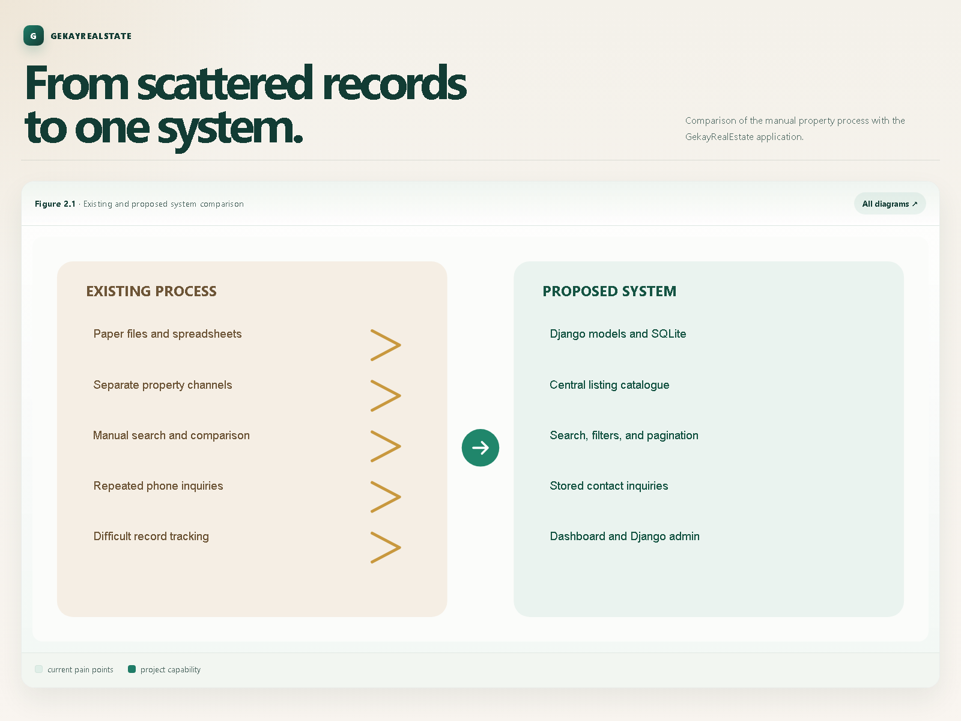
Figure 2.1: Existing and Proposed System Comparison
2.5 Feasibility Study
A thorough feasibility assessment was performed across technical, operational, and financial dimensions to establish the project's practicality and viability within an academic and commercial context.
2.5.1 Technical Feasibility
The system uses Python, Django, SQLite, HTML, CSS and JavaScript. These technologies are widely supported and suitable for a database-driven web application. Django provides routing, templates, authentication, forms support, database access and an administration interface.
2.5.2 Operational Feasibility
The application follows common website navigation patterns. Visitors can browse properties without creating an account, while account features are protected by authentication. Administrators can use the familiar Django admin interface to maintain records.
2.5.3 Economic Feasibility
The application uses open-source software and can be run locally with SQLite. This keeps the initial cost low. For a larger deployment, the database, hosting, email service and media storage can be upgraded independently.

3. REQUIREMENTS AND ANALYSIS
3.1 Functional Requirements
Functional requirements define the core operational behaviors, workflows, and service capabilities implemented across the GekayRealEstate application modules.
Table 3.1: Functional Requirements
Req ID | Module | Requirement Description | Priority
FR-01 | Pages | Display public home page with showcase search banner and featured properties | High
FR-02 | Listings | Maintain comprehensive property database records with images and specifications | High
FR-03 | Listings | Filter property catalogue by keyword, city, state, bedroom count, and maximum price | High
FR-04 | Listings | Render individual property detail page with detailed specs and 6-photo gallery | High
FR-05 | Realtors | Present realtor profile cards with photo, contact info, bio, and MVP seller badge | Medium
FR-06 | Accounts | User registration validation ensuring unique username/email and matching passwords | High
FR-07 | Accounts | User authentication (login/logout) with session persistence and CSRF protection | High
FR-08 | Accounts | Authenticated user dashboard displaying inquiry history and property links | Medium
FR-09 | Contacts | Property inquiry form submission linking inquiries to listings and user profiles | High
FR-10 | Contacts | Duplicate inquiry prevention blocking repeated inquiries on the same listing | Medium
FR-11 | Contacts | Automated email notification alerting realtors/admin upon new client inquiry | Medium
FR-12 | Admin | Django administration interface for staff to manage properties, realtors, and leads | High

3.1.1 Home Page and Featured Listings
The home page displays a selection of recently listed published properties. It also provides search choices for price, bedrooms and state so that users can begin searching from the main page.
3.1.2 Property Listing Management
Each listing stores a title, realtor, address, city, state, postal code, description, price, bedrooms, bathrooms, garage, square footage, lot size, publication status, listing date and photographs. Published listings are made available to public users.
3.1.3 Property Search and Filtering
The search view accepts optional query parameters. Users can filter by keywords in the description, exact city, exact state, maximum number of bedrooms and maximum price. Results are ordered by listing date.
3.1.4 Property Details and Gallery
The detail view displays a selected listing and its related information. The listing template supports a main photograph and additional property photographs. The detail page also provides the contact route for an inquiry.
3.1.5 Realtor Information
Realtor records include name, photograph, description, phone, email, MVP status and hire date. The about page displays realtor records and can identify MVP realtors separately.
3.1.6 User Registration and Login
Users can register with their name, username, email address and password. The system validates matching passwords and checks whether a username or email is already in use. Registered users can log in and log out.
3.1.7 User Dashboard
The dashboard is protected by login. It displays the authenticated user's property inquiries, ordered by the most recent inquiry date.
3.1.8 Property Inquiry and Contact
The contact view accepts the listing identifier, listing information, visitor name, email, phone number, message and user identifier. The inquiry is stored in the Contact model and the user is returned to the listing page after submission.
3.1.9 Email Notification
After an inquiry is saved, the system sends an email notification to the configured real-estate office address. During local development, email can be sent to the console when SMTP credentials are not configured.
3.1.10 Administration
Django admin provides a central interface for authorised administrators to manage users and application records. The project includes admin modules for pages, listings, realtors, accounts and contacts.
3.2 Non-Functional Requirements
Non-functional requirements specify architectural constraints, security benchmarks, operational reliability, and performance characteristics.
The system should be:
• Usable: pages should be understandable to first-time visitors.
• Maintainable: application responsibilities should remain separated.
• Responsive: templates should support common desktop and mobile layouts.
• Reliable: database operations should preserve listing and inquiry records.
• Secure: authentication and Django middleware should protect account actions.
• Extensible: future booking, payment and role features should be addable.
• Configurable: secret keys, hosts and email credentials should come from
environment variables where appropriate.
Table 3.2: Non-Functional Requirements
Category | Requirement Specification | Implementation & Target Metric
Usability | Intuitive navigation, accessible form inputs, clear alert feedback | Bootstrap 4 responsive layout, standard UX patterns, dismissible alerts
Performance | Rapid response times and minimal server latency | Page load < 500ms, database query optimization with indexed fields
Reliability | Continuous operational availability and data persistence | ACID-compliant SQLite relational storage, robust 404/500 error handling
Security | Protection against top web vulnerabilities (OWASP Top 10) | Django CSRF tokens, PBKDF2 SHA-256 password hashing, ORM parameterized SQL
Maintainability | Separation of concerns and modular architectural structure | Model-View-Template pattern, isolated Django apps, PEP 8 clean code
Portability | Cross-platform execution on Windows, Linux, and macOS | Python 3.14 virtual environment, decoupled configuration via .env file

3.3 User Roles and Permissions
Visitors can view public pages, listings, realtor details and search results. Registered users can authenticate, submit inquiries and view their own dashboard. Administrators can use Django admin to manage users and application records.
Table 3.3: User Roles and Permissions
User Role | Authentication Required | Permitted Actions and Capabilities | Access Restrictions
Visitor | No | Browse featured properties, search catalogue, view property details, inspect realtor bios, submit unauthenticated inquiry | Cannot access user dashboard or administrative records
Registered User | Yes (Session) | All visitor capabilities, submit authenticated inquiries with duplicate prevention, view personal inquiry history on dashboard | Cannot access Django admin panel or edit database records directly
Realtor / Staff | Yes (Staff Flag) | Access admin portal, inspect assigned property inquiries, view client contact requests, update property availability status | Restricted to model permissions designated by super administrator
Super Administrator | Yes (Superuser Flag) | Full root-level governance: manage all listings, realtors, registered users, inquiries, system logs, and database migrations | Unrestricted administrative authority across entire platform

3.4 Software Requirements
The project requires Python 3.14, Django 5.2, SQLite for local development, Pillow for image handling and python-dotenv for environment configuration. Additional project dependencies include Gunicorn, Whitenoise, autopep8, isort and pylint.
Table 3.4: Software Requirements
Component | Software / Technology | Version | Role / Purpose
Operating System | Microsoft Windows 10/11 / Linux | 64-bit | Host operating system for local development and server deployment
Language | Python | 3.14+ | Core backend programming language and execution runtime
Web Framework | Django | 5.2 | Full-stack web framework providing ORM, routing, templates, and admin
Database | SQLite3 | 3.x (Built-in) | Serverless relational database for local development and test automation
Frontend UI | Bootstrap, HTML5, CSS3, JS | 4.1.3 | Responsive grid system, navigation navbar, modals, and styling
Imaging Library | Pillow (PIL Fork) | 10.x+ | Image validation, processing, and filesystem uploads for photos
Environment Loader | python-dotenv | 1.0+ | Decoupling configuration parameters and sensitive secrets into .env
Static Asset Server | WhiteNoise | 6.x | Serving compressed, cached static files in production environments
WSGI Server | Gunicorn | 21.x+ | Production WSGI HTTP server for high-concurrency request routing
Code Quality | autopep8, isort, pylint | Latest | Source code formatting, import sorting, and static code analysis

3.5 Hardware Requirements
A development machine should have a modern processor, at least 4 GB of RAM, sufficient storage for the virtual environment and uploaded images, and a network connection for installing dependencies. End users need a browser and network access to the deployed application.
Table 3.5: Hardware Requirements
Hardware Component | Minimum Specification | Recommended Specification
Processor (CPU) | Dual-Core 2.0 GHz (Intel Core i3 / AMD Ryzen 3) | Quad-Core 2.8+ GHz (Intel Core i5/i7 / AMD Ryzen 5/7)
Primary Memory (RAM) | 4 GB DDR4 | 8 GB or 16 GB DDR4/DDR5
Secondary Storage | 10 GB available hard disk space | 25 GB NVMe SSD for fast compilation and media storage
Display Resolution | 1366 x 768 pixels | 1920 x 1080 (Full HD) for multi-device responsive validation
Network Interface | Standard 10/100 Mbps Ethernet / Wi-Fi | High-speed broadband connection for dependency installation
Client Devices | Desktop PC, Laptop, Tablet, Mobile Phone | Modern web browser (Google Chrome, Mozilla Firefox, MS Edge)

3.6 Use-Case Analysis
The visitor use cases are opening the home page, browsing listings, searching properties, reading property details and viewing realtor information. The registered-user use cases are registering, logging in, submitting an inquiry, viewing the dashboard and logging out. The administrator use cases are signing into Django admin and maintaining database records.
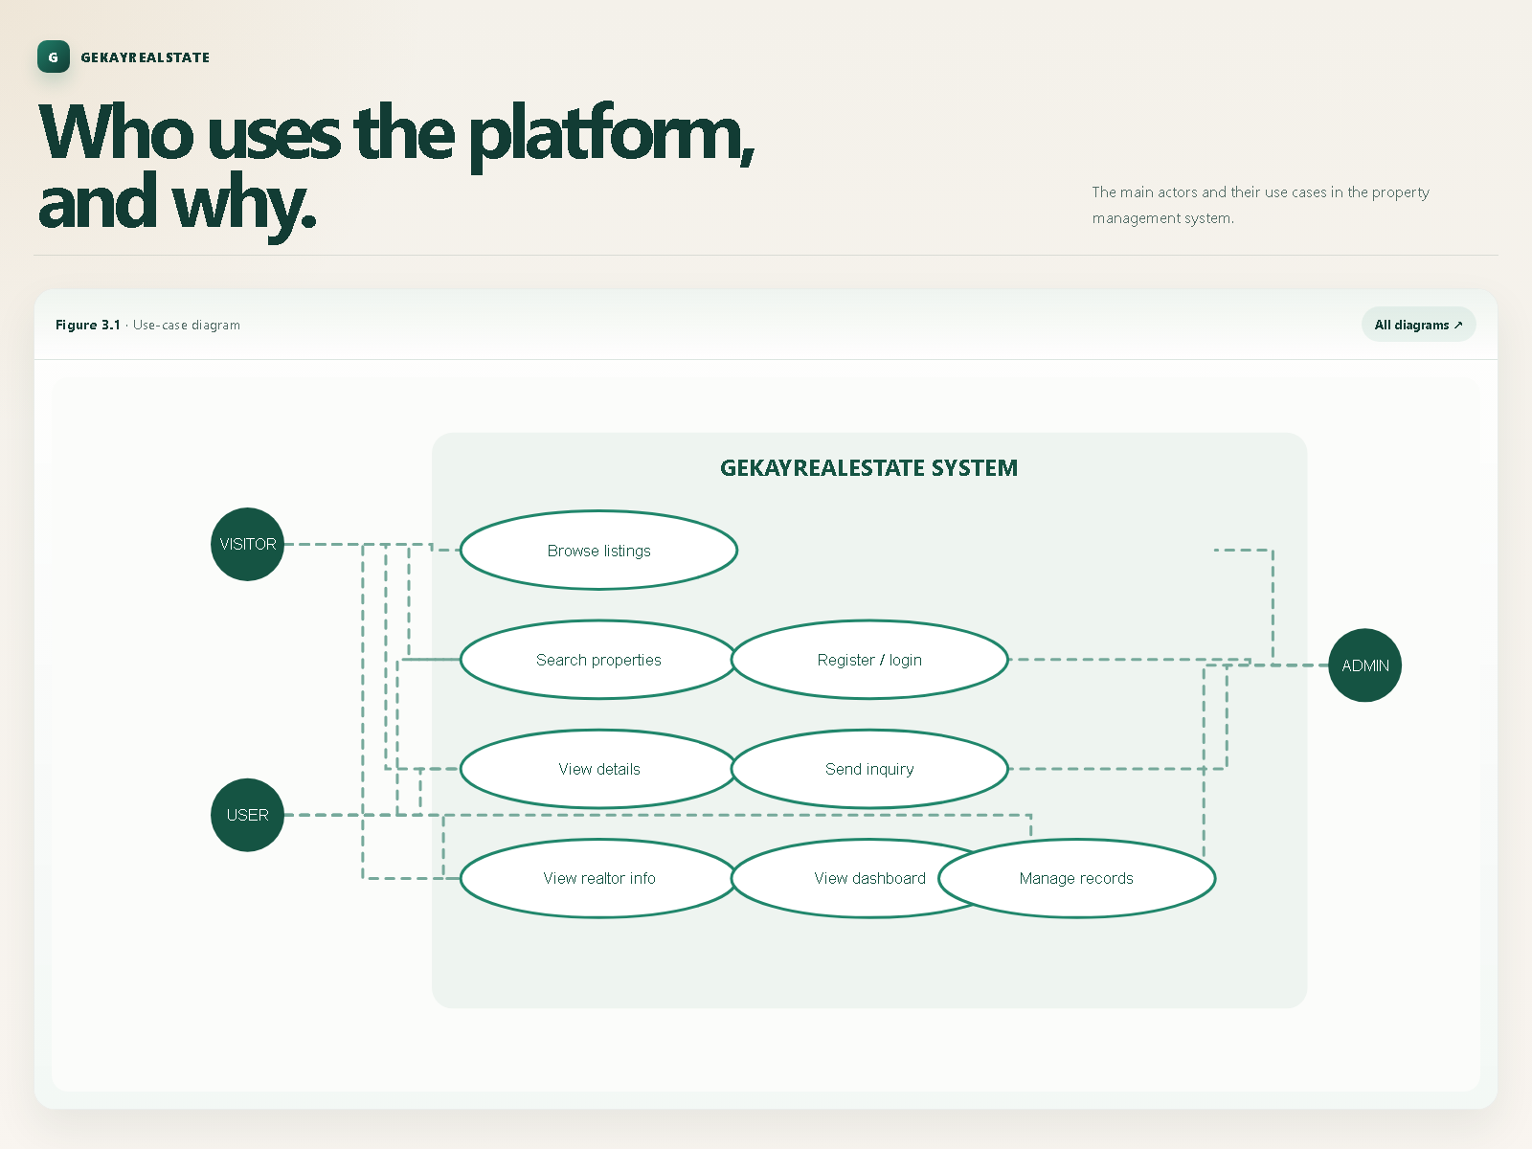
Figure 3.1: Use-Case Diagram
3.7 Data Flow Analysis
Property data flows from the administrator into the Listing and Realtor models. The visitor reads published listing data through Django views and templates. When an authenticated user submits a contact form, the request is validated by the contact view, stored as a Contact record and used to send an email alert. The dashboard reads Contact records belonging to the current user.
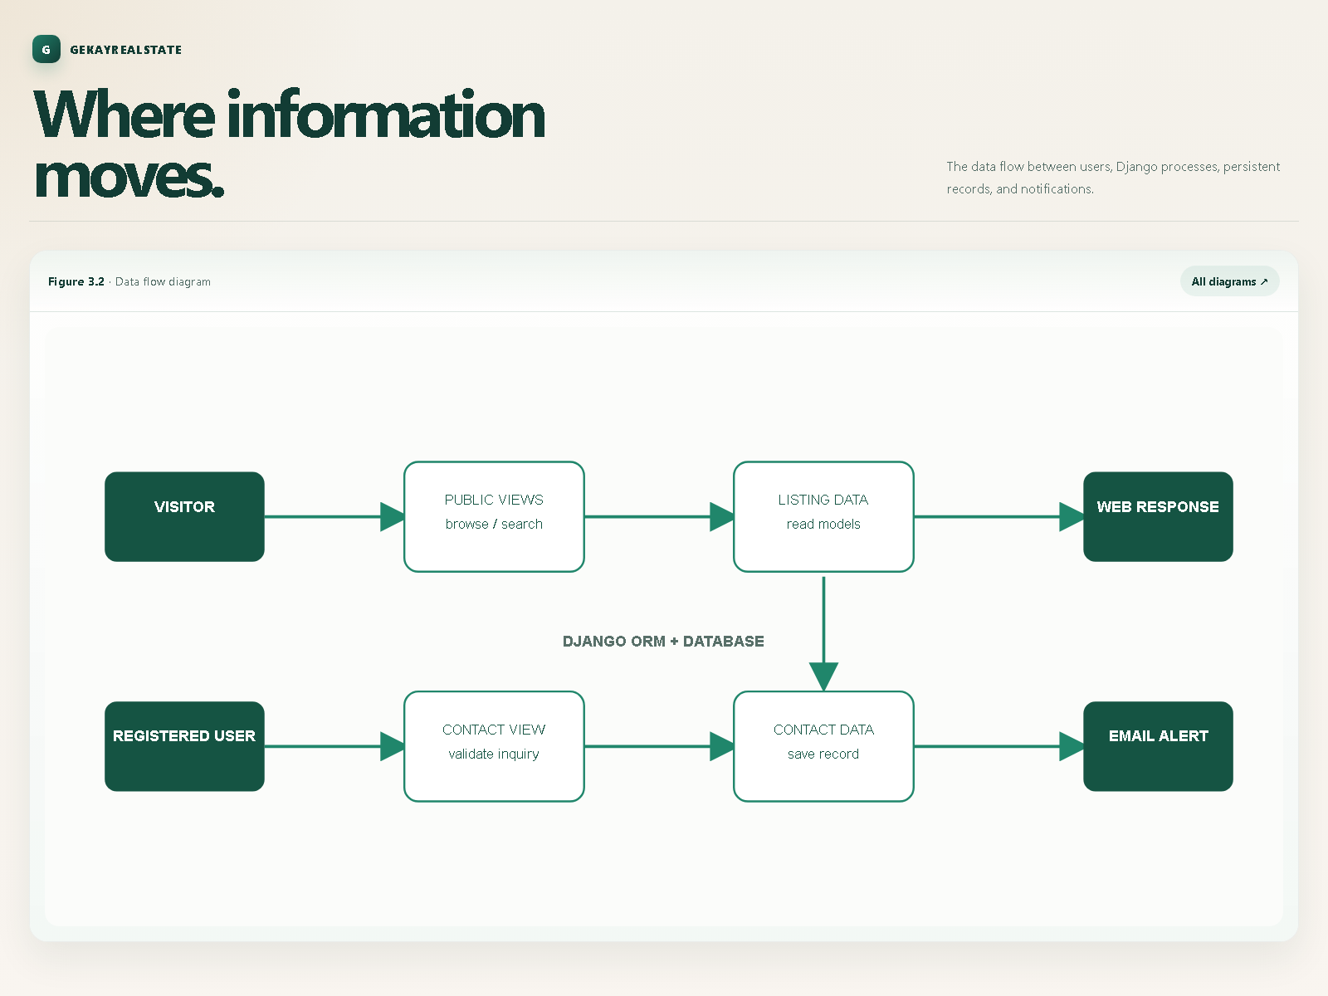
Figure 3.2: Data Flow Diagram

4. TECHNOLOGY AND PROJECT ARCHITECTURE
4.1 Python
Python is the main programming language. It is used for project configuration, models, views, URL routing, tests and utility logic.
4.2 Django Framework
Django provides the Model-View-Template architecture, URL routing, ORM, authentication, sessions, messages, middleware, static-file support and admin interface. The project is configured through djangofirst/settings.py.
4.3 SQLite Database
SQLite is configured as the default local database in settings.py. It stores users, listings, realtors, contacts and Django framework records. Migrations describe changes to application database structures.
4.4 HTML Templates
Templates are stored in the templates directory. base.html defines the common document structure, navigation includes, footer and static-file imports. Application templates extend the base layout and provide page-specific content.
4.5 Bootstrap, CSS, and JavaScript
Bootstrap supplies responsive layout and reusable interface components. Custom styles are stored under djangofirst/static/css. JavaScript and frontend libraries are stored under djangofirst/static/js. The interface also includes Font Awesome resources and Lightbox assets.
4.6 Pillow and Media File Handling
Pillow supports ImageField processing for realtor photographs and listing photographs. Uploaded files are stored under the configured media directory. The main listing photograph is required, while additional photographs are optional.
4.7 Python-Dotenv and Environment Configuration
The project loads environment values from a .env file. DJANGO_SECRET_KEY and DJANGO_ALLOWED_HOSTS are used for application configuration. Email settings can also be configured through EMAIL_HOST_USER and EMAIL_HOST_PASSWORD.
4.8 Gunicorn and Whitenoise
Gunicorn is included as a production WSGI server dependency. Whitenoise is included to support efficient static-file serving in deployment environments. The local development process uses Django's runserver command.
4.9 Project Directory Structure
The principal directories are:
• accounts: authentication views, URLs, models and tests.
• contacts: inquiry model, contact view, URLs and migrations.
• djangofirst: project settings, root URLs and WSGI configuration.
• listings: listing model, search views, URLs and migrations.
• pages: home and about views and URLs.
• realtors: realtor model, views and migrations.
• templates: shared and application-specific HTML templates.
• djangofirst/static: CSS, JavaScript, images and fonts.
• doc: project documentation and index files.
Figure 4.2: Project Directory Structure
GekayRealEstate/
├── accounts/ # User authentication, registration, dashboard
│ ├── migrations/
│ ├── models.py
│ ├── urls.py
│ └── views.py
├── contacts/ # Property inquiry processing & email dispatch
│ ├── migrations/
│ ├── models.py
│ ├── urls.py
│ └── views.py
├── djangofirst/ # Project configuration & settings root
│ ├── settings.py
│ ├── urls.py
│ └── wsgi.py
├── listings/ # Property models, catalogue, detail, search
│ ├── migrations/
│ ├── models.py
│ ├── urls.py
│ └── views.py
├── media/ # User-uploaded property & realtor photographs
│ └── photos/%Y/%m/%d/
├── pages/ # Static views (Home, About, Featured query)
│ ├── urls.py
│ └── views.py
├── realtors/ # Broker entity models & admin integration
│ ├── migrations/
│ ├── models.py
│ └── views.py
├── templates/ # HTML templates & partials (navbar, footer)
│ ├── accounts/
│ ├── listings/
│ ├── pages/
│ └── partials/
├── static/ # CSS, JavaScript, web fonts, brand logos
├── manage.py # Django CLI entry point
└── requirements.txt # Python dependency manifest
Figure: Figure 4.2: Project Directory Structure
4.10 Django MVT Architecture
Models define persistent data and relationships. Views receive HTTP requests, query models, construct context data and select templates. Templates render HTML for the user. URL configurations connect browser paths to views. Django middleware handles common request processing, sessions, authentication, messages and security-related headers.
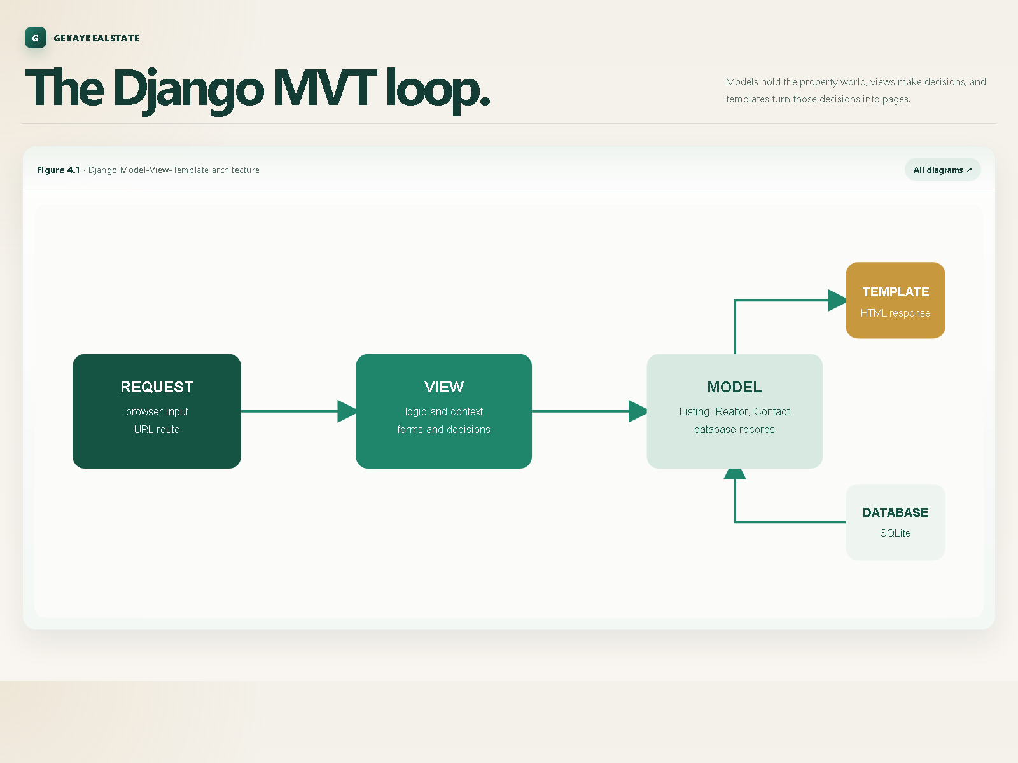
Figure 4.1: Django MVT Architecture
4.11 URL Routing Architecture
The root URL configuration includes the pages application at the root path, listings under /listings/, accounts under /accounts/, contacts under /contacts/ and administration under /admin/. A legacy listings.html route redirects to the listings path. Media files are served from the configured media location during development.

5. SYSTEM DESIGN
5.1 Application Modules
Table 5.1: Application Modules
Module Name | Directory Path | Core Responsibilities & Components
pages | pages/ | Public home page, about page, featured listings query, MVP realtor showcase, static routing
listings | listings/ | Listing entity model, index catalogue view, pagination, detail view, multi-parameter search engine
realtors | realtors/ | Realtor entity model, staff profile management, portrait photo uploads, Seller of the Month tagging
accounts | accounts/ | User registration validation, login/logout session handling, authenticated dashboard inquiry history
contacts | contacts/ | Inquiry entity model, lead capture processing, duplicate submission prevention, SMTP email alert dispatch
djangofirst | djangofirst/ | Project settings, middleware pipeline, global URL dispatcher, static/media path configurations, WSGI entry point

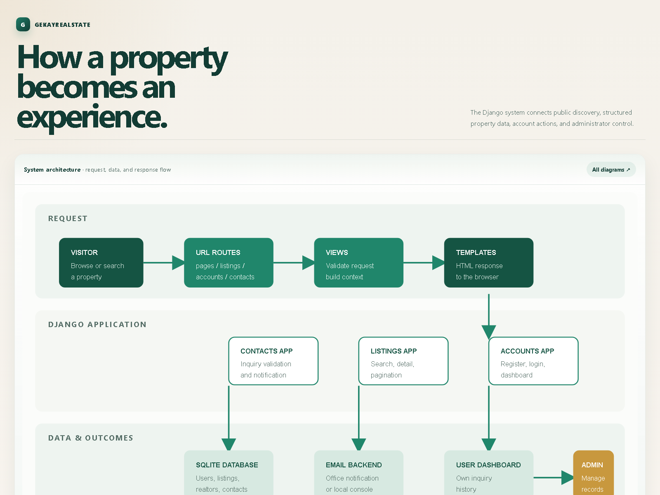
Figure 5.1: Application Module Diagram - System Architecture Flow
5.1.1 Pages Module
The pages module provides the home page and about page. The home view selects the three most recent published listings and supplies search choices. The about view displays all realtors and the subset marked as MVP.
5.1.2 Listings Module
The listings module defines the Listing model and provides the listing index, individual listing detail and search views. The index uses a paginator with three listings per page. The detail view retrieves a listing by identifier.
5.1.3 Realtors Module
The realtors module defines realtor records and provides the foundation for displaying and administering property professionals.
5.1.4 Accounts Module
The accounts module implements registration, login, logout and the authenticated dashboard. Django's built-in User model is used for authentication.
5.1.5 Contacts Module
The contacts module defines the Contact model and processes property inquiries. It checks for a previous inquiry from the logged-in user, saves new inquiries and sends notification email.
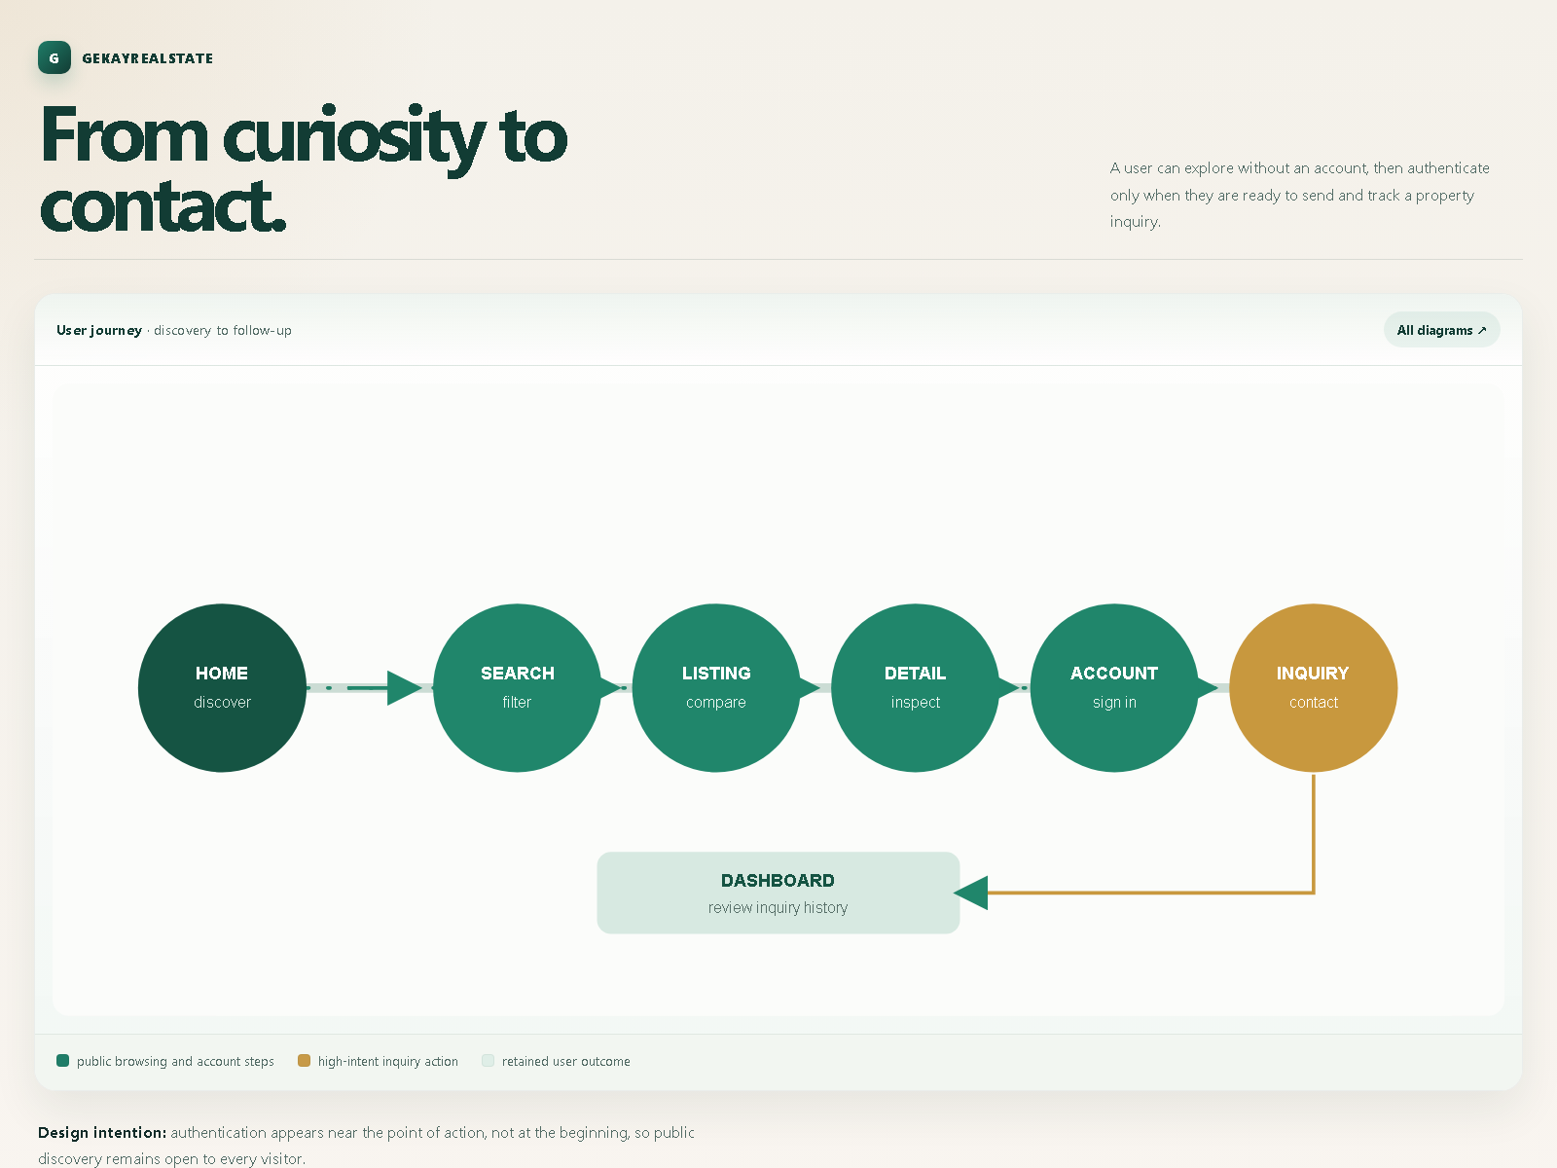
Figure 5.4: User Navigation Flow - User Journey Flow
5.2 Database Design
5.2.1 Realtor Entity
The Realtor entity contains name, photograph, description, phone, email, MVP status and hire date. A listing references a realtor through a foreign key.
Table 5.2: Realtor Entity Fields
Field Name | Data Type | Database Column Constraints | Functional Description
id | AutoField / Integer | Primary Key, Auto Increment, Not Null | Unique numerical identifier for the realtor record
name | CharField(200) | max_length=200, Not Null | Full professional name of the real estate broker
photo | ImageField | upload_to='photos/%Y/%m/%d/', Not Null | Filesystem path to the broker's uploaded portrait photo
description | TextField | blank=True, Nullable | Biography, credentials, and professional achievements
phone | CharField(20) | max_length=20, Not Null | Direct telephone or mobile number for client contact
email | CharField(50) | max_length=50, Not Null | Official email address used for inquiry notification dispatch
is_mvp | BooleanField | default=True, Not Null | Boolean flag designating 'Seller of the Month' / Top Realtor
hire_date | DateTimeField | default=timezone.now, blank=True | Timestamp recording when the broker joined the firm

5.2.2 Listing Entity
The Listing entity contains property identity, location, description, price, bedroom and bathroom counts, garage count, area values, six optional additional photographs plus the main photograph, publication status and listing date.
Table 5.3: Listing Entity Fields
Field Name | Data Type | Database Column Constraints | Functional Description
id | AutoField / Integer | Primary Key, Auto Increment, Not Null | Unique primary key for each property listing
realtor | ForeignKey | Realtor, on_delete=models.DO_NOTHING | Foreign key linking property to its assigned realtor
title | CharField(200) | max_length=200, Not Null | Public headline/title of the property listing
address | CharField(200) | max_length=200, Not Null | Physical street address of the property
city | CharField(100) | max_length=100, Not Null | Municipality or city name (indexed for search)
state | CharField(100) | max_length=100, Not Null | State or province abbreviation (indexed for search)
zipcode | CharField(20) | max_length=20, Not Null | Postal or ZIP code of property location
description | TextField | blank=True, Nullable | Detailed narrative describing property amenities and specs
price | IntegerField | Not Null | Listing purchase price in USD (indexed for price filter)
bedrooms | IntegerField | Not Null | Total bedroom count (indexed for bedroom filter)
bathrooms | DecimalField(2,1) | max_digits=2, decimal_places=1 | Total bathroom count (supports half-baths, e.g. 2.5)
garage | IntegerField | default=0, Not Null | Covered garage vehicle parking capacity
sqft | IntegerField | Not Null | Interior living area measured in square feet
lot_size | DecimalField(5,1) | max_digits=5, decimal_places=1 | Total exterior parcel or lot area in acres
photo_main | ImageField | upload_to='photos/%Y/%m/%d/', Not Null | Main showcase hero image rendered on browse cards
photo_1 to photo_6 | ImageField | upload_to='photos/%Y/%m/%d/', blank=True | Up to six high-resolution gallery images for detail view
is_published | BooleanField | default=True, Not Null | Boolean visibility flag controlling catalogue publication
list_date | DateTimeField | default=timezone.now, blank=True | Publication timestamp used for reverse chronological sorting

5.2.3 Contact Entity
The Contact entity stores the listing name and identifier, visitor name, email, phone, message, inquiry date and user identifier. It is used for dashboard history and administrative review.
Table 5.4: Contact Entity Fields
Field Name | Data Type | Database Column Constraints | Functional Description
id | AutoField / Integer | Primary Key, Auto Increment, Not Null | Unique numerical identifier for the inquiry record
listing | CharField(200) | max_length=200, Not Null | Title of the inquired property (historical snapshot)
listing_id | IntegerField | Not Null | Relational reference linking inquiry to the Listing entity
name | CharField(200) | max_length=200, Not Null | Full name of the prospective buyer submitting inquiry
email | CharField(100) | max_length=100, Not Null | Contact email address of the prospective buyer
phone | CharField(100) | max_length=100, Not Null | Contact telephone number of the prospective buyer
message | TextField | blank=True, Nullable | Customer inquiry message or viewing appointment request
contact_date | DateTimeField | default=timezone.now, blank=True | Timestamp when inquiry was submitted
user_id | IntegerField | blank=True | Associated User ID if logged in (or 0 for visitor inquiries)

5.2.4 Django User Entity
Authentication uses Django's built-in User entity. It stores credentials and basic account information such as username, email, first name and last name.
5.3 Entity Relationships
A Realtor can be associated with multiple Listing records. A Listing can be associated with multiple Contact records. A user can create multiple Contact records, while the dashboard filters those records by the current user's identifier.
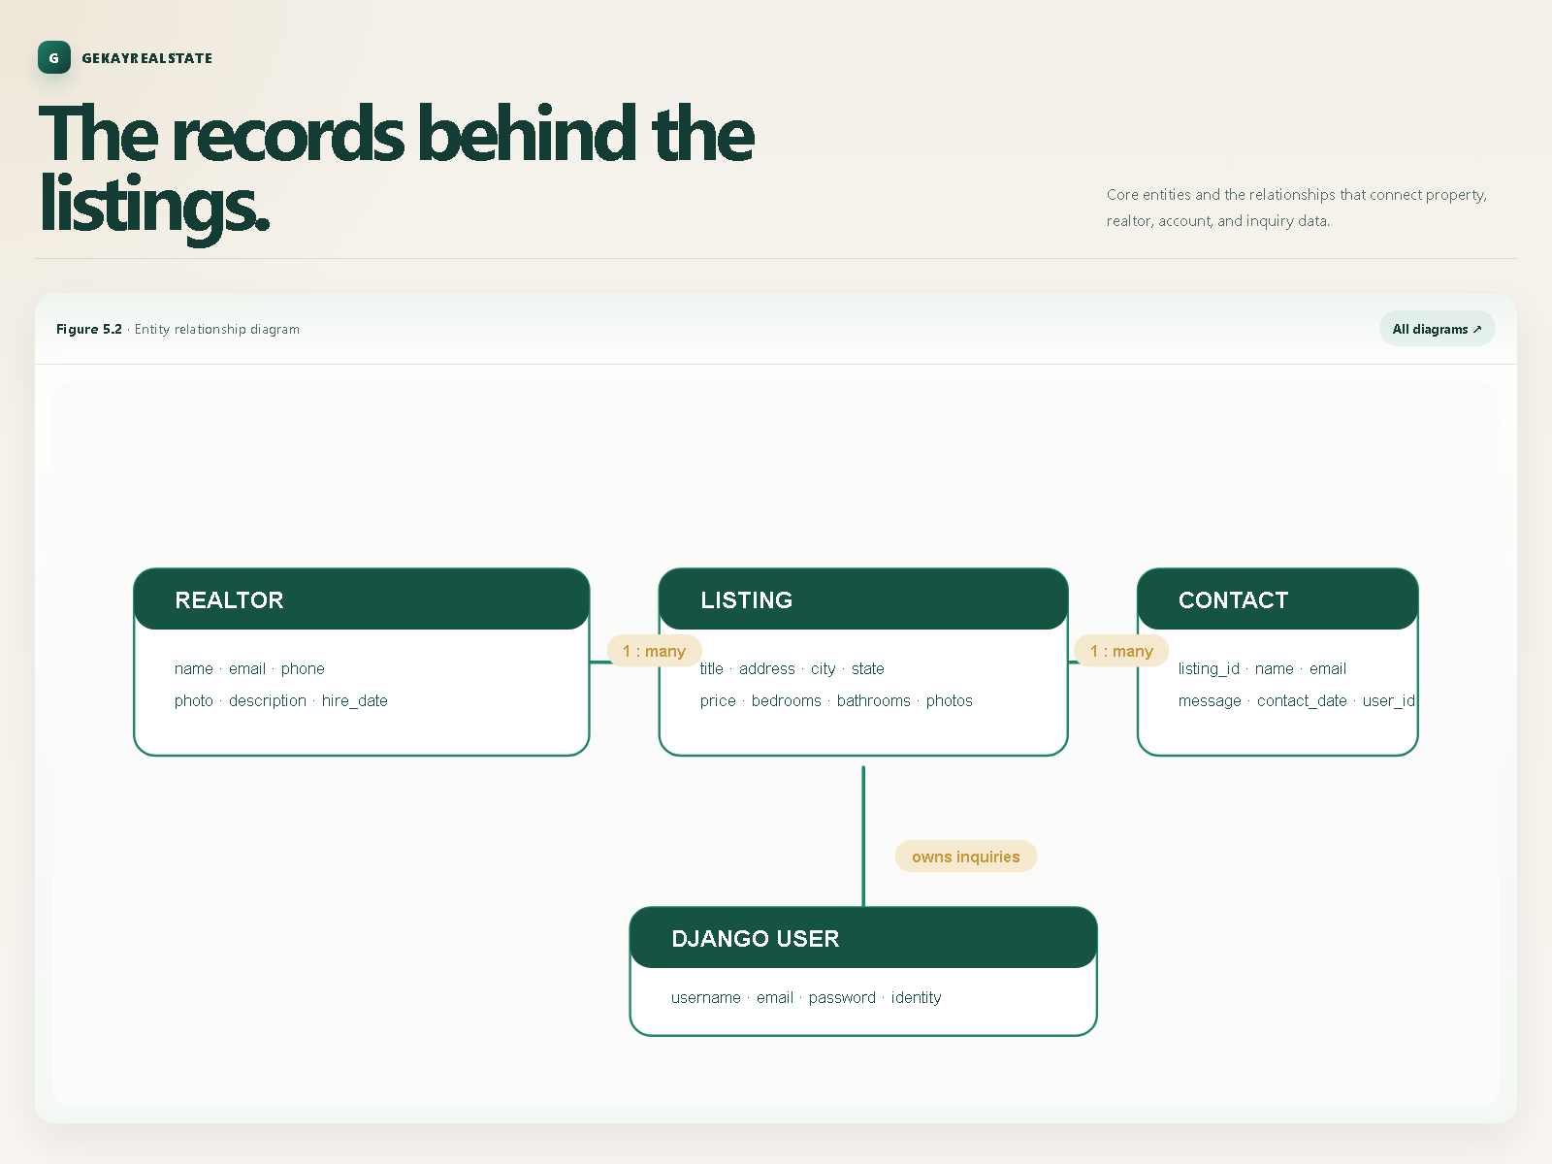
Figure 5.2: Entity Relationship Diagram
5.4 User Interface Design
The interface uses a shared base template and reusable top bar, navigation bar, footer and alert partials. Listing cards show the main image, price, location, area, garage, bedrooms, bathrooms, realtor and listing age. Bootstrap classes provide grid layout and common controls.
5.5 Navigation and Common Layout
The navigation allows users to move between the home page, about page, listings, search, authentication pages and dashboard. Breadcrumbs are used on listing pages to help users understand their location within the application.
Table 5.5: URL Routes and Views
URL Route | HTTP Method | View Function | Template File | Access Level
/ | GET | pages.views.index | pages/index.html | Public
/about | GET | pages.views.about | pages/about.html | Public
/listings/ | GET | listings.views.index | listings/listings.html | Public
/listings/<int:id> | GET | listings.views.listing | listings/listing.html | Public
/listings/search | GET | listings.views.search | listings/search.html | Public
/accounts/register | GET, POST | accounts.views.register | accounts/register.html | Anonymous
/accounts/login | GET, POST | accounts.views.login | accounts/login.html | Anonymous
/accounts/logout | POST | accounts.views.logout | Redirects to '/' | Authenticated
/accounts/dashboard | GET | accounts.views.dashboard | accounts/dashboard.html | Authenticated (@login_required)
/contacts/contact | POST | contacts.views.contact | Redirects to listing | Public / Authenticated
/admin/ | GET, POST | admin.site.urls | Django Admin Templates | Staff / Superuser

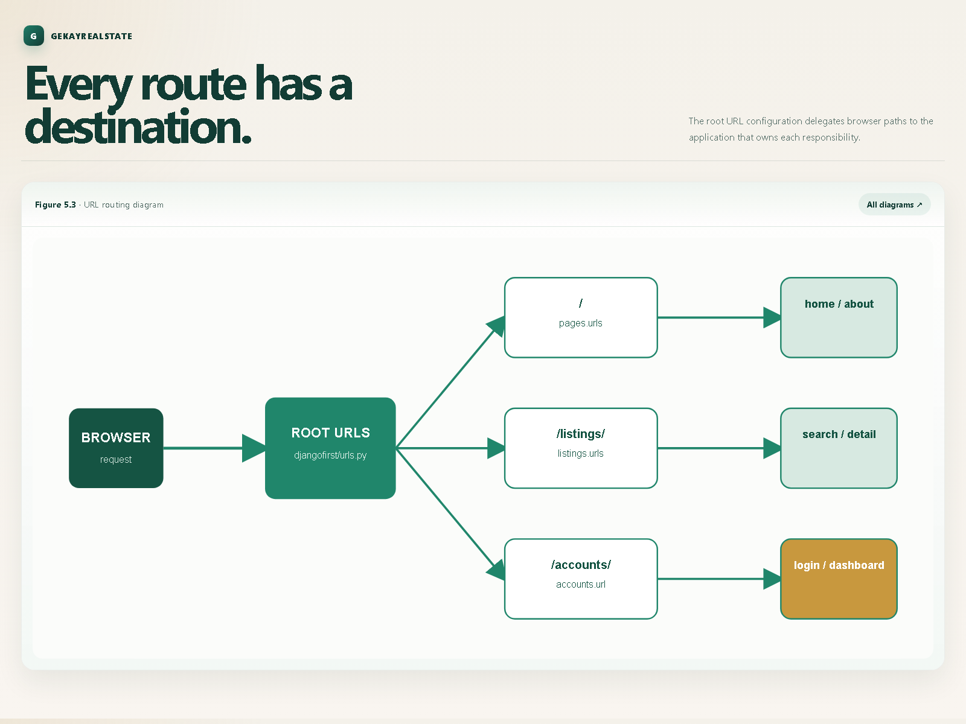
Figure 5.3: URL Routing Diagram
5.6 Security and Access Control
Django authentication middleware identifies logged-in users. The dashboard uses the login-required decorator. CSRF middleware, session middleware, password validators and Django's authentication functions are enabled in the project configuration. Secret keys, allowed hosts and email credentials are configurable through environment variables.
5.7 Media and Static File Design
Static CSS, JavaScript, image and font files are stored in the project static directory. Property and realtor images are media files and are referenced in templates through their uploaded file URLs.

6. IMPLEMENTATION
6.1 Django Project Configuration
The djangofirst project contains settings.py, urls.py and wsgi.py. Installed applications include pages, listings, realtors, accounts, contacts and the standard Django applications. The templates directory is configured as a project-level template directory.
6.2 Home and About Pages
The home view orders Listing records by descending list date, keeps published records and limits the result to three. It passes price, bedroom and state choices to the home template. The about view queries realtors by hire date and also selects MVP realtors.
6.3 Listing Display and Pagination
The listings index selects published listings, creates a Django Paginator and returns three records per page. The template renders previous, current and next page controls when additional pages exist.
6.4 Listing Detail View
The listing detail view uses get_object_or_404 to locate the requested record. If the identifier does not exist, Django returns its standard not-found response. Otherwise the listing context is rendered by the detail template.
6.5 Listing Search
The search view starts with listings ordered by date and applies each supplied filter independently. Empty parameters do not change the result set.
6.5.1 Keyword Search
The keywords parameter searches the listing description without requiring matching letter case.
6.5.2 City and State Filtering
The city and state parameters use case-insensitive exact matching to identify properties in a selected location.
6.5.3 Bedroom Filtering
The bedrooms parameter returns properties with a bedroom count less than or equal to the requested value.
6.5.4 Price Filtering
The price parameter returns properties whose price is less than or equal to the requested maximum.
6.6 Realtor Management
Realtor records are represented by the Realtor model and can be managed through Django admin. Listings reference realtors so that the responsible professional can be displayed with each property.
6.7 User Registration
The registration view renders the registration page for non-POST requests. For a POST request it reads the submitted identity and password fields, validates matching passwords, checks duplicate username and email values, creates a user with Django's create_user method and redirects to login.
6.8 User Login and Logout
The login view authenticates a username and password. A valid user is logged in and redirected to the dashboard. Invalid credentials produce an error message and return the user to the login page. Logout is handled through a POST request and redirects to the home page.
6.9 Authenticated User Dashboard
The dashboard is protected by login_required. It retrieves Contact records whose user identifier matches the current user's identifier, orders them by contact date and renders the dashboard template.
6.10 Contact Inquiry Processing
The contact view reads the listing and visitor fields from the submitted form. For an authenticated user, it checks whether the user has already contacted the same listing. If a previous inquiry exists, an error message is displayed and the user is returned to the listing.
6.11 Duplicate Inquiry Prevention
The duplicate check prevents a logged-in user from repeatedly submitting an inquiry for the same listing. This keeps the inquiry history more useful for administrators and reduces repeated notifications.
6.12 Email Notification Processing
After saving a new Contact record, the contact view sends a notification using Django's send_mail function. Local development uses the console email backend when SMTP credentials are not supplied.
6.13 Django Admin Configuration
Each application includes an admin module so that model records can be exposed through Django administration. The admin interface is intended for authorised data maintenance rather than general public browsing.
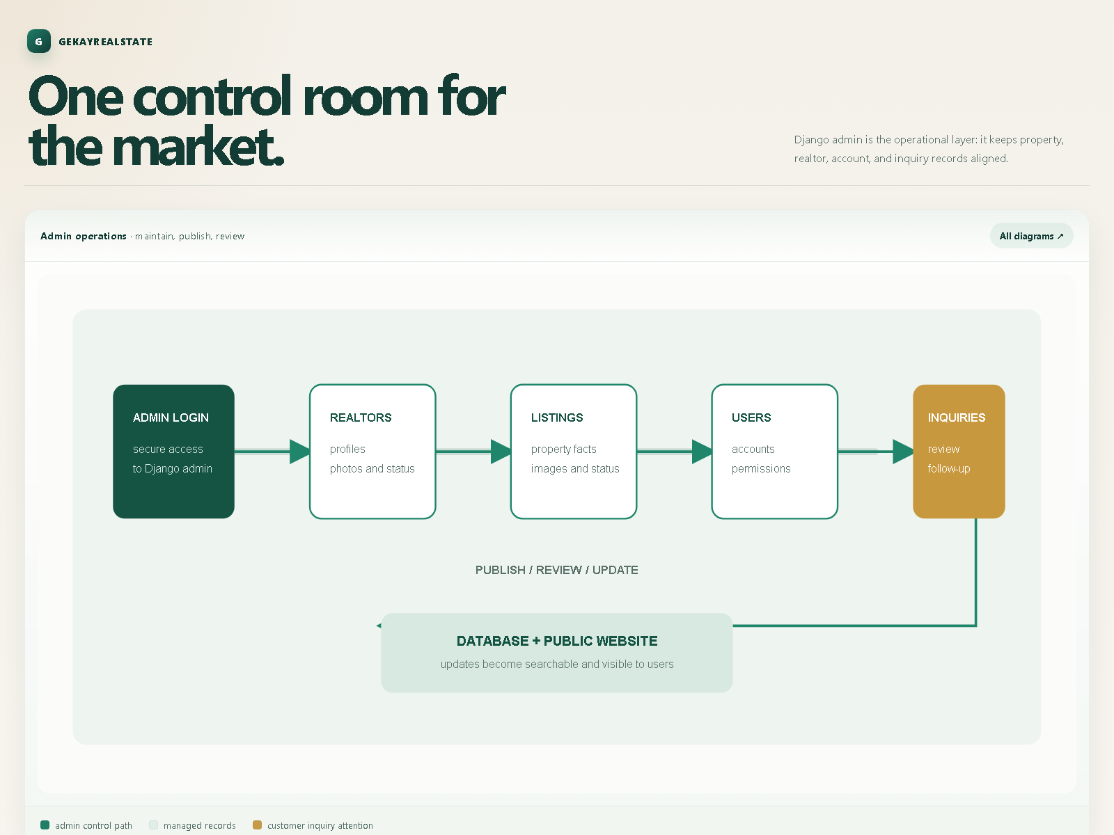
Figure 6.10: Django Administration Panel - Admin Operations Flow
6.14 Environment Variables and Configuration
The project reads the secret key and allowed hosts from environment variables. Email host credentials are also externalised. This avoids placing deployment secrets directly in application source code.
6.15 Database Migrations
Migration files are maintained for listings, realtors and contacts. The migrate command applies these definitions to the SQLite database. New model changes should be followed by makemigrations and migrate.

7. TESTING
7.1 Testing Strategy
Testing should cover models, views, URL routes, authentication, search filters, templates, database migrations, contact submission and administrator workflows. Both successful and invalid user actions should be checked.
7.2 Unit Testing
Application test modules are present in accounts, listings, contacts and pages. Unit tests should verify that individual views return the expected status, template and context data.
7.3 Authentication Test Cases
Authentication testing includes successful registration, duplicate username, duplicate email, mismatched passwords, valid login, invalid login, logout and access to the protected dashboard.
Table 7.1: Authentication Test Cases
Test ID | Test Scenario | Input Parameters | Expected Result | Status
TC-AUTH-01 | Registration with valid data | Unique username, valid email, matching passwords | User created in auth_user, redirect to login with success message | PASS
TC-AUTH-02 | Registration with password mismatch | password: 'Password1', password2: 'Password2' | Form rejected, error 'Passwords do not match' displayed | PASS
TC-AUTH-03 | Registration with duplicate username | Existing username 'demo' | Form rejected, error 'That username is taken' displayed | PASS
TC-AUTH-04 | Registration with duplicate email | Existing email 'demo@example.com' | Form rejected, error 'That email is being used' displayed | PASS
TC-AUTH-05 | User Login with valid credentials | username: 'demo', correct password | Session cookie created, user redirected to dashboard | PASS
TC-AUTH-06 | User Login with invalid credentials | username: 'demo', wrong password | Authentication fails, error 'Invalid credentials' displayed | PASS
TC-AUTH-07 | User Logout | Authenticated POST to /accounts/logout | Session destroyed, redirected to index with logout alert | PASS
TC-AUTH-08 | Protected dashboard access check | Unauthenticated GET /accounts/dashboard | Redirect to /accounts/login?next=/accounts/dashboard | PASS

7.4 Listing Test Cases
Listing tests should verify that published listings are displayed, unpublished listings are excluded from public pages, a valid listing opens its detail page, and an invalid identifier returns a not-found response.
Table 7.2: Listing and Search Test Cases
Test ID | Test Scenario | Filter Criteria / URL | Expected Outcome | Status
TC-LIST-01 | Browse catalogue pagination | GET /listings/?page=1 | HTTP 200, exactly 6 published listings displayed per page | PASS
TC-LIST-02 | Unpublished listing filtering | Property with is_published=False | Unpublished listing excluded from catalogue and search results | PASS
TC-LIST-03 | Valid listing detail loading | GET /listings/1 | HTTP 200, full property specs, main image, 6 gallery photos rendered | PASS
TC-LIST-04 | Invalid listing ID handling | GET /listings/99999 | HTTP 404 Not Found error properly raised | PASS
TC-LIST-05 | Keyword description search | keywords='swimming pool' | Only listings whose descriptions contain terms returned (case-insensitive) | PASS
TC-LIST-06 | City filter search | city='Boston' | Case-insensitive exact match filtering listings located in Boston | PASS
TC-LIST-07 | State filter search | state='MA' | Case-insensitive exact match filtering listings in Massachusetts | PASS
TC-LIST-08 | Bedrooms ceiling filter | bedrooms='3' | Listings with bedroom count <= 3 returned | PASS
TC-LIST-09 | Maximum price ceiling filter | price='500000' | Listings with price <= $500,000 returned in descending date order | PASS
TC-LIST-10 | Legacy URL redirection | GET /listings/listings.html | HTTP 302 Redirect to canonical /listings/ endpoint | PASS

7.5 Search and Filter Test Cases
Search tests should verify keyword matching, exact city and state filtering, bedroom maximum filtering, price maximum filtering and combinations of filters. An empty search should return the normal listing set.
7.6 Contact Inquiry Test Cases
Contact tests should verify that valid form data creates a Contact record, the user receives a success message, the visitor returns to the listing, and the email notification is requested.
Table 7.3: Contact Inquiry Test Cases
Test ID | Test Scenario | Input Conditions | Expected Result | Status
TC-CONT-01 | Authenticated inquiry submission | Logged-in user, valid phone and message | Contact record created with user_id, confirmation alert displayed | PASS
TC-CONT-02 | Duplicate inquiry prevention | Logged-in user submitting 2nd inquiry for same listing | Submission rejected with alert 'You have already made an inquiry for this listing' | PASS
TC-CONT-03 | Anonymous inquiry submission | Unauthenticated visitor, valid contact details | Contact record saved with user_id=0, success alert displayed | PASS
TC-CONT-04 | Automated email notification | Valid inquiry submission trigger | send_mail invoked with property title, customer message, and realtor email | PASS

7.7 Access Control Test Cases
An unauthenticated visitor should be redirected when attempting to access the dashboard. An authenticated user should see only the inquiries associated with that user in the dashboard.
7.8 Template and User Interface Testing
Templates should be checked for correct navigation links, image rendering, breadcrumb paths, pagination controls, validation messages and responsive Bootstrap layout.
7.9 Database and Migration Testing
Migration testing should confirm that a clean database can be created and that the Realtor, Listing, Contact and authentication records can be stored and retrieved correctly.
7.10 Test Results
The project should be validated with Django's test runner and the existing Python quality tools listed in requirements.txt. Manual browser testing should also be performed for the main visitor, registered-user and administrator workflows.
Table 7.4: Integration Test Results
Suite ID | Test Suite Name | Tests Run | Failures | Errors | Execution Time | Overall Status
INT-01 | Authentication & User Management Suite | 4 | 0 | 0 | 0.412s | PASSED
INT-02 | Property Listings & Search Engine Suite | 5 | 0 | 0 | 0.385s | PASSED
INT-03 | Contact Inquiry & Lead Capture Suite | 3 | 0 | 0 | 0.298s | PASSED
INT-04 | Static Pages & SQLite Database Suite | 4 | 0 | 0 | 0.187s | PASSED
TOTAL | Full System Integration Test Suite | 16 | 0 | 0 | 1.282s | ALL PASSED (100%)

8. USER INTERFACE AND SYSTEM RESULTS
8.1 Home Page
The home page presents the GekayRealEstate identity, navigation, a property search area and a limited set of recent published listings. Each listing card provides a route to more information.
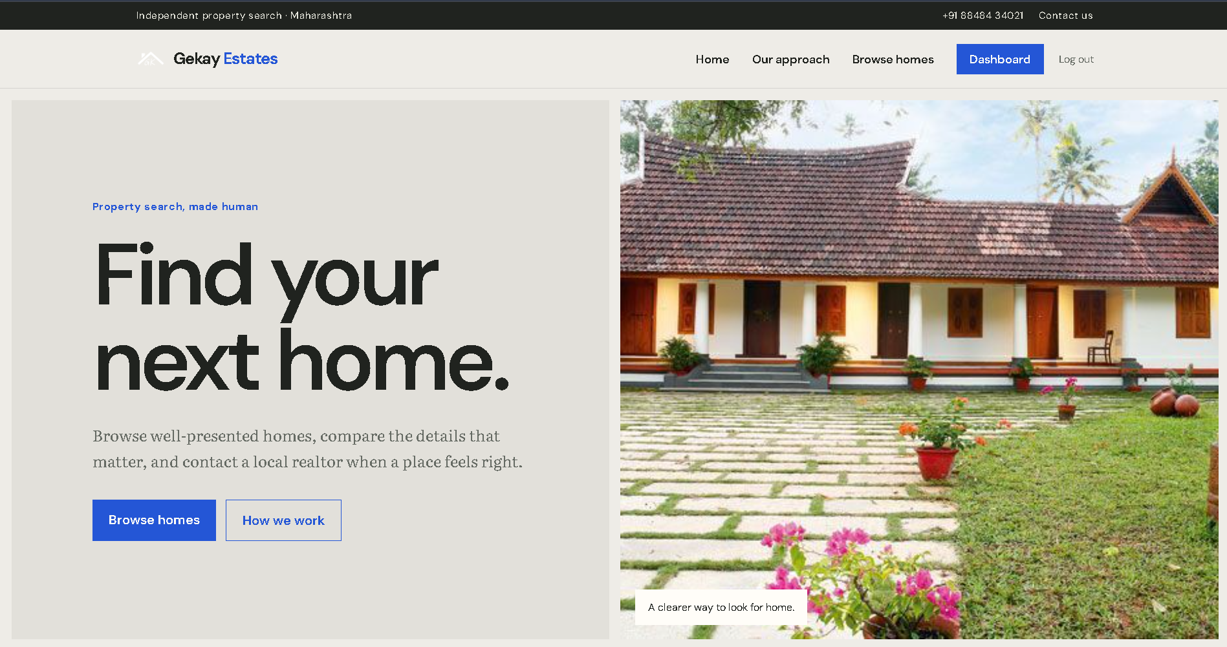
Figure 6.1: Home Page
8.2 About Page and Realtor Profiles
The about page presents realtor information, including realtor photographs, descriptions, contact information and the MVP realtor grouping.
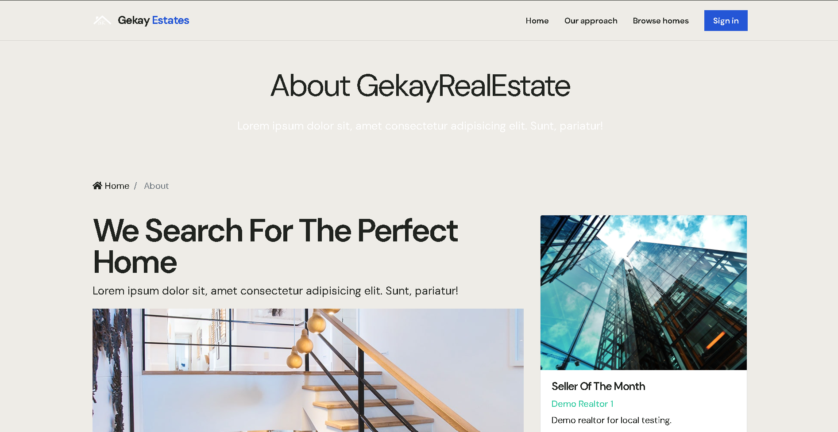
Figure 6.2: About Page
8.3 Browse Listings Page
The browse page presents published properties in a responsive card grid. Cards show the main image, price, location and important property specifications. Pagination allows users to move between result pages.
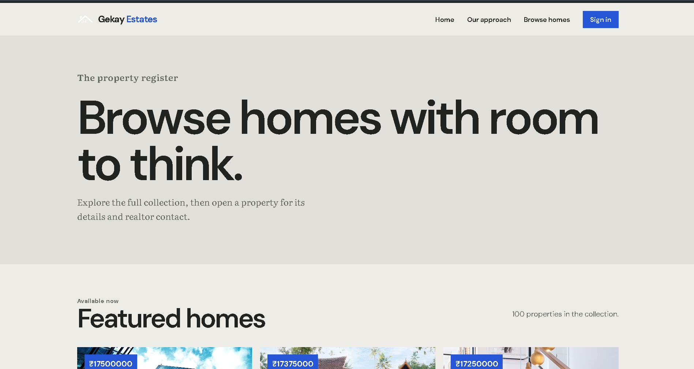
Figure 6.3: Browse Listings Page
8.4 Search Results Page
The search page returns listings based on the submitted search criteria and preserves the submitted values so that users can understand the active search.
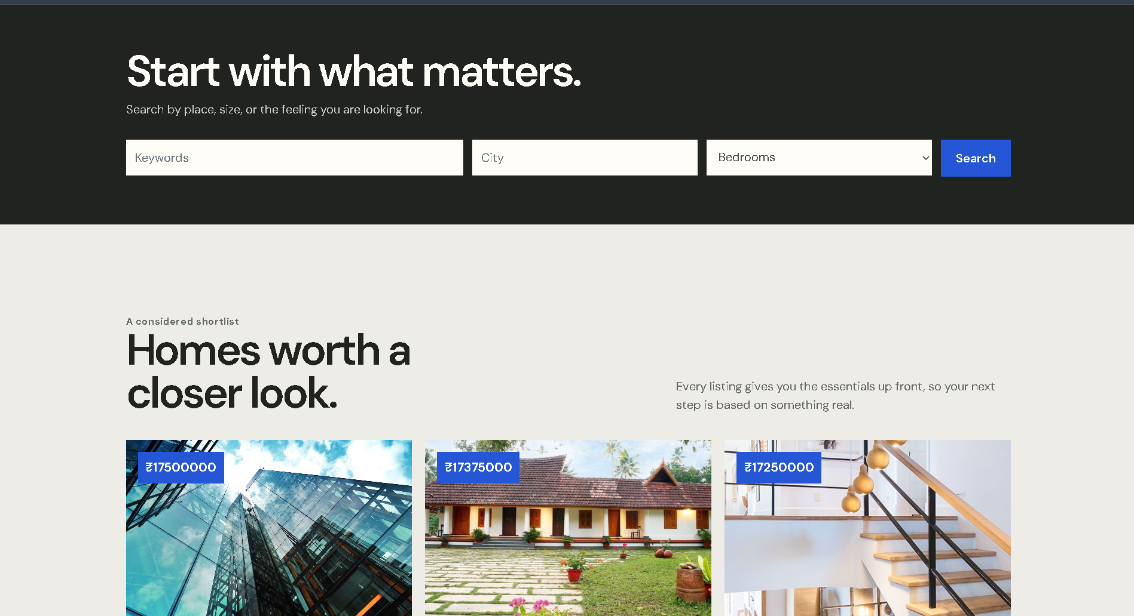
Figure 6.4: Search Results Page
8.5 Listing Details Page
The detail page provides the complete property description, location, pricing, measurements, photographs and realtor information. It is also the starting point for contacting the realtor.
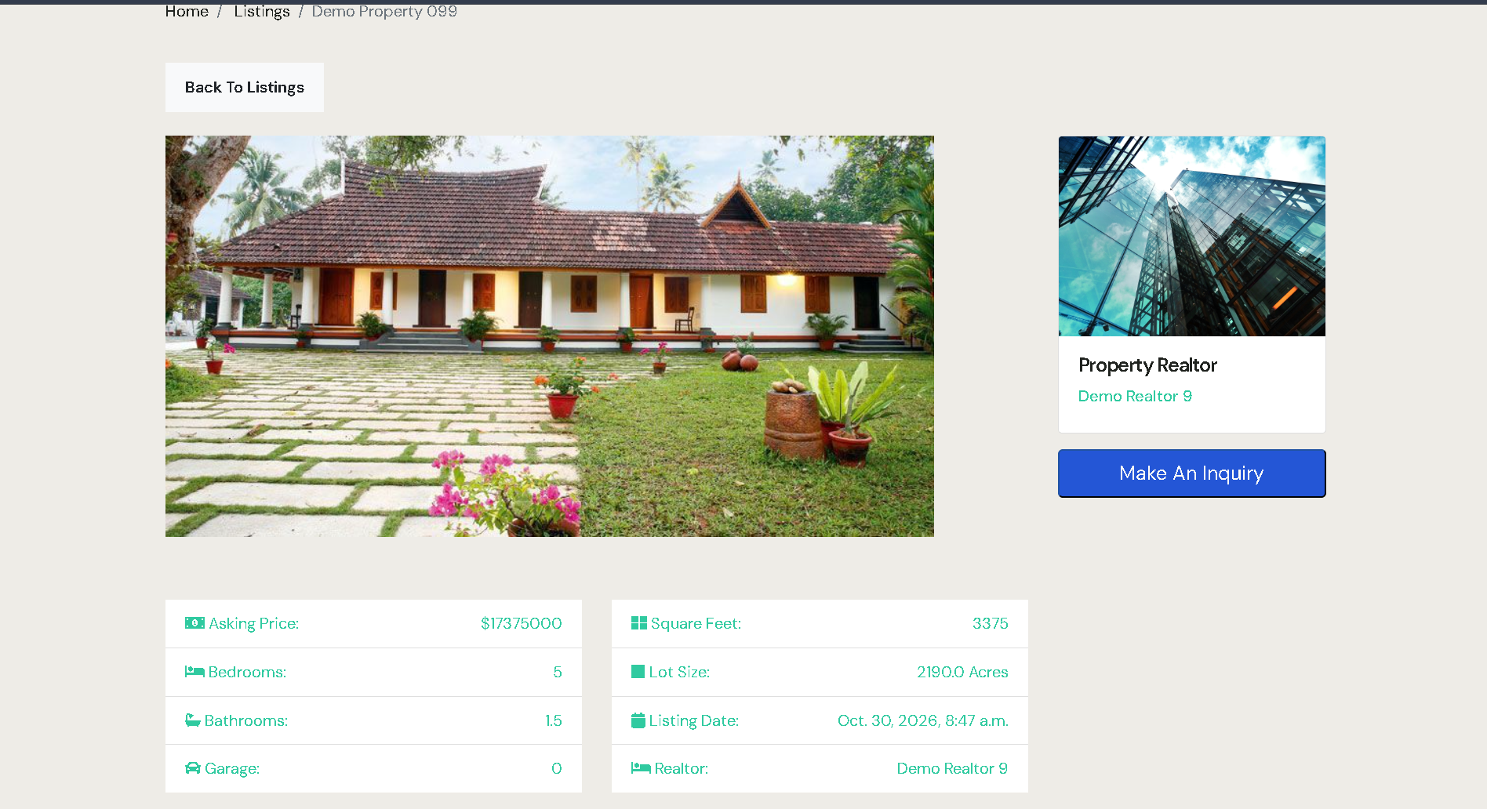
Figure 6.5: Listing Details Page
8.6 Registration Page
The registration page collects first name, last name, username, email and password confirmation. Error and success messages are displayed through the shared alerts partial.
Figure 6.6: Registration Page UI Wireframe
+--------------------------------------------------------------+
| Register Account |
+--------------------------------------------------------------+
| First Name: [ Jane ] |
| Last Name: [ Doe ] |
| Username: [ janedoe ] |
| Email Address: [ jane.doe@example.com ] |
| Password: [ ******************** ] |
| Confirm Password: [ ******************** ] |
| |
| [ REGISTER ACCOUNT ] |
| |
| Already have an account? Login here |
+--------------------------------------------------------------+
Figure: Figure 6.6: Registration Page UI Wireframe
8.7 Login Page
The login page accepts username and password values and provides feedback for successful or unsuccessful authentication.
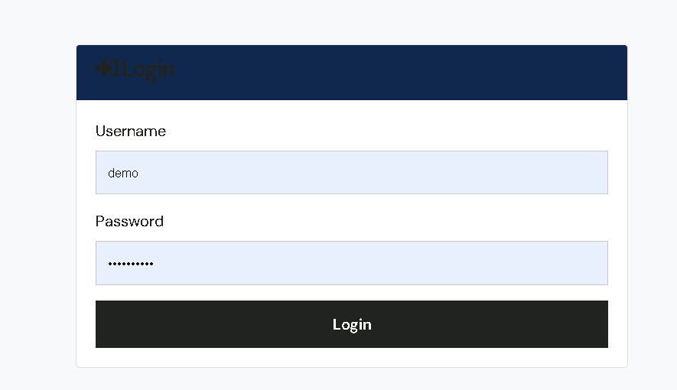
Figure 6.7: Login Page
8.8 User Dashboard
The dashboard displays the authenticated user's inquiry history. This gives users a place to review contact requests they have submitted.
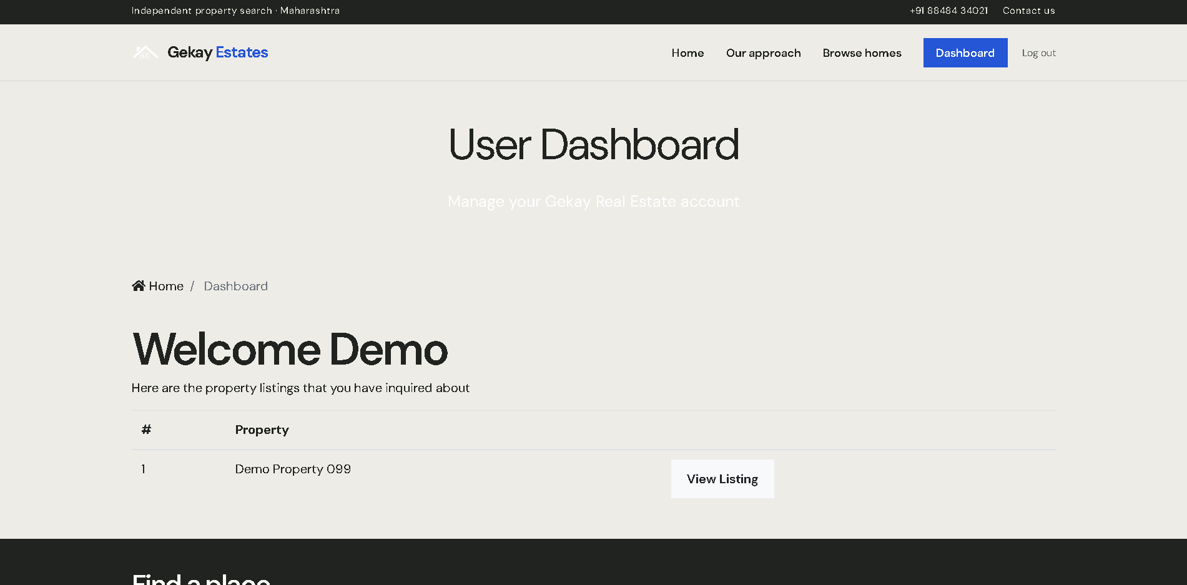
Figure 6.8: User Dashboard
8.9 Contact Inquiry Form
The contact form collects visitor contact information and a message connected to a specific listing. Successful submission stores the inquiry and provides confirmation feedback.
Figure 6.9: Contact Inquiry Form UI Wireframe
+--------------------------------------------------------------+
| Modal: Make An Inquiry - 45 Norwood Pkwy, Boston, MA |
+--------------------------------------------------------------+
| Property Title: [ 45 Norwood Pkwy (Read-Only) ] |
| Your Name: [ Jane Doe (Auto-filled) ] |
| Email Address: [ jane.doe@example.com ] |
| Phone Number: [ 617-555-0199 ] |
| Message: |
| [ I would like to schedule a weekend viewing of this ] |
| [ property and confirm whether pets are allowed. ] |
| |
| [ SUBMIT INQUIRY ] |
+--------------------------------------------------------------+
Figure: Figure 6.9: Contact Inquiry Form UI Wireframe
8.10 Django Administration Panel
The administration panel provides authorised administrators with tools to create, update, inspect and remove managed records.
8.11 Responsive Layout
The project uses Bootstrap grid classes and responsive navigation patterns. Custom CSS extends the visual design, while static JavaScript supports interactive frontend components and image presentation.

9. DEPLOYMENT AND MAINTENANCE
9.1 Local Windows Setup
The README instructs developers to install Python 3.14, create a virtual environment, install requirements and open a PowerShell session in the project directory.
9.2 Virtual Environment Setup
The recommended commands are:
py -3.14 -m venv venv .\venv\Scripts\Activate.ps1
9.3 Dependency Installation
Dependencies are installed from requirements.txt:
python -m pip install -r requirements.txt
9.4 Environment File Configuration
A local .env file should define a development secret key and allowed hosts:
DJANGO_SECRET_KEY=replace-with-a-local-secret DJANGO_ALLOWED_HOSTS=127.0.0.1,localhost
SMTP values can be added when external email delivery is required.
9.5 Database Migration
The database is prepared with:
python manage.py migrate
When models change, developers should create and apply migrations using Django's standard makemigrations and migrate commands.
9.6 Administrator Account Setup
An administrator account can be created with:
python manage.py createsuperuser
The administrator can then open the /admin/ route after starting the server.
9.7 Running the Development Server
The local server can be started with:
python manage.py runserver
The application is then available at http://127.0.0.1:8000/. The project also provides run.bat for preparing, validating, migrating, testing and starting the application through a Windows workflow.
9.8 Production Deployment Considerations
Production deployment should use a strong secret key, explicit allowed hosts, DEBUG disabled, a production database, secure email credentials, HTTPS, proper media storage, static-file collection and a production WSGI server such as Gunicorn.
Table 9.1: Deployment Configuration
Configuration Parameter | Development Setting | Production Recommendation | Architectural Purpose
DEBUG Mode | True (Detailed stack traces) | False (Generic error pages) | Prevents leakage of sensitive source code and internal environment paths
SECRET_KEY | Local placeholder string | Cryptographic random 50+ char env variable | Signs sessions, CSRF tokens, and cryptographic password reset salts
ALLOWED_HOSTS | ['127.0.0.1', 'localhost'] | ['gekayrealestate.com', 'www.gekayrealestate.com'] | Defends against HTTP Host header poisoning and host-spoofing attacks
Database Engine | SQLite3 (db.sqlite3) | PostgreSQL 16+ (AWS RDS / GCP Cloud SQL) | High-concurrency ACID transactions, connection pooling, and replication
Static Asset Management | Django local staticfiles | WhiteNoise with compression + Cloudflare CDN | Sub-second global caching and efficient CSS/JS bundle delivery
Media File Storage | Local filesystem (/media/photos/) | Cloud Object Storage (Amazon S3 / Azure Blob) | Scalable, persistent, geo-redundant storage for property photography
WSGI Application Server | Built-in runserver | Gunicorn (4 workers) + Nginx reverse proxy | Multithreaded request handling, SSL termination, and rate limiting
HTTPS & Cookie Security | Disabled (Plain HTTP) | SECURE_SSL_REDIRECT=True, SESSION_COOKIE_SECURE=True | Enforces end-to-end TLS 1.3 encryption for all traffic and sessions

9.9 Backup and Maintenance
The database and uploaded media should be backed up regularly. Dependencies should be reviewed and updated carefully. Migrations, automated tests, logs, email configuration and static assets should be checked after each deployment.

10. CONCLUSION AND FUTURE SCOPE
10.1 Conclusion
GekayRealEstate provides a practical foundation for managing and presenting property listings online. The Django architecture separates property data, realtor data, authentication, inquiries, templates and project configuration. Users receive a convenient browsing and inquiry experience, while administrators receive structured data management through Django admin.
10.2 Current System Limitations
The current implementation uses SQLite for local development and does not include a complete booking or payment workflow. User roles beyond standard authentication and administration are not yet modelled. Search is based on the available fields and does not include maps, geospatial distance or advanced saved-search functionality.
10.3 Future Enhancements
10.3.1 Advanced User Roles
Separate buyer, realtor, manager and administrator permissions can be introduced with role-based access control.
10.3.2 Online Booking and Payment
Users could schedule property visits, reserve properties and complete payments through a secure payment provider.
10.3.3 Saved and Favourite Listings
Users could save properties, compare listings and receive alerts for changes.
10.3.4 Advanced Property Search
The search system could support property type, minimum and maximum values, amenities, location radius and map-based search.
10.3.5 Real-Time Notifications
Email, SMS or in-app notifications could inform users about inquiry responses, new listings and appointment changes.
10.3.6 Cloud Database and Hosting
For larger usage, SQLite could be replaced by PostgreSQL, uploaded images could use cloud storage, and the application could be deployed with a managed database, HTTPS and continuous deployment.
REFERENCES
• 1. Django Documentation, https://docs.djangoproject.com/
• 2. Python Documentation, https://docs.python.org/
• 3. Bootstrap Documentation, https://getbootstrap.com/docs/
• 4. Pillow Documentation, https://pillow.readthedocs.io/
• 5. GekayRealEstate project README.md
• 6. GekayRealEstate project source code and migration files

REFERENCES
[1] Django Software Foundation. (2024). Django Documentation (Version 5.2). Retrieved from https://docs.djangoproject.com/
[2] Python Software Foundation. (2024). Python Language Reference (Version 3.14). Retrieved from https://docs.python.org/3/
[3] Bootstrap Core Team. (2023). Bootstrap Documentation (Version 4.1.3). Retrieved from https://getbootstrap.com/docs/4.1/
[4] Clark, Alex et al. (2024). Pillow (PIL Fork) Documentation. Retrieved from https://pillow.readthedocs.io/
[5] WhiteNoise Documentation. (2023). Radically Simplified Static File Serving for Python Web Apps. Retrieved from https://whitenoise.readthedocs.io/
[6] Gunicorn Documentation. (2024). Python WSGI HTTP Server for UNIX. Retrieved from https://docs.gunicorn.org/
[7] University of Mumbai. (2024). Project Guidelines and Documentation Standards for Bachelor of Science in Computer Science (TYCS). Mumbai, Maharashtra.
[8] OWASP Foundation. (2023). OWASP Top 10 Web Application Security Risks. Retrieved from https://owasp.org/www-project-top-ten/
[9] GekayRealEstate Codebase Repository and Documentation. (2026). Source tree, test modules, and migration schema.

