GekayRealEstate
A Project Report
Submitted in partial fulfillment of the
Requirements for the award of the Degree of
BACHELOR OF SCIENCE (COMPUTER SCIENCE)
By
Manish
Class: T.Y.B.Sc. (Computer Science) - TYCS
2026012040(510515147)
Under the esteemed guidance of
Asst. Prof. Saba Ansari
Head of Department

DEPARTMENT OF COMPUTER TECHNOLOGY
J. K. COLLEGE OF SCIENCE AND COMMERCE (AUTONOMOUS)
Affiliated to University of Mumbai
NAVI MUMBAI, 400701
MAHARASHTRA
2026-27

GekayRealEstate

Real-Estate Management System
Project documentation
Prepared from sample_doc.pdf, the project source tree, and the diagrams in
doc/img/.

Contents
• 1. Introduction
• 2. System Study
• 3. Requirements and Analysis
• 4. Technology and Project Architecture
• 5. System Design
• 6. Implementation
• 7. Testing
• 8. User Interface and System Results
• 9. Deployment and Maintenance
• 10. Conclusion and Future Scope
• Figures and project diagram index
• References

1. Introduction

1.1 Project background
GekayRealEstate is a web-based real-estate management system developed with
Python and Django. Visitors can browse property listings, inspect property
information, learn about realtors, and contact a realtor about a property.
Registered users can log in and review the inquiries associated with their
accounts.
Property information is stored in structured database records rather than only
in paper files, spreadsheets, or scattered messages. A listing includes
location, pricing, measurements, description, publication information, and
property photographs. Each listing is associated with a realtor.

1.2 Problem statement
Traditional property promotion makes it difficult to search available
properties quickly and maintain consistent information. Buyers may need to
request the same details repeatedly, while property managers may struggle to
track inquiries, realtor information, and listing status.
The project addresses these problems through a central application that
provides:
• searchable and paginated property listings;
• property detail pages and image galleries;
• realtor information;
• user registration and authentication;
• contact inquiries connected to listings;
• inquiry history in a protected dashboard; and
• an administration interface for managing records.

1.3 Project objectives
1. Provide a clear home page for discovering featured properties.
2. Display property listings with photographs and important details.
3. Support search by keyword, city, state, bedrooms, and price.
4. Provide a complete detail page for each property.
5. Maintain realtor records and display realtor information.
6. Provide registration, login, and logout functionality.
7. Allow authenticated users to view their submitted inquiries.
8. Record inquiries and notify the responsible office.
9. Provide Django administration for application data.
10. Keep the project maintainable through separate Django applications.

1.4 Scope

Included
• Public home and about pages.
• Featured listings.
• Paginated listing catalogue.
• Listing detail pages and photographs.
• Property search and filtering.
• Realtor profiles.
• Registration, login, logout, and dashboard pages.
• Authenticated contact inquiries.
• Duplicate inquiry prevention for the same user and listing.
• Email notification after an inquiry.
• Django admin support.
• SQLite storage for local development.
• Static files and uploaded media.

Not included in the current version
• Online payments.
• Property reservations or booking workflow.
• Real-time chat.
• Map or geospatial search.
• Advanced role management.
• Dedicated appointment scheduling.

1.5 Intended users
User | Main activities
Visitor | Browse, search, compare informally, and read property information
Registered user | Submit inquiries and review personal inquiry history
Realtor | Have property and contact information represented in the system
Administrator | Maintain listings, realtors, users, and inquiries
Developer or student | Study a Django-based database web application

1.6 Benefits
The application makes property information easier to discover and maintain.
Search and pagination reduce browsing effort, while database records preserve
listing and inquiry history. Administrators receive a central place for data
maintenance instead of relying on disconnected files and messages.

2. System Study

2.1 Existing real-estate listing process
In the existing manual or partially digital process, property details may be
kept in spreadsheets, paper files, social-media posts, and separate
communication channels. Information about photographs, prices, locations, and
contacts may not be presented consistently.

2.2 Existing-process limitations
• Slow property discovery.
• Inconsistent or outdated information.
• Difficulty comparing multiple properties.
• Repeated responses to common questions.
• Poor inquiry tracking.
• Limited historical records.
• Difficulty maintaining realtor and listing relationships.

2.3 Proposed GekayRealEstate system
The proposed system stores realtors, listings, users, and contact inquiries in
a Django-managed relational database. Public users can browse published
listings. A listing detail page displays its images, specifications,
description, location, and realtor. An authenticated user can submit an
inquiry and later review it from the dashboard.
The application is divided into focused modules:
Module | Responsibility
pages | Home and about pages
listings | Listing display, detail pages, pagination, and search
realtors | Realtor records and administration
accounts | Registration, authentication, and dashboard
contacts | Property inquiries and email notifications

2.4 Proposed-system advantages
The proposed system provides a single source of property information, faster
search, reusable templates, structured records, and Django administration. The
separation between applications, models, URLs, views, and templates also makes
the system easier to extend.

2.5 Feasibility

Technical feasibility
Python, Django, SQLite, HTML, CSS, and JavaScript provide the required
capabilities for a database-driven web application. Django supplies routing,
templates, authentication, forms support, database access, middleware, and
administration.

Operational feasibility
Visitors can browse properties without an account. Account-only functions are
protected by authentication, and administrators can use the familiar Django
admin interface to maintain records.

Economic feasibility
The system uses open-source software and can run locally with SQLite. Hosting,
database, email delivery, and media storage can be upgraded independently for
a larger deployment.

Figure 2.1 — Existing and proposed process
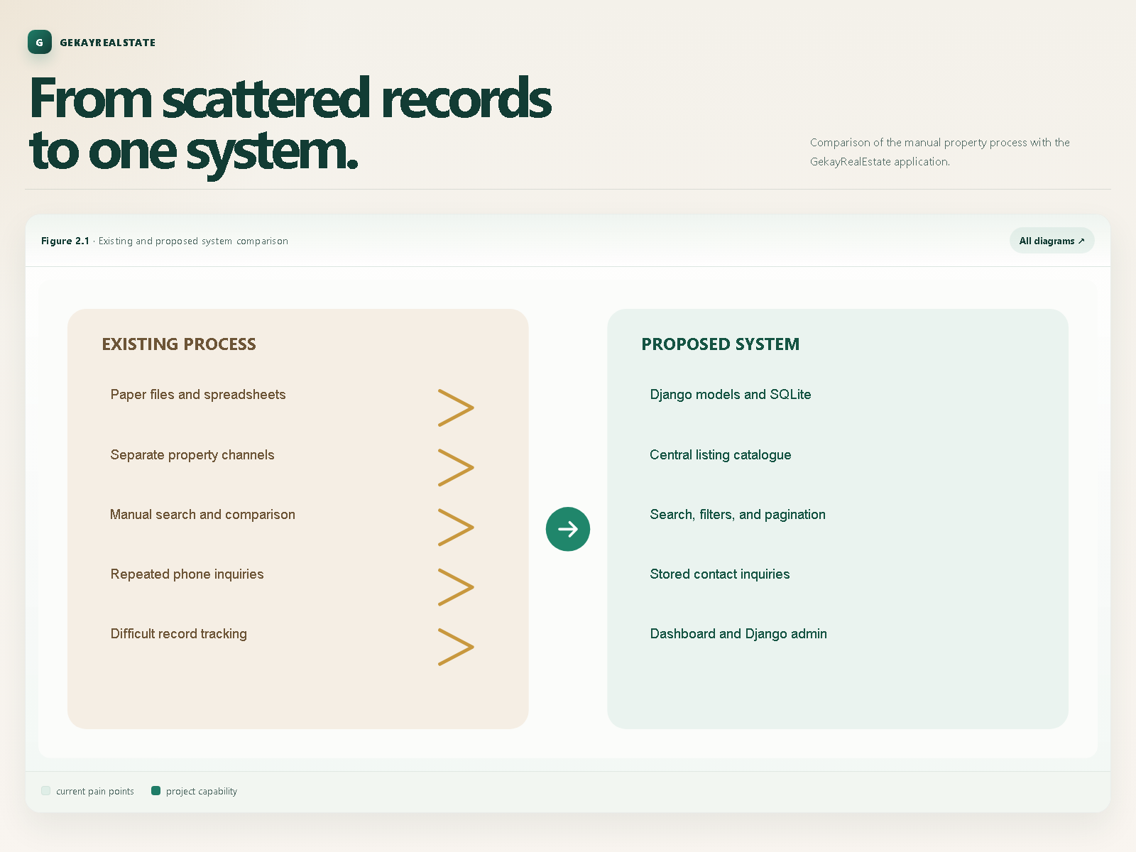
Figure 2.1 — Existing and Proposed System Comparison
The figure connects the manual process—paper records, separate channels,
manual comparison, repeated calls, and difficult tracking—to the proposed
centralized Django system.

3. Requirements and Analysis

3.1 Functional requirements
ID | Requirement
FR-01 | Display a home page with featured published listings
FR-02 | Store and manage property listing records
FR-03 | Search by keyword, city, state, bedrooms, and maximum price
FR-04 | Display a property detail page and gallery
FR-05 | Display realtor profile and contact information
FR-06 | Register, authenticate, and log out users
FR-07 | Display a protected inquiry dashboard
FR-08 | Submit and store inquiries for a selected listing
FR-09 | Prevent duplicate inquiries by the same logged-in user
FR-10 | Send an email notification after a valid inquiry
FR-11 | Provide Django admin for authorised data maintenance

Home page and featured listings
The home page displays a limited selection of recent published properties and
provides search choices for price, bedrooms, and state.

Listing management
A listing stores title, realtor, address, city, state, postal code, description,
price, bedrooms, bathrooms, garage, floor area, lot size, publication status,
listing date, and photographs.

Search and filtering
The search view accepts optional parameters. Keyword matching uses the
description, city and state use case-insensitive exact matching, and bedrooms
and price act as maximum filters. Results are ordered by listing date.

Details and realtor information
The detail view displays a selected listing, its photographs and related
realtor. Realtor records include name, photograph, description, phone, email,
MVP status, and hire date.

Registration, login, and dashboard
Registration validates matching passwords and duplicate username or email
values. The dashboard is protected by authentication and displays the current
user's inquiries, ordered by contact date.

Contact and email notification
An inquiry contains listing information, visitor details, phone, message,
contact date, and user association. After a successful save, Django sends an
email to the configured office address. During local development, email can be
written to the console when SMTP credentials are absent.

3.2 Non-functional requirements
• Usable: clear navigation for first-time visitors.
• Maintainable: responsibilities separated by application.
• Responsive: usable on desktop and mobile layouts.
• Reliable: listing and inquiry records persist correctly.
• Secure: authentication and Django middleware protect account actions.
• Extensible: future booking, payment, and role features can be added.
• Configurable: secrets, hosts, and email credentials come from environment
configuration.

3.3 Roles and permissions
Role | Permissions
Visitor | View public pages, listings, realtor details, and search results
Registered user | Authenticate, submit inquiries, and view personal dashboard
Administrator | Manage users and application records through Django admin

3.4 Software requirements
• Python 3.14
• Django 5.2
• SQLite for local development
• Pillow
• python-dotenv
• Gunicorn
• Whitenoise
• autopep8
• isort
• pylint

3.5 Hardware requirements
A development machine should have a modern processor, at least 4 GB RAM,
sufficient storage for the virtual environment and uploaded images, and network
access for dependency installation. End users need a browser and network
connection.

3.6 Use-case analysis

Figure 3.1 — Use-case diagram
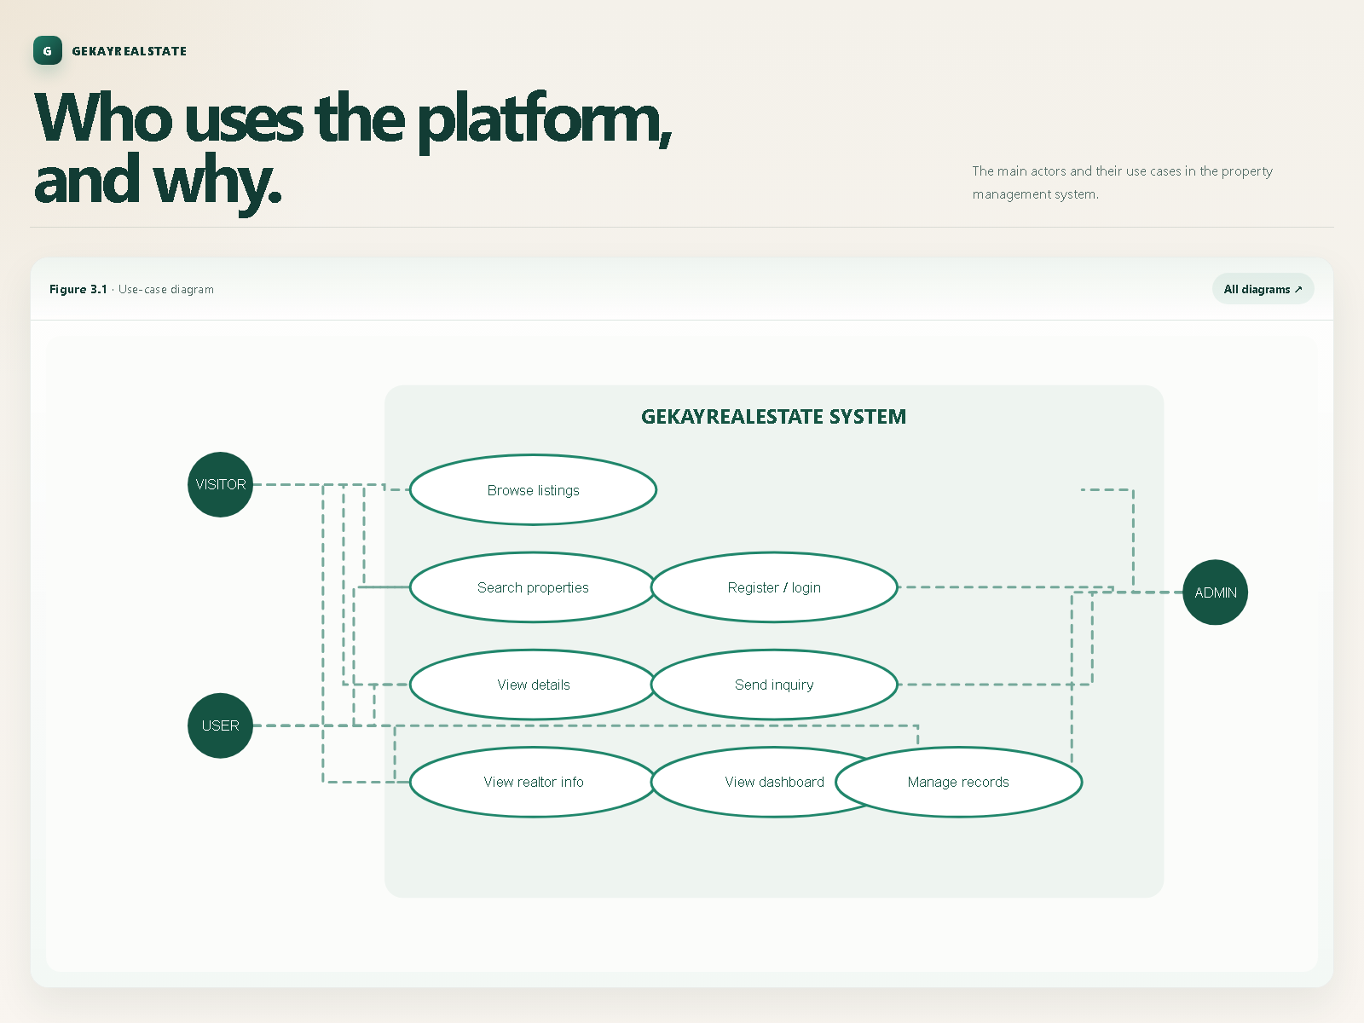
Figure 3.1 — Use-Case Diagram
The visitor uses browsing, search, detail, and realtor-information functions.
The registered user adds registration, login, inquiry, dashboard, and logout
functions. The administrator manages application records.

3.7 Data-flow analysis

Figure 3.2 — Data-flow diagram
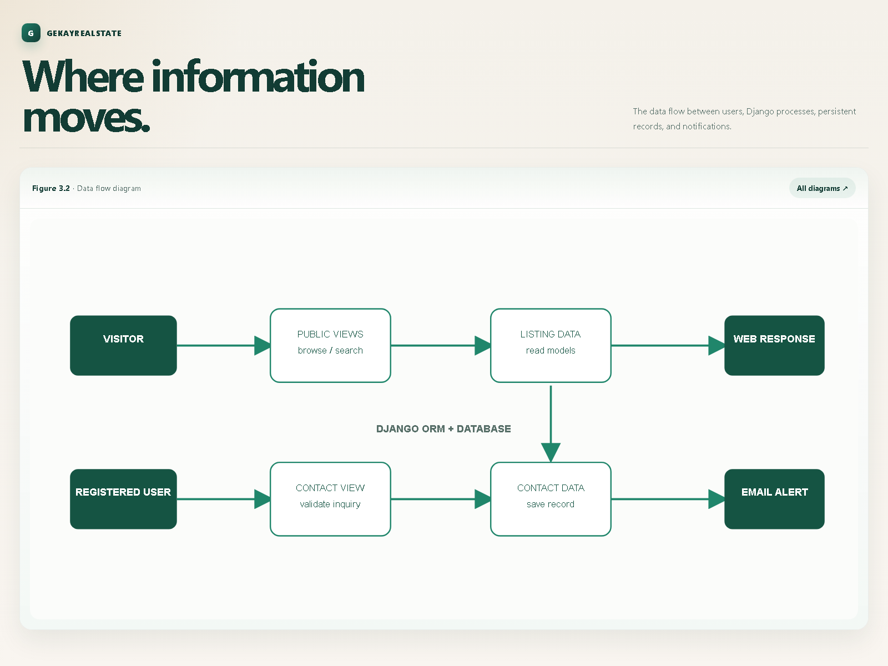
Figure 3.2 — Data Flow Diagram
Property data flows from administrators into listing and realtor records.
Visitors read published data through Django views and templates. Authenticated
contact submissions are validated, saved as Contact records, and used to
send email alerts. The dashboard reads contact records associated with the
current user.

4. Technology and Project Architecture

4.1 Technology stack
Technology | Use
Python | Configuration, models, views, routing, tests, and utilities
Django | Web framework, ORM, authentication, middleware, templates, and admin
SQLite | Local relational database
HTML templates | Shared and page-specific rendering
Bootstrap | Responsive layout and common controls
CSS | Project visual styling
JavaScript | Frontend interaction and image presentation
Pillow | Uploaded realtor and listing image handling
python-dotenv | Environment configuration
Gunicorn | Production WSGI server
Whitenoise | Static-file serving support

4.2 Project directory structure
GekayRealEstate/
├── accounts/ # authentication, dashboard, tests, URLs
├── contacts/ # inquiry model, views, URLs, migrations
├── djangofirst/ # settings, root URLs, WSGI configuration
├── listings/ # listing model, search views, URLs, migrations
├── pages/ # home and about pages
├── realtors/ # realtor model, views, migrations
├── templates/ # shared and application templates
├── djangofirst/
│ └── static/ # CSS, JavaScript, images, and fonts
└── doc/ # project documentation and diagrams

4.3 Django MVT architecture

Figure 4.1 — Django MVT
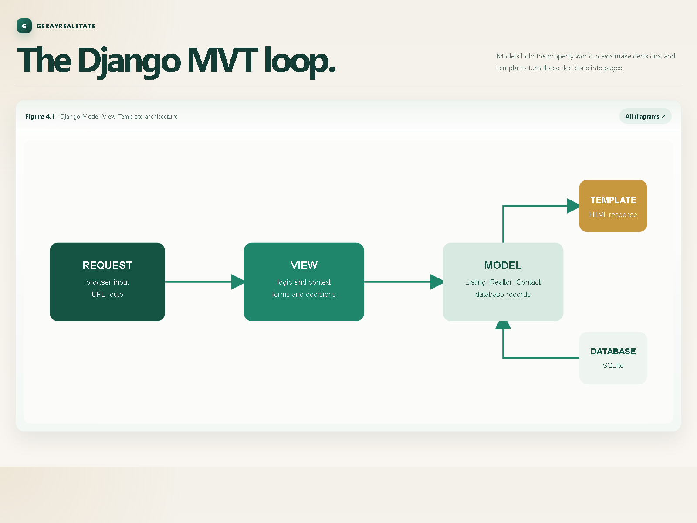
Figure 4.1 — Django MVT Architecture
The request reaches Django URL configuration, which delegates to a view. The
view queries models through the ORM, prepares context, and renders a template.
The response returns HTML to the browser. The database persists users,
listings, realtors, and inquiries.
flowchart LR
Browser[Browser request] --> URLs[Root URL configuration]
URLs --> View[Django view]
View --> Model[Models and ORM]
Model --> DB[(SQLite database)]
View --> Template[HTML template]
Template --> Response[HTTP response]
Response --> Browser

4.4 URL routing architecture

Figure 5.3 — URL routing
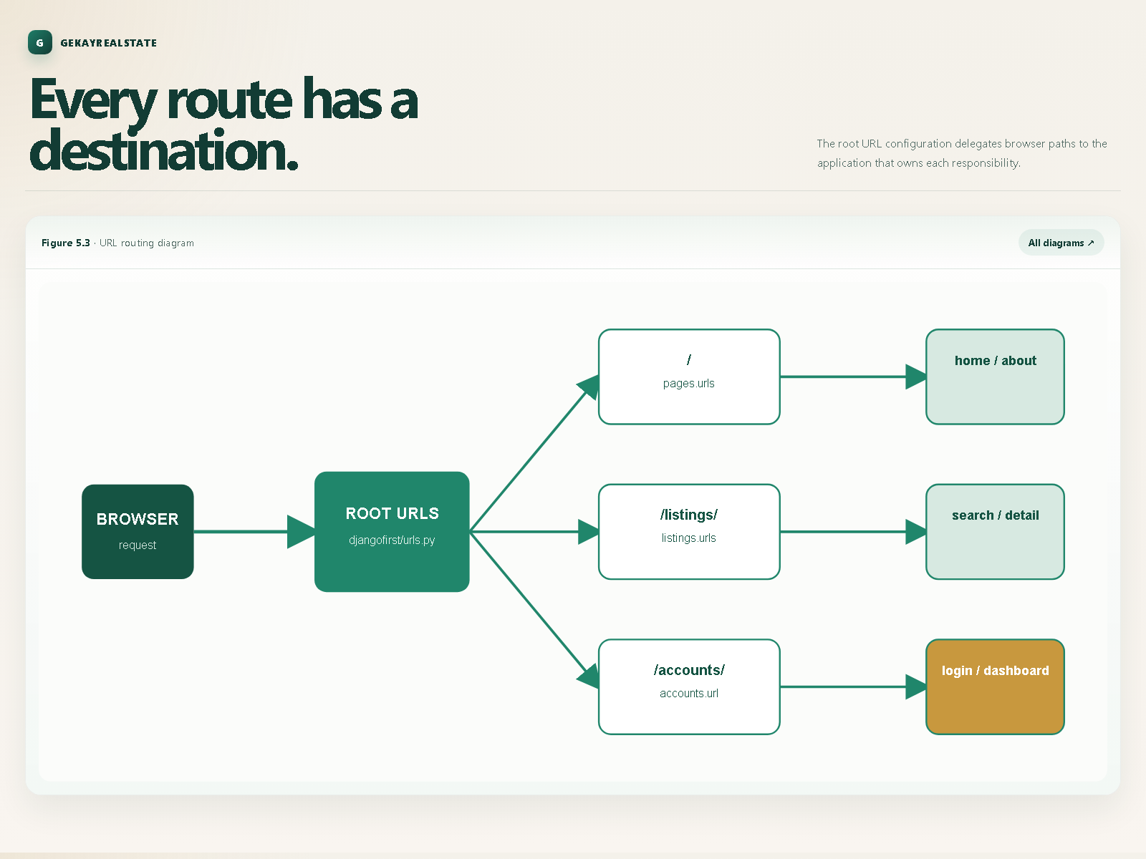
Figure 5.3 — URL Routing Diagram
The root configuration delegates:
Path | Application or destination
/ | pages
/listings/ | listings
/accounts/ | accounts
/contacts/ | contacts
/admin/ | Django administration

Media files are served from the configured media location during development.

4.5 Project architecture flow
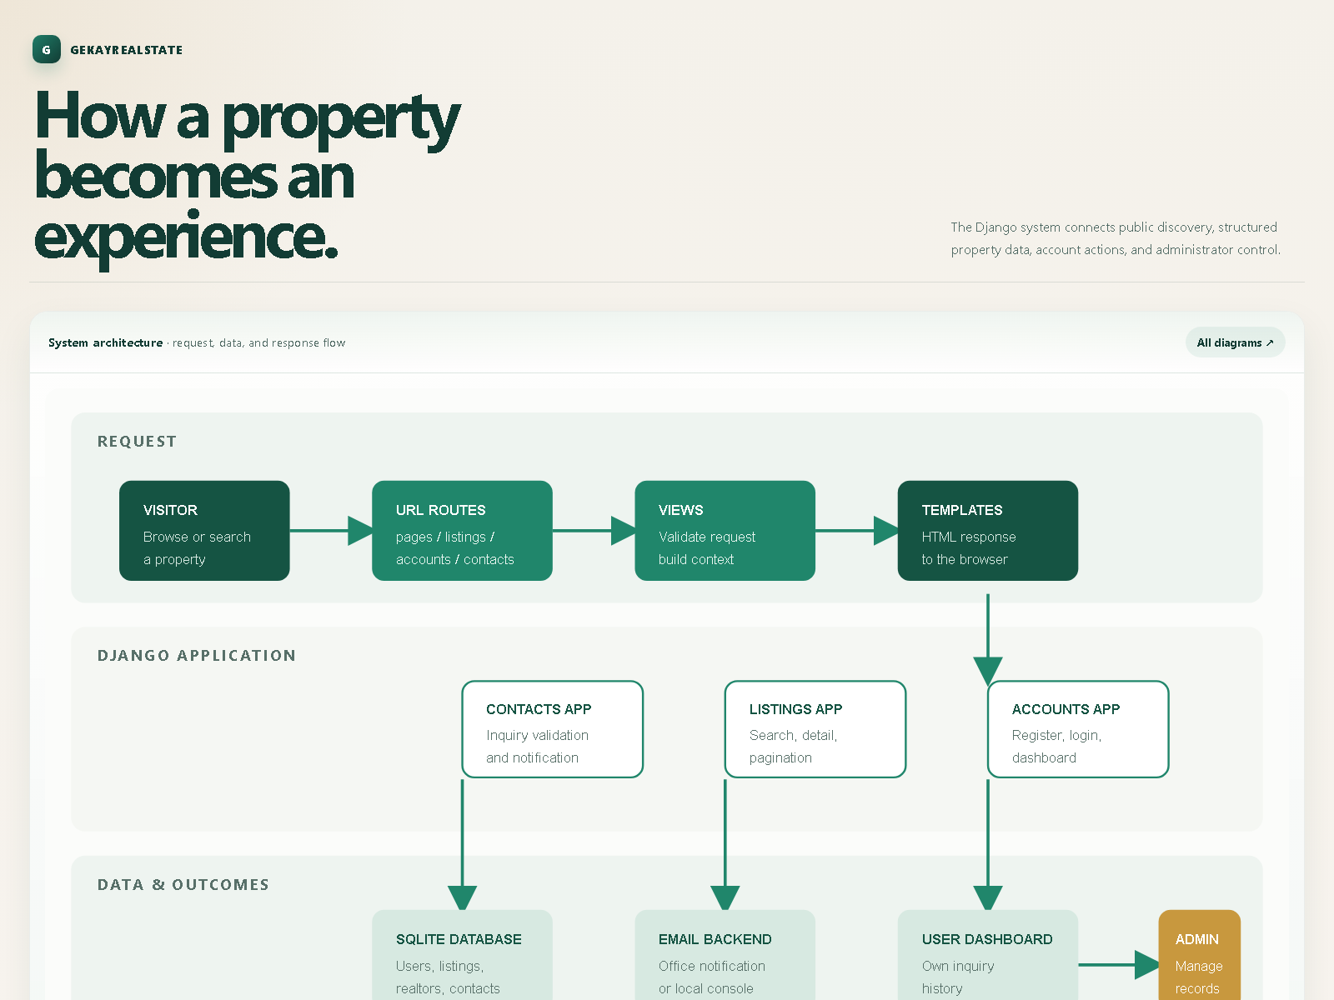
Figure 5.1 — System Architecture Flow
This project diagram provides a broader view of the request, application,
database, email, and administration responsibilities.

5. System Design

5.1 Application modules
Module | Main design responsibility
Pages | Home page, about page, featured listings, and realtor groups
Listings | Listing model, index, detail, pagination, and search
Realtors | Realtor records and administration
Accounts | Registration, login, logout, and authenticated dashboard
Contacts | Inquiry model, duplicate check, and email notification

User journey
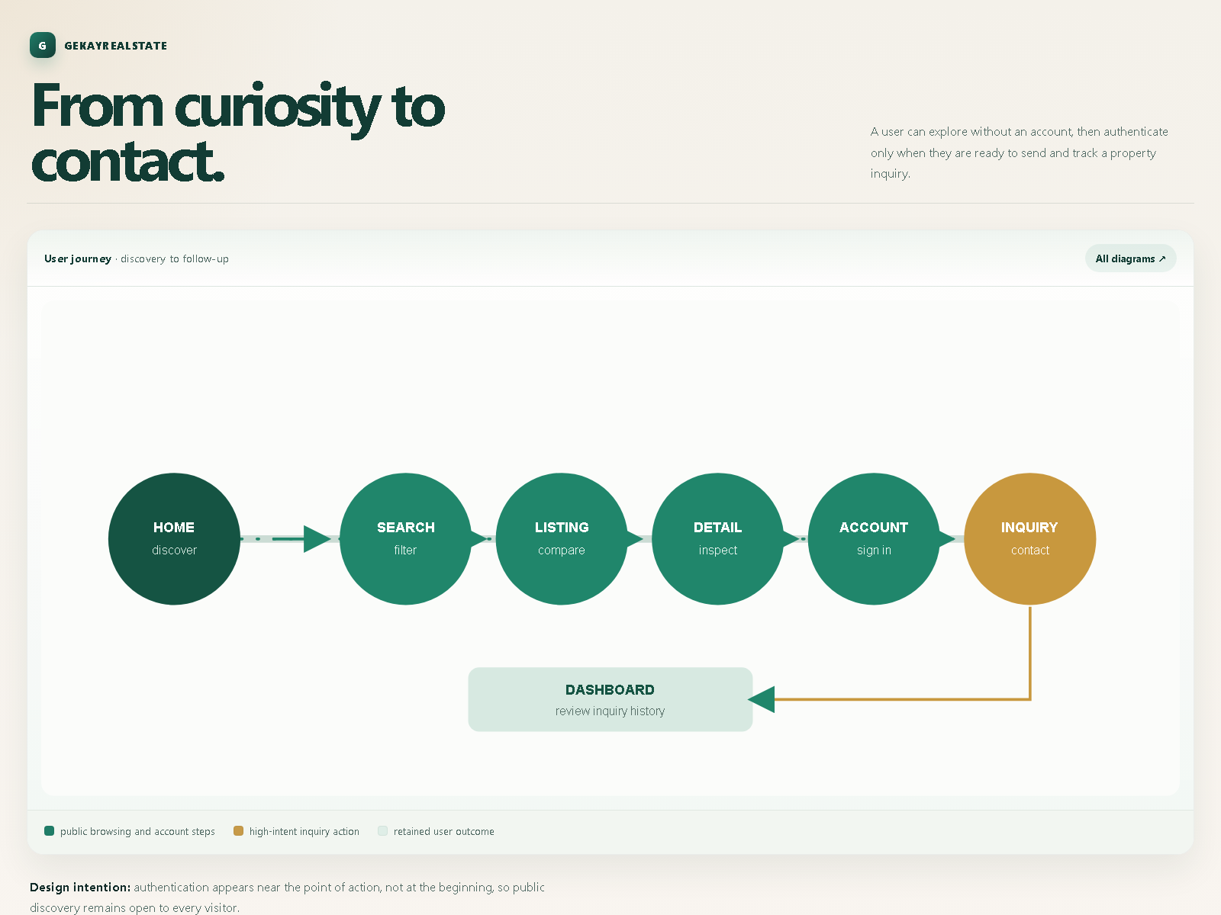
Figure 5.4 — User Navigation / Journey Flow
The journey moves from property discovery to search, detail review,
registration or login, inquiry submission, and dashboard review.

Administrator operations
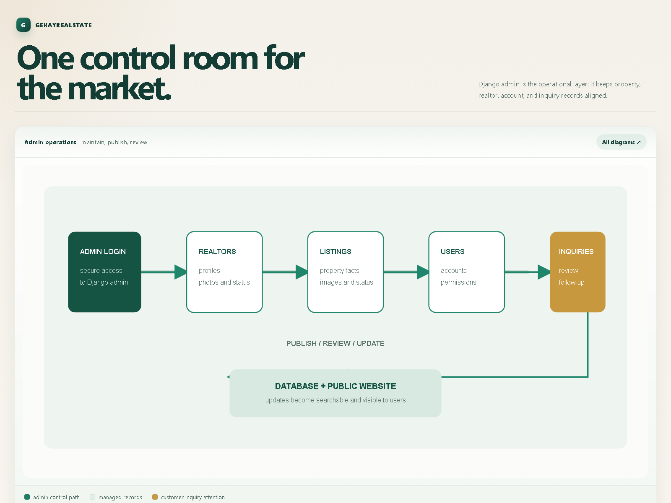
Figure 6.10 — Django Administration / Admin Operations
The administrator flow covers maintenance of listings, realtor data, users,
and property inquiries through Django admin.

5.2 Database design

Realtor entity
The Realtor entity contains name, photograph, description, phone, email, MVP
status, and hire date. A listing references a realtor.

Listing entity
The Listing entity contains property identity, location, description, price,
bedrooms, bathrooms, garage count, area values, main and additional
photographs, publication status, and listing date.

Contact entity
The Contact entity stores listing name and identifier, visitor name, email,
phone, message, inquiry date, and user identifier. It supports dashboard
history and administrative review.

Django User entity
Django's built-in User entity stores credentials and basic account
information, including username, email, first name, and last name.

5.3 Entity relationships

Figure 5.2 — Entity relationship diagram
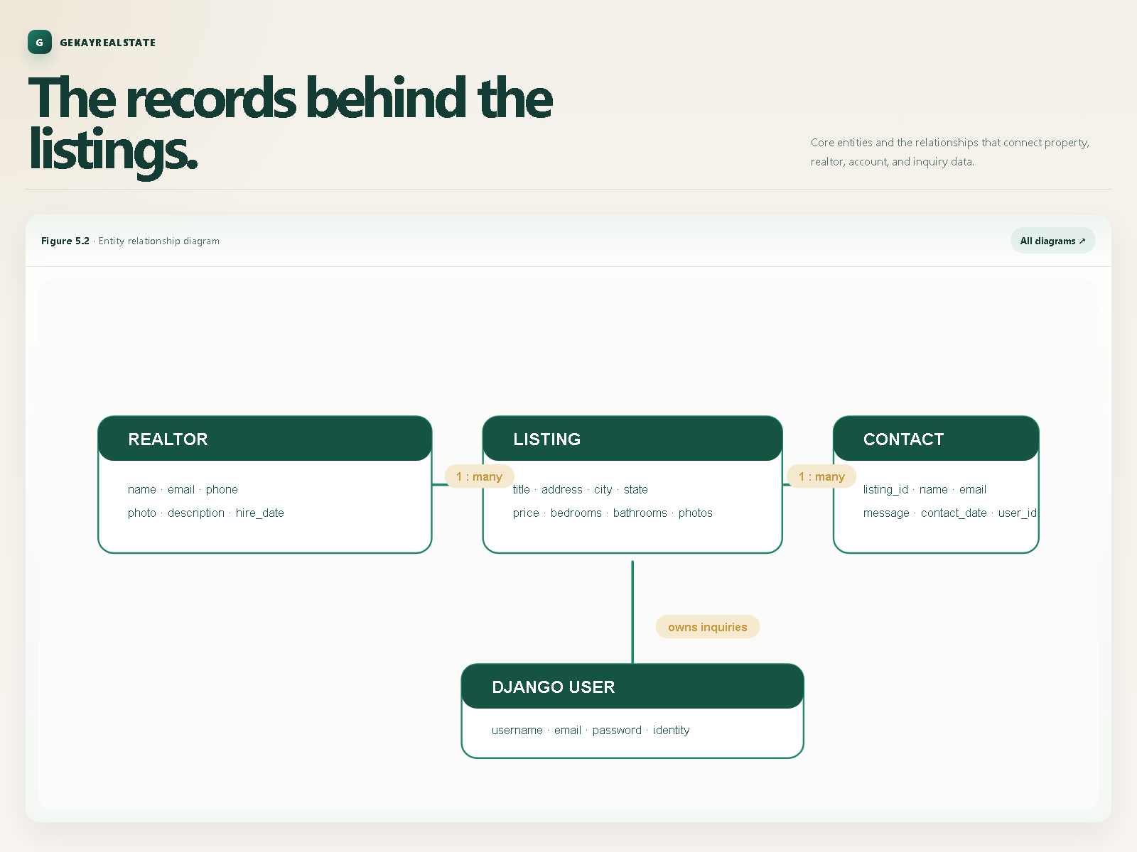
Figure 5.2 — Entity Relationship Diagram
The relationships are:
• one realtor can be associated with many listings;
• one listing can have many contact inquiries; and
• one user can create many contact inquiries.
The dashboard filters contact records by the current user's identifier.
erDiagram
REALTOR ||--o{ LISTING : manages
LISTING ||--o{ CONTACT : receives
USER ||--o{ CONTACT : creates
REALTOR {
int id
string name
string email
string phone
date hire_date
}
LISTING {
int id
string title
string address
string city
string state
decimal price
int bedrooms
int bathrooms
}
CONTACT {
int id
int listing_id
int user_id
string name
string email
string message
datetime contact_date
}
USER {
int id
string username
string email
}

5.4 User interface design
The interface uses a shared base template and reusable top bar, navigation,
footer, and alert partials. Listing cards show image, price, location, area,
garage, bedrooms, bathrooms, realtor, and listing age.

5.5 Navigation and common layout
Navigation connects the home page, about page, listings, search,
authentication, and dashboard. Breadcrumbs help users understand their
location on listing pages.

5.6 Security and access control
Django authentication middleware identifies logged-in users. The dashboard
uses login_required. CSRF protection, session middleware, password
validators, authentication functions, secret-key configuration, and allowed
hosts support the security model.

5.7 Media and static files
Static CSS, JavaScript, image, and font files are stored in the project static
directory. Realtor and property photographs are media files referenced by
uploaded file URLs.

6. Implementation

6.1 Django configuration
The djangofirst project contains settings.py, urls.py, and wsgi.py.
Installed applications include pages, listings, realtors, accounts,
contacts, and standard Django applications. The project uses a shared
templates directory.

6.2 Home and about pages
The home view selects the three most recent published listings and supplies
search choices. The about view orders realtors by hire date and identifies MVP
realtors.

6.3 Listing display and pagination
The listing index selects published records and uses a Django paginator with
three listings per page. Previous, current, and next controls appear when
additional pages exist.

6.4 Listing detail
The detail view uses get_object_or_404 to locate the requested record. An
invalid identifier returns Django's standard not-found response.

6.5 Listing search
The search view starts with listings ordered by date and applies each supplied
filter independently:
• keyword search against listing description;
• case-insensitive exact city match;
• case-insensitive exact state match;
• maximum bedroom count; and
• maximum price.
Empty parameters do not change the result set.

6.6 Realtor management
Realtor records are represented by the Realtor model and managed through
Django admin. Listings reference realtors so the responsible professional can
be displayed with each property.

6.7 Registration
The registration view validates identity fields, matching passwords, duplicate
username and duplicate email conditions, then creates the user with Django's
create_user method and redirects to login.

6.8 Login and logout
Valid credentials authenticate the user and redirect to the dashboard. Invalid
credentials return the user to the login page with an error message. Logout is
handled through a POST request and redirects to the home page.

6.9 Dashboard
The dashboard is protected by login_required. It retrieves Contact records
for the current user, orders them by contact date, and renders the dashboard
template.

6.10 Contact processing
The contact view reads listing and visitor fields, checks for a previous
inquiry by the same authenticated user, saves valid new inquiries, sends
notification email, and returns the user to the listing.

6.11 Duplicate inquiry prevention
The duplicate check prevents a logged-in user from repeatedly submitting an
inquiry for the same listing. This keeps inquiry history useful and reduces
repeated notifications.

6.12 Email processing
After saving a new Contact, the view uses Django's send_mail function.
Local development uses the console email backend when SMTP credentials are not
configured.

6.13 Django admin
Each application exposes relevant model records through an admin module.
Django admin is intended for authorised maintenance, not general public
browsing.

6.14 Environment configuration
The project reads secret key, allowed hosts, and email credentials from
environment variables so deployment secrets do not need to be stored directly
in source code.

6.15 Migrations
Migration files are maintained for listings, realtors, and contacts. Model
changes should be followed by:
python manage.py makemigrations
python manage.py migrate

7. Testing

7.1 Testing strategy
Testing should cover models, views, routes, authentication, search filters,
templates, migrations, inquiries, and administrator workflows. Both successful
and invalid actions should be tested.

7.2 Unit tests
The project includes test modules in accounts, listings, contacts, and
pages. Unit tests should verify expected status codes, templates, redirects,
and context data.

7.3 Authentication test cases
• successful registration;
• duplicate username;
• duplicate email;
• mismatched passwords;
• valid login;
• invalid login;
• logout; and
• protected dashboard access.

7.4 Listing test cases
• published listings are displayed;
• unpublished listings are excluded;
• valid listing detail opens;
• invalid identifier returns not found.

7.5 Search and filter test cases
• keyword matching;
• city filtering;
• state filtering;
• bedroom maximum;
• price maximum;
• combined filters; and
• empty search returning the normal listing set.

7.6 Contact inquiry test cases
• valid data creates a Contact;
• success feedback is shown;
• the visitor returns to the listing; and
• notification email is requested.

7.7 Access-control test cases
Unauthenticated dashboard access should redirect to authentication.
Authenticated users should see only their own inquiry records.

7.8 Template and UI testing
Check navigation links, image rendering, breadcrumbs, pagination, validation
messages, alerts, and responsive Bootstrap layouts.

7.9 Database and migration testing
Confirm that a clean database can be created and that realtor, listing,
contact, and authentication records can be stored and retrieved.

7.10 Test execution
Run the Django test suite from the project root:
python manage.py test
Manual browser testing should cover visitor, registered-user, and administrator
workflows.

8. User Interface and System Results

8.1 Home page
The home page presents the GekayRealEstate identity, navigation, search area,
and recent published listings.
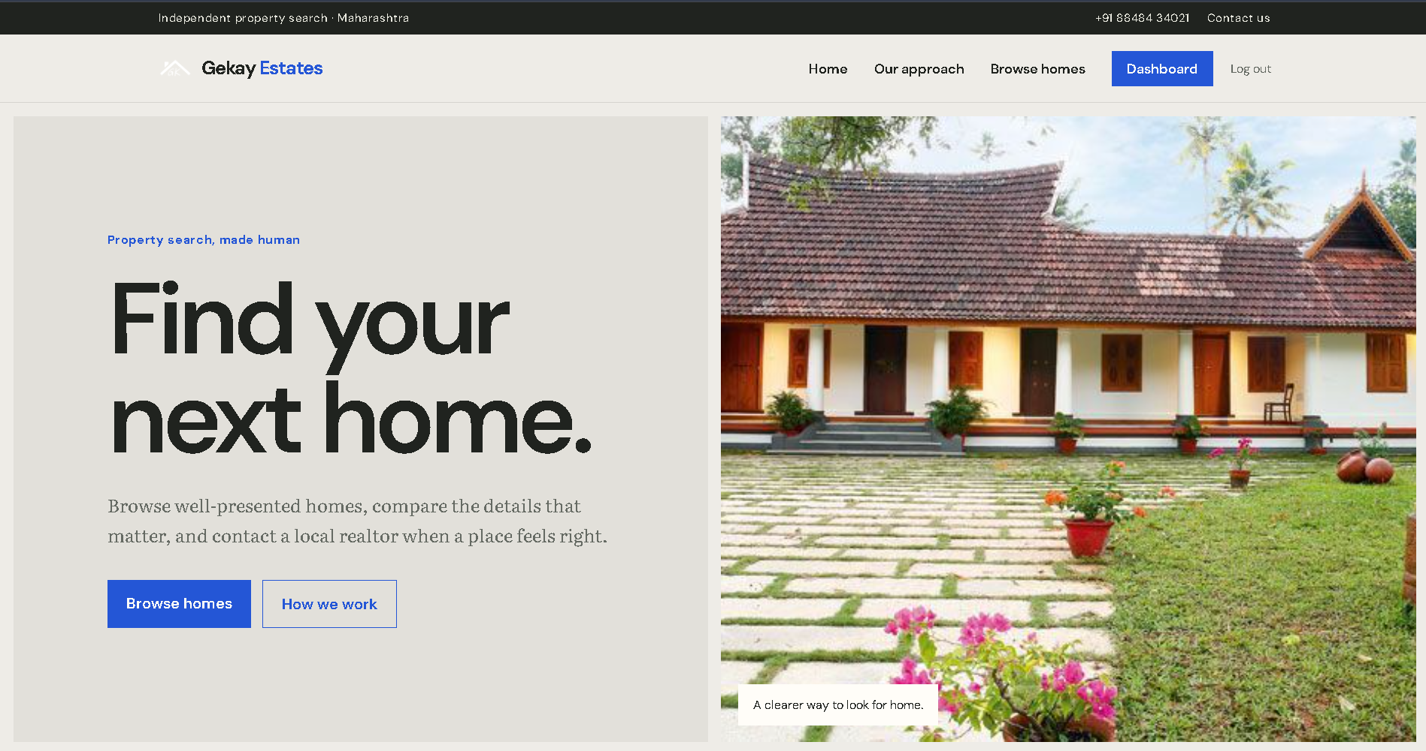
Figure 6.1 — Home Page

8.2 About page and realtor profiles
The about page presents realtor photographs, descriptions, contact information,
and MVP grouping.
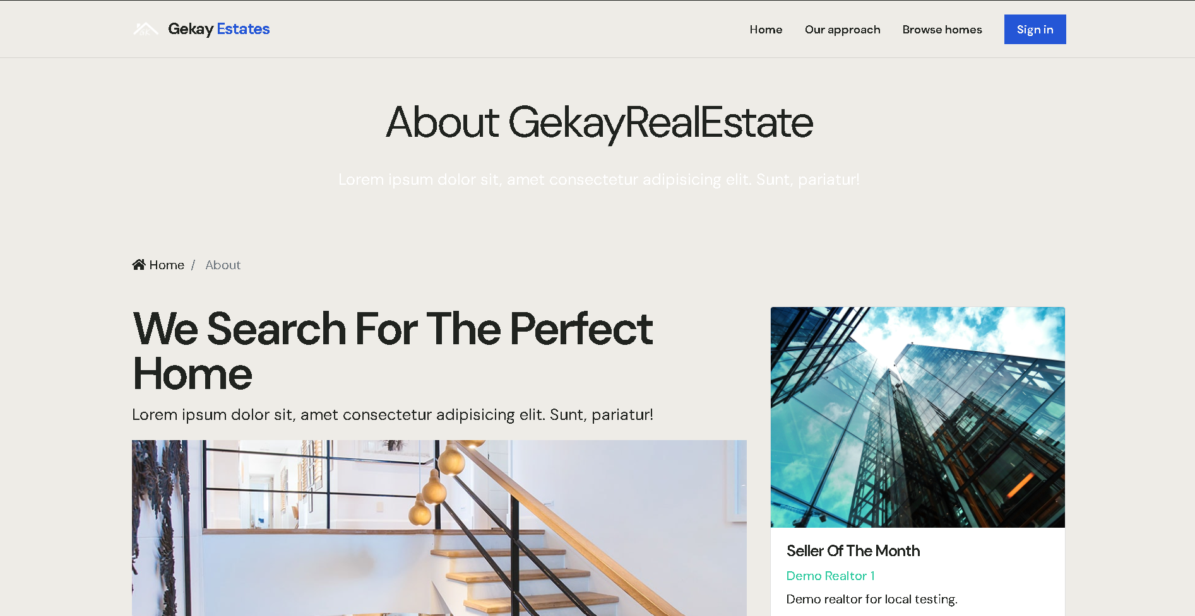
Figure 6.2 — About Page

8.3 Browse listings
The browse page presents published properties in a responsive card grid with
main image, price, location, and specifications. Pagination supports movement
through the catalogue.
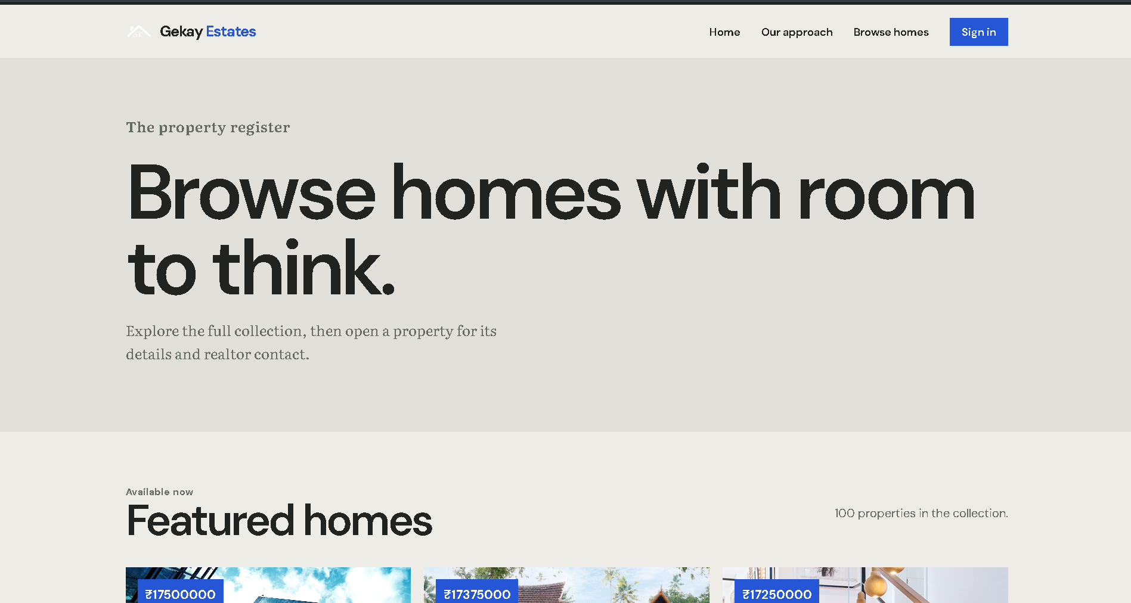
Figure 6.3 — Browse Listings Page

8.4 Search results
Search results are based on submitted criteria and preserve those values so
users can understand the active search.
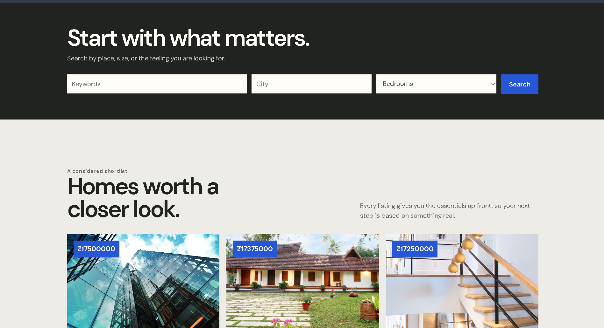
Figure 6.4 — Search Results Page

8.5 Listing details
The detail page provides description, location, price, measurements,
photographs, realtor information, and the inquiry route.
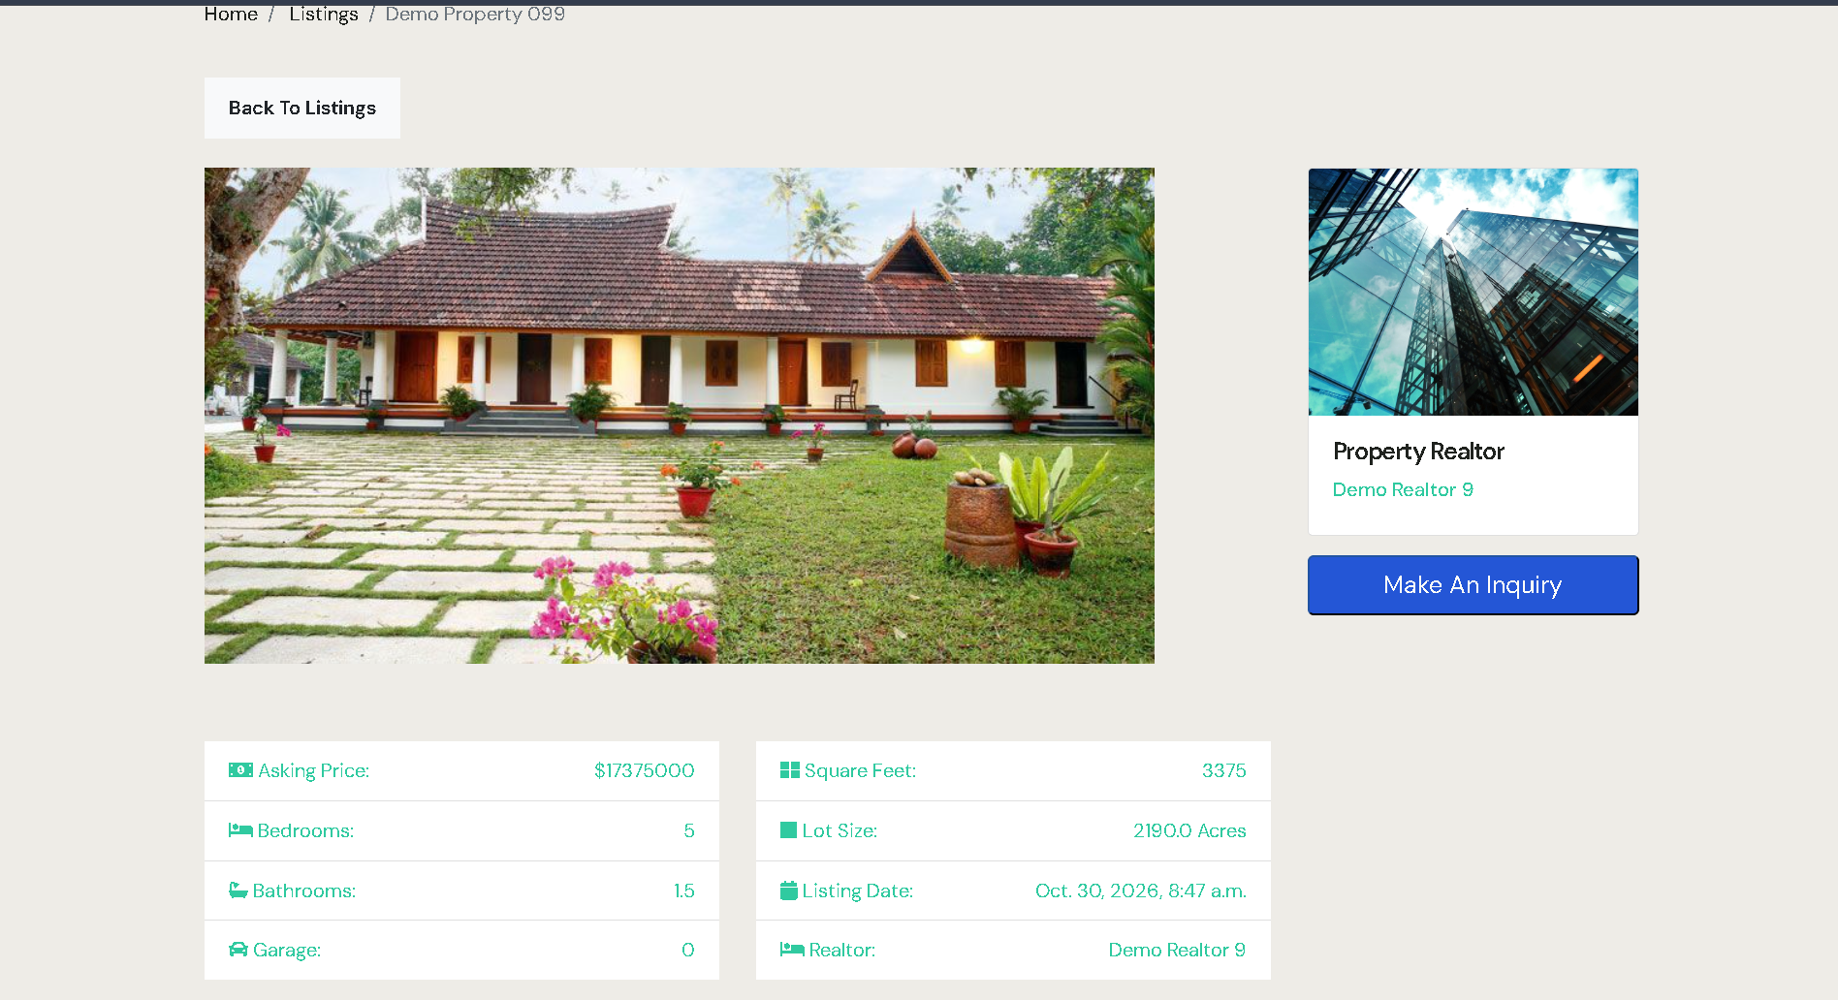
Figure 6.5 — Listing Details Page

8.6 Registration and login
Registration collects identity and password values and reports validation
feedback. Login accepts username and password and reports authentication
feedback.
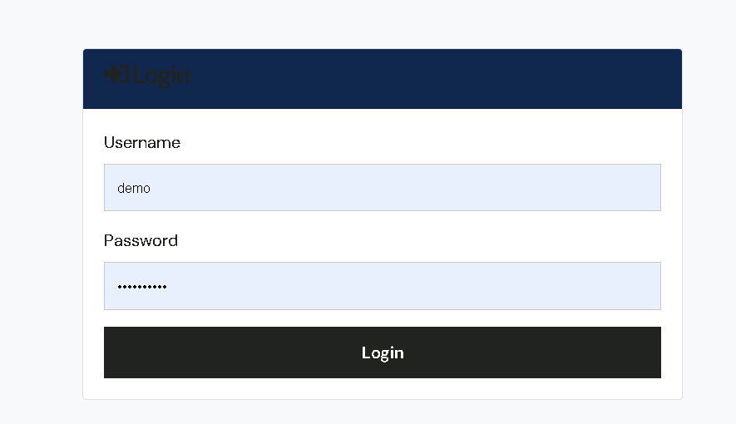
Figure 6.7 — Login Page

8.7 User dashboard
The dashboard displays the authenticated user's inquiry history.
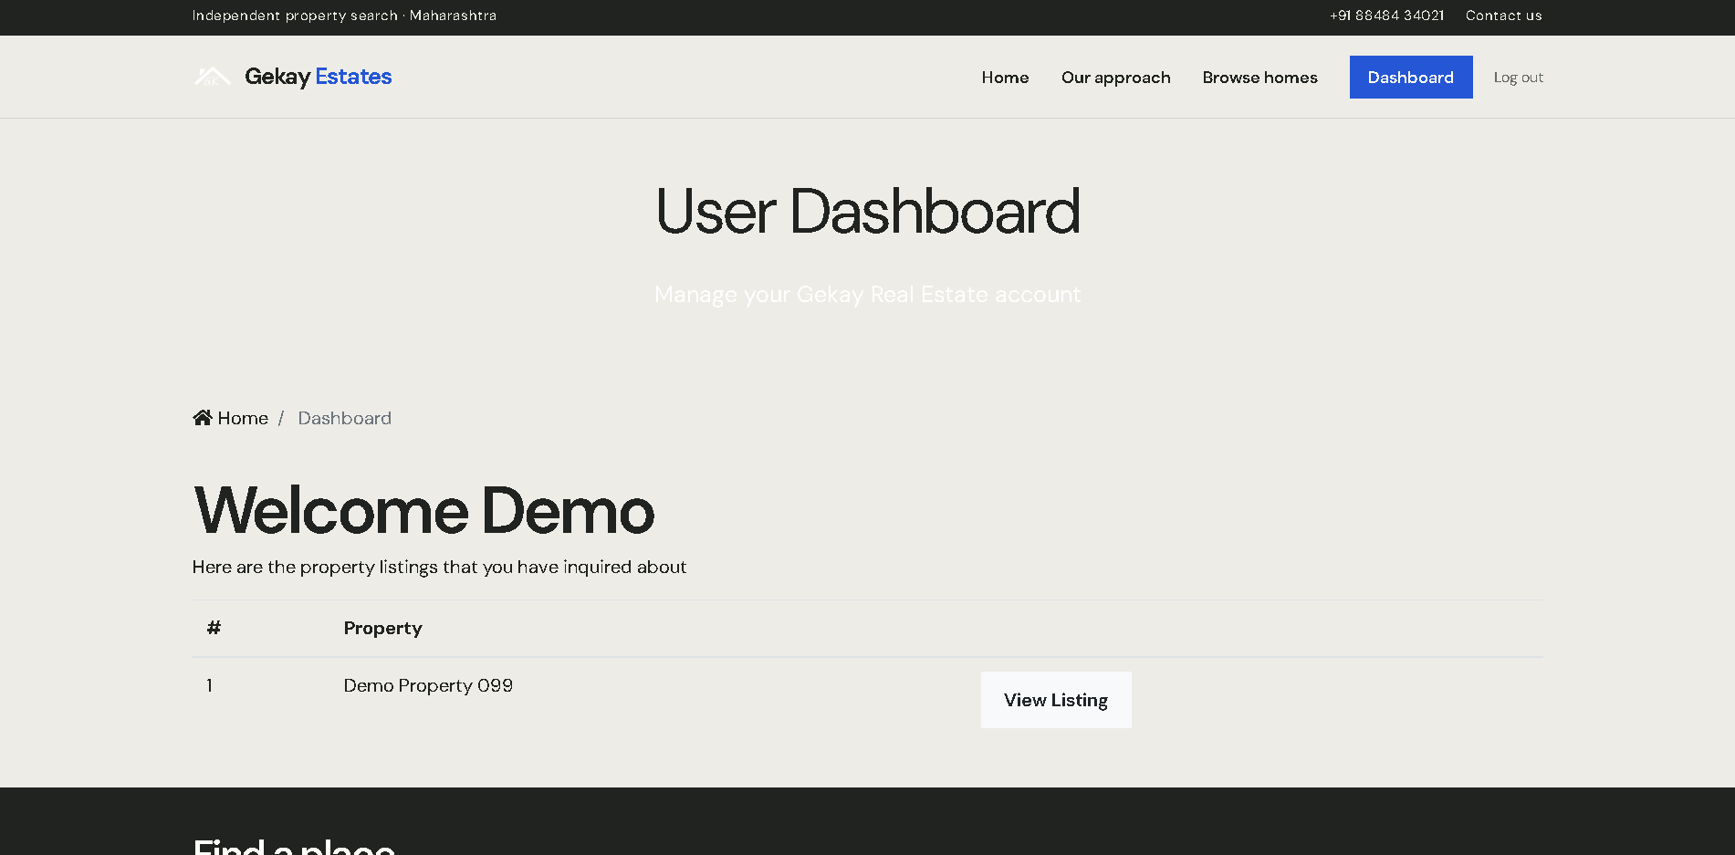
Figure 6.8 — User Dashboard

8.8 Contact inquiry form
The form collects contact information and a message connected to a specific
listing. Successful submission stores the inquiry and provides confirmation.

8.9 Django administration
Authorised administrators can create, update, inspect, and remove managed
records.

8.10 Responsive layout
Bootstrap grid classes and responsive navigation patterns support common
desktop and mobile layouts. Custom CSS and JavaScript extend the visual
presentation and image interaction.

9. Deployment and Maintenance

9.1 Local Windows setup
Install Python 3.14, open PowerShell in the project directory, create a
virtual environment, and install the dependencies.

9.2 Virtual environment
py -3.14 -m venv venv
.\venv\Scripts\Activate.ps1

9.3 Dependency installation
python -m pip install -r requirements.txt

9.4 Environment file
Create a local .env file:
DJANGO_SECRET_KEY=replace-with-a-local-secret
DJANGO_ALLOWED_HOSTS=127.0.0.1,localhost
Add SMTP values when external email delivery is required.

9.5 Database migration
python manage.py migrate

9.6 Administrator account
python manage.py createsuperuser
The administrator can then open /admin/ after starting the server.

9.7 Development server
python manage.py runserver
The application is available at <http://127.0.0.1:8000/>.

9.8 Production considerations
Production should use a strong secret key, explicit allowed hosts,
DEBUG=False, a production database, secure email credentials, HTTPS,
appropriate media storage, static-file collection, and a production WSGI
server such as Gunicorn.

9.9 Backup and maintenance
Back up the database and uploaded media regularly. Review dependencies,
migrations, automated tests, logs, email configuration, and static assets after
each deployment.

10. Conclusion and Future Scope

10.1 Conclusion
GekayRealEstate provides a practical foundation for managing and presenting
property listings online. Its Django architecture separates property data,
realtor data, authentication, inquiries, templates, and project configuration.
Users receive a convenient browsing and inquiry experience, while administrators
receive structured data management through Django admin.

10.2 Current limitations
• SQLite is intended mainly for local development.
• There is no complete booking or payment workflow.
• Advanced user roles are not yet modelled.
• Search does not include maps, distance, or saved searches.

10.3 Future enhancements

Advanced user roles
Introduce buyer, realtor, manager, and administrator permissions with
role-based access control.

Online booking and payment
Allow users to schedule visits, reserve properties, and complete payments
through a secure payment provider.

Saved and favourite listings
Allow users to save, compare, and receive alerts for properties.

Advanced property search
Add property type, minimum values, amenities, radius, and map-based search.

Real-time notifications
Add email, SMS, or in-app notifications for inquiry responses, new listings,
and appointment changes.

Cloud database and hosting
For larger usage, replace SQLite with PostgreSQL, move uploaded media to cloud
storage, and deploy with HTTPS, managed infrastructure, and continuous
deployment.

Figures and project diagram index
All currently generated HTML figures are connected below. Each link opens the
interactive figure and preserves its accessible SVG description.
Figure | Description | Link
Figure 2.1 | Existing and Proposed System Comparison | Figure 2.1
Figure 3.1 | Use-Case Diagram | Figure 3.1
Figure 3.2 | Data Flow Diagram | Figure 3.2
Figure 4.1 | Django MVT Architecture | Figure 4.1
Figure 4.2 | Project Directory Structure | Not available in the current image set
Figure 5.1 | Application Module / System Architecture Flow | Figure 5.1
Figure 5.2 | Entity Relationship Diagram | Figure 5.2
Figure 5.3 | URL Routing Diagram | Figure 5.3
Figure 5.4 | User Navigation / Journey Flow | Figure 5.4
Figure 6.1 | Home Page | Figure 6.1
Figure 6.2 | About Page | Figure 6.2
Figure 6.3 | Browse Listings Page | Figure 6.3
Figure 6.4 | Search Results Page | Figure 6.4
Figure 6.5 | Listing Details Page | Figure 6.5
Figure 6.6 | Registration Page | Application page screenshot not stored in doc/img
Figure 6.7 | Login Page | Figure 6.7
Figure 6.8 | User Dashboard | Figure 6.8
Figure 6.9 | Contact Inquiry Form | Application page screenshot not stored in doc/img
Figure 6.10 | Django Administration / Admin Operations | Figure 6.10

Diagram collection
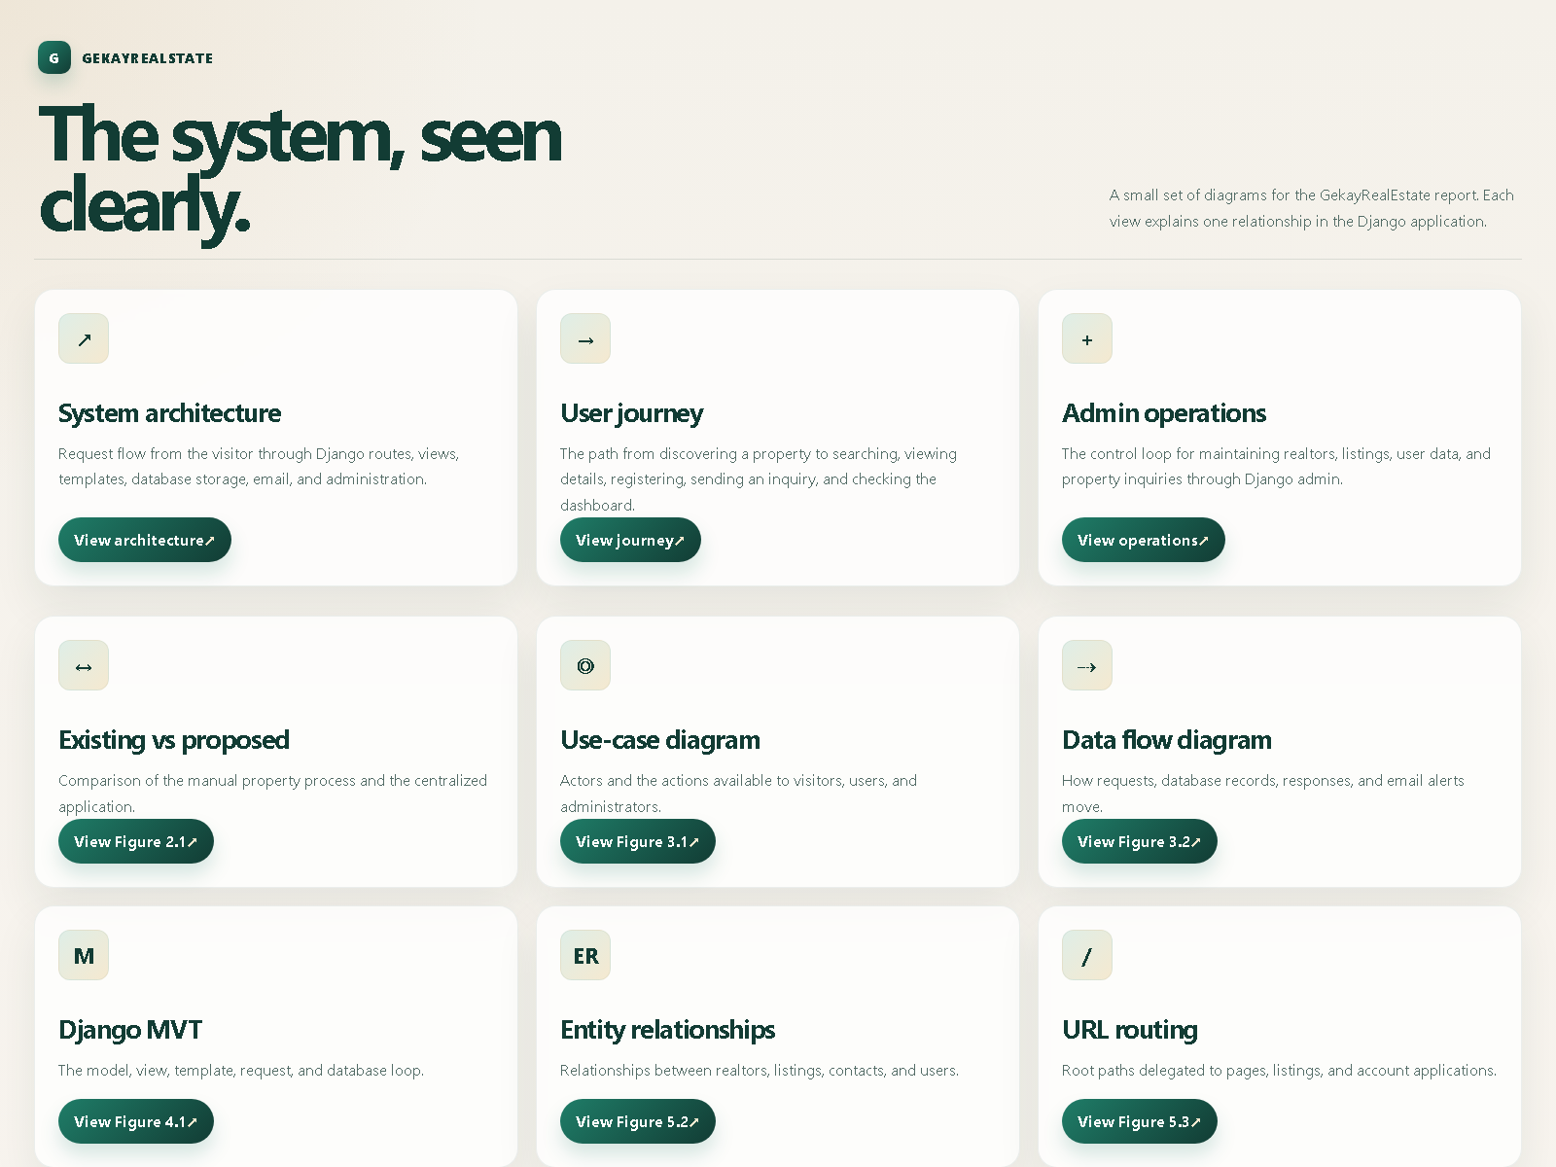
Complete diagram index

References
1. [Django Documentation](https://docs.djangoproject.com/)
2. [Python Documentation](https://docs.python.org/)
3. [Bootstrap Documentation](https://getbootstrap.com/docs/)
4. [Pillow Documentation](https://pillow.readthedocs.io/)
5. GekayRealEstate project `README.md`
6. GekayRealEstate project source code and migration files
7. [`doc/sample_doc.pdf`](./sample_doc.pdf)

