**Data Analysis Report:** Profitability and Sales Performance Insights of Bicycle

**Introduction**

This report provides a detailed analysis of the company's sales and profitability data, focusing on market segments, regions, and the impact of discount strategies. The goal is to identify actionable insights that can guide resource marketing strategies, and discount optimization to maximize revenue and profitability.

1. Profitability Analysis by Market Segment and Region

Objective:

Identify the most profitable market segments and regions by analyzing sales, profit margins, and units sold. This will help the company allocate resources effectively and focus marketing efforts on high performing areas.

Key Insights:

* 1. Highest and Lowest Profit Margins by Segment and Region

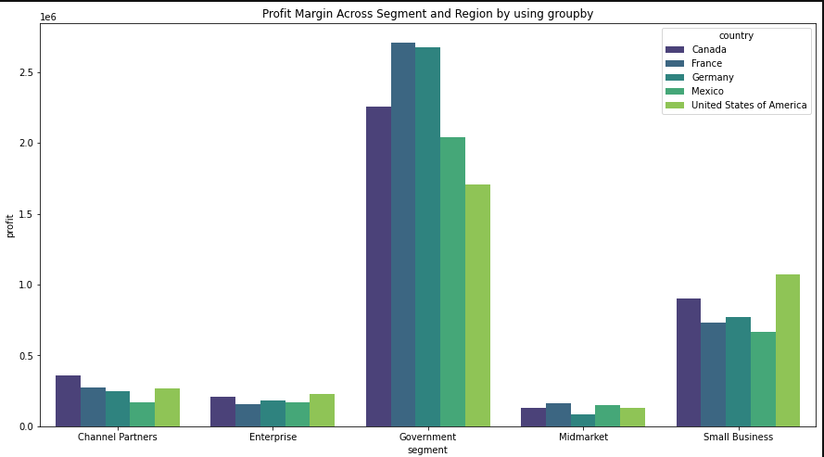

Segments:

* Government and Small Business segments yield the highest profits.
* Midmarket contributes the least to the company's profitability.

Regions:

* Mexico, Germany, and France are the top performing regions, contributing significantly to the company's profits.
* Other regions, particularly those with Midmarket focus, underperform.

Suggestion:

* Focus marketing and resource allocation on Government and Small Business segments in Mexico, Germany, and France.
* Avoid overinvesting in Midmarket segments until a better market strategy is developed
  1. Impact of Discounts and Manufacturing Prices on Profit Margins

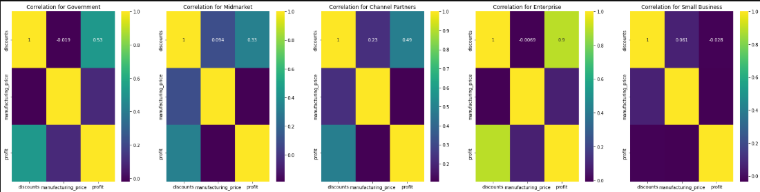

Insight:

* There is no significant correlation between discounts and manufacturing prices.
* Discounts do not directly impact manufacturing costs, but they do affect profit margins.

Suggestion:

* Reevaluate discount strategies to ensure they align with profit goals.
* Avoid unnecessary discounts that do not drive significant sales volume.
  1. Profit Trends Over Time (Seasonal and Regional Factors)

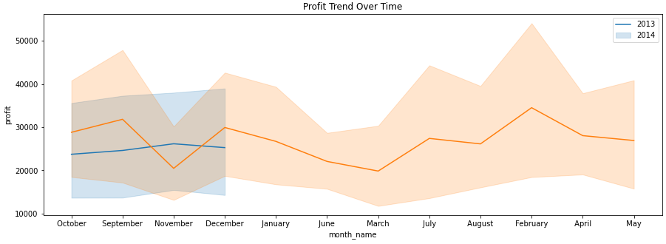

2013:

* Profits spiked in November, with limited data available for October and December.

2014:

* High profits were observed in September, December, and February.
* Other months showed relatively lower profitability.

Suggestion:

* Plan promotions and inventory stocking around peak months (e.g., September, November, December, and February) to maximize profits.
* Analyze seasonal trends further to identify additional opportunities.

2. Sales Performance and Discount Impact Analysis

Objective:

Understand the impact of discount rates on sales volume and revenue across products, segments, and regions. This will help optimize discount strategies to drive sales without significantly reducing profit margins.

Key Insights:

2.1 Correlation Between Discount Levels and Sales Volume/Profit

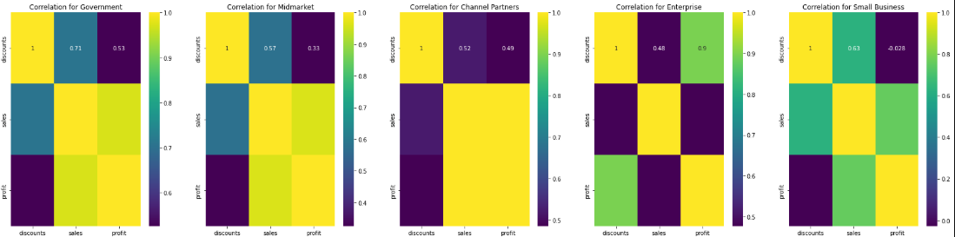

Insight:

* High discounts lead to losses due to reduced profit margins.
* Low to medium discounts maintain profitability while driving sales.
* Small Business and Enterprise segments show low correlation between discounts and profit, indicating potential losses.

Suggestion:

* Avoid high discounts unless absolutely necessary.
* Focus on low to medium discounts to maintain profitability while driving sales.
* Reassess discount strategies for Small Business and Enterprise segments to minimize losses.

2.2 Product Performance by Region and Segment

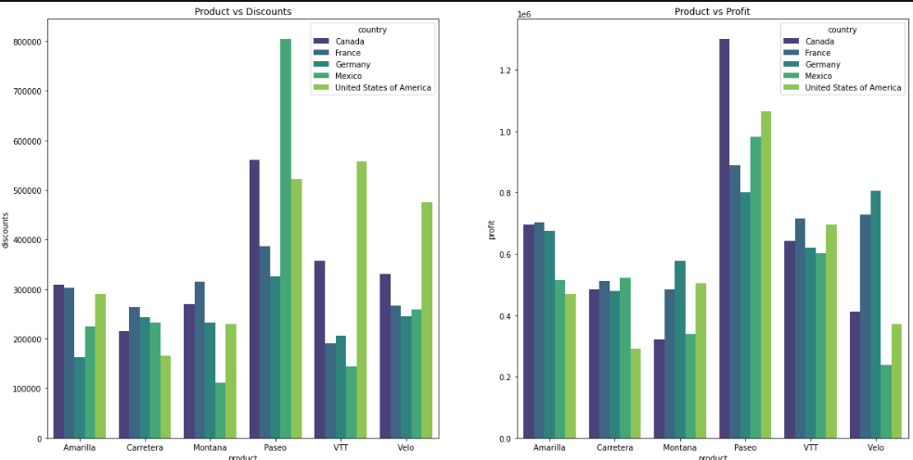

Best Performing Products:

* VTT and Amarilla perform well with low discounts, generating significant sales and profits.
* Carretera, Montana, and Paseo also show strong performance in the market.

Underperforming Products:

* Velo underperforms despite high discounts, indicating poor market response.

Suggestion:

* Increase focus on VTT and Amarilla products, as they respond well to low discounts.
* Reassess the strategy for Velo, potentially reducing discounts or repositioning the product in the market.

2.3 Overall Sales Trends with Discount Strategies

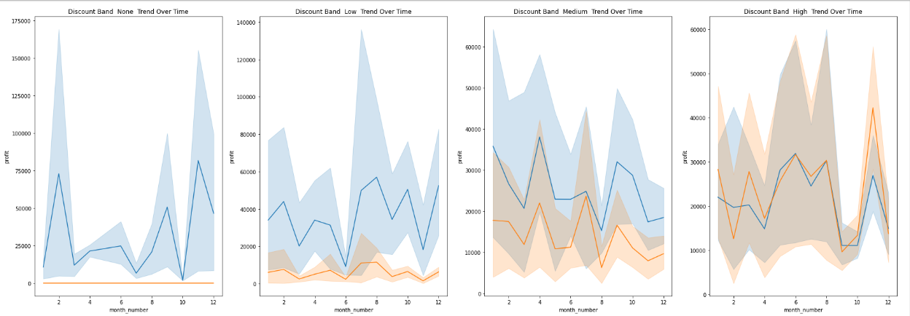

Insight:

* High discounts result in losses for the company.
* No discounts or low discounts yield the highest profits.
* Medium discounts provide a balance between sales volume and profitability

Suggestion:

* Implement minimal discount strategies to maintain profitability.
* Use medium discounts selectively to drive sales without significantly impacting profit margins.
* Avoid high discounts unless there is a clear strategic need (e.g., clearing inventory).

3. Recommendations

Profitability and Resource Allocation:

1. Focus on Government and Small Business segments in Mexico, Germany, and France, as they are the most profitable.
2. Avoid overinvesting in Midmarket segments until a better strategy is developed.
3. Plan promotions and inventory stocking around peak months (e.g., September, November, December, and February) to maximize profits.

Discount Strategy Optimization:

1. Avoid high discounts as they lead to losses.
2. Use low to medium discounts to maintain profitability while driving sales.
3. Reassess discount strategies for Small Business and Enterprise segments to minimize losses.
4. Increase focus on high performing products like VTT and Amarilla, and reposition or reduce discounts for underperforming products like Velo.

Conclusion

This analysis highlights the importance of focusing on high performing segments and regions while optimizing discount strategies to maintain profitability. By reallocating resources and refining discount strategies, the company can maximize revenue and improve overall financial performance. Further analysis of seasonal trends and customer behavior can provide additional insights for long term growth.

Prepared by: Ashwini Prajapati

Date: 16/02/2025

Email: ashwiniprajapati411@gmail.com