Simon Fraser University

CMPT 106
Harinder Khangura

Project Proposal
Autonomous Pet-Bot

Brady Will – 301211924
Jacky Hsu -301229204
Avis (Avneet) Toor – 301222912
Steve Statia – 301265587
Jialin(Jerome) Lu – 301178375
Chelsea Zhao – 301317808
Alvin Ho – 301311102
Kaalo Dabney - 301212818

October 12, 2016

Introduction and Background:

Our project is an artificial intelligence controlled, mobile, pet-like robot. The “Pet-Bot” will have basic AI components and will perform actions such as responding to touch, moving and avoiding obstacles, and will have general features that are found in an actual pet.

This Pet-Bot has medical purposes as well, such as becoming a therapeutic companion to those who may require it like the elderly, veterans and other sufferers of various mental illnesses such as PTSD. An example of a commercial use of such a pet-bot is PARO, a robotic seal [1].

Mental health issues have been present for thousands of years, but today this issue has been brought into the forefront and is actively being studied and treated. Often people with mental illness feel lonely or helpless and on some occasions can act erratically [3]. Studies have a shown that companionship is one way to help those with mental illness [4]. Pet-Bots can offer this type of companionship for those who may need it.

Objectives:

The objective of the “Pet-Bot” is to create a pet like robot, controlled by AI that can be a companion or medical assistant to those who need it. As well as striving to help people, it will allow us to go out of our comfort zone by learning new technologies that we previously were not familiar with. The “Pet-Bot” will be controlled by motors, caster wheels or a ball bearing as well as different sensors such as infrared, touch, and ultrasonic to allow to have better interaction. The success of the project relies on the robot being assembled and able to navigate with minimal collision, as well as establishing a basic emotional connection with the user.

Design and Deliverables:

The design for our project is going to be rectangular box chassis with 2 wheels controlled by servo motors, a caster wheel, or ball bearing to allow smooth turning, and a variety of sensors: infrared (IR), ultrasonic, and touch. On the top of the chassis there will be a screen for message display, and speakers for sounds.

The sensor and motor control will be accomplished using an Arduino controller programmed in C/C++. The robot’s AI will be programmed with a Raspberry Pi written in Python.

Deliverables:

- Robot with controllers, sensors and screen.
- Arduino Sketch files for mechanical controls
- Python files for brain AI
- Help/How to documents
- Design documents

Success Criteria:

- Robot is fully assembled
- Robot can move
- Robot can make sounds and interact with the user
- Robot can perform routine tasks at specified times of the day
- Robot can navigate with minimal collision.

Milestones:

We have split our group into 4 divisions:

AI/Raspberry Pi: Jacky, Avneet, Chelsea
Control/Arduino: Jerome, Alvin
Electronics/Mechanics: Brady, Steve
Integration/Project Coordination: Kaalo

Milestone 1

By the end of October, our goal is to have the robot main parts assembled, be able to move, make sounds, core controls.

Milestone 2

By the end of November, include more complex AI, complete robot build, communication with Arduino and RasPi, collision detection, user/robot interaction, basic robot emotions, and display.

Milestone 3

If time allows we would like to also have the robot recognize voice/bluetooth commands, have location interaction, and have an electronics enclosure.

Timeline:

The teams are structured with a heavier focus on the AI core team, with two specialized teams on the Mechatronics side. We also have someone focused on the integration and coordination of the whole project, who can help teams that are struggling, work on general work, and push the teams towards the general goals.
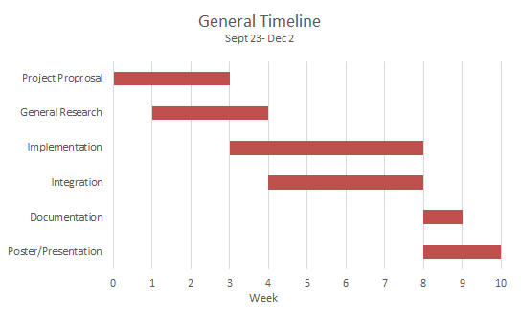
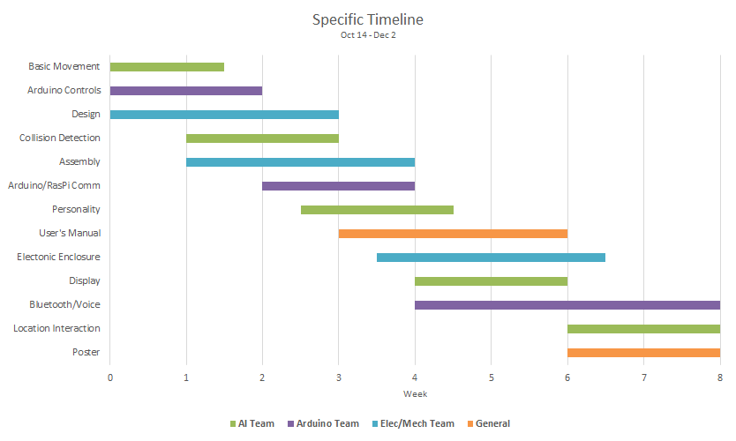

Budget and Components:

The budget and components list is based on products easily found on amazon.ca and other online consumer electronics dealers. We will most likely be able to obtain the majority of components from group members and other sources for free or at a reduced cost.

Software Components

- Github
- Arduino IDE (AVR-C/C++ programming)
- NOOBS (rpi os installer) [2]
- Raspian (rpi os) [2]
- IDLE 3 (rpi IDE) [2]
- Python 3.2.3 [2]
- pySerial (library for communicating between Raspberry Pi and Arduino via serial interface) [5]
- openSCAD (script based 3D modeling software)
- Repetier Host (g-code generator for 3d printing)

Hardware Components

- ($25.99) Arduino Uno R3
- ($29.99) Breadboard and basic electronic components
- ($51.99) Raspberry Pi 3
- ($12.99) Arduino servo motor shield
- ($4.81) Plastic Wheel and DC motor x2
- ($1.49) Ultrasonic sensor
- ($2.87) IR sensor
- ($15.00) LED MATRIX RGB 8x8 (x2?) or ($29.60) -2.8” TFT LCD Touch Display Module for Raspberry Pi
- (~$40) misc. materials, hardware, electronic components and batteries

Total Price
~$185 with LED display
~$200 with LCD touch display

Bibliography:

- [1] PARO Robots Inc. (2016, Oct.). Paro Therapeutic Robot [Online]. Available: http://www.parorobots.com.
- [2] Raspberry Pi Foundation. (2016, Oct.). Raspberry Pi Documentation [Online]. Available: https://www.raspberrypi.org/documentation/
- [3] A. Matthews, “Mental Illness, History,” JAMA, Feb. 2005.
- [4] S. Daniels, “Animal magic: pet therapy could provide the companionship and solace that many people with mental health illnesses crave,” Nursing Standard, Oct. 2008.
- [5] Arduino LLC. (2016, Oct.). Arduino and Python [Online]. Available: http://playground.arduino.cc/interfacing/python

