Titanium Scleral Buckle (TSB)



Manufactured by LA Eye, LLC,

109 Lake Forest Dr., St. Louis, MO 63117, USA

[Contact@macularbuckle.com](mailto:Contact@macularbuckle.com)

Rx only: Caution Federal (USA) law restricts this device to sale or on the order of a physician

**Description:**

Titanium Scleral Buckle (TSB) is a scleral buckle implant made up of medical implant grade titanium designed to facilitate the buckling effect of a scleral buckle in the macular area to help surgically repair retinal detachment involving the macular area. The device is for single use only.

**Indication:**

Retinal detachment involving macular area.

**Contraindications:**

Active infections of the eye or the body.

No light perception eyes.

Extremely thin sclera where suturing for a scleral buckle is not appropriate.

**Possible Complications and Adverse Reactions**

Conjunctival and scleral erosion.

Choroidal detachment or hemorrhage.

Change in the refraction.

**Warnings and Precautions**

Do not use the device if the sterile package integrity has been compromised. Do not re-sterilize the implant.

It should be implanted by a surgeon familiar with scleral buckle suturing.

**Consider adjusting the body curvature of the implant for obtaining a desired postoperative axial length as suggested in the Appendix.**

If the sterility is compromised, or any part of the implant is broken during the implantation, discard the implant or contact the company for possible exchange.

**How Supplied**

The implant is supplied in a sterile pouch. Product Information via the QR code scanning on the box, Patient Chart Labels, Implant Notification Card, and a Patient ID card are also enclosed with sterile package. The implant has been terminally stabilized by Gamma Radiation. Sterility is assured provided that the peel pouch has not been opened, and the sterility expiration date has not lapsed. The peel pouch is intended to be opened using sterile technique, allowing the implant to be dropped into the sterile field.

**NOTE: The manufacturer disclaims all warrantied expressed or implied, including but not limited to suitability for a particular purpose.**

**INSTRUCTIONS ON HOW TO PLACE THE TITANIUM SCLERAL BUCKLE:**

**Consider adjusting the body curvature of the implant for obtaining a desired postoperative axial length as suggested in the Appendix.**

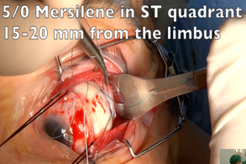

**a**

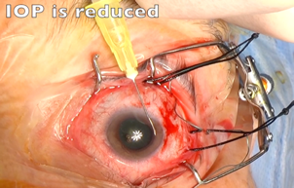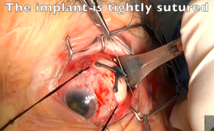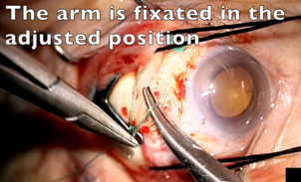

**b**

**c**

**e**

**f**



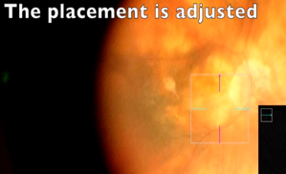

**d**

**C**

1. Titanium Scleral Buckle (TSB)
2. Perform a peritomy at the limbus 180 degrees centering the superotemporal quadrant.

Bluntly and thoroughly dissect the Tenon’s in the superotemporal quadrant to provide a relaxed space all the way to the retrobulbar area.

Place 5/0 mersilene double arm mattress suture at 90 degrees angle to the limbus exactly in the middle of the superotemporal quadrant, anterior bite of which is 18-20 mm from the limbus, with 5 mm apart bites, strong enough deep in the sclera (about 2/3 of the scleral thickness). Try to make the bite about 3-4 long.

Place a VALVED trocar in the superotemoral or inferotemporal quadrant.

1. Doing a paracentesis with a side-port blade, empty the anterior chamber near totally to provide the maximum hypotony with this procedure.
2. Place the implant through the preplaced Mersilene and gently push it as posterior as possible until some resistance is felt, and at that point, permanently tie the Mersilene to fixate the implant.
3. Place a chandelier light in the preplaced nasal valved trocar and visualize with a wide-angle operating microscope (e.g., BIOM, Resight or EIBOS), that the implant indents the desired area. if required, fine adjustments can be made by tweaking the placement by manipulating it though the anterior horns.

1. Finally, the implant is fixated in the adjusted position by placing an additional suture in one or more of the 3 holes at its anterior section.

**Instructions for placing the Titanium Macular Buckle (Also available as a 40 seconds EyeTube Video.)**

Click the link or scan the QR code to watch the Video:

<https://eyetube.net/videos/titanium-macular-buckle-placement>



**Appendix**

**Suggested adjustments for approximating to the desired postoperative resultant axial length.**

**The results will vary for the tightness of the surgical suture and the surgeon’s individual technique.**

The End-to-End distance in the original packaging measures 21.5 mm and is estimated based on a post-operative axial length target of 25 ± 1 mm regardless of the pre-operative axial length (Figure 1).

If the desired final axial length varies from this target for the case having this implant, such as in cases where a significant reduction in axial length may negatively impact post-operative refraction (e.g., pseudophakic eyes), a lesser indentation, like shortening the axial length by 2 mm with the implant, may provide the desired improvement in macular pathology. For such situations, the table below can be consulted to determine the recommended modification for the End-to-End distance (such as in Figure 2) regardless of the pre-operative axial length.

FIGURE 1 FIGURE 2

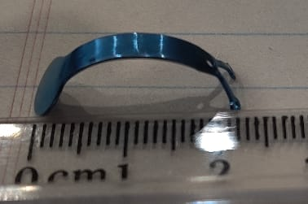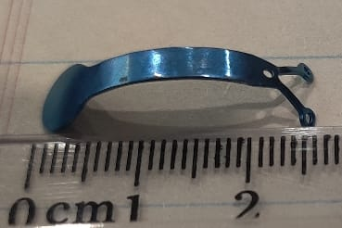

End-to-End Distance = 21.5 mm End-to-End Distance = 25.0 mm

TABLE:

|  |  |
| --- | --- |
| Desired Postoperative Axial Length (mm)  Regardless of the pre-operative axial length. | Recommended End-to-End Distance (mm) |
| 25 ± 1 | 21.5 |
| 26 ± 1 | 22.00 |
| 27 ± 1 | 22.75 |
| 28 ± 1 | 23.25 |
| 29 ± 1 | 23.75 |
| 30 ± 1 | 24.25 |
| 31 ± 1 | 24.50 |
| 32 ± 1 | 25.00 |
| 33 ± 1 | 25.25 |
| 34 ± 1 | 25.50 |
| 35 ± 1 | 25.75 |
| 36 ± 1 | 26.00 |
| 37 ± 1 | 26.25 |
| 38 ± 1 | 26.50 |